

Rules for
Live Action Roleplaying

Version 3.0 February 2008
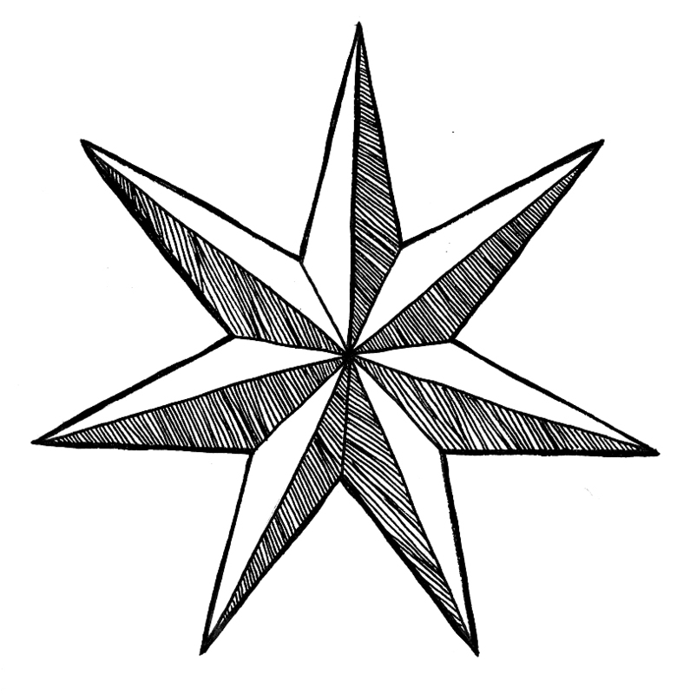
KINGDOMS OF NOVITAS
RULES FOR LIVE ACTION ROLE PLAYING

©2004, 2005, 2006, 2008 by the Mohawk Valley Gaming Club.

Based on the Adventures in Mid-Land fantasy rules, ©1995, 1997, 1999, 2001, 2004. Used with permission.

All Original Artwork © Kingdoms of Novitas

The Kingdoms of Novitas “KN” logo and the circle of seven seven-pointed stars design is © Kingdoms of Novitas

All characters in this book are fictitious. Any resemblance to actual persons, living or dead is purely coincidental.

This information is protected under the copyright laws of the United States of America. Any reproduction or unauthorized use of the material or artwork contained herein is prohibited without the express written permission of the Mohawk Valley Gaming Club, Inc.

This book contains information and rules needed to run live action role playing games of the variety run by Kingdoms of Novitas and the Mohawk Valley Gaming Club. Groups not associated with Kingdoms of Novitas may still use these rules for their own purposes as long as they are not a professional organization. The charging of admission or collection of membership monies for non-sanctioned games is prohibited. The use of the name “Kingdoms of Novitas” for any group or event not sponsored by Kingdoms of Novitas or the Mohawk Valley Gaming Club, Inc. is also prohibited.

Visit our web sites at www.mvgc.net and www.KingdomsOfNovitas.org

Disclaimers and Notices
Kingdoms of Novitas and the Mohawk Valley Gaming Club, Inc., nor its individual owners, partners, employees, or members, assumes no responsibility nor liability for any injuries, physical, mental or emotional, received, or allegedly received, due to the playing of the game, Kingdoms of Novitas LARP, or any variation thereof.

These rules are the result of over eighteen years of play testing by experts in live action role-playing, table top gaming, historical re-enactment, and martial arts. The information in this book, especially in regards to safety, is not to be taken lightly. Members of Kingdoms of Novitas are expected to follow the rules set down in this book. People intending to use this book to run live action role-playing games outside of Kingdoms of Novitas are urged to carefully consider all changes to the basic system before playing.

Credits & Blame

The Mohawk Valley Gaming Club partners are: Kevin Buckley, David Haldenwang, Steven Hunt, Craig Korycinski, Felix Mendez, and James Roth

Kingdoms of Novitas was founded by: David Haldenwang, Felix Mendez, James Roth, and Rosemary Siebold

Edited by: David Haldenwang and Drew Urbanek

Contributors to this text: Todd Burnop, David Haldenwang, Jeff Kwasniewski, Felix Mendez, David Morgan, James Roth, Drew Urbanek, Rich King, and Rosemary Siebold

Artwork done by: Ann Aumick and Julie Bednar

Interior Photography by: Julie Bednar and Steve Marsh

Front and back cover by: Julie Bednar

Cartographers: Todd Burnop, Justin Capen and David Haldenwang

Original Adventures in Mid-Land rules written by: Tom Gleason IV, Keith Jurgens, Lance Kazmark, Ben Pierce and Charles Waterman

Special Thanks to: Steve Marsh, Daniel Meershaert, David Morgan, Todd Burnop, Justin Capen, Jordan Bellassai, Drew Urbanek, William Rexroat, Bob Manning, Mike Nichols, Rick King, Tom Hall and Vanderkamp.

Table of Contents

Introduction Page 7
- Fundamentals 8
- The Kingdoms of Novitas 13
World Map 13
Free Lands Map 18
- Religions in Novitas 20
- Races of Novitas 34
- Character Creation & Skills 41
Skill Charts & Descriptions 48
Equipment 59
- Magic & Spells 62

Roleplaying Skills 70
- Production Skills 75
Alchemical Compounds 78
- Weapons & Armor 85
Armor Values 96
- Adventuring 99
- Combat 119
- Traps & Locks 125
- Loot! 127
- Other Jobs: NPCs & GMs 131
- Crime & Punishment 136
Appendix A: Spell List 138
Appendix B: Alchemical Compound Descriptions 155
Glossary 162

Introduction

Your blood surges, answering the yells of your tribesmen as you clash your axes together, adding your noise to the din of the others. Like a human wave, the sunlight glinting from the crest of your raised weapons, you charge forward to engage your enemies. As your axe strikes home, you realize that this is what you were made for.
This game is fantasy

The world and events of this game take place in the imagination of the players. Like actors, the players refer to each other by their character’s names, and this rulebook also adopts that casual approach, often using “you” to mean “your character.” In reality, you are no more your character than you are the king when you play chess. Likewise, the world, cultures, history, and religions of this world are imaginary. It’s all just a game for fun…
In another part of the world, you lift your head from an ancient tome. Firelight reflects from your glistening scales as your apprentices watch you begin your incantation. Your voice crescendos majestically, climaxing as you clap your hands together. There is a burst of light, and your apprentices flinch reflexively. When they look back at you, you are sheathed in a shimmering field of magic. “Observe,” you say, and walk unharmed directly into the room’s central firepit. “This, this, is the power of DRAGONS!”
Somewhere else, you mentally quell a small tremble in your hand as you slide through the forest. Your light touch on the thin ceramic of the eggshell you hold steadies. You laugh to yourself silently, fangs gleaming in the moonlight, as you ponder for a moment the satisfaction your enemies would get from finding you dead of your own poison – but not tonight, you think. Up ahead, you see the glow of your quarry’s campfire. You’ve been watching them for an hour, so you know that their sentries are not vigilant. Too bad for them, you think. Checking the load of your crossbow, you gather yourself, and then burst from the trees. One elf gets a glimpse of your long white hair and pale face, and calls out, “Snow Goblins!” He dies first as your crossbow bolt, wet with virulent poison, slams into his chest. His comrades scrabble frantically for weapons, but it is too late. You are a whirling dervish, poison death spraying from your hands. Your left hand flashes out even as your right moves to draw another weapon, and the ceramic eggshell whips through the air to impact on another elf. He starts to charge you, but suddenly falls over, clutching his throat. The last elf steadies himself, the tips of his two swords weaving through the air. Both your hands become blurs as you hurl four daggers in quick succession. The elf is good – he dodges three of them - but the fourth one nicks his arm, drawing a thin line of blood. He takes two steps toward you before he pitches over onto his face. “Snow GOBLIN, thank you.”
Welcome to Kingdoms of Novitas live action role-playing, a game where you and your own abilities do as much to define you as your character sheet does.

What is live action role-playing?
Live action role-playing (LARP) is a fluid combination of fantasy gaming, interactive theatre, real-time combat, and medieval re-enactment. While some live action games lean heavily on imagination, players at Kingdoms of Novitas look, act and dress the parts of their characters, whether they are a simple human bard or a howling Tribesman warrior.
While your character has skills written on a character sheet like many other fantasy role-playing games, those skills only serve to simulate fantastic abilities (such as magic), or to provide game balance (most of the combat skills). The basic rule of Kingdoms of Novitas is that if it can be physically done, and done safely, you have to do it. Climbing, running, hiding – these are all things there are no substitute for. While combat is fought with padded weapons called “boffers”, it is full speed, and very deadly for characters. Don’t worry though, it’s not that hard, and with a little practice you too will be able to hold your own against marauding ogres or shambling zombies moaning for brains.
How do I start?
A good source of information is our website, found at www.kingdomsofnovitas.org. Players should also familiarize themselves with the contents of this rulebook. If you’re still a little unsure of your feelings about LARP, attending your first game is cheap, and we encourage you to come check it out. While we know it’s not for everyone, most people quickly find themselves hooked on the unmatched role-playing opportunities, the depth of the immersion and the suspension of disbelief they get. Welcome to your new world.

1. Fundamentals

The Fundamentals section of these rules covers a few things everyone at a Kingdoms of Novitas event should know: what to do in unsafe situations, what to do when you hear people yell certain things, and other stuff that doesn’t fit anywhere else in the rules. Every player is expected to know and understand these things, and, as some of them are vital to the functioning of the game, ignorance is no excuse.
Even if you have played at other LARPs before, please take the time to familiarize yourself with how we do things at Kingdoms of Novitas.

In game, Out of game
In game and out of game are two vital concepts that every player should understand.
When a player is in game, he should be in character, wearing the full costume and garb of his character, and ready for anything. Players who are in game are playing the game, and should react accordingly – as their character would. Most characters are assumed to be in game at all times.
If a player is in game, it also means that all of his in game items, such as money or treasure, are also in game. It is strictly against the rules for a player to be in game, while his hoard of potions, scrolls, money, and valuable items is safely stowed out of game in his car, under his bunk, or other out of game place. Players found securing their treasure in such a manner are cheating, and will likely lose all their items if caught doing this.
Players can go out of game at any time, except to gain advantage for their character – like in the middle of a fight or encounter. Players should go out of game when they are going to the bathhouse, their vehicle, or leaving the game area for any reason. Game Masters will frequently mark themselves or their NPCs or encounter areas out of game until they are ready for use. Out of game players should mark themselves with a fluorescent (hunter) orange vest, armband, or headband. Any object or area marked with hunter orange tape or flags is out of game.
When a player goes out of game, all of his in game items on his person or in his tent or bunk go out of game with him, whether or not they are attended. However, unattended in game items left out in the open are fair game, so if you go out of game to use the bathroom, but leave your silver dagger on a table in the middle of the game area, it’s likely to disappear. If in doubt, take it with you when you go out of game.
Other players who see a player marked out of game should ignore him. If contact is initiated at a distance, it is customary for an out of game player challenged to respond simply, “I’m out of game.” Sometimes, players who are out of game will tell other players, “I’m the wind, ignore me” or similar nonsense. Once you have determined that a player is out of game, you should leave them alone. After all, they don’t exist.
Out of game areas marked with orange tape or flags should be completely avoided by players. The instant you see orange tape on an area, you should turn around and leave. Don’t scout it out, and don’t “camp” the area – that’s cheating. The area is either hazardous, or is being prepared for something by a Game Master. In either case, you shouldn’t be there.
A word on sleeping players is also in order. Players sleeping in in game areas are considered in game, unless they have marked themselves or their bunk clearly with orange. Some players do choose to remain in game for the entire weekend, adding to their adventure.
Sleeping players marked with orange are out of game, and they and all their gear, both in game and out of game, should be left alone. If you are sleeping out of game and you are awakened by in game activity in your sleeping area, you are honor bound to remain out of game until the encounter has ended. Stay quietly in your bunk, try not to hear anything you shouldn’t, and don’t get involved. If you wanted to be involved in such things, you should have stayed in game while you slept.

GAME HOLD!
One of the first things you should know is what to do if you think there is a dangerous, or potentially dangerous, situation. This would cover things like dropped glasses, broken bottles, nail-filled boards, fighting very close to campfires, bears, injuries, etc. In the normal course of play, you should simply do what you can to remove the hazard – pick up the glasses, bury the broken bottle, move away from the campfire, and so on. If the game is in full swing, i.e. everyone’s fighting and yelling and running, you may not have time to take that action. This is when you call a Game Hold.
To start a Game Hold, simply yell out, as loud as you can, “GAME HOLD!” All players and Game Masters hearing this should immediately STOP what they are doing and repeat the game hold as loudly as they can.
When you hear the call of GAME HOLD, all action stops. Players are free to talk quietly about out-of-game stuff, or to assist with the situation at hand as necessary. Otherwise, players should not move, adjust equipment, discuss in game plans, or other related things, as this is cheating.
When the situation has been dealt with, the person who called the Game Hold is responsible to end it. All players should be in the position they were in when the hold was called, holding the same equipment, and with the same intentions. The person who called the Game Hold, or a Game Master or other responsible player if that person is gone, should count down loudly, “Three, two, one, GAME ON!”
Good Game Holds

You are injured
You see a dangerous situation
Someone else is injured and cannot call the Game Hold themselves
Dropped glasses. Although they should be secured with a safety strap, accidents happen.
Illegal hits in combat. If you get your bell rung due to a bad hit, it is OK to call a hold to clear your head and recover. You should not be at a disadvantage because of your opponent’s illegal hit.

Bad Game Holds

You fall but are not injured
You drop your weapon
You don’t agree with a rules call
Combat is going badly for you
There is no immediate danger to anyone
When players hear the call of Game On, they are free to act normally again.
Any player can call a Game Hold at any time, but please try and ensure you have a good reason. Dropped weapons, falls not resulting in injuries, or arguing rules are NOT valid reasons for calling a Game Hold. If you see a person fall, they should call the Game Hold themselves, if they need it, as they are the one who knows if they are injured. The obvious exception to this would be if they are too injured to speak, in which case you should immediately call a Game Hold and get help. This is very unlikely, but should be addressed.
Please try to refrain from reflexively calling a Game Hold every time someone takes a tumble. After all, people fall down in medieval fantasy all the time and the world doesn’t stop for them. Being aware of your surroundings is just as much of a part of the game as everything else, and is part of what makes it “live action”. But, as in everything else, safety first. If you are unsure of the situation, call a Game Hold.
Time stop
Sometimes the Game Masters will need to position something, impart information, or otherwise set the scene for an encounter that’s already in full swing. When this happens, the Game Master will frequently call “TIME STOP!”
When a player hears a Time Stop called, they should IMMEDIATELY stop what they are doing, take a knee, close their eyes, and begin making meaningless noise. The object of all this is to prevent you from seeing something you shouldn’t yet see that would upset the plot or ruin the surprise for you.
Players in a Time Stop should not speak to each other, look around, or move. To do so is cheating. Unlike a Game Hold, players should never call a Time Stop. It is a tool for GMs only.
A Time Stop is ended in the same way as a Game Hold – the person who started it will call “Three, two, one, GAME ON!” At that point, action should resume exactly where it left off.
Safety
Safety is a paramount concern at Kingdoms of Novitas. While it ain’t golf, and people are frequently hitting each other with padded weapons, this doesn’t mean we want to see anyone injured.
While all rules of the game are important, rules dealing with safety concerns always take priority. Players ignoring Game Holds, initiating bodily impacts during combat, using unsafe weapons, and other such things, especially to gain advantage for their character, will be dealt with far more harshly than players who break other rules, whether knowingly or inadvertently.
Touching other players at Kingdoms of Novitas is sometimes a, well, touchy issue. People who are friends and are comfortable with each other sometimes forget that other people, especially new players, might not appreciate a clap on the back or a friendly hug. Players in game at Kingdoms of Novitas should always ask before initiating physical contact with another person. Don’t just assume that because you’re “rescuing” the maiden that she wants to be grabbed and slung over your shoulder – she may have very different ideas!
Contact in combat is another matter, and is covered in greater detail in the Combat section of these rules, but, in short, the only contact in combat that should be happening is with weapons.
In game theft
Invariably, characters get the urge to steal from each other. While this is allowed, there are a few rules to follow.
First, Kingdoms of Novitas has no character skills that allow theft. If you want to steal from another character, you need to actually pick their pocket, empty their pouch, or otherwise take their items.
Second, only items that are in game items may be stolen. All in game items, even though they may be in the possession of a character, are Kingdoms of Novitas props, and must be returned to Logistics if your character dies or you permanently leave the game. Looking at it another way, character theft is more a matter of game props changing hands between characters than stealing from another person. Normal weapons, armor, garb and equipment all may not be stolen. Potions, scrolls, magic items, and marked treasure are all fair game.
An easy example of this is a character who has a wooden chest that he keeps some of his belongings in. While the things inside that chest may be in game items, and hence fair game for stealing, the box itself usually is not. If you wish to steal the items inside that box, you may do so, but you cannot simply pick up the box and walk off with it. You also may not damage the box to get inside it.
Real world personal items should NEVER be touched. Things like medicines, wallets/money, car keys, or cell phones are all off limits. Players who take these items are committing a real world crime, and will be dealt with accordingly.
Often, characters will want to search a cabin or building. This is allowed, but there is one important rule: things under bunks are out of game. Under your bunk is the place to store things like clothes, food (in sealed containers), etc., and in game items should never be stored there unless the player who owns them is out of game. To do so is cheating, and if a Game Master sees you taking in game items from under your bunk while you are in game, you will likely lose them.
Characters sleeping out of game should likewise not be touched. Neither them, nor their equipment, including their in game items, are in game at that time, and they should have marked themselves or their bunk clearly with orange tape, or an orange glow stick if it is dark to be sure.

Searching players
The first thing on many character’s minds after a battle is loot. Naturally, they will want to search the fallen for information, money, magic items, or treasure, but this must be done in a certain way. Not every player wants another person touching them to search them, and not every person desires to have to pat down other players who may have hidden their loot in dubious places.

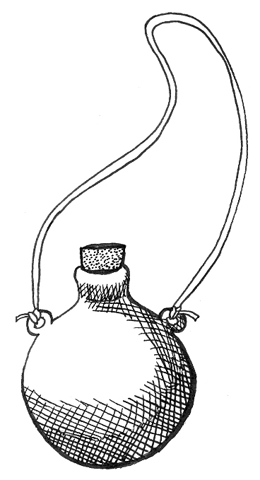

To deal with this potentially delicate issue, Kingdoms of Novitas uses the following procedure for searching other players:

- Announce your search, and wait for a response. A simple declaration to the fallen person of “I’m going to search you now” is sufficient.

- Players who do not wish to touch another player to search may simply begin a detailed search.

- The player being searched should decide how they are willing to be searched – detailed search or physical search. If they don’t want to be touched, they should reply with “Detailed search please.” If they are willing to allow the player to search them, they should simply reply with “Go ahead,” or something similar.

- If the player being searched desires a detailed search, do not touch them. Take a knee next to them, and begin describing your search to them. If your search describes an area where an in game item is carried or hidden, the player being searched is honor-bound to give it to you.

- If the player doesn’t mind a physical search, it is your responsibility to find any items they have on their person, and they are under no obligation to assist you in any way.

If at any time either player desires a physical search to stop, they may say so, and the search must become a detailed search. The player being searched also has the option to simply give up all his in game items when a search is declared.

Restraining other players
Occasionally, a situation may arise in which characters wish to take a prisoner or a hostage, or restrain a criminal. Binding another player works basically the same way as searching another player. It’s also important to note that if you don’t have rope, thongs, manacles, or some other means of actually restraining someone, they can’t be restrained.
If both parties agree, then go ahead and tie them up. They are free to try and get loose. However, we don’t recommend this option, as most players have no idea how hard it is to actually tie someone up effectively. Also, it’s uncomfortable, and usually painful, for the person being restrained.
A better option is to simply tell the player they are being tied up. Loosely loop your rope or thongs a couple times around your captive’s wrists and leave it at that. The bindings don’t have to be at all tight, and the captive player should help by holding the rope in place. In this case they are NOT free to get loose, and another player must “untie” them or role-play cutting them free. There is no chance of a captive undoing such a restraint themselves, so it’s generally a better option for the captor anyway.
Garb
Few things can ruin the atmosphere of the game more than players with bad costumes (usually called “garb”). Sneakers, T-shirts, or jarringly modern clothes (such as camouflage fatigues) can completely destroy the suspension of disbelief the game tries to create.
We don’t expect everyone to have perfect period garb. In fact, that in itself would be silly, since Kingdoms of Novitas is a fantasy game, and not set in a specific historical period. But it is expected that players will try their best to wear some sort of a fantasy/historical blend.
For a new player, this can be quite simple. Neutral colored sweatpants suffice for pants. On your feet, modern leather work boots with burlap or cloth wrappings from ankle to knee to disguise them would be great. A renaissance/pirate/medieval shirt or tunic with a belt over it would complete your garb nicely. If you wanted to go a bit further, a cape or cloak will make you look great.
As you attend more events, you’ll accumulate more garb. Thrift stores can sometimes be a great source for garb if you’re willing to take some time with your items. Renaissance Faires, while expensive, are a source of some really great stuff. And a quick search on eBay will usually turn up hundreds, if not thousands, of items at reasonable prices. To completely outfit yourself from head to toe will cost much less than $100 if you’re thrifty. Like any hobby, you should expect to spend some money on LARPing, but just because you’re on a budget doesn’t mean you have to look bad. On the contrary, the players on a budget often look the best, as they have to carefully evaluate their needs and pick just the right things, and are usually willing to work with items, like old leather coats, to make them look great.
But regardless of how you do it, Kingdoms of Novitas does expect a certain standard of garb and costuming from players, and this is your responsibility. While players will be given some slack for their first couple events, by your third event you are expected to have a complete costume for your character.
If you need help with garb, don’t hesitate to ask an experienced player. Like anyone, they love to talk about their hobby, and are glad to see new players.
Players who consistently demonstrate sub-standard garb, or who are wearing something jarringly anachronistic, will be removed from the game and given the option of continuing to play as a non-player character for the Game Masters, or to leave until they can correct the anachronism. Items that will merit this level of response are things such as white sneakers or modern jackets.

Age Requirements
- Players must be eighteen years of age or older to participate in Kingdoms of Novitas events.
- Players ages fifteen and up are allowed if accompanied by a sibling, parent, or legal guardian who is over the age of twenty one. The accompanying adult must be a signed-in participant and must remain on-site at all times.
- Any exceptions to these rules will be handled on a case by case basis by the GMs. The GMs have the final say in matters concerning the maturity of all participants.
- If, for any reason, someone under the age of fifteen is present, they must be in the immediate vicinity of a sibling, parent, or legal guardian over the age of twenty one at all times without exception.

The purpose of these rules is to ensure the safety of all participants (regardless of age) at Kingdoms of Novitas events.

Adult situations and minors This game is intended for adults over the age of eighteen and may contain adult themes dealing with violence and romance, among other things. It is the responsibility of the accompanying adult (relative or guardian) to monitor what is or is not appropriate for the minor. It is the sole responsibility of the accompanying adult to remove the minor from any scenes deemed inappropriate (without interrupting the game). It is not the responsibility of Novitas GMs, players, or NPCs to alter the game around your child - the responsibility is yours.

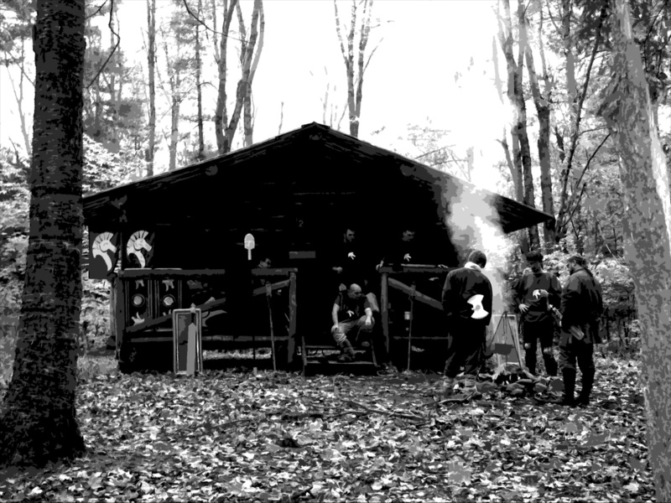
2. The Kingdoms of Novitas
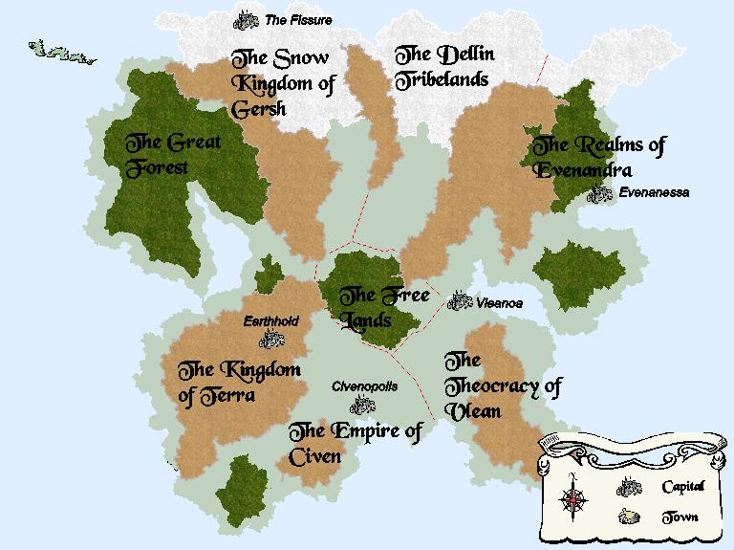

Ancient History

The Time of the Gods
No mortal truly knows the state of things before the birth of our world. Manuscripts written by Septons whose bones have long ago crumbled to dust report that before the arrival of the first god, a dark and shapeless void stretched to infinity in every direction. This god, whom we call Illumitas for a lack of true knowledge, was reportedly greater of stature and power than any god worshipped in the present day.
Being peerless as he was, Illumitas grew weary of his old existence and stepped forth from the beyond to explore the void. At first the deity was delighted by the formlessness of his new environs but in time he once again became bored.
Illumitas drifted into sleep and began to dream. In his dream he saw a new world hanging in the void, a world populated by many lesser beings. Illumitas was amused and intrigued by these beings, watching their struggles in his dream for some time and always from a distance.
When he woke, the deity was pleased to see that during his repast he had already begun to form this dream world from the only material available - his own body! Illumitas decided to complete this world, as leaving it unfinished would be wasteful of his own power and would ensure his tedium for millennia to come. And so his bones became mountains, his flesh formed the stretching plains, and the riverbeds and deeps were filled with his blood. The deity plucked out his right eye and set it afire so that it would provide heat and light to his creation.
Illumitas marveled at the world he had fashioned, for it was a wondrous accomplishment indeed. The beautiful sphere from his dreams now hung in the void before him, a perfect paradise that practically begged to be occupied by the many creatures he had envisioned. The work had proven quite taxing to the deity, however, and Illumitas fell into a deep slumber.
The Dark Powers
Unfortunately, another had been watching the mighty god at work. This dark being, who none dare to name, coveted the sphere for his own purposes. He knew that he was no match for the first god, even asleep and debilitated as Illumitas was. He Who Is Made Of And Dwells In Darkness then enlisted the help of two others to execute his foul designs. Together with Nox the Putrescent and a brutal warrior god called Grak, Darnkess fell upon the sleeping form of Illumitas and tore him to pieces. But then something happened that he could not have anticipated.
Illumitas had been dreaming of new life and subconsciously created it at the same time. Seven new deities sprung fully formed out of his corpse to challenge the trio of Darkness. War reigned for a time and the newly made planet was severely damaged. Eventually the Seven (called the Sept by modern mortals) triumphed, sealing the three dark gods into chasms deep in the planet’s core.
Draconus
While the Sept battled the dark powers, one last creation of Illumitas awakened. In a huge cavern deep in the mountains, the spine of Illumitas’ slain body rose again as the dragon god, Draconus. He was huge, and magnificent, and powerful beyond mortal knowledge. He took no part in the battles of the Sept and the dark powers, and instead turned his powers to coaxing his first children into the world. He used his magical arts to transform the last fragments of bones into the first dragons, who became his loyal followers.
The Golden Age
Once the evil deities were sealed in their prison, the Sept surveyed the damage and began to repair the ravages inflicted upon the masterpiece of the first god. The Soldier and the Knight cleared the wreckage while the Smith forged discarded material into new landscapes; the Elemental renewed the foliage while the Mother tended the wounds of her brethren. Even the Scholar was active in this endeavor, for only he knew the exact dimensions of the world when it was first made.
So it came to be that the Stranger was first to discover that the gods were not alone. Illumitas was enormous and had died in the midst of a creative dream. The Sept were only the first things that had sprung from his corpse, guardians of all that came after them.
Returning to the spot where the first deity had died, the Stranger found a veritable explosion of life. Birds, beasts, men, Elves, and faeries were all present. The Stranger led these creatures to where the sphere hung in the void and the gods unanimously decided that they should dwell there on the lush continent of Vargainen as Illumitas had planned. The gods even lived among mortals for a while, for they quickly learned that men and Elves were similar to themselves, if a bit less majestic.
So the Scholar taught them language and philosophy, that they might communicate with the gods and each other. The Mother made them fertile so their races might continue on even after individuals have perished. The Elemental gave the gift of agriculture, that they might feed themselves and always respect the power of nature. The Soldier taught men and Elves the ways of battle so they would have the means to defend themselves in a world that was wild and untamed. The Knight taught them the concepts of law and honor so they would know when and why to use the gift of the Soldier. The Smith instructed the sentient races in many crafts, even taking many of the best artisans to live in Voltanicus, his underground stronghold. Finally, the Stranger bestowed upon mortals the gift of afterlife as both incentive towards and reward for honoring the gods and keeping their principles.
Though most men and Elves had been nomadic hunter-gatherers before, they soon began to congregate into villages. As mortals learned more and more from the gods, some villages grew into cities and civilizations flourished.
Three great countries as well as a dozen city-states sprung up in this age and the wilds of Vargainen were pushed further and further north. The nation of Andar became particularly wealthy and influential during this period. The capital city Andarsin boasted the largest library and greatest university in the world; its markets were so vast that anything one might want could easily be found there.
It was the Andarans, with the help of the Knight and the Smith, who built the fortress Wahkarn over the prison of the dark powers. Upon its completion, the virtuous and mighty man Kalbis the Bold founded the Templars of Wahkarn. This knightly order took up the vital task of guarding the sealed portal that enclosed the triumvirate of evil deities. Centuries passed and peace reigned.

The Dark Powers Are Released
As thousands of years passed, the people of Andar, particularly the Templars of Wahkarn, came to regard themselves as beloved of the Sept. In truth, all mortals held the favor of the Sept in those days, but the Andarans became filled with pride and overzealous righteousness.
A small faction within the Templars began to question exactly what they were guarding. They could feel great power beneath their feet and began to ask if the gods had not hidden something from them. Nobody knows for sure, but it is thought that ^{Darkness} had found a way to bleed a small measure of his power beyond the barrier. Whether the cause was dark magic or simple faithlessness, the results were the same.
This rogue faction of Templars destroyed the portal and released the dark powers into the world once more. The trio of Darkness “rewarded” any Andarans they found by twisting them into their own image. Elves became goblins and the race of orcs was born from human stock. Light fae were infused with evil, and their hearts darkened. The gods gathered their armies and a terrible war ensued.
The world was nearly torn asunder for a second time. Some scribes claim that the mysterious dragon god known as Draconus fled the sphere amidst this chaos, creating the moon as his sanctuary and thus initiating the slow decline of his progeny.
In the end Vargainen, the continent where mortals had always dwelled, was undone and crumbled into the sea. So many lives were lost that it did not take the wisdom of the Scholar to know this war would eventually destroy the world.
All the gods struck a bargain by which they would never again walk the sphere in their true forms but rely upon mortal worshippers to decide the fate of Illumitas’ masterpiece. All mortals were deposited upon the former home of the deities, and the continent was re-named Novitas (the new land). The gods then withdrew from the world, crafting a magic circle around it to ensure that no immortal could physically reach the sphere again.

So began the age of mortals.

The Age of Mortals

Paradise Gained
As those mortals that could be saved in time were collected by the gods, they were relieved that the deities were not deserting them. But to their dismay, the gods in their haste deposited them about Novitas in a haphazard manner. Whatever armies and hosts had been fighting in the same area during the last battles were placed together in the new land, staring in wide-eyed wonder at the former home of the immortals.
The whole continent possessed a perfect climate. Completely tame animals nuzzled at their blood-stained hands and an abundance of food grew naturally on every tree, bush and vine. It was as if Novitas were new made by the elder god Illumitas and blessed by the long-time residence of his children all at once. Here and there abandoned buildings, artifacts and tools could be found, made and used by the Sept themselves!
After thanking their gods for salvation and picking themselves up off their knees, the mortal races began to labor. Most created villages wherever they stood, since the resources to support life were not an issue. A short period of adjustment to their new environs was followed by an age of exploration. A new calendar was started, and the year they arrived on Novitas was called year one of the Age of the New Land (1 NL). Villages grew into cities, and in some cases into nations. Dragons traversed the land in search of their brethren and re-established their empire, dominating the forests, mountains and coastlines of the west. Goblins who had found employ in the armies of the dark gods founded the nation of Gersh in the north. Soon they were joined by their Sept-worshipping cousins, for the “goodly races” seemed only to remember those goblins that fought for the dark gods.
Artifacts of great power were discovered. Some of these were benevolent, others malicious, and more than a few were simply never meant to be used or even seen by mortals. Many explorers vanished, never to be seen again, but a few came back wielding great magic, carving out a place of power in their new-made societies. In 6 NL, Garan Draisson, a great human hero from the war of the gods, found a great stone fortress already made and stocked with magical weaponry in the far south. He led the remnants of his legion there, founding the city of Civenopolis. Three other predominantly human nations rose up: Adecia in the east, Dellindanar to the north, and Quaradar nestled against the mountains to the west.
The majority of the Terran race settled in these western mountains and was promptly forced underground by the brown dragons and their thralls. In 34 NL, the Elves completed the luminous alabaster city of Evenanessa on the eastern coast of Novitas.
A mixed army of humans and Elves discovered a great library in the heart of Novitas. It was believed that the Scholar himself had lived there at one time; the very air sparkled with magical energy. A village called Nalbendel sprouted next to the library and quickly grew into a city. Nalbendel became known as the greatest center of learning in a land of budding civilization, producing or training nearly all the mightiest mages of this time.
For nearly a thousand years the peoples of the new land co-existed in relative peace, broken only by minor disputes and skirmishes.

Trials and Tribulations
Even a golden age can not last forever, and the end was foreseen by the sages of Nalbendel. Slowly, the radiance of the Sept began to bleed out of the land. Animals grew wary of the sentient races, forcing them to hunt for their meat. The bountiful food plants that once littered the land had to be cultivated or else died out entirely. The once-palpable divine presence faded from holy sites. Powerful artifacts that had been used to aid or protect the people crumbled to dust, eaten by their own magical energies. Famine and disease reared their ugly heads anew and devastated peoples who had forgotten such things existed. Violent, chaotic weather became commonplace as the wards put in place by the Sept decayed, and the climate of Novitas shifted. Hurricanes lashed the shores in the south.
In 985 NL, gigantic blizzards slammed the Northlands, particularly Gersh, and few were prepared. Thousands froze to death or starved and thousands more tried to flee south. The southlands had their own troubles, however. The humans and Elves still remembered the Goblins who had fought for the dark gods; the flood of refugees was turned back as though they were an army.
The Draconic Empire to the west was having even larger problems. The flight of the god Draconus from Novitas had begun working a long process of decay upon the physical forms of his children. Once the dragons were huge, majestic reptiles that walked on four legs and had enormous wingspans; the degeneration had reduced them to reptilian humanoids resembling the races that had worshipped them. The dragons had used their superior grasp of magic to conceal this fact for generations, but now the metamorphosis of dragons to Drakes was complete.
The lesser reptilian races finally perceived the change in their masters and threw off their chains. In 992 NL, Gorgons, Troglodytes and Basks rose up in such great numbers that the Drakes were forced to flee. The Draconic Empire was torn asunder from within, and this great reptilian host turned its attention to conquest.
The Earthkin quickly sealed the gates to their underground holds, so instead the reptiles raced down the mountain slopes to fall upon the human kingdom of Quaradar. The unsuspecting humans were slaughtered, though a few were able to escape the southern port city Sulanash by taking ship. These men sailed on to warn the Civenites of the fate that would soon befall their realm, and eventually re-settled in Adecia.
The Civenites mustered rapidly, despite not having known war in generations, and also managed to warn Nalbendel to the north. Despite beseeching the Nalbendelese for aid, the Civenites were left to their own devices and the two nation-states prepared for the onslaught independently.
Luck was with them, however. After centuries under the brutal centralized rule of the Drakes, the reptilians now fragmented into tribes rather than remaining one cohesive unit. But even divided as they were, the reptilian armies bore down man and Elf alike with sheer weight of numbers alone. In the end, both Civenopolis and Nalbendel were besieged. Each of these great sieges lasted a decade, until the reptilian losses made victory seem pointless, and the tribal leaders lost interest. In 1005 NL, the remnants of the tribes scattered into every land, sowing chaos wherever they went.

Divine Intervention
The gods watched their children with growing concern. The Sept had anticipated that one day the residual magic their immortal presence had left behind would fade. They still imparted magic, knowledge and guidance to their followers, but the Sept fully intended to adhere to both the letter of the bargain and its spirit; none would touch the world with their physical forms. Even famine, disease, and war among mortals could not wreak the havoc that a war of deities had.
The dark gods, however, were not so scrupulous. Ever since taking the loathsome oath had ^{Darkness} chafed against his bonds. Sometime around 1150 NL, unbeknownst to most other beings, he stumbled upon a way to bypass his oath and touch Novitas in a limited way. Channeling some of his personal power into the most devious and deadly mortal he could find, ^{Darkness} created the first avatar.
In no time at all Maon was the advisor to the Emperor of Civen. Soon after, Maon took control of the ruler’s mind through a sorcerous Compulsion ritual. ^{Darkness} was pleased, and he shared his secret with Nox and Grak. Nox managed to corrupt the Goblin sorcerer Erdarusk, who led the forces of Gersh southward into battle. Grak chose Rannigar, a young tribal chief in Dellindanar. Until this time, Dellindanar had been a nation only on maps; Rannigar became the first chief strong enough to unite all twelve of the tribes.
The avatars of the dark triumvirate slowly and deliberately gathered their power. Nevertheless, the Sept was not caught completely unaware. The Scholar began to suspect the nature of these avatars before the evil gods’ plans were in readiness; he shared his suspicions with the Stranger, who created an avatar of his own. Maon discovered the identity of the black-cloaked man called Umiel when he entered the Emperor’s court in Civenopolis, but in failing to destroy him revealed himself. Likewise, the Sept now knew precisely who and what Maon was, and the Sept hurried to empower their own avatars in order to counter the dark gods.

The War of the Avatars
^{Darkness} accelerated his plans. In 1182 NL the Civenites, under the influence of Maon, invaded Adecia, subjugating them handily at first. The Adecians were simple folk who had not known war in generations. They might have fallen without notable resistance if not for the arrival of Vlean, a great hero and war leader. He organized and trained an army seemingly from nothing, slowing the onslaught of the Civenites and making them pay dearly for any gains.
At the same time the Goblins poured forth from the north to make war on the Nalbendelese. Still bitter about being forced back into their harsh land, the Goblins proved to be implacable foes, driving inexorably toward Nalbendel under the leadership of Erdarusk. Half the tribes of Dellindanar attacked the elves of Evenandra, keeping them from aiding anyone. Rannigar himself led the other six tribes against Nalbendel from the east, working with the Goblins to tighten the noose on the great city.
Just when all appeared lost, the avatars of the Sept entered the fray. Most of the Elves of Nalbendel vanished, led to safety deep in the Great Forest by the heroine Bethanael. A smaller group of scholars somehow escaped to Evenandra, carrying a wealth of knowledge and many artifacts.
Meanwhile, the arch-mage Gorgannash sundered a relic of unimaginable power as the rampaging armies closed in on the library at Nalbendel. The resulting blast wiped Nalbendel completely from the map, creating a huge crater and destroying the land for miles around. The invaders were destroyed utterly, though the cost was horrible.
Another band of heroes (thought to be avatars of the Sept) followed Umiel back to the court of the Civenite Emperor. Maon was driven off, his magical link to the Emperor’s mind severed. By 1185 NL, the tribes of Dellindanar were retreating back to their own lands, as were the Snow Goblins, and the War of the Avatars drew to a close.
Lands of the Present Day
The nations fortified themselves and licked their wounds. The Earthkin unbarred their gates a bit and began to trade more openly, but remained unashamedly neutral in their dealings with any nation that had been at war. Even so, this gradually eased trade prohibitions among the nations themselves, though tensions still remained.
The Civenites refused to relinquish control of Adecia. In 1250 NL the Adecians protested by re-naming their city Vleanoa, after the hero that had defended them and slain so many Civenites. The Elvish refugees from Nalbendel created a loosely held nation in Fionn A’ilean, the Great Forest.
A time of relative peace ensued, and the nations rebuilt and moved on. The great crater where Nalbendel once stood filled with rain and was named the Eldirloch; villages sprung up in the surrounding lands. Over the next 300 years, a dozen battles were fought over the lands once occupied by Nalbendel. No one nation trusted any other to reside there due to the strategic location of this land that stood in the center of the nations.
In the year 1371 NL the Treaty of Ghage was signed on the shores of the Eldirloch by all of the rulers of Novitas. This treaty demarked all of the lands once held by Nalbendel to be free lands, a buffer between the nations that was immune to both tariffs and conquest.
In the year 1480 NL a cabal of Septons incited a rebellion in Vleanoa and the Civenites were cast out. The Empire of Civen has not ceased trying to win its province back for the last 100 years.
Present day in the year 1583 NL sees the continent of Novitas broken into seven distinct territories. Each has its own culture, and each is predominantly populated by one race. In the center of the continent is an unclaimed area known as the Free Lands.
The Free lands
The Free Lands serve an important purpose for all countries as a free trade zone, neutral meeting ground, and buffer between countries. Occasionally, one country will decide to try and occupy the Free Lands, and invariably the other countries band together to make common cause against such an occupation.
The Free Lands have no cities. There are, however, a number of small towns, the foremost among them being the Free Town of Pinedale, built near the ruins of Nalbendel. While it claims a majestic title, the reality is that, like everything else in the Free Lands, Pinedale is rather small and disorganized. The lack of central government in the Free Lands means that there are no courts to establish law, and no armies to keep the peace. Frontier justice and vigilantism are the orders of the day.
Even so, some people prefer the chaotic, unstructured life in the Free Lands, so towns like Pinedale never lack for new settlers. In addition, there is always money to be made from traveling merchant trains, who, by routing themselves through the Free lands, often avoid awkward border crossings and tariffs between neighboring countries.

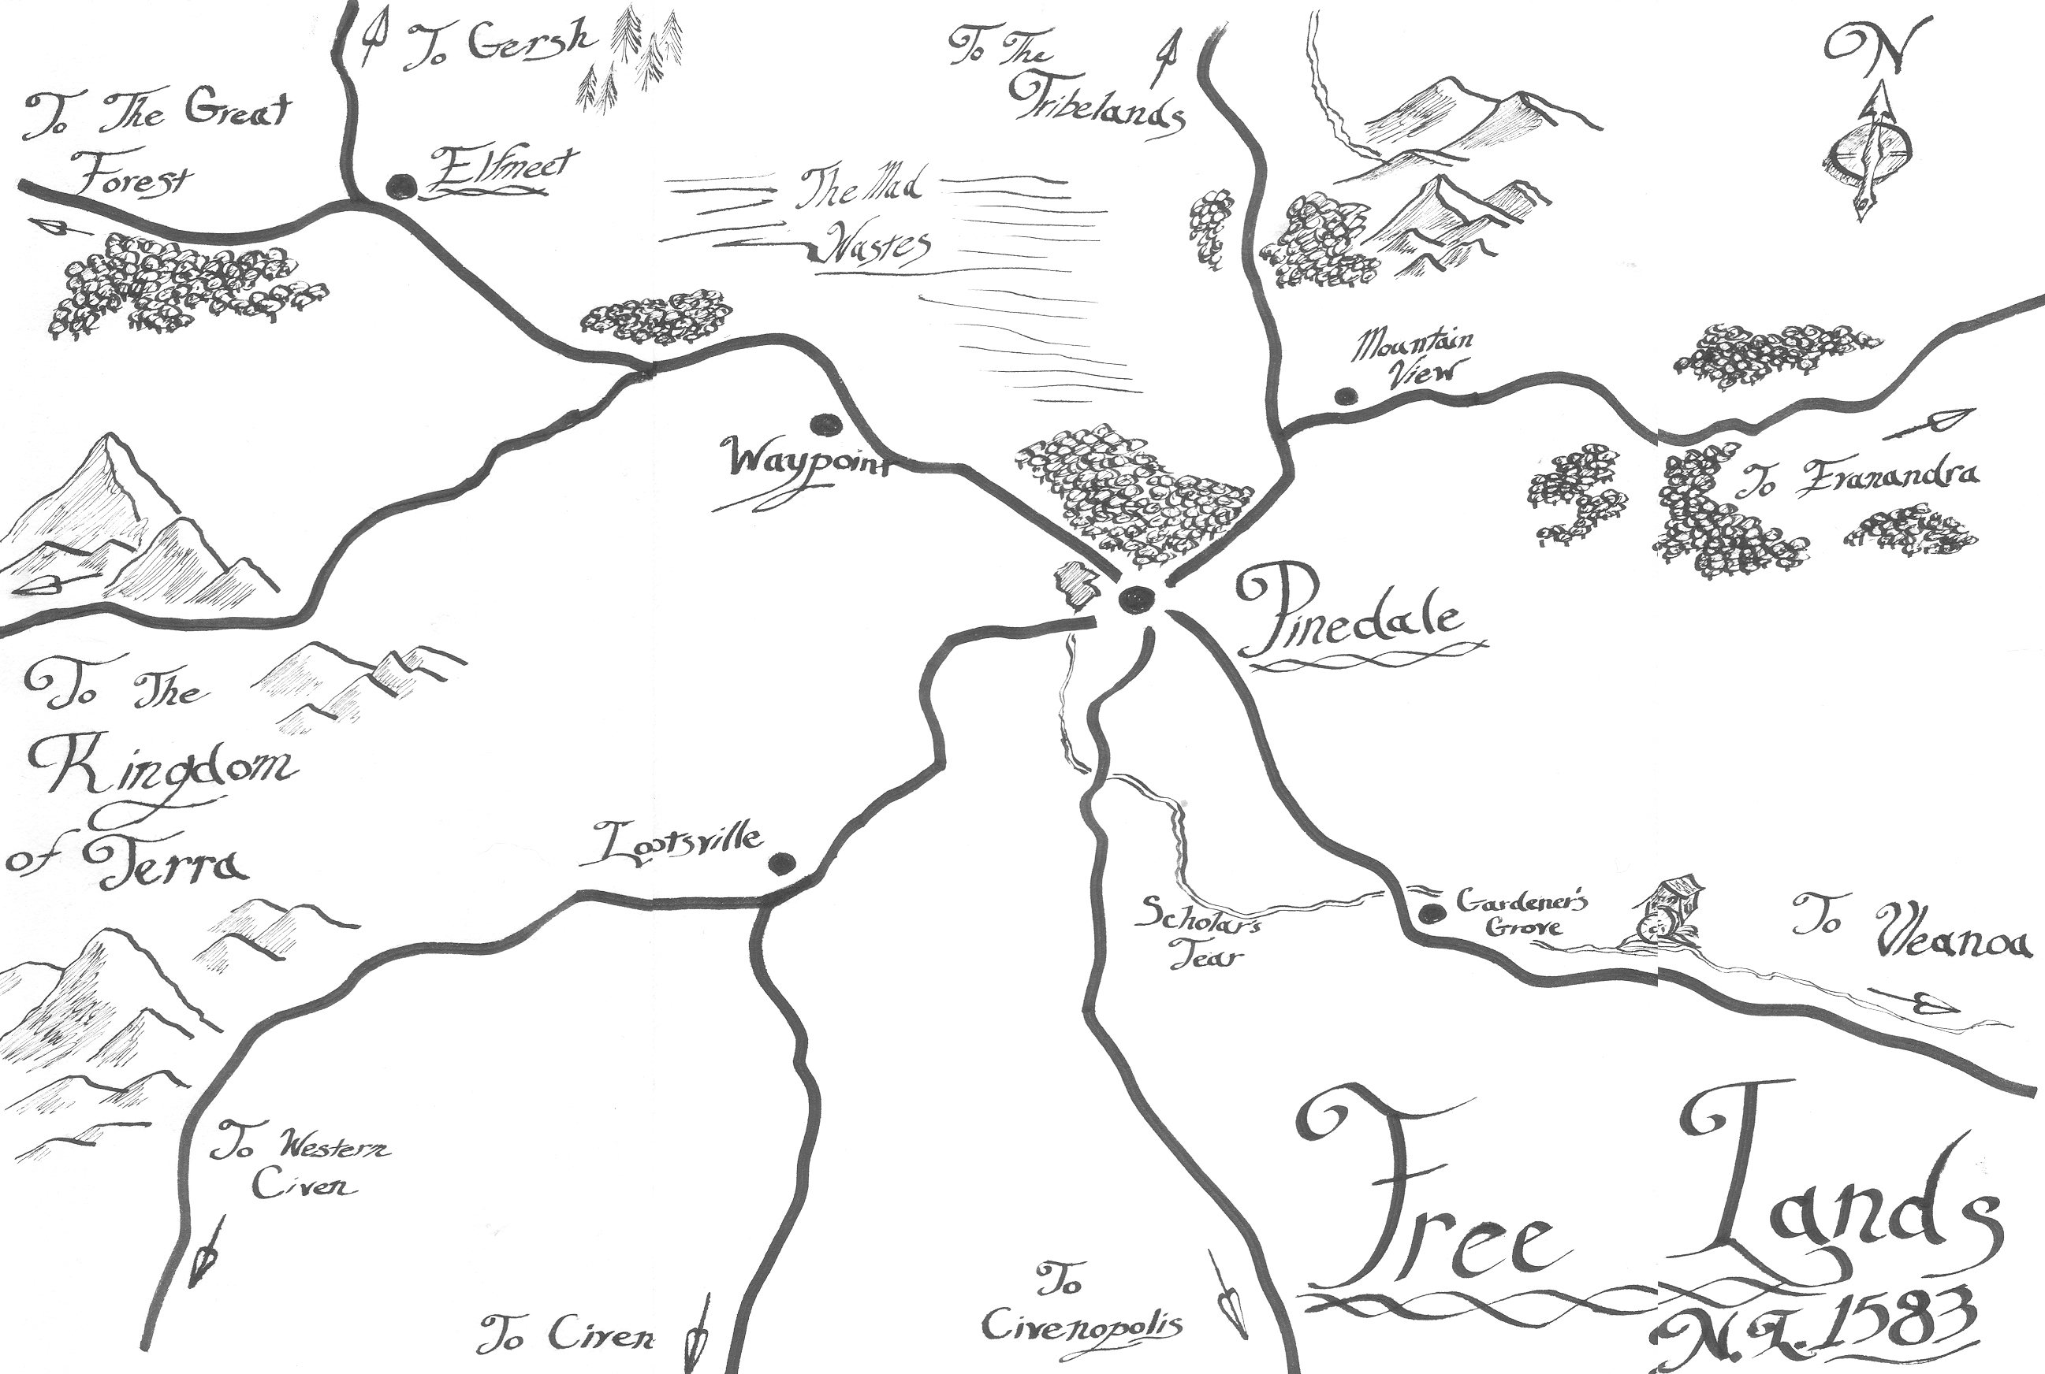

The Great Forest
In the northwest of Novitas lies an enormous forest that stretches for hundreds of miles. This is the Great Forest, Fionn A’ilean in the Elvish tongue, home of the Wood Elves. Here the elves live a nomadic, and largely carefree, existence. They are hunter-gatherers who routinely move through the forest in large familial clans, uprooting themselves with regularity so as to not strain the resources of one patch of forest for too long.

The Snow Kingdom of Gersh
In the frigid north of Novitas lies the Snow Kingdom of Gersh, home to the Snow Goblins, a twisted and malevolent race. Their capital, known as The Fissure, is a hyperborean city built into the sides of an enormous crack in an immobile glacier. From there, their king, known as the Bitter Mikado, rules all with an iron hand. Murder, assassination, and poison are all commonplace in his court. It is often said by Snow Goblins that the fastest way up is by standing on the corpses of your enemies – and that it’s only a crime if you get caught.
The Dellin Tribelands
Stretching from the Free Lands to the northeast corner of Novitas is the sprawling steppes known collectively as the Dellin Tribelands. Here, there are no cities, only huge tribes that move across the steppes in search of better grazing for their herds or better hunting grounds. When two tribes meet, they are as likely to fight as they are to trade, and sometimes do both. In the Tribelands, every tribe’s chief is a king, and every man’s worth is judged only by his fighting skill.

The Realms ofEvenandra
The eastern coast of Novitas is dominated by the Realms of Evenandra. Here, in the beautiful white coastal city of Evenanessa, dwells the pinnacle of Elvish art, beauty, culture, and scholarship. Evenanessa is home to the largest university of magic on Novitas, as well as the largest cathedral of the Sept. Attached to the cathedral is a seminary, a college for priests. The Septons trained here are the finest in the Kingdoms, and admission depends solely on an applicant’s faith, not his race or social standing.

The Theocracy of Vlean
Formerly a part of the Empire of Civen, the Theocracy of Vlean (pronounced VLENN, like then or glen) broke away one hundred years ago because of religious differences and longstanding cultural resentment. They have established themselves as a repressive government, totally intolerant of other religions. There is even a hint of xenophobia and racism evident in the country, as people grow more and more distrustful of non-humans. The fledgling country claims a large portion of the land formerly part of the Empire, including the large port city of Vleanoa, but much of it is still contested by Civen. Only recently the Empire recognized the Theocracy to be a sovereign state, ending a protracted civil war. Border skirmishes are still regular and bloody.

The Empire of Civen
Dominating the south of Novitas, the Empire of Civen is the cream of human civilization, boasting large cities, robust trade, and levels of freedom and democracy seen in no other land. Civen is ruled by a Senate, which is directly elected by the population’s citizens. Citizenship in Civen is bestowed at birth to everyone, and upon reaching their majority at twenty-one all citizens are entitled to vote. If the Empire has lately stagnated, it is still the shining jewel of humanity’s endeavors, and while it may outwardly seem that the gods of the Empire are money and trade, the reality is that everyone there worships the Sept. That they are less outwardly devout than some does not lessen their inner faith in the gods.

The Kingdom of Terra
In the southwest of Novitas, the Terran Mountains stretch from the shore of the sea all the way to the Free Lands. These mountains are the Kingdom of Terra, the ancestral home of the Earthkin. From their glittering subterranean capital of Earthhold, they move throughout the mountains, mining metals and gemstones from deep in the roots of the mountains. To outsiders, they seem taciturn and gruff, but to those who know them they are loyal, fast friends, and possess a dry wit seemingly at odds with their dour mien.

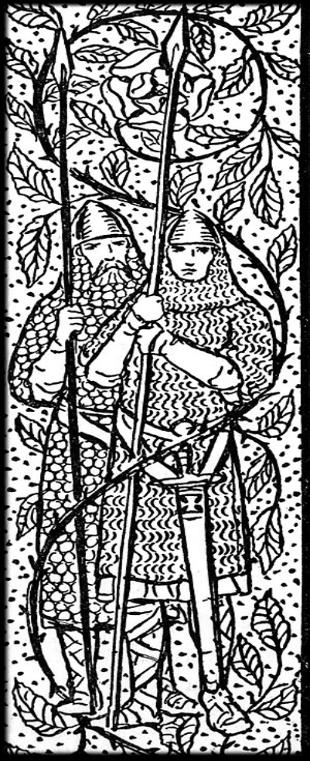
3. Religions in Novitas

Note: The use of religion within the live action game is intended to produce fictional drama and background for other stories. The following material is not real. It is make believe, and should not become the basis of real world choices, identity, or associations.

The Ancient Religions
The glory of the ancient world has been lost, and with it, much scholarship and understanding of the ascendant beings that touch the world of mortals. The refugees from long-abandoned Vargainen brought only token knowledge with them, and rebuilt their faith from these scraps. Stories persist of ancient temple-cities, elaborate week-long ceremonies, and a belief that lifelong rigorous faith could extend life, increase aptitude, or even change the world.
What is known is this: That the Aspected God Illumitas, the three baleful gods of Nox, Darkness, and Grak, and the serpentine Draconus were the gods that followed their mortal races to Novitas. What is not known is what gods were left behind -- and why.
Religions today
Throughout the continent and its distant colonies, worship is a natural part of life. Rare are the mortals who have never felt the grace (or spite) of the gods upon their shoulders. In a world where miracles are confirmed, there is very little doubt that divine beings exist and occasionally answer the call of their followers. Still, there persist those who resent the divinities; be it for their errant fate-writing, blasé interference, or mercurial attentions. These secular “orphans” represent only the slimmest of percentages in the mortal populations, however.
The particulars of worship are cultural as well as personal. Only Vlean, with its rigorous orthodoxy, has any formal national doctrines, prayers, and systems of grace and sin. In other lands, worship is much more local or even individual. It may be found in a pastoral chapel, which is as much a bulwark against threats to the flesh as threats to the spirit. Families may keep private prayer circles, usually led by the matron. A sacred grove may be tended by a faithful forest hermit. A complicated hinge may be stamped with the maker’s mark as well as a prayer to the Craftsman. A wound in battle may be dedicated to the gods of conflict. Gravetending may be undertaken to please the death-aspected gods. Ritualized household shrines may be dedicated to god, spirit, or ancestor alike, and certainly, black cults might gather in dark dank places for secret ceremony.
Also, it should be noted that stories of the gods often disagree on certain key points and explanations. This is to be expected; the tales that worshippers tell often paint their patron in the most favorable light. Therefore, canon doctrines for each of the gods are often a matter of tradition, propaganda, and mythology.

The Gods themselves
On this, there is little fact. At times, the gods seem as individual and personalized as anyone met in a marketplace. At other times, they are a thunderstorm: empty of personality and intent yet forceful and present in their power. And on many occasions, they are known only by the individual works of their followers.
To be certain, though, there are some truths that have been discovered, recorded, taught, and observed.
The Sept
When Illumitas was destroyed he shattered into shards, each shard containing a unique quality of his existence. After his destruction, these shards reformed into the seven children of Illumitas, known today as the Sept. These seven gods fought on against the Dark Three, and still do this day, to preserve Novitas from their foul designs. Most civilized and good creatures of Novitas worship the Sept. Civen, Vlean, Terra, Evenandra, and the Great Forest are all lands in which the seven-pointed star of the Sept is proudly held in reverence.

The Sept work in concert to exemplify the seven aspects of a good life. Through their teachings and actions, they work to guide mortal beings to live a good life, and the eternal rewards that come afterwards. This divine guidance is their principle concern.

The Mother
Goddess of Healing and Life, Illumitas’ Shard of Love
Dominion: Restoration School of Magic
Precepts: Serve life; soothe the injured; forgive the remorseful.

The first aspect of Illumitas, the Mother is worshipped by all manner of person – the fighting man lying wounded in the field, the farmer midwife, the temple healer, brides and grooms. She is known by many names: High Mercy, Grace, and The Grieving Goddess are but a few. She is the embodiment of Illumitas’s aspect of love.
She concerns herself with all things oriented towards life and living. The raising of crops, the birth of children, charity to those in need, the healing of the sick and wounded, forgiveness of wrongs, the feeding of the hungry are her domains. She is always in contention with her sister, The Stranger, and often the dying will see both of these goddesses struggling for their fate. For all her worshippers, power, and praise, in the end the Mother always loses to Grak, to Nox, or to the Stranger.
The responsibilities of the Mother are pulled between the two opposing poles: All life is blessed and should persist, but some life is corrupt and willfully denies redemption. With life, there is hope for change and for the future, yet sustaining a corrupt life may end the lives of unforeseen innocents in the future. Love for the individual and love for the greater good sometimes find themselves in conflict in the life of a disciple of the Mother. Each worshipper finds his own place on this sliding scale.
Prayers to the Mother are simple affairs, devoid of embellishment or ritual, but often begin with the same word spoken in a reverent pleading whisper: Please. She is always portrayed as a matron, simply dressed, either carrying a babe in her arms, tending to a fallen man, or smiling with radiance. Her cathedrals are the most numerous across Novitas, and are both meeting hall and hospital. In the tradition of her mercy, even criminals may find hospitality at these cathedrals, and no soldier or bounty hunter may take them away. Indeed, there are legendary stories of criminals remaining in these houses of healing for decades, with the occasional refugee eventually converting and seeking redemption.
While the Mother has the largest number of worshippers, each organizes her duties and ethics according to her current circumstances. Midwives of the Mother may jealously hoard what power they have to spend it only in aiding the birth of children. Battlefield medics may have to spend hours in atonement after healing only the wounded on their side of the battle, rather than all who cried out for the Mother’s mercies. Pilgrims may spend the Mother’s gifts freely and without thought to whether they heal the deserving or the evil. Judges in Vlean may hold elaborate court-room debates on the merits of reviving a particular fallen supplicant, or not.
The Mother is friend to all her Sept kin, though her work often demands that she focus her attention solely on the mortal realm. It is a wisely held belief that the Mother is closer in friendship with her mortal faithful than with her divine brothers and sisters. The Mother is sometimes portrayed as missing the Elemental, however, with whom she was confidante in the times before.
While always in contention with her sister the Stranger, the Mother loves her kin and does not regard them as unkind. However, the Mother stands opposed to Nox, the great corrupter of life, with a closed fist. Some heretical texts suggest that the Mother need only forgive and heal Nox to defeat him. But the Mother, as of yet, struggles to achieve this depth of mercy within herself. To fail the Mother, a worshipper need only renounce life in some fashion, but fallen acolytes of the Mother are always welcomed back, in time.

The Knight
God of Idealism and Order, Illumitas’ Shard of Principles
Dominion: Aegis School of Magic
Precepts: Lead justly; build a better world; consider everyone in your actions.

This god concerns itself with the achievement and sustenance of mortal ideals. Honor, Justice, Protection, Fairness, Chivalry, Courage, Discipline, Loyalty, and Rule of Law. The Knight serves as principle by which ethical mortals chart their own worth and morality. In pursuing these ideals, the Knight also does not yield to peace, and Knightly Adherents spend as much time training for conflict as they do in studying ethics, morality, and leadership. The Knight is the embodiment of Illumitas’s aspect of principles.
The Knight has no other names to its followers, as only “The Knight” is the proper title for this deity. The Knight is typically regarded as masculine, though there is a feminine version in some Knightly cults. Knightly abbeys are part meeting hall, part library, and part public armory. Oftentimes, they may be mistaken for a bailey rather than a temple, as they are often adorned with functional battlements. These abbeys are always defensible, public, and are common in civilized lands.
Adherents to the Knight are the rarest of the Sept’s worshippers, due to the extreme self-awareness and strict moral paths they must walk. To serve the Knight, one must embody the Knight’s virtues. Chivalric orders dedicated to the Knight typically devote their knighthood to the pursuit of these Knightly Virtues: Faith, Prudence, Hope, Temperance, Charity, Justice, and Fortitude. Adherents to the Knight typically lead from the front, and do not proselytize, choosing instead to exemplify. Successful Adherents are typically the best and shortest-lived heroes of any bard’s tale. Paladins of the Knight, the best court barristers and advocates, philosophers pondering ethics and law, and moral Inquisitors are all examples of those who serve the Knight.
Idealism, in the Knight’s paradigm, is to be the best that mortal-kind may be. Order is understood to be the Rule of Laws, fairly made, to both protect and represent the citizens of a culture or country equally. Adherents to the Knight struggle with the fact that the Knight places equal worth on both Order and Idealism. A corrupt kingdom that cares for its citizens embodies Order, and yet violates Idealism. A rebel army that revolts against its rulers may champion Idealism but destroys Order to do so. The Knight’s view is codified in terms of absolutes, and can get lost in the murky moral shades of grey. Each Adherent must find his or her own balance between these two responsibilities.
Worshipping the Knight is most often done by deed, rather than words. Raising up the impoverished, defending the weak, punishing the evil, and sacrificing for the greater good are all considered to be more meaningful to the Knight than spoken prayers or ritual.
Of all the Sept, the Knight usually stands alone. He leads the Sept in their missions, and provides the moral compass for his brothers and sisters, who follow him into battle. While all fight with him, only the Stranger speaks with him socially, as her strength of principles is a mirror for his own. While the most highly regarded of the Sept, the Knight’s endless quest to be the best in all things sometimes isolates him from his kin; leaving him a lonely deity.
The Knight stands opposed to Grak, in all cases. Violence must have purpose, not be merely contest. The Knight stands opposed to Nox, in every way -- life must be protected, for the preservation of hope. But the true enemy of the Knight is Darkness Itself, who, as the leader of the Dark Three is responsible for all the ills of the world. To fail the Knight, an Adherent need only abandon the cause of Idealism or Order. Redemption that is found through deed and experience may allow the fallen Adherent back into the Knight’s auspices. Often, these redeemed Adherents return to the narrow path of Virtue with more understanding and power than they had in innocence, for while the Knight may lose a battle, he has never lost a war.

The Soldier
God of strength and survival, Illumitas’ Shard of Will
Dominion: The School of Battle Magic
Precepts: Sacrifice for total victory; cunning is a form of strength; accept the leadership of others.

After the Mother, the Soldier is the next most widely invoked god of the Sept. The Soldier is the god of the foot soldier in the field, of the thief evading capture, of the sailor braving a storm, of the general planning a devious battle plan, of the prisoner struggling to turn the wheel. The Soldier concerns himself with the raw application of will and determination to accomplish great tasks and overcome terrible odds. Those that follow the Soldier follow a simple principle: Do what must be done. Though a warrior like the Knight, the Soldier has a more pragmatic view of conflict and resolution. The Soldier knows that if victory changes things for the better, then all impediments to victory must be abandoned. Ethics, chivalry, fair play, and the bonds of friendship and family must sometimes be abandoned if they interfere with serving victory and the greater good. The Soldier values will, strength, and cunning. When Illumitas was shattered, his will resolved into the Soldier.
The Soldier has many names, and many faces. Bold Tidings, Victory, the Resolved Sneer are some of his names though ‘Luck’ is his most frequent pseudonym. During times of war, Civenopolis will issue pay to their Legionnaires that is minted with the Soldier’s likeness. Of all the Sept gods, only the Soldier may find safe passage through the lands held by Grak, as his cunning and defiance are well esteemed by those who serve Glory. The Soldier is always regarded as a male, and never regaled in finery.
The Soldier allies himself with the rest of the Sept, out of kinship and ethos, though his favor sometimes falls on those that the rest of the Sept may regard as heretical or evil. A thief stealing from a well-guarded castle would invoke the ire of the Knight, but would also invoke the praise and attention of the Soldier for his audacity, cunning, and strength of will. Slaying a pregnant mother would violate the precepts of the Mother, but if the babe was destined to become a tyrant the Soldier might grant the murderer strength. While sometimes in opposition to his brothers and sisters in the Sept, there can be no doubt of the aid the Soldier brings to the forces of good when rallied by his kin against true evil.
The paradox of the Soldier is a complicated one. Briefly put, the Soldier’s cunning, wits, tenacity, and boldness allow his followers to overcome many obstacles others could not. However, faithful followers of the Soldier soon uncover the central mystery of the deity: His gifts could serve good or evil equally well, for there is little inherently good in the Soldier by himself. Instead, the Soldier must be led by the wiser gods of the Sept. Should there come a day when the Soldier must be unleashed, and forced to lead, one can expect a great contest of dubious result. Thus, devout worshippers of the Soldier tend to keep themselves in check, advancing only to the penultimate level in whatever arena they visit. Civen worshippers of the Soldier may climb to be a General, but they are commanded by a Senate; a sailor may be the best man at the tiller, knowing he would be a useless captain; the Soldier’s lot in life is to always be led. The cunning and gifts bestowed by the Soldier usually makes his Destriants the right person in the right place at the right time, provided someone else leads them there.
Prayers to the Soldier are usually short, and may be confused for curses. Spoken in haste at the imminent moment of need, off-color language is forgiven by the Soldier. Some claim that clever uses of profanity speed the prayer to his ears faster. Temples to the Soldier are found where outnumbered defenders man the parapets above a dread besieging host, or where desperate men form audacious plans. Small shrines consecrated in the moment of need, with each fighting man donating a candle, a coin, incense, or a dagger are the most holy to the Soldier, despite their imperfections and impermanence.
The Soldier stands against all enemies of the Sept, but only when roused either by his kin or by immediate threat. To fail the Soldier, a Destriant must choose defeat over doing what must be done. To date, those that fail the Soldier either are recruited by the powers of Darkness (mainly Grak) or fade away un-absolved into obscurity.

The Scholar
God of wisdom, learning, and truth. Illumitas’ Shard of Knowledge
Dominion: The Compulsion School of Magic
Precepts: Emotions mask facts, so be dispassionate and patient; all problems disappear if understood; the mind controls the body.

Known as the Master Planner, the Great Painter, or by a number of other colorful sobriquets, the Scholar is the divine insistence that reason and research alone can find the solution to any question of chaos or uncertainty. While the Craftsman may have the raw skill to build, it is the mind of the Scholar that plans for the finished product. While the Knight may be the insistent heart of the Sept, it is the Scholar that finds the path to success. The Scholar is a patient god, and often seems to suffer defeat in the short term only to achieve a greater victory (decades later) because of that initial defeat. The Scholar moves slowly, but with great deliberation. Often, those that follow the Scholar will appear erratic or touched, only to have their actions make sense years later when those strange actions put them in an advantageous position. The Scholar has no jealousies, and is content to let the Knight be regarded as the leader of the Sept. The Scholar is the keeper of all secrets known and unknown, and he alone decides which mortal to enkindle with the spark of discovery or inspiration. His secrets, great mysteries of science and history, are kept in a single volume that never leaves his side. It is suspected that with the absence of the Elemental, it is the Scholar who paints the skies at sunsets. The Scholar is fallen Illumitas’ intellect made manifest, and is thought to have been the first such shard to become a god in its own right.
Following the destruction of Vargainen, it was the Scholar who led the reconstruction of civilizations on Novitas. Remembering both the societies of Vargainen, and the intent of Illumitas, the Scholar worked with the all his kin to establish civilization for the sept-faithful. Indeed, language, mathematics, and the principles of engineering and alchemy were passed directly from the Scholar to the races of Novitas.
Worshippers of the Scholar often obsessively pursue a certain academic question. Be they Seekers of Art, Seekers of Numbers, Seekers of Truth, or even Seekers of Power, these are the Scholar’s faithful. The great Universities of Evenandra, of Civenopolis, and the Learning Halls of Terra serve as temples, and the thinkers, philosophers, researchers, professors, and doctors serve as the Scholar’s priesthood. For his followers, study in search of understanding is worship, examinations and inventions are rites of passage, and the spread of new understandings to those who seek them constitute good works. There are few portrayals of the Scholar directly, though when embodied he is usually sculpted as a wizened old man with his book, the Libri Exemplar, gripped tightly in his hands.
One of the few secrets carried from long lost Vargainen is the Scholar’s gift of palaver, or Compulsion, as it is now known. Through this path of sorcery, Seekers may achieve their goals without base conflict or insulting coin. Additionally, this school embodies the Scholar’s favorite methodologies of planning, observation, deception, and struggles of mind over contests of flesh. Originally intended as a teaching tool for mortals, they have since adopted Compulsion into a tool for their own uses, which pleases the Scholar. Thus, the Scholar is not only the god of wise academics, but also careful diplomats, cunning courtiers, and deceptive grifters. Any who would succeed through skill of mind, rather than application of force, falls into the Scholar’s good graces whether they worship him formally or not.
The great failings of the Scholar are his lack of swiftness and his mistrust. As a divinity of long, careful planning, a sudden need or change cannot be addressed by the Scholar until all aspects of the crisis have been researched, tested, studied, catalogued, and contemplated. The Scholar is loath to change plans once they have been precisely formed. Immediate demands will often go unattended by the Scholar while he studies. Evidence will not be admissible by Seekers until it has been confirmed to be trustworthy, rather than a dupe or a lie. Dramatic change, or a disruption of long and elaborate plans, will often frustrate the Scholar and will force him back to his studies, leaving the matter to twist and fester as it will. It is thought that the absence of the Elemental, who herself relished wreaking these changes in the direct path of the Scholar, is the result of a scheme by the Scholar to remove her pranks from his work.
Prayers to the Scholar by the uninitiated are often ignored, and the burning of libraries and sacking of laboratories almost assuredly result in some calamitous injury to the vandals… though usually not until years later. Prayers by students, scholars, artists, researchers, and engineers often are composed as poetry. Clever rhymes, mathematically balanced stanzas, and obscure diction reveal the strength of the applicant’s mind to the Scholar. If pleased, he will act. If not, the applicant is ignored.
The Scholar stands against everything barbarian and base, which always puts him at odds against Grak and Nox. Sometimes he is pleased by Darkness’ labyrinthine plots, and will allow them to persist longer as a matter of study, though the Scholar keeps this fact hidden from his fellow Sept kin. Only an active assault on learning or understanding can earn the Scholar’s reprisal. Academics who abandon their research are still considered Seekers to the Scholar. The deity is a patient one, and so when the wayward academic returns to his work she is once again an active member of the Scholar’s demesne. Thus do most modern academies support the notion of tenure, in deference to the Scholar’s own policies.

The Elemental
Goddess of nature, elements, and storms. Illumitas’ Shard of Passion.
Dominion: The Nature School of Magic.
Precepts: Serve passion regardless of creation or destruction; beauty is truth; live well, for your time is short.

The Absent Goddess, Blight, the Fickle Sky, the Bitch of Fire, the Bitch of Floods, Lady Winter, Dawn, The Green Matron, Gaia, The Thorned Lover, Venai, Gale, Auctumnae… The Elemental has the most names in the Sept, and the fewest clergy. The reasons for these phenomena are the same; for hundreds of years, the Elemental has been gone. Those who believe that she was with the heroes of Nalbendel would state that she has only been gone for 400 years – the blink of an eye for a fickle goddess. However, those who disbelieve these rumors would count her absence as much longer. The deepest, most primal facets of fallen Illumitas coalesced into the Elemental. Thus, Illumitas’ capacity for beauty and passion lived on beyond his death. Though now uncoupled from principle or love, the Elemental’s beauty is found equally in careful loving growth and sudden passionate destruction.
Ancient ruins or relics bearing her likeness depict a young woman, in the flower of her beauty, dancing by moonlight in a secluded forest glade. Other times, she is painted as a furious scorned lover, her hair a thunderhead of dark clouds, with lighting crackling from her fingertips. Modern Elvish sculptors in the Great Forest sculpt her as an elf maid, bathing beneath a waterfall, revered by wolf and deer alike. These tributes are always anointed with perfumes and aromatic oils, as these were her earliest gifts to the world.
The inspiration for creation itself, the Elemental within Illumitas chose the colors of each flower, decided on the taste of venison and hawk, invented rain, and sets stars in the night sky to guide travelers across her lands. She also was known to indulge in mercurial rages, and has burned fields, shaken the earth, ravaged the seas with storms, pushed over houses with great winds, and cursed mortals with famines born of drought. Her priests were known to share her madness, and would endlessly strive to find new ways to supplicate her glory, and assuage her anger. Sometimes, these rituals would approximate the workings of the Dark Three, rather than the Sept.
Other than the natural world, she was in contention with the Scholar over artistic inspiration. The exact esoterica of this divine debate have been lost, but it is thought the two gods contested over who could claim the divine right of mortal inspiration. Even in her absence, some poets and playwrights will make a small token sacrifice to the Elemental as their muse.
Certain heretical texts suggest that of all the Sept gods, she was the only goddess who ever knew romantic love. The texts are unclear if this romantic love was with other deities, mortal followers, or spirits or ghosts. Some say she fell in love with the ugliest of mortal men, and thus were the Druids created. Some say she plucked a soul from the Stranger’s Well, and unleashed her fury at all attempts to reclaim the spirit. Some suggest her lover may even have been Nox, who behaves as much like a scorned lover as it does a god of ill intent. Questions of any offspring are similarly muddied. Still, it is said those kin of the Fae all share a similar look about them, and must have a common ancestor in their otherwise discordant lines. Or perhaps the Druids and wardens of nature, who only began to appear after she vanished. Or banshees and other sentient spirits, driven by their own turbulent emotions and passions. None can say for certain.
Where she has gone, none can say. Some believe she is raising Vargainen, and remaking it anew. Some say she has been killed by Grak, but this murder has not yet been discovered by the other gods. Still others think she has been called on to create a new world in some other starlit realm far away from Novitas. No evidence exists to support any of these theories.
What is known as fact is the following: That despite the charity of the Mother, the discipline of the Knight, the strength of the Soldier, the knowledge of the Scholar, or the skill of the Craftsman, the Elemental was the strongest of the Sept in terms of raw power. When Vargainen was destroyed, it was she that laid the continent low. It was she who created winds both strong enough to carry the survivors of that place to the new lands of Novitas, but also gentle enough to keep them asleep for the journey. It was the flora and fauna of the Elemental that fed all mortal creatures alike. It was she who blessed all things young with an instinctive reverence, at the Mother’s behest. It was she that hid raw ores and minerals in the land for the Craftsman to make use of. It was she that brokered with the Soldier to save armies and mortals from warlike disaster with the precise application of lightning, fog, wind, or snow.
Her lesser gifts are equally worthy of note: Romantic love, appreciation of beauty, fallen branches for hearths and forges, wool to spin, streams to drink, pain to teach, snow to clean, and the like. While the Sept embodies the pinnacle of good living, no life would be possible without the Elemental’s gifts.
And then, one day, she was gone.
However, in her absence she did not forget the world she left behind. She left a lower form of her Nature magic behind, as tools for those who would act in her stead. She pushed the elemental planes to motion, so that their warp and woof would keep the mortal lands in seasonal balance. She banished her formal priests, who had grown too erratic and insane to be of any use, awoke certain trees to wisdom and sentience. She called the Druids to replace her crazed heretics, and loosed these wardens upon the land.
Were she still a part of the world, she would doubtless have the most followers among the mortal realm. A clever man might rub his chin and ask, who then had the most to gain with her absence?
Prayers to the Elemental now go unheard, and unheeded. Her mysteries and paradoxes are lost to posterity. No temples now remain to her glory, and she is cursed more than she will ever be venerated. Such is the fate of uninhibited passion. Long absent now, the Elemental is represented by her scions, the Druids. The druids and witches do what they can to defend their local interests, though they do so without any higher coordination or guidance. To keep a lakes clean, or forests free of deadfalls, or to coax blight out of farm fields, or to incant rituals for rain; these are the self-appointed tasks of the Druids and the Great Trees. They do this while they wait, endlessly wait, for her return. Only then will they be rewarded with a unified mission, and an angry goddess to grant them the tools to change the world.
Until such time as the Elemental returns, there can be no ordained priests devoted to her. The empowered Druids simply serve what they believe are her wishes.

The Stranger
Goddess of death, secrets, and vengeance. Illumitas’ Shard of Peace
Dominion: The path of Necromancy
Precepts: Keep secrets sacred; embrace the peace of ending; serve the dead who can no longer serve themselves.

The Keeper of Secrets, Lady Dusk, The Late Woman, Crows, or simply Death, the Stranger is the last entity mortals meet on their life’s journey. A quiet goddess, the Stranger is the deity responsible for the Empyrean. At the moment of death, she collects those freed from life and worthy of her embrace and carries them to this paradise, this Well of Souls. There, they enter new mysteries and beauty unknown to all mortality. Those who are not worthy are not collected and helpless, they eternally roam. Several philosophers, having noted trends in history, suspect that the Stranger sometimes surrenders worthy souls to the Mother so that they may be reborn into the world for some divine purpose.
The Stranger did not exist within Illumitas until he was torn apart at the hands of the Dark Three. When his blood pooled into his shadow, his shadow awoke cognizant of the notion of coda, and became the Stranger. She arose, and sided with her brothers and sisters in war against the Three.
Coda, the Stranger’s way, conceptualizes death as a peaceful ending to the sufferings of life. Death is the time for the faithful to muse over the lessons learned in life, free of the politics, passions, or divisions that drive conflict. If these passions persist beyond death, these troubled dead must be eased with justice. In these ways, peace is served.
While her crows carry these souls, the goddess speaks with each one. They speak freely to her, though there is no sorcery compelling them to do so. In these conversations, she learns much about the races of Novitas. She is sworn to keep their secrets, and her natural quiet demeanor is suspected to be a result of her reverie and nostalgia for all that has been created and lost. Sometimes these secrets are so tragic, so horrific, that her quiet contemplation flares to sudden action, and soon thereafter there are many new souls freed from life. Her secrets are sacred and private. Often times, the Soldier or the Scholar will ply her with reasons and rationales, trying to mine her for information that they ‘need.’ The others, on occasion, try as well, all save the Knight, who alone respects her sacred oaths. For this reason, the Knight is the only member of the Sept that does not contend or struggle with the Stranger in one fashion or another.
The Stranger is often portrayed as feminine, though sometimes she is also genderless. Most artists envision her as slender and hidden, though particular crafters may simply hide her face with shadow, the hood of a cloak, or even her own hands as if weeping. Her temples are usually built in hospices or adjacent to crypts and grave sites, and her worshippers are often anonymous and unknown until they are unmasked. These places of reverence are marked by veils, curtains, and screens of silk. They are less a meeting hall, than places for quiet contemplation and funerary rites. Often, the smell of incense lingers on those that have visited these places.
Her formal worshippers are often regarded with a mild sense of dismay or discomfort by the populations they serve. Often, these veiled priests and priestesses are responsible for death rites, burial rituals, and counseling the grieving. As their patron goddess exemplifies, these Mutes are sworn to keep all secrets uttered by the grieving and about the dead. They merely listen and in doing so, soak up the pain of those the deceased had left behind. Additionally, this cult tends to the elderly and infirm as they near their meeting with the Stranger. Again, the Mutes collect stories and secrets, in exchange for care and comfort in their dim temples. Some wonder what secrets these monks and nuns have at their disposal.
Aside from the formal clergy, the Stranger is worshipped by anyone with a secret to keep. Often times, she herself is a secret patron. While a King may publicly worship the Knight, for example, in secret he may venerate the Stranger in the hopes that his secrets will remain unknown. Faithful assassins may spend several long minutes after a murder to anoint their victims and compose their corpses so they may meet the Stranger with dignity, and thus please the Stranger, who will in turn keep the killer’s identity a secret. The Stranger holds no jealousy in her heart, for in the end everyone meets her alone. At times, she is appeased with incense and small sacrifices to keep her at bay. Merchants going on a long journey will bury lace in a new grave before undertaking their travels. Sailors will burn rose petals before stepping off the dock and boarding a ship. Diplomats will donate small sums of coin to the local graveside temple of the Stranger before undertaking dangerous assignments in foreign countries. Mothers-to-be might pay for a professional mourner for someone else’s funeral. Adventurers might contract with the Mutes for a portion of their loot in return for the Stranger’s favor while exploring a newly discovered ruin. It is rumored that the sentient Undead have secret elaborate blood rituals to rebuke her and keep their immortality intact. In all these cases, sacrifices and ceremonies exist more the keep her at bay than to invite her presence.
Prayers to the Stranger are often whispered, at night, while something of value is sacrificed to her. The whisper is the reverence for her secrets, and the loss of the treasured item is a little death that acknowledges her eternal presence throughout the world. Her supplication is rarely a public affair, save at funerals themselves. It is said that when one wonders about the sensation of falling off a bridge, or drowning peacefully, that this is the Stranger sending her quiet warning. This sensation is her only communication, until the end.
The central mystery of the Stranger’s cult is that a lifetime can only be judged when it is over. In the midst of a life, the individual is caught in their own river, and cannot see further than the bend ahead or the rapids behind. Mortality is often at odds with itself only because it cannot see the entirety of its own lives, how they integrate, and how one action can affect dozens of other lives. This creates conflict, and conflict is the ruin of life. However, when a soul is at the point where it can see this pattern, it is too late for anything to be done. This mystery is, however, natural. And it is this greater understanding that compels newly rescued souls to speak with the Stranger of what they see, and the part they played. Thus is mortal kind doomed to confusion, the Stranger to knowledge, and is why, of all the Sept, it is the Stranger that has the greatest understanding and sympathy for mortal beings.
All of which is why she fights so terribly against the Undead. These corrupted bodies may be empty of the souls she has harvested, but their keening sends ripples through the Empyrean Well of Souls. They may be individuals who, through careful planning and power, have eluded her embrace, thus denying her the rightful role to filter out the evil from the world and reward the righteous dead. Or they may be those who seek to keep their secrets as their own, eluding death in order to prevent the Stranger from hearing their final whispers and adding their mysteries to her tapestry of tales. As such, she claims dominion over the Path of Necromancy, so that the Undead may be undone, order re-established, and peace maintained.
The Stranger does not stand against any divine evil, but waits for that evil to come to her. To earn the ire of the Stranger is to try to cheat Death, or to reveal dangerous secrets recklessly. There is rarely any redemption from violating the Stranger’s order. Instead, the offending mortal is simply collected into her embrace, his secrets added to her own. The Stranger is incapable of forgiveness.

The Craftsman
God of tools, machines, and building. Illumitas’ Shard of Creation.
Dominion: The Magical School of Enchantment
Precepts: Build rather than own or destroy; serve all with your work; coordination is the best tool.

The Craftsman is the patron god of smiths, engineers, miners, carpenters, weavers, stonemasons, and anyone who improves their world through construction, smiling on anyone who builds for the greater good. A bridge connecting two villages allows new friendships and trades to form. A city wall protects everyone from mutual harm. A loom can produce cloth for others to use for any number of purposes. Referred to as Old Sweat, The Great Maker, The Forge God, or First Fire, the Craftsman is both the weakest of the Sept and the most important.
The Craftsman has only one formal temple, and that is Voltanicus, which resides deep inside the mountains of Terra near a glowing river of magma. In most cases, the Craftsman’s temples are found in a workman’s tools. An anvil stamped with the Craftsman’s mark, or the keystone for an arch is inscribed with his rune, or even something as small as the gears for a clock can count as a thing of worship. It is the act of fabrication that turns even the most drafty workshop into a place of divinity. Any worker who loses time, his hurts, and his hunger while making a thing of beauty and worth to all, is counted as an Artisan of the Craftsman. Be it the master sword smith, or the village shoemaker, none of the Artisans holds any rank above their peers.
The Craftsman is often portrayed as a robust man carrying workman’s tools. His followers, both formal and private, are known collectively as Artisans. These Artisans will typically have a small shrine in their workshop. A particularly successful circle of potters in Terra call themselves the Craftsman’s Brides, thus demonstrating the forgiving ease with which both the god and his followers accept life as it comes.
The Craftsman’s powers are only found in what he can build. Without tools and materials, the Craftsman is an empty divinity. The Craftsman borrows materials from the Elemental. He borrows ingenuity from the Scholar. He makes use of the Soldier’s strength, and asks the Mother to heals the burns, pinches, and fatigue that come with hard work. The Stranger is asked to extend the life of the construction, so that the builder might not see its end in his or her lifetime. And the Knight’s sense of purpose is used to craft an item that satisfies some need. In return, the Craftsman builds roads, so the fields are not all trampled. Libraries, to house the great intellectual works. Shields to protect the fighting men, and beds in which they may rest and recover from their wounds. Sepulchers and catacombs for the Stranger’s children. And spurs and swords for those sworn to champion the lofty goals of the Knight. Only through negotiation with all his kin can the Craftsman satisfy his divine purpose. Thus, alone, he is powerless.
However, it is the Craftsman that acts as the chain that links the Sept together. Without the Craftsman to build bridges between these disparate entities, Illumitas may have drifted apart after his seven rebirths. It is the Craftsmen who converses with all his brothers and sisters in turn and keeps the family knit together. He spreads news, collects stories, and hears their various woes and concerns. The gift the Craftsman brings to the Sept is coordination through communication, or the concept of acting in concert. His tools and machines can change the world, but without the Sept acting together the changes would be greatly different. The greatest invention the Craftsman has ever built was this notion of family. But it was not his only invention, by far.
Time was built by the Craftsman. Envisioned as a Great Dam, time keeps everything from happening all at once. This allowed a slow but steady series of experiences to be relished, struggled with, and learned from.
Promises are a collaborative work of the Knight, the Scholar, and the Craftsman. The Knight’s ideals, the Scholar’s words, and the Craftsman’s parchment and ink still to this day form the basis for binding agreements between sincere cooperating individuals.
Worth and merit were his inventions, and the minting of coins to ease the chaos of barter still exists as a successful (if abused) system. The first coins were blank, and made of soft metals, so that each man could hammer his mark into a coin. In this way, the Craftsman wanted to show that everyone had some worth to their community.
Later, after societies had cooled from the forge, he tooled them with the use of horses, the wheel, the mastery of fire, emptiness as a virtue for vessels, smelting and purification and the like. It is said that the Elemental once asked him to forge the most beautiful ring he could, though she never returned to claim it from him. Artisans today tell that story with a smile, and use it as a parable for making things of beauty just to make the world more beautiful, and for no other purpose. They suspect that the Elemental simply wanted to see the hard working Craftsman smile, though some think that only the Stranger knows the reason behind the ring, now that the Winter Lady has disappeared.
The Craftsman is the one god of the Sept who has made peace with his own mystery, accepting that no matter how powerful, self-sufficient, or skilled a being may be, the mortal and divine alike are connected to their companions. No one can ever be alone and be thought of as whole. Great experiences are worthless if not shared. Without communication and compromise, nothing can change the world. Thus, while most of the other Sept gods struggle with their essential natures, the Craftsman alone finds peace simply by aiding his family.
The Craftsman does not so much stand against the Dark Three as he stands valiantly with the Sept. When they need him, he is there. Much like certain of his Kin, the Craftsman is not a jealous god, and smiles upon Artisans who keep both he and his brothers and sisters in their thoughts and actions. To betray the Craftsman is to turn against the Sept. Redemption from this error is possible, though like smelting ore, the candidate must work the impurities from his or her soul before they can be reforged.

The Neutral Gods
Not all gods fall on one side or the other. Those gods who favor neutrality rarely involve themselves in the workings of Novitas or its contested divinities. Their goals and projects are instead alien and unknowable.

Draconus
Godbeast of magic, mystery, dreams, and the moon
Dominion: As of yet, unrevealed.
Precepts: Unknown, though many cults share the collection of Draconus Lore as a principle.

The Great Dragon, the Moon, Nightmare, the GodBeast, Draconus has only a few names. Draconus is represented in two forms; the silvery full moon, or a terrible dragon with wings that shade the world. Its likenesses do not acknowledge its degenerate children, the Drakes, save in their own art.
Above the masses of mortals, above the rivers, mountains, and sky itself, above the other gods and their contested concerns, watches the baleful luminous eye of Draconus. Endlessly waiting, though for what none can say.

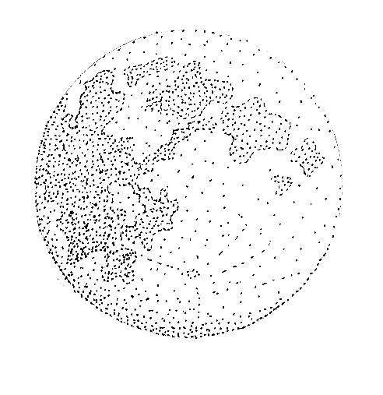
Its power is both mysterious, and undeniable. Some suspect that the moon is an illusion, and is merely the radiant light of the Dragon’s raw power. Others think it is a giant fortress, carried up into the night sky, within which the Dragon amasses his giant hoard of treasure. Still others think the moon itself is only the Dragon’s Eye, or perhaps an Egg for its rebirth. What is known is that the moon has some mysterious power over the world. From illuminating the night’s gloom, to changing its face, to its mastery over tides and birth, to its power over shapeshifters… Draconus does not merely sleep. Something is happening.
Certain oracular dreams inspire thoughts on the GodBeast’s designs among the followers of Draconus. From traveling as a companion to the wandering Elemental, to reclaiming all its stolen magic from the world, to reviving the diluted blood of DragonKind, to providing the balance between the Sept and the Dark Three, to hunting all the other gods in return for some great theft, to gnawing on the lost souls discarded by the Stranger -- these dreams and portents are often turned into hysterical rumor, prophecies of doom, works of poetic art, or street plays for the poor. A single dream can spawn a dozen theories, which is retold into a hundred meanings. The timid will wail, rub dirt into their hair, and proceed into violent madness. In Vlean and Gersh, it is not uncommon for any such hysterical riots to be crushed by force and its leaders put to the Question – often the dreamer is lobotomized to keep the dreams at bay forevermore. In the Tribelands, however, the Dellin Tribesmen greet these dreams with great celebration, for many tribes have taken oaths that they will be the ones to slay the last true Dragon and feast on its giant heart.
Whatever mysteries and paradoxes worshippers of Draconus have, they keep secret inside their monasteries and cloisters. Never ones to build anew, the cult of the Dragon instead adopts ruins and haunted towers as its home. Over long generations, they slowly lay a deep mystical claim to the place, through some strange means.
Worshippers of Draconus are not limited to Drakes. Men and Terrans account for a vocal minority of the cult, and while Elves are welcomed, very few seek entrance into their cloisters. Snow Goblin cultists are known by name even outside the cult, as they are so few.
Different sects of the cult believe in different aspects of Draconus. Some worship fire, and use complicated alchemical reagents to somehow transmute it into dragonfire, about which they dance and exhaust themselves into vision and prophecy. Others hoard treasure, and hide whatever they find into great underground caches. One cult has taken a keen interest in Drake bloodlines, and is attempting to breed a true dragon. Still others practice Draconus’ neutrality, and either refuse to participate in the events unfolding around them, or act as negotiators and diplomats between the zealots and fanatics of both the Dark Three and their Sept counterparts. One thing all the sects share, however, is the pursuit of lore and writings on Draconus. Every cloister has a vast hidden library. The cultists and monks spend their time trying to establish patterns between these recorded works and the events that unfold in the present. Tracking prophetic dreams also has some academic credibility within the cults. Essentially, the cults are endlessly seeking a direction to rally around. Endlessly trying to solve the mystery of who Draconus is, and what it wants. For this reason, particularly stable cults are often allied with certain colleges or academics of the Scholar. Though usually, most cults of Draconus fall apart under the weight of their own impatience or arguments.
Draconus stands alone, for reasons that remain hidden. One cannot fail Draconus, as the Great Dragon hears no pleas and dispenses no mercy. Certainly, each sect of Draconus-worship develops its own rules, codes, and morality. All these may be failed or betrayed, earning the heretic a severe punishment, no doubt.

The Dark Triumvirate
The Dark powers are ancient gods that predate Novitas. These powers work against the Sept directly, which they see as holding the mortal races of Novitas hostage with their demands. Each has their own reason for their fight, and their followers are turned against the Sept faithful as well. These gods are worshipped openly only in the Snow Kingdom of Gersh, the Dellin Tribelands, and by small but savage clans of Earthkin.
Grak the Destroyer
War God of the Three
Dominion: None.
Precepts: Defiance, Strength, and Glory!

Grak is the God Under the Mountain, the Maw, the Judge, Glory, the Iron Father. Fires and sacrifice are dedicated to his name by the warlike peoples everywhere: Orcs, Kasvaks, Tribesmen, Snow Goblins, and mannish hunters of glory everywhere. Elves are too weak to join his cause, and pointy-eared supplicants to his name are always spies for other powers. These are not killed by axe or spear, but are chained to Grak’s Mountain to die of cold, hunger, or become food for wolves. Earthkin who bring weapons for Grak’s chosen are fed and told the truth of Grak by firelight, but come morning they are dispatched. Fascinated only with the tools of Grak’s work, they have no stomach for the spirit of his message.
Grak demands that his faithful carry only axe, hammer, or spear, for these are tools in addition to being weapons. Thus, a stoneworker or logger or spear-fisher may use his tools and turn them into weapons. No one is ever disarmed. Everyone can fight. Always.
Grak’s depictions are usually of a barbaric mortal, of human, Goblin, Orcish, or Wolvish race, glorious in victory, ringed by black lightning. Such statuaries or graffiti are often splattered with fresh blood, and have trophies of war piled about them. Prayers to Grak are found in the scars of his chosen. Every wound earned and given is a prayer to the Iron Father. A battle cry, or perhaps a command for Grak to ‘Witness!’ is all the Wargod requires. Temples to Grak are carrion-ridden battlefields, blood-muddied gladiator pits, war-paint drawn from the veins of the conquered, or a harness of fetishes and war trophies worn about the shoulders of the chosen. Deep within the Tribelands looms the Mountain of Grak. A black mountain, unadorned by snow, it is said that this is Grak’s hall. That Grak alone has the courage to dwell on the face of Novitas and spits on any mystical divine agreements to the contrary.
The Truth of Grak is more than his enemies may suspect. Rather than being a mindless god of destruction, Grak’s teachings lead his chosen to strength enough to forsake the gods, one and all, and to cut their own wounds into the world. To be strong, to earn respect, is to be free of gods, kings, coins, and slavery. Thus, Grak pushes his worshippers ever forward, to grow stronger, to defeat everything that rises up against them. And once the chosen is killed, if he comes to the God Under the Mountain, he did not learn this lesson and Grak devours his soul whole. Grak is an unlikely god of independence, and a harsh one at that. Those with great strength, and great will, who learn the failings of the gods and deny their slavery, have walked Grak’s Road of Pain, and are only then considered adults to the brooding Wargod. For this reason, Grak claims no dominion and awards his followers nothing. The truly faithful need no such bribes to worship, or chains to obey.
While religious worshippers from every sect understand the nature of divine paradoxes, it is the orphans who point out that Grak worship makes no logical sense. A god who demands that his supplicants obey his wishes that they follow no gods? At this, the secular can only shake their heads and label the entire business of worship as madness.
Grak himself fights for the Three, not out of corrupt malice, but because the odds are against him and that makes the struggle glorious. That he wishes revenge for his imprisonment is also of prime importance to this god. Indeed, Grak is the rebellious ally within the Dark Three. Grak has been known to brew his StormMead and drink wildly with the Soldier before their children meet against each other in battle, for while Grak hates the slavery the Sept confuses for guidance, the Soldier has proven himself to be a wily and worthy adversary, and has earned a grudging respect from Glory. It is sung that despite Nox’s lust for torture, Grak killed the Elemental outright and that this almost brought war between the followers of Nox and the chosen of Grak. Darkness forced Nox to capitulate and kneel, thus making him worthless as a prize in the eyes of Grak; the war was averted. It is sung that when Grak dreams, he dreams of new monsters and horrors from which the chosen may earn glory. When he awakes, he finds that these nightmares have taken form, and harass both Sept faithful villages and Darkness’ enclaves alike – and then he laughs with great mirth. Mortals know this as thunder, but the chosen of Grak know this is a sign that he has dreamed, awoken, and that a new chance for glory is near.
Despite his rebellion, Grak has served his role as War Leader for the Three without second thoughts. It is sung that Grak slew the father of the Sept. It is sung that Grak defeated both the Knight and the Soldier, but spared their lives and thus cursed them with eternal shame. The chosen sing that Grak delivered the stroke that killed Vargainen and sank it beneath the seas. It is sung that he wounded the Great Dragon, and sent it back to its cave in the night sky. It is sung that Grak’s chosen were the berserkers that smashed the gates of Nalbendel, and terrified the defenders into sudden suicide rather than to have their limbs hewn from them and slung as trophies. Lo, this is good.
Grak stands against all the gods, though first he will pick his teeth with the bones of the Sept before turning on Nox and Darkness. To betray Grak is to die of old age, to surrender, live in comfort, or accept slavery over oneself. There is no penance for this betrayal, ever.
Nox the Putrescent
Insane god of the Apocalypse
Dominion: Theft of all Schools for his servitors. Poisons. Disease. Undeath.
Precepts: Destroy all life; divest yourself of hope of redemption; serve suffering absolutely

Nox, the Turning Worm, Dust and Bones, Lord of Rats, the Wounded God, his name is a curse in every language. Nox is a god that favors an end to all things. Societies, traditions, countries, history, promises, duties, life, the ground, the sea, the air, the world itself. It is this god's most fevered desire to scour the lands of the world clean of every living thing, and at last find peace from all the screams.
Nox is the amalgamated misery of every being in Novitas. The hunger of the destitute, who languish the shadow of opulent temples to the Sept. The betrayed, whose husbands forsake them for new lords, new wives, new causes. The murdered, bleeding out, whose final thoughts linger on cursing their killers. The grief ridden, who bury sons, wives, daughters, and cousins, yet linger on suffering, forgotten by the Stranger. The abandoned, the sick, the insane, the lost; their cries are heard by Nox, who drinks their sighs from his cupped hands. It is these miseries that have broken him.
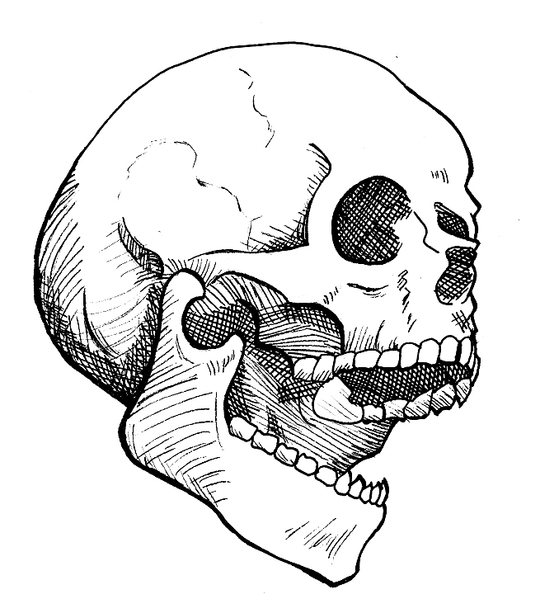
Once an ancient god of wine and good tidings, he was tricked by Darkness into listening to all of those that drank from his cup. At first, he heard only those who sought his cup in celebration, reveling in their exuberance. But, in time, he began to hear the sighs of those who used his cup to escape their mortal woes. Shocked at their plight, the god of celebration abandoned his fetes, and turned his attention to the kin of these hopeless drunken mortals, urging his followers to surrender some of their joy to raise the condition of their brothers and sisters around them.
They refused, and abandoned him, content to serve only their own joy to exclusion of all others. Cruelly disappointed and devoid of worshippers, he turned to those that needed a god. But he only knew joy, and found that he could not raise these sufferers to their feet with mindless glee. No, these souls need a solution, but he could only offer distraction. Desperately frustrated by his inability to serve the stricken, he used wine and play to seduce a nature goddess into revealing the art of poison, to offer the suffering the escape of sleep. Those that drank of his now poisoned cup died quietly, and found rest. But those they left behind began quailing in grief, and the stink of the dead bodies brewed disease that became plague, and the cacophony of misery grew ever louder. The god, who had for eternity known only the joy of celebration and pleasurable abandonment, found himself battered to his knees by the combined grief and suffering of the world. It broke his divine heart. He had no capacity to better the world with play, and even less as a fallen god of wine.
His pain, ever reinforced with mortal suffering, became anger. He missed his privileged place as a joyous god, and realized it was the mortals who had driven him from it. That no matter what could be done, they would endlessly find new torments. That mortalkind was a contemptuous and festering thing. And so he renamed himself Nox, unleashed plague and poison, his new domains, and killed his world. Then Darkness returned, and whispered that a new world was in the making, and that soon it would be filled with more hungry mouths, more betrayals, more voices that would echo towards him across the cosmos.
Thus did Nox side with Darkness, and come to Illumitas ready for murder.
Now Nox stands abreast with Grak, and plots to bring an end to all things. Only with total destruction and silence can Nox ever hope to be soothed. Early in the struggle, Nox swindled the secret of magic from the Sept, who had first stolen it from Draconus himself. Intended by the Sept to be a tool for only their own servitors and slaves, Nox corrupted it and made it freely available to those who served the Three. However, in doing so he suffered a terrible wound by the Knight, who could not be corrupted. The pain of this wound in chorus with the pain of the world’s miserable outcasts has driven this god insane. He inflicts punishment to all mortals, those who follow him and those who oppose him, equally. He commands disfigurement in his highest acolytes. He created undeath to have an unnatural hungry hate towards life; there is no reason why this should be so save that Nox wills it. He commands kidnapping and torture conversions of both the highest wizard and the most unimportant farm girl alike. He builds diseases that infect through laughter as well as loving touches, and sets them free without plan or intent. His water is sewage, his meat corpses, his bed is ash and he would invite everything to share his home and be welcome in his madness. The punishing torment of disease, the sudden seizing death of poison, a world of servitor undead who have no tongues to voice misery... these are goals of Nox. All in an effort to shut out the noise of the world.
Why would anyone serve such madness? The truly faithful believe that once Nox has erased the world, that he will repopulate it. Such new populations will need masters, and who better the serve as these new masters than those who earned their place by assisting with Nox’s pogrom? When confronted with the fact that Nox wishes all life destroyed, the zealots snarl and say that this is propaganda put forth by the hated Scholar, who wishes to confuse Nox’s faithful. Indeed, this may not be incorrect, as this notion does agree with the Scholar’s use of tricks and mind games to establish his desired result.
Worship of Nox is both incidental and formal. Incidental worship is found even in the happiest of mortals. A suffering disease, the loss of a loved one, the common tragedies of life visit even the most pampered, giving cause for some misery. But the poor and forgotten are the true priests of this incidental worship. Lives that know only suffering do little more than sing to the mad god with every breath taken. Sobbing for the remembered dead, the keening wail of a broken heart, the rash actions of anger, the gnawing pain of hunger, the jagged intent of jealousy; all these miseries place another drop of bile in Nox’s poisoned cup. In this, everyone can for a short time worship Nox.
Formal worship of Nox is a grand affair, and reserved only for those fellows the world has broken. Nox only accepts his brothers and sisters into his coven. The insane, the vengeful, the power hungry, the desperate, the corrupt – these are the priests of Nox. Their worship is an overwrought ritualized affair; the coven's subjugation to apocalypse must be complete. Any who drink from Nox’s cup, and have any reservations or doubts, are doomed to never die and to know every pain and humiliation that Nox’s true servants may visit upon them. Those that embrace apocalypse, and willingly suffer the torments of Nox rise to great power. At the heart of his temples is an Oracle. Kept in delirious pain and suffering, she whispers Nox’s black secrets to these covens. Foul ritual magic, blackmail, and dark prophecies spill out from gasping bleeding mouths festering with sores. And with these secrets, covens of Nox work to end the world.
Within these cults, Nox is only ever depicted as a skull. Outside of these cults, Nox is a forbidden god to all civilized lands save Gersh. In the Snow Kingdom, he is acknowledged as a god of mercy, both one who deserves some measure of mercy for that terrible burden he suffers as well as the one who administers it with his quick acting poisons.
It is impossible to break with Nox once formally indoctrinated into the coven. Willing convert, or unwilling victim, life is continued only so long as the mortal is useful and pious to the cause of apocalypse. Those who have a moment of clarity or seek redemption instead find themselves suddenly serving Nox as a member of his undead host.
Nox is the most zealous of the Dark Three, but he is not their leader.
Darkness
Dark Lord of the Three
Dominion: Unrevealed to date
Precepts: Unknown

Shadow, the Black Dragon, He Who Is Made Of And Dwells In Darkness, He Who Must Not Be Named, Malice, Darkness has many aliases. None of these, however, are its true name. That is but one of many secrets surrounding the Leader of the Dark Three.
Its hate for Illumitas and his scions, the Sept, knows no bounds. Yet the reasons for this hate are cloaked in mystery.
Its love of deceit and trickery is known. The recruitment of Grak, the creation of Nox, the seduction of the Templars of Wahkarn are the ones known to history. Imagine what deceits have never been uncovered?



Its defeats are also well recorded, and yet it perseveres endlessly. No force is strong enough to kill it entirely, and it always manages to struggle back into the great conflict. Indeed, it is for this tireless suffering of wounds and endless commitment regardless of defeat, which renders Darkness as the chief divinity in the Snow Kingdom of Gersh. Where they endlessly suffer in the most inhospitable of landscapes, like Darkness, they too have stubbornly continued to build and conquer.
Its thoughtful malice is well marked. When Darkness has claimed victory, the loss is always terrible and absolute. No survivors, no clues, no warning. Where Grak seeks glory, and Nox works for annihilation, Darkness is clever and its goals are occluded. Despite their antagonism, Darkness keeps Grak and Nox moving in concert. Thoughtful men wonder if Grak and Nox, for all their violence and destruction, are nothing more than a distraction in some larger gambit planned and enacted at the will of Darkness. Darkness is not a berserker, and is not insane. It is cunning and clever, and rarely takes the field itself, keeping its reserves and resources hidden from the Sept.
It depictions are numerous: A black disc, the eclipse, is a representation that chills adventurers descending into a warren of Darkness. Those few records that survive the destruction of Nalbendel speak of Darkness’s legions as following a standard bearing black talons on a field of red. Its temples are often built as mazes, making the maze one of the forbidden marks associated with Darkness. In the last century, only one high priest of Darkness was every found, and when he was at last slain he carried a sword of fire and teeth. Thus the fiery bonesword is sometimes regarded as a symbol of allegiance to Darkness.
Its followers wear dark colors and meet only at night, never daring to strike a light as it displeases Shadow. Its temples, rarely discovered, are opulent, artistic affairs built with a strange black brick that always weeps and drinks in light from any torch, glow worm, or lantern. These temples and meeting places are often underground, and well guarded with traps, zealots, and magic. Its precepts and traditions are unknown to any outside the cult, and Darkness chooses its followers with careful deliberation and testing. No zealots, no madmen, Darkness’s recruits are always composed, intelligent, rational beings who leave little to chance.
Certain prophecy dreams from Draconus suggest that at the murder of Illumitas, Darkness stole a piece from that corpse before it could form into a member of the Sept. That it even now keeps this unclaimed shard in some secret place. The only other clue as to this shard, and Darkness’s plan, is that the Shard is rumored to be female.
That is all that is known, but it is enough to inspire concern in the bold, and fear in the thoughtful.

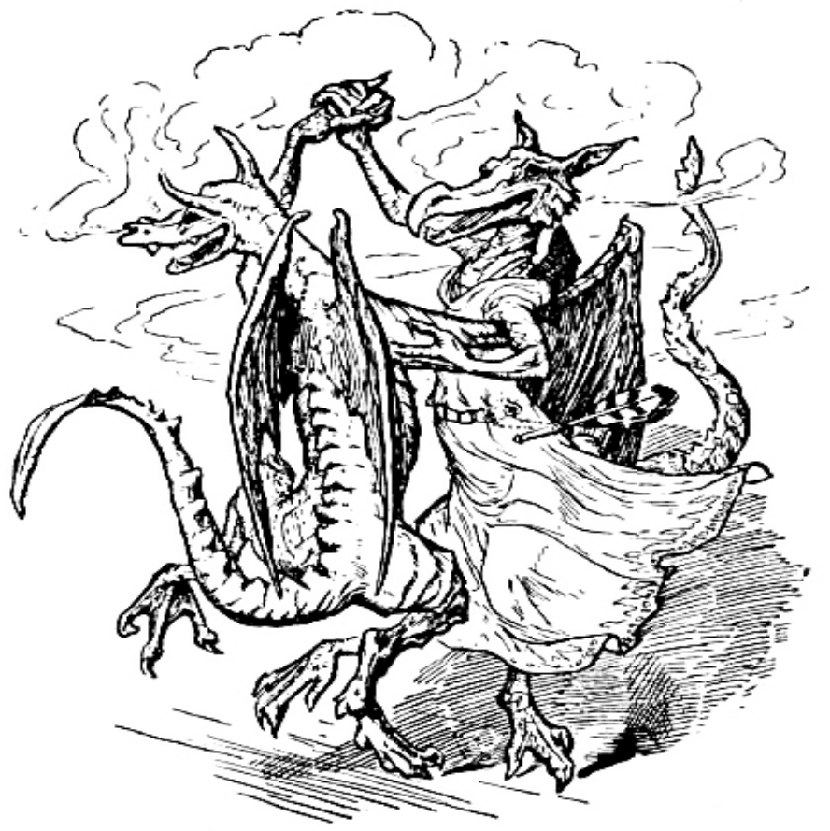

4. Races of Novitas
Drakes
Drakes are the offspring of ancient, long dead dragons. While Draconus has been locked away over the millennia, the once-powerful race of dragons has suffered, and has atrophied into their present state: that of the humanoid bipedal Drakes. Lacking fearsome claws, fangs, or wings, the Drakes have turned to magical pursuits to offset their loss of physical power. They are now the foremost practitioners of magic in Novitas. Drakes have no homeland, but live together in monasteries and enclaves throughout Novitas.
Drake culture revolves around the spell casters. The most powerful magic users are the leaders of each enclave, and seniority depends on magical power. Drakes who show little or no aptitude for the art are put to work at menial tasks, which encourages many of them to leave the monasteries and seek their fortune elsewhere. Often, a Drake will come into his magical heritage late in life after leaving the enclave. Each individual Drake exhibits a dominant color, which is indicative of what type of dragon they are descended from.
White Drakes are descended from the arctic dragons who made their homes in the northern wastes. They tend to be aloof and, well, chilly towards non-drakes. Generally, they show friendship or hatred towards Snow Goblins, and judge each other race individually. White Drakes are particularly fond of well-made weapons, especially those with magical properties.
Green Drakes are descended from the forest dragons who made their homes in the forests of the Free Lands and Fionn A’ilean. They tend to be fun-loving and friendly towards non-drakes. They generally dislike Snow Goblins and Earthkin, like Wood Elves, and greatly enjoy the company of light-descended Faekin. They judge humans individually, but fairly. Green Drakes are particularly fond of magical knickknacks and items (not jewelry, scrolls, potions or weapons).
Brown Drakes are descended from the mountain dragons of Terra. They tend to be taciturn and quiet. They get along well with Earthkin and Brownies, dislike the company of Elves, and are disinterested in Snow Goblins and humans. Brown Drakes are particularly fond of precious metals and gemstones.
Blue Drakes are descended from the aquatic dragons that lived along the secluded southern coastlines. They tend to be warm and friendly towards others, almost treating them as equals (especially people who have magical skills). They get along particularly well with the Elves of Evenandra, and many make their homes along the coastlines of that country. Blue Drakes are particularly fond of magical jewelry.

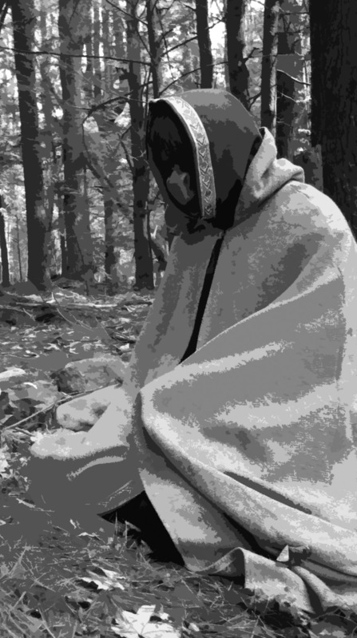

Drakes venerate Draconus, their imprisoned dragon god. They believe that one day, he will be born again from the egg of the moon, and descend to Novitas to restore the Drakes to their former glory. Drakes acknowledge the other gods, but do not worship them.
Their costume requires a reptilian or amphibian facial prosthetic with make-up to blend it with the skin. All exposed skin must be covered or made-up to match the facial prosthetic. Their clothing tends toward ornament and rich fabrics such as velvets and brocades, and can be from any background, as Drakes have enclaves and monasteries in every land.

Costuming Difficulty: Very difficult and expensive

All Drakes gain Racial Language: Draconic for free at first level.
Earthkin
Thousands of years ago, deep below Novitas in the magical caverns of Voltanicus, the humans and elves who were originally the Smith’s folk slowly became the dour Earthkin. Their close proximity to the magic of the Smith and long exposure to the bowels of Novitas had seeped into their very bones, causing them to become a part of it. While Voltanicus was destroyed in the chaos after the dark powers were released, the Earthkin survived, and even today thrive.

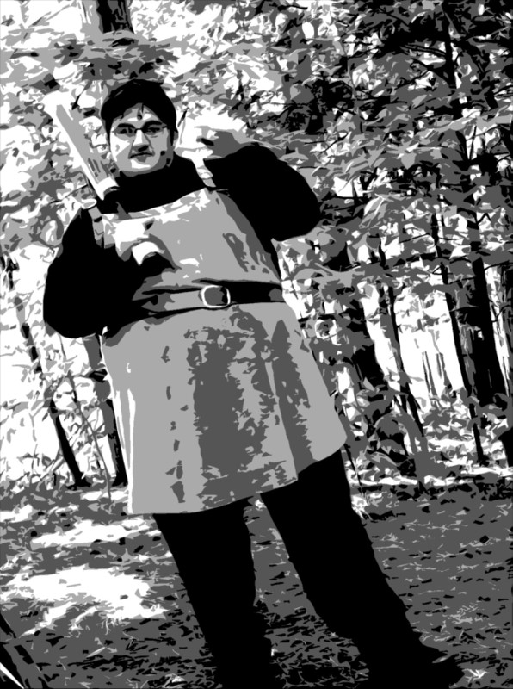

Earthkin are a race of subterranean miners and craftsmen. Their proximity and affinity for the earth causes small nodules and gemstones to grow from their skin. Earthkin live in the Kingdom of Terra, and their underground capital of Earthhold sprawls beneath the glittering ceiling of a vast cavern. Their culture is law abiding, harmonious, and respects strength, good craftsmanship, and strong ale, which they drink prodigiously. They are an urban and social race, gathering together in their huge underground halls to mine, smelt and smith together. A typical Earthkin is slow to act, deliberate, taciturn, and untrusting of strangers - but once you have gained their trust, they are loyal friends.
Earthkin hate Snow Goblins, and dislike elves. Humans of all lands are welcome as long as they follow the laws. Faekin are alternately a welcome distraction and a nuisance with their frivolity. Drakes are accorded much respect.
Earthkin worship the Sept. Some few venerate Grak the Destroyer, but they are usually not found in the cities.
Earthkin must affix at least five coin sized gemstones to clearly visible areas of their body with prosthetic adhesive. Earthkin are also encouraged to darken their skin with grey or brown make-up, but this is optional. Their costume is typical medieval European garb, tending towards dark colors and earth tones. Earthkin often wear aprons. Jewelry of metals and gemstones are common. Their warriors fight with whatever they are most comfortable with, but they exhibit a general trend toward axes, hammers, maces and pole arms.

Costuming Difficulty: Very easy and inexpensive

All Earthkin gain Racial Language: Terran for free at first level.
Elves
Elves are long lived humanoids with pointy ears. While similar to humans, the typical Elf can expect to live about 300 years. This tends to make them more patient, and less ambitious, than other races. For an Elf, there’s always tomorrow. And the day after. Or the day after that. Elves in Novitas live in two distinct countries, the Great Forest (who refer to themselves as Wood Elves) and The Realms of Evenandra (who refer to themselves as High Elves).
All Elves gain Racial Language: Elvish for free at first level.

Wood Elves
The Wood Elves of the Great Forest are chaotic and loosely organized. They have no cities that serve as capitals or trade centers - everyone lives in small villages and farming settlements.
Wood Elves dislike the staid Earthkin, and get along well with Faekin. They laugh at elves from The Elven Realms, respect Drakes, and judge most everyone else on their individual merits.
They worship the Sept, when they bother to pray. Their religious observances tend to resemble parties more than services, and Wood Elves are not known for their piety.
Wood Elves must wear ear tip prosthetics. These must be affixed with prosthetic adhesive and blended with the surrounding skin using make-up. Their dress tends towards earth tones – mostly browns and greens. Warriors tend to use missile weapons, bows, or two swords, and avoid heavy armor.

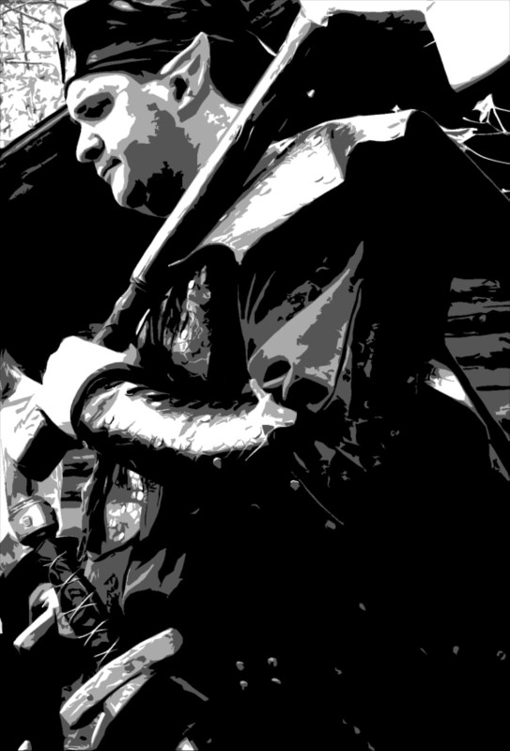

Costuming Difficulty: Fairly easy and inexpensive

High Elves
In stark contrast to the Wood Elves, the elves of Evenandra are urbane, lawful, socially stratified, aloof, and dignified. They revere the study of the magical arts and Alchemy, at the expense of martial prowess. They like trade, but engage in unfair trade practices like tariffs and quotas to always gain a favorable advantage (which agitates the Empire of Civen).
Elves in The Realms of Evenandra are fascinated by Drakes, and accord them much respect. They enjoy the company of Faekin (who they view as entertaining), tolerate Wood Elves and humans from the Empire, dislike Earthkin and Snow Goblins, and have outlawed tribesmen from Dellin and priests from Vlean.
They worship the Sept with great pomp and circumstance, if less sincerity.
Their costume is long ears and finery. Elves must wear ear tip prosthetics. These must be affixed with prosthetic adhesive and blended with the surrounding skin using make-up. Their clothing tends to be rich and ornate, if not always practical. Warriors (such as they are) tend to use spear, bow, or sword and shield – but elves from The Realms are far more likely to make their way in the world as scholars, mages, or alchemists.

Costuming Difficulty: Fairly easy, but expensive

Faekin
Faekin are human, Earthkin or Elvish individuals whose ancestry indicates a dalliance with a fae. The evidence of the union appears every few generations. As the Faekin grows up, his hair and eyes gradually change color to indicate the type of ancestor he is descended from - brown for brownies, green for dryads, blue for nyads, etc. Almost any color can be rationalized, and the coloring of a Faekin often gives a clue about his demeanor. Red Faekin might have fiery tempers, while green Faekin might be earthy and wise. By the time the Faekin reaches adulthood, he is clearly different from his family and friends. (The change to Faekin ALWAYS takes place before a character enters the game. Characters who do not start as Faekin at first level will NEVER change to a Faekin during play.)
Faekin have no cities, and no homeland. They tend to be flighty and irreverent wanderers and adventurers, rarely staying in one place for any length of time. They laugh frequently, and have a generally cheerful demeanor.
Faekin like elves and humans, although the repressive government of the Theocracy of Vlean disgusts them. They sometimes find Earthkin society too dour, and Snow Goblins too cruel. Tribesmen alternately terrify and delight them. They avoid Drakes, as a Drake's dedication to study and scholarly pursuits is totally alien to them, and makes them uncomfortable.
Faekin venerate the Sept, with varying degrees of piety.
Their costume can reflect any background, or none, as they are wanderers. The distinguishing characteristic of a Faekin is colored costume contact lenses and a matching wig or colored hair. All facial hair must be colored to match the contacts, and a player must color his hair or wear a wig – you can’t claim your natural hair color is “red enough”, nor may you be bald. It should be visibly different and unnatural. Likewise, it is never acceptable to say that your green eyes are “green enough”. Costume contacts are a required part of the costume. Faekin warriors reflect their varied ancestries, and anything is possible.
Faekin who choose to play a character who was an elf or Earthkin before undergoing their change in adolescence are required to fulfill the racial makeup requirements of both races, although their race is always considered to be Faekin. Faekin who grew up as Earthkin will need to wear the appropriate gems with their Faekin contacts and wig; players who are playing an Elvish Faekin are required to wear ear tips exactly as elves along with their Faekin requirements.

Costuming Difficulty: Fairly easy, but expensive

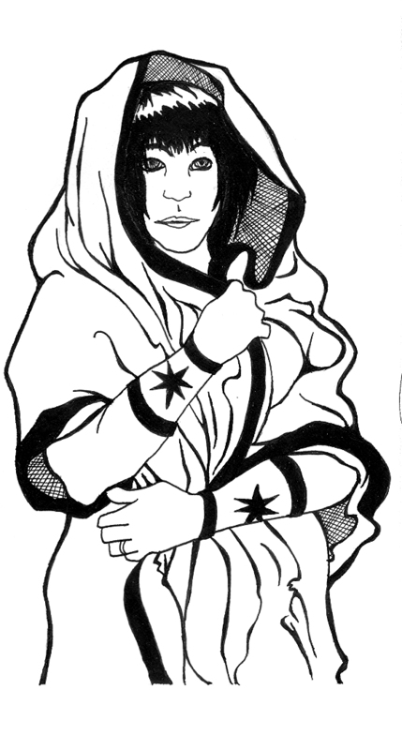
All Faekin gain Racial Language: Sylvan at first level for free. Faekin players who choose to play Elvish Faekin additionally get Racial Language: Elvish. Those who choose to play an Earthkin Faekin get Racial Language: Terran in addition to Racial Language: Sylvan.
Humans
Humans in Novitas come in three basic varieties: citizens of the Empire of Civen, barbarians from the Dellin Tribelands, and subjects of the Theocracy of Vlean.

The Empire of Civen
The Empire of Civen is grounded in democracy, industry, free trade, and the rule of law. It is an urban society, and its citizens congregate together in several large towns and cities. Their capital is Civenopolis. Their culture is a Greco-Roman amalgam.

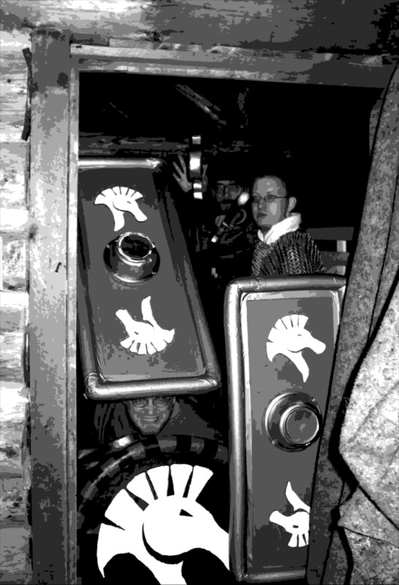

Civenites judge people on their individual merits. Individual merit is judged mainly by the size of your purse. Drakes are highly respected. Priests from Vlean are outlawed, and although Septons are still not uncommon they are often viewed with suspicion by government officials. Civenites like Earthkin and Elves, and tolerate Snow Goblins. Tribesmen are allowed until they start breaking stuff or killing people.
They worship the Sept, but religion is separate from government, and individual citizens exhibit varying degrees of piety.
Their costume is typical Roman or Greek garb of any class. Togas, robes, tunics and skirts are common for men and women. Warriors tend to use swords and shields or spears. Some films that give a good idea of life in Civen are Troy, 300, Gladiator, and the HBO series Rome.

Costuming Difficulty: Fairly easy and inexpensive

The Dellin Tribelands
Tribesmen believe in force of arms, self-reliance, martial prowess, and a lot of drinking. They are hard fighters and even harder partiers. Tribesmen are a nomadic, tribal race. When tribes meet on the steppes of the Tribelands, they are as likely to fight as they are to trade - and sometimes do both! There are no cities in the Dellin Tribelands, and each tribe sees their chief as a king. Their culture is a northern European barbarian amalgam.

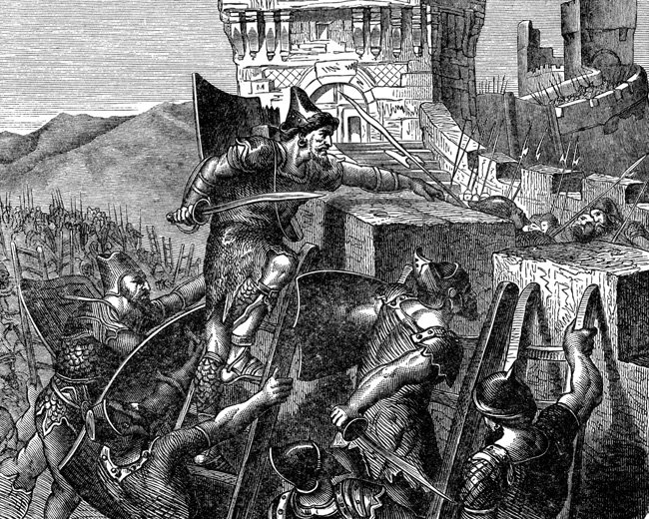

Tribesmen judge individuals without respect to their race or country on their physical prowess. Anyone not a warrior is a second-class citizen. Tribesmen are scared of Drakes, although they'd never admit it.
They worship Grak the Destroyer. Individuals sometimes venerate other gods as well.
Their costume is typical dark ages northern European garb. Furs, leathers, and kilts are all common, as is woad and war-paint. Warriors eschew shields as cowardly, but fight with whatever else they feel comfortable with. An Irish or Scottish accent is sometimes affected, and sometimes a Tribesman will simply yell everything using small words. Some films that provide good insight into Tribesmen characters are Braveheart and Conan the Barbarian.

Costuming Difficulty: Easy and inexpensive

The Theocracy of Vlean
The Theocracy of Vlean is new, having recently (100 years ago) broken away from the Empire of Civen in a vicious civil war. The civil war was precipitated by a cabal of priests who distrusted the "greedy and atheist" government of the Empire. They believe in religious piety and strong religious government led by strong leaders. The Theocracy of Vlean is a cruel, repressive place, ruled by a council of Septons who often twist the meanings of things to justify their own ends. There is one main city, Vleanoa.
The Theocracy distrusts Civenites and Elves. Tribesmen are outlawed. Drakes are openly welcomed and secretly feared. Earthkin and Snow Goblins are tolerated if they bring trade. Faekin are ignored, or reviled as bastard offspring of monstrous unions.
Everyone worships the Sept with great devoutness. Worship of other deities is officially forbidden. Religion is used to justify many barbarities and crimes, including crushing taxation, slavery, Jus Primae Noctis, aggression against their neighboring states, and mutilation as punishment for minor transgressions.

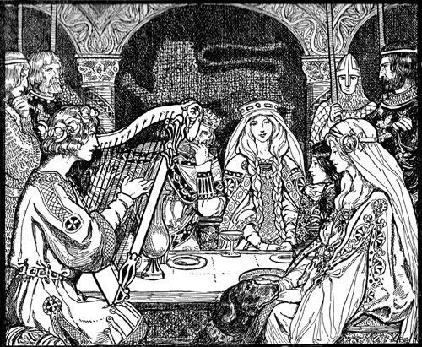

Their costume is typical medieval European garb, but only Septons have finery. Everyone who is anyone in Vlean is a Septon, and everyone else works for them. All nobles from Vlean are also Septons, but not all Septons are nobles. It is rare that an individual from Vlean does not wear the circle of seven somewhere on their person. Good films to watch for insight into Vleanoan culture are Ladyhawke, The Name of the Rose, and The Seventh Seal.

Costuming Difficulty: Easy and inexpensive

Snow Goblins
Might makes right to a Snow Goblin, and the strong are destined to rule the weak. Failing that, the devious will rule the trusting and stupid. Snow Goblins possess a fierce sense of honor and personal reputation, and insults or slights are often settled by elaborate duels. Snow Goblins follow their laws, and lawbreakers are punished severely. Snow Goblins live in the Snow Kingdom of Gersh. Their capital is The Fissure, a town cut into the walls of a deep crevasse in the icy plains. Snow Goblin culture is an oriental amalgam, with evil tendencies. It is well known that the leaders of the Gersh are often seen as a malicious, evil, and oppressive regime. However, it is important to note that the average Snow Goblin is often oppressed and unhappy with the state of affairs. As such, many of them turn to lifestyles as merchants, mercenaries, or travelers to get away from this lifestyle. Snow Goblins travelling outside Gersh in an unofficial capacity are pretty much just regular folks trying to make their way in the world.
Snow Goblins typically hate Drakes, as they fear their magical prowess. They see Tribesmen as useful tools, and have no use for Wood Elves, who they see as chaotic and flighty. Likewise Faekin are not liked in Gersh, and no Snow Goblin ever became a Faekin. They tolerate elves from Evenandra as long as they don’t make trouble, and welcome trade from the Empire, Terra and the Theocracy. Many powerful Snow Goblins have social and economic contacts in Vlean.
Snow Goblins worship anyone but the Sept, who they see as responsible for their ancient banishment to the frigid north. Worship of Nox, Grak, Darkness, and odd forms of ancestor worship, spiritualism, or animism are all common. Religion is very much a private affair in the Snow Kingdom – there are no public sacrifices or dark rituals held in town squares. Even so, the leadership and nobility of Gersh are fairly open about their homage to the Dark Triumvirate, forcing many of the average citizens to pay lip service to these gods, particularly in the military and government service. However, most of the general population of Snow Goblins actually follows a religious path of animism and ancestor worship.
All Snow Goblins share two distinct traits, white skin and stark white hair. Snow Goblins have long hair of pure white that they often intricately braid or attach bones, decorations, or trophies to. Players are required to completely hide their hair under a long white wig, or be bald. Players may not claim that their own hair is sufficiently white. Players with facial hair must completely cover it with a white fake beard and moustache, or color it white.
Snow Goblins must also cover all exposed skin with white makeup. This need not be completely opaque, but must be noticeably lighter than even a pale-skinned person, particularly on the face. If the player chooses to not put makeup on certain areas, such as the hands, and instead cover them with clothing (like gloves) they cannot remove that clothing unless they first apply makeup to that area.

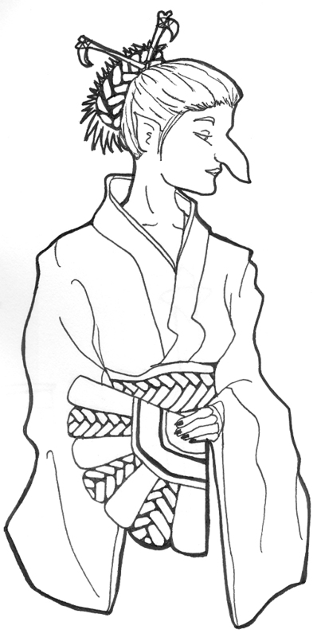
All Snow Goblins are further required to add at least one item of additional costuming in the form of physical irregularities. These can include things such as:
- Pointed ears
- Oversized nose
- Fangs
- Extra limbs
- Tail
- Extra eye
- Deformities (hunchbacked, etc.)
- Horns
- Large claws
- Extra fingers
- Costume contacts
- Severe ritual scarring

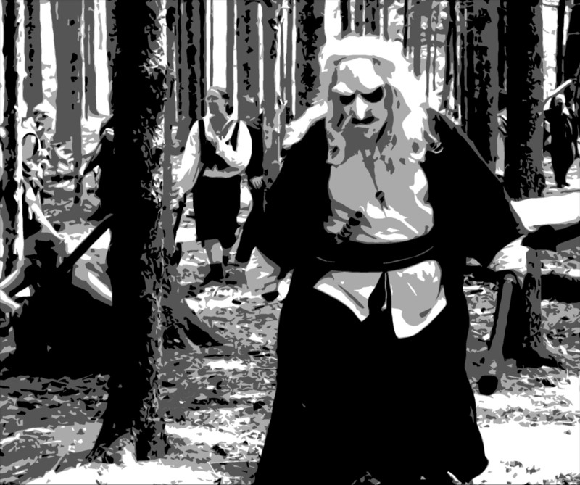

These irregularities in no way grant the Snow Goblin special abilities or penalties, and once used become a permanent part of the characters costume and may not be discarded later for convenience. Unique additions and irregularities are highly encouraged and will help your character stand out.
Snow Goblin clothing is an amalgam of oriental clothing or armor pieces. Warriors fight with standard oriental weapons such as katanas or naginatas, as well as oddly-shaped weapons such as the Klingon Bat’leth from Star Trek, the war fan, butterfly knives, the moontooth shovel, or hook swords. For those choosing to play a Snow Goblin, a simple Google Image search for “Chinese kung fu weapons” is extremely interesting and enlightening. Some films that give appropriate cues are Crouching Tiger, Hidden Dragon, Seven Samurai, and The Last Samurai, as well as episodes of Star Trek involving Klingons or Ferengi.

Costuming Difficulty: Moderately difficult and expensive

All Snow Goblins gain Racial Language: Snow Goblin for free at first level.

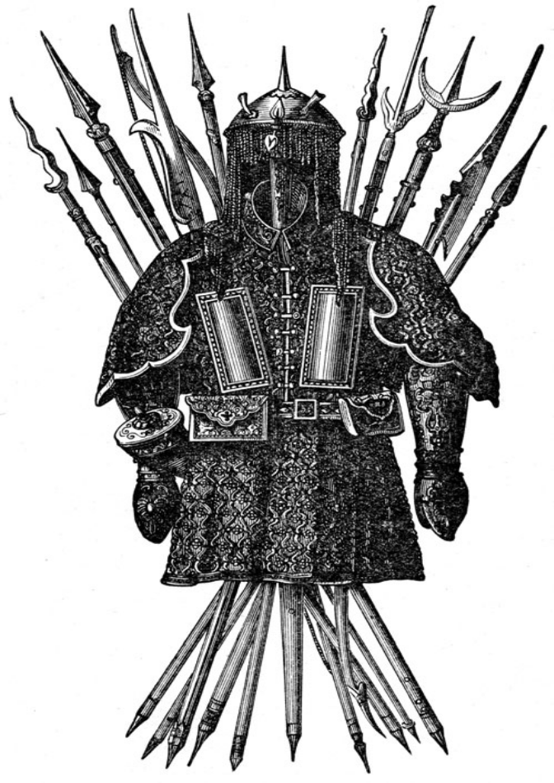

5. Character Creation

Character creation basics
Kingdoms of Novitas, like any story, uses characters as the catalysts of the plot. How the characters in a story interact with each other and the environment determines the mood and often the direction of the story. Unlike a normal book or play, the plot at Kingdoms of Novitas is fluid and changes almost every hour based on the actions of the participants. By creating their own characters, players personally impact the game world and the ongoing plot line. This multitude of variables makes Kingdoms of Novitas far more dynamic than any book, movie or play is even close to capable of!
The character acts as a template and guides players actions during the game. The character is a combination of fictional skills, game background, and a player’s personal real world ability. Since Kingdoms of Novitas is a live-action activity, a player’s personal skill, such as running or fighting, has enormous influence on the character. There are no character skills for things like hiding or climbing – players must actually climb or hide themselves. Where real world skill is not possible or safe, a character’s fictional abilities take over. For example, combat is not actually beating each other into submission, so a system of points is used to determine when a character has received an injury or died. These fictional skills also allow characters to make use of fantastic abilities such as spell casting or speaking foreign languages.
Alignment,
and the lack thereof
While we sometimes use the standard fantasy alignment system designations in a broad sense when talking about races and cultures, individual character alignment is a common aspect of many fantasy role playing games that does not appear in Kingdoms of Novitas. A character’s motivations are viewed and judged based on the perception of other players and are fluid and subjective. What one character might perceive as good another character might view as evil. For example, one Necromancer is unlikely to view a fellow Necromancer as evil. Overall, this system proves more realistic than a set alignment system and results in more dynamic, three-dimensional characters.

The last major function of the character creation system is as a means of game balance. Characters are measured in levels of proficiency and restricted in their abilities to reflect this. Players are not permitted to enter the game and simply fabricate the abilities of their character. Low level characters are less skilled than older characters, and this system allows a character to develop as they spend time at Kingdoms of Novitas. Young apprentice magic users grow to be powerful wizards, green fighters develop into champions, and below them is the next generation waiting to rise.
How a player designs their character has a direct impact on the role they will play while participating at Kingdoms of Novitas. Every player takes a different approach to the design of his or her character. Some simply develop characters based on a background or concept, picking skills that just seem right and having no real concern for how powerful their character is. Other players consider their character’s abilities, mixing them with their own real-world abilities and attempting to compensate for the weaknesses of both. And some carefully calculate their skill choices to develop the perfect character based on statistics alone. There is no right or wrong way to create a character and there is no magical formula for creating a “super character”. Players should focus on what interests them and generate a character based on that. Kingdoms of Novitas characters are classless and do not follow the preset templates typical in the fantasy game genre.
It is important that while writing a character history for your new character, that you do not include blinding hatred for any other PC race. There can be distrust, dislike and even fear, but we ask that all players refrain from creating a character that will immediately hate and cause potential PC Death upon first contact.
Character sheets
Character information is stored on a document known as the character sheet. Character sheets are required during the game to act as a reminder of the character’s skills and abilities. The sheet can also act as a reference for Game Masters in the event a dispute occurs between players. The Game Master has the right to remove a player from the game if they are unable to present a character sheet upon request. Only Game Masters may request to see a player’s character sheet during a game, and only when they are acting officially as a Game Master. Players should avoid showing their character sheet to other players whenever possible, as there is no guarantee that other players will keep this information a secret – they may use the information for less than honorable reasons! Blank copies of the character sheet are obtained at Logistics when players sign in, or can be printed out from the Kingdoms of Novitas website.

Character death
Character death is a rare but unavoidable aspect of any Kingdoms of Novitas event, and most players will lose a character at some point. Should a character permanently die during the course of an event, the player is required to create a new character. It is required that the player wait until the next event before they are allowed to bring a new character in game. This gives the player time to prepare a new costume and develop another character background. None of the old character’s belongings, abilities, experience points, or memories transfers to the new character. Players are required to turn in all their dead character’s in-game possessions not looted from their dead body at logistics and report the death of their character. It is strictly forbidden for players to use information acquired from past characters to aid new characters, or to avenge old ones!
When creating their new character, players must develop a new concept and should shy away from past goals and affiliations. Changing weapons, garb, armor, race, and skills are great ways to make one character distinct from the last. Players will find it hard to fall into old habits if their last character was a Earthkin fighter and their new character is a Snow Goblin healer. Players who create a new character and simply assume the habits and affiliations of their dead characters are cheating, and must change their character design, volunteer to play an NPC, or leave the event until they are ready to properly assume the persona of their new character. Most veteran players are constantly acquiring out-of-game garb, weapons and equipment in preparation for their next character, and this makes the transition easy and less stressful. Some players actually look forward to the death or retirement of their current character so that they can start again.
Players attending their first event are allowed a single death or “newbie death” to give them time to acclimate to the live action environment and/or game system. The first time a character dies a player is permitted to ignore that death and keep playing the same character. Players using a newbie death must report to Logistics or a Game Master to report their first death. The Game Master will instruct the character what to do and introduce them back into the game when it is convenient.
This only applies to players attending their first event, not veteran players that are playing new characters. Players using their newbie death are required to accept damage and wounds as normal and cannot simply “pop” back to life and continue playing – they should stay “dead” until the encounter has moved away from them. A player using a newbie death reenters the game healed of any wounds, body damage, poisons and disease, but all armor and protective spells lost as a result of death are still gone.
Kingdoms of Novitas also ensures that your time and money spent at the game are never totally wasted if your character dies. All players who experience character death are free to use one-half of their dead character’s levels (rounded up) towards the creation of a single new character, if they so desire. While some players truly enjoy building a character up from nothing, we recognize that others see this as a huge step backwards, and may become dismayed or discouraged. This rule helps soften the sting of death for many players.

Character Retirement and second characters
Many players will, over time, grow tired of a particular character. Perhaps the character made some bad decisions and cannot avoid the consequences, or perhaps it is just time for a character to ride off into the sunset. If this happens to you, you have two options: you may retire that character, or you may make a second character (an “alt”, or alternate PC).
Character retirement is very similar to character death. Your PC is gone forever, and you are required to turn in all your in-game items to Logistics. While Logistics does not usually track item ownership, and it may be very tempting to a player to hand out all his worldly possessions to his friends before retiring, the idea of a retiring adventurer striding off over the horizon naked and destitute is not even slightly realistic, and strains the ongoing suspension of disbelief of the other players too far. Giving away all your items before retiring is cheating, and you should expect penalties on both your next character and your former companions if you do this. Once a player has turned in all his items at Logistics and officially retired the character, he or she is free to create a new character, following all the rules for character death. Players who retire a character are entitled to use half the levels (rounded up) of the retired character towards creation of a single new character.
Players may create a second character, or alt, at any time after their first character has reached 10th level. There are several other rules that govern the creation of alts:

- No player may have more than two PCs active in the game at any time.
- Players must choose which character they will be playing for each weekend. No player may play both his characters in a single weekend.
- It is permissible for a player to sign-in to play one character but have all XP earned that weekend applied to his other character.
- A player's second character must follow all the rules for new characters.
- No player may share resources of any type or kind between his two characters. At no time may a player swap money or in-game possessions of any amount or type between his two characters for any reason or by any mechanism. Any player caught attempting to circumvent this rule by utilizing a third-party to transfer goods, hiding items in the woods between games, or any other such malfeasance will be punished in-game severely.
Character Amnesty
Creating a bad character concept is a very common occurrence when a player first attends a Kingdoms of Novitas event. In most cases, new players have little or no experience with live action role-playing when they join Kingdoms of Novitas and so have no basis for decisions about their character.
To help with this, Kingdoms of Novitas observes a policy of character amnesty for new characters. Every player is allowed to alter their character once at the end of their first event with that character or before the start of their next event with that character. Once the player enters their second event with a character, that character is set in stone. Character amnesty allows the player to change any aspect of their character or even create an entirely new character. A player using character amnesty does not lose any experience, treasure, or magic objects they obtained while playing the first version of their character. Characters that keep the same name and general background as their old character may assume the old life, goals, and affiliations of their altered character. Players creating a totally new character with character amnesty are obligated to follow the same rules as characters that died. It is recommended that players simply alter their character as opposed to creating an entirely new concept. To use character amnesty the player must report the change to Logistics at the end of their first event or before they enter play at their second event.

Character creation process
The following is a basic overview of the steps involved in character creation. It is recommended that new players take plenty of time to create their first character trying several combinations of skills, before they settle on a final concept.

- Experience and levels
- Determine character background
- Choose a race
- Pick skills
- Decide on equipment
- Obtain Game Master approval and starting coin
- Create an archive character sheet

1. Experience and levels
Characters usually enter the game as novices with little or no experience as adventurers. It is assumed new characters left some form of mundane life, such as farmer or apprentice in order to take up a life as an adventurer. From this point on characters learn from their adventures, gain experience and transform from green novices into worldly personas.
To represent this progression, characters are awarded experience points for their participation at events. Players use these experience points to buy levels that indicate their level of proficiency in relation to other characters and non-player characters. Characters begin at level one, but it is possible to save up experience from NPCing or other sources and apply it to a fresh character, allowing the player to start higher than first level, but players may not use experience gained while signed in as one character towards another. Primarily, levels determine when characters get new skills. Levels also allow the Game Master to make quick judgments on how well a character, or group of characters can handle in-game situations such as encountering monsters. When a character gains experience, a Game Master or Logistics official will write the amount on the player’s character sheet and sign it.
Experience & Character Level
Character level | Experience needed | Total skill points
1 | 0 | 6
2 | 5 | 8
3 | 10 | 10
4 | 15 | 12
5 | 20 | 14
6 | 25 | 16
7 | 30 | 18
8 | 35 | 20
9 | 40 | 22
10 | 45 | 24
11 | 55 | 26
12 | 65 | 28
13 | 75 | 30
14 | 85 | 32
15 | 95 | 34
16 | 105 | 36
17 | 115 | 38
18 | 125 | 40
+1 | +10 | +2
Players are awarded experience for their participation in the game as a player or non-player character, trading in wealth, and donating supplies to the club. Experience is not rewarded for in-game actions, such as killing monsters, in order to foster a better role-playing environment. Characters gain levels regardless of their in-game motivations or deeds and so are free to role-play their character as they see fit. This system also allows characters to advance in level without running around in the woods on adventures. Players are free to portray farmers, merchants, entertainers, or even the town bum without fear of losing out on experience.
Players are allowed to exchange in game coin for experience once per event, or more if the character possesses certain skills. Other valuable objects, such as jewelry or gems, can also be redeemed for experience points. This policy is designed to create an in-game economy and also cycles money back to Logistics for use by Game Masters. The amount of money allowed for turn in is limited to keep the game from developing too strong of a greed-based setting.

Character Backgrounds
Players who provide the Game Masters with a typed, well written, Novitas-appropriate character background of 500 words or more can receive 5 experience points. Your background can detail your life before coming to the Free Lands, your family, your motivations, or any other relevant information. To get this bonus experience, your background must be submitted via email or the forums at least two weeks prior to an event. Players who wish to mail their backgrounds should ask a Game Master for their mailing address. This experience award is only available before the character reaches second level, or before a character’s first appearance in game, whichever comes first. Once you’ve started progressing a new character’s level and skills, it’s too late. Finally, this award is given solely at the discretion of the Game Masters. If they feel you didn’t put enough effort into your background, it’s not appropriate, or any other reason, you may not receive this bonus award. They will, however, usually work with players to help them craft something that will be acceptable.

Post Event Letters (PELs)
Players who provide to the Game Masters a Post Event Letter after an event are awarded 2 experience points. A Post Event Letter is an optional short write-up of your adventures during the course of a weekend, both as a PC and as an NPC. Include as much detail as possible – names, facts, eyewitness accounts, any secrets your NPC character learned, and other such useful bits of information. Your PEL is definitely the time for creative writing, but should remain factual. The following are all rules for writing PELs:

- 500 words minimum.
- Essentially free of grammatical and spelling errors.
- Clearly describes both PC and NPC actions, with an emphasis on PC actions. The Game Masters only need to know you played an orc for two hours if something substantial happened to your orc.
- May be written as a narrative, or a factual report. A simple shift-by-shift list of your activities is generally not acceptable.
- Must be posted to a blog on the forums, posted publicly on the forums, or emailed to pel@kingdomsofnovitas.org.

The Game Masters use PELs to plan future events and help with game continuity, so turning one in is a good way to have your character be more involved in the game world, or to lock yourself into a fun recurring NPC role. Players who want help with writing a PEL should ask for help from a Game Master or experienced player, as there is currently no template for writing a PEL.
The Experience Awards chart lists and explains the various sources of experience points and the amount of experience they yield. The amounts of the rewards are strictly set and even a Game Master is not allowed to alter them!
Once a player acquires enough experience to gain a level they can advance their character when they sign in at Logistics. A player must advance their character when they sign into the game or they must wait until the next event. Players may not advance their character during play and report the advance to Logistics at a later time! The Experience and Character Level chart lists the experience required to obtain levels and the total number of skill points the character should have at their present level of experience. The table only lists character levels one through twenty-eight, but it easily scales beyond that. Characters who need help progressing above this level can obtain assistance from Logistics.

2. Character background
Experience Awards
Activity | Experience awarded | Notes
Attending the event | 2 | Awarded at sign-in
Participating as a GM, first two shifts | 2 | Per shift
Participating as a GM, second two shifts | 3 | Per shift
Participating as an NPC, first two shifts | 1 | Per shift
Participating as an NPC, second two shifts | 2 | Per shift
Participating as an assistant GM, first two shifts | 1 | Per shift
Participating as an assistant GM, second two shifts | 2 | Per shift
Trading in 10 coins or 10 coins worth of loot | 1 | Only once per event, or more with certain skills
Donation of OOG supplies | 1 per $10 in value | With GM approval only
Written Background | 5 | Restrictions apply
Post Event Letter | 2 | Restrictions apply
Assisting with setup or cleanup | 1 | Per hour
Every character in Kingdoms of Novitas is expected to have some sort of established background. Without a little fleshing out a character is nothing more than a pile of numbers and skills. Shallow characters might appeal to some people; however, one-dimensional characters ruin the atmosphere for others. At the very least, a character should choose a name to use during play, pick where their character is from, and decide what has brought their character to the Free Lands. Character backgrounds allow Game Masters to tailor the main plot to the characters, making the game more interesting. To keep the main plot line serious, there are several rules players are required to follow when creating a background for their character. Despite these rules players still sometimes enter play claiming outrageous and often silly things. Very often, this is due to inexperience with the plot line or game, but players who continue to violate these rules will lose their character and must create a new one under the supervision of a Game Master.

- Make your own name. Players may not take names directly from history or literature. For example, a player may not choose the name Robin Hood, Drizzt Do’Urden, Rand Al’Thor, or Arthur Pendragon. It is also not permitted for a character to assume the name of another established Kingdoms of Novitas character. Players should choose only serious names for their characters and avoid silly or insulting names.
- You’re probably a nobody. No player may start the game with a noble (or similar high social status such as “Guild master”) or military rank, as it is customary to earn these ranks through game play. This restriction includes the use of generic titles such as “Sir”, “Lord”, or “Lady”, which are reserved for characters who have taken the Nobility, Medium, Druid, or Ordained skills.
- You’re not rich. A player may choose to come from any social background common to Kingdoms of Novitas so long as the background does not grant the player any special abilities. For example, a player may not claim their character is the son of a rich merchant who sends money from time to time.
- You come from Novitas. A player may claim to come from any country in Kingdoms of Novitas even if it is not a country of their race. No player is permitted to come from a land of his or her own creation or from other non-Kingdoms of Novitas fictional worlds.
- You’re inexperienced. A player may (and is encouraged to) create as elaborate of a prehistory as they like so long as it does not violate other background rules or interfere with the main plot. Players should avoid building too much of the character’s history before entering play so the character has room to grow. Characters should not have lived a lifetime of adventure before entering the main plot as “new characters”.
- Novitas has enough gods. A player may follow any religion listed in these rules. Players are not permitted to create religions of their own, even if these religions are fakes or intended as hoaxes. It is permitted for characters to portray clerics of a faith so long as they do not violate rules two or three, and have taken the Ordained skill.
- It’s good to want things. Players may create objectives or goals for their character as they see fit. Players should never expect fulfillment of these goals. For example, a character could claim to quest for an ancient magic sword, but this in no way guarantees they will discover the sword in future games.
- Dead means gone. In the case of death, player’s new character cannot claim to be a relative, close friend, or partner of their old character. This practice leads to bad role-playing or attempts to resurrect dead characters.
- Two’s company, twelve’s a crowd. Players are allowed to start organizations, adventuring parties, or guilds as long as the guild grants no in game benefits. It is recommended that players limit the size of their guild; six to ten people is more than enough for any situation. Larger groups often find it difficult to interact with plot lines and often get excluded from adventures.

3. Player character race
A large part of the appeal of fantasy live action role-playing is the opportunity to portray a race other than human. Kingdoms of Novitas is rich with exotic lands and fantastic creatures allowing players a wide range of racial options. Not every race in Kingdoms of Novitas is allowed as a player character race as some are far too unintelligent (trolls) or powerful (undead) to consider them as fair player races. With the exception of Humans, every race requires the player to wear some form of advanced costume or make-up. For example, elves have distinctly pointed ears and players portraying them must wear latex ear prosthetics. Wearing make-up and prosthetics is very difficult, time consuming, uncomfortable, and expensive so players should carefully deliberate playing a non-human race. The allowed player character races offer a variety of options and players should choose one that realistically fits their tolerance and pocket book.
Player Character Races
Character race | Description, costume, or make-up
Drake | Reptile or amphibian prosthetic and facial makeup
Earthkin | At least 5 gems affixed to visible skin and facial make-up
Elf | Pointed ear prosthetics and regional garb suggestions
Faekin | Colored contact lenses and matching colored hair
Human | Regional garb suggestions
Snow Goblin | Various mutations, white wig, and facial make-up
Want to play a non-human?

Read this first!

Players that fail to meet the racial requirements or wear their costume in a lax fashion will lose their character permanently! DO NOT try and rationalize a bad non-human costume by saying your Elf’s ears were cut off, or your Snow Goblin’s nose fell off due to frostbite. If the race you have chosen requires make-up or prosthetics, ENSURE that anyone seeing you knows immediately that you are not human.
All required parts of the racial make-up and prosthetics are just that – REQUIRED, so make sure there is no doubt about your compliance with the rules. Remember also that the requirements are a MINIMUM requirement, and while meeting the minimum requirement is adequate, it won’t make your character stand out in anyone’s memory and it won’t motivate the Game Masters to include your character in special plotlines or adventures. Nothing ruins the event atmosphere like players wearing low quality racial make-up - and players with such habits are not welcome to play non-humans!
Players that take the time to play a non-human race do gain the advantage of knowing their native racial language for free. This small incentive is intended to reward good role-players who play quality non-human races. Offering larger special abilities often invites players that simply play a non-human race to gain the special abilities, and this sort of attitude ruins the atmosphere for others.
It is recommended that first time players avoid playing complex races such as Snow Goblins, Drakes or Faekin. Players with little or no experience with make-up and live action games might consider playing simple races like Humans, Earthkin, or Elves until they understand the difficulty involved in working with heavy make-up and prosthetics. All players portraying non-human races are required to report to Logistics for a costume check. A Logistics officer or Game Master will approve the players costume for play or disapprove the costume and instruct the player on any required improvements.
4. Pick skills
Skills represent the fantastic abilities that a character possesses but the actual player does not, such as the ability to use magic. There are no skills that replace a player’s natural abilities such as running, climbing, or stealth – these are talents that the player must execute himself. A few skills do limit a player’s natural talent to prevent the player from gaining undue advantage with every character they play. For example, Two Weapon Fighting is a skill required to use two weapons in combat regardless of the player’s personal ability. Kingdoms of Novitas is a classless character system and so it is not required that a character fit into a typical fantasy archetype. It is possible for mages to wear armor, thieves to wield two-handed weapons, or a fighter to cast healing magic.
Every character starts the game with six skill points to spend purchasing skills. The player may spend these skills as they see fit buying whatever combination of skills best fits their character concept as long as they meet the prerequisites for the skills they choose. It is allowed to save unused points for future skill purchases when the character goes up in level. Every level past first the character gains two skill points to spend on new skill choices. The Experience and Character Level table lists the total number of skill points a character will have at each level and players should use this chart to check their math as they increase in level.
Many skills have prerequisites that the player is required to purchase before they are allowed to buy the new often more advanced skill. For example it is required that a player purchase a point of Magic Power before they are allowed to purchase a level one spell. Since a character’s skill points are limited it may often take several levels before they are able to purchase all the skills they desire. Prerequisites make it difficult for characters to spread their abilities out over a wide range of skills and still gain in proficiency often forcing them to concentrate on one or two directions, although this is by no means required.
Skill use is largely self-explanatory and each skill description includes instruction on how to use the skill or gives reference to future chapters explaining the skill. Players are encouraged to add to the role-playing of their skill use as much as possible during play in order to improve the atmosphere of the game. For example, a character using the skill First Aid might apply fake bandages or medicines to a victim’s wounds. The skills Pick Locks and Disarm Traps require the player to carry tools in order to perform the skill and the player must provide these tools themselves.
Magic Power and Production Points are unique skills in the fact that players are allowed to purchase the same skill several times up to a maximum of twenty points.

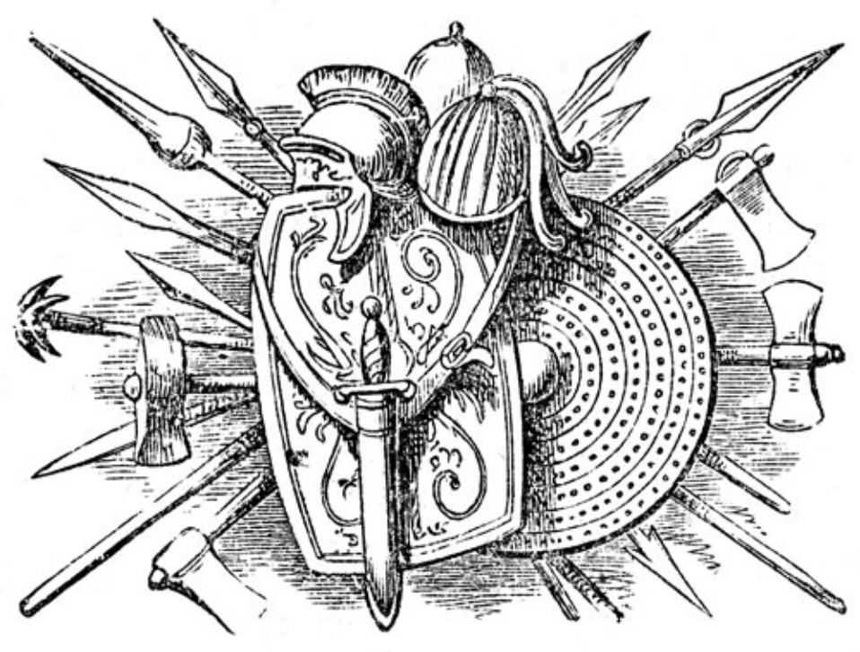

Combat Skills
Skill | Skill Point Cost | Prerequisite | Notes
Body 1 | 1 | -- | 1 Body point
Body 2 | 2 | Body 1 | 2 Body points total
Body 3 | 3 | Body 2 | 3 Body points total
Body 4 | 4 | Body 3 | 4 Body points total
Bucker Fighting | 1 | -- | Fight with a buckler
Great Weapon Training | 2 | Melee Training | Use weapons longer than 42”
Melee Training | 2 | -- | Use weapons 30” to 42”
Melee Proficiency | 3 | Melee Training | 2 point damage total
Melee Expert | 4 | Melee Proficiency | 3 points damage total
Melee Master | 5 | Melee Expert | 4 points damage total
Missile Training | 2 | -- | Use missile weapons
Missile Proficiency | 2 | Missile Training | 2 points damage total
Missile Expert | 2 | Missile Proficiency | 3 points damage total
Missile Master | 2 | Missile Expert | 4 points damage total
Shield Fighting | 1 | Buckler Fighting | Fight with a shield
Thrown Weapon Training | 2 | -- | Use throwing weapons
Thrown Weapon Master | 3 | Thrown Weapon Training | 2 point damage total
Two Weapon Fighting Training | 2 | Melee Training | Use two weapons, both under 30”
Two Weapon Fighting Expert | 3 | Two Weapon Fighting Training | Use two weapons, one up to 42”
Two Weapon Fighting Master | 4 | Two Weapon Fighting Expert | Use two weapons, both up to 42”

General & Knowledge Skills
Skill | Skill Point Cost | Prerequisite | Notes
Estimate Value | 2 | -- | Know monetary value of non-magical treasure
Identify Magic | 2 | -- | Know function of magical items
First Aid | 1 | -- | Basic medical skills
Herbalist | 2 | -- | Safely handle and use Alchemical compounds, especially poisons
Lore | 1 | -- | Ask questions of GMs between games
Master Merchant | 1 | Merchant | Trade in triple the allowed amount of coins for XP each game
Merchant | 1 | -- | Trade in double the allowed amount of coins for XP each game
Racial Languages | 1 | -- | Speak and be literate in one racial language, may be taken multiple times
Read Magic | 2 | -- | Use Magic Scrolls
Tradesman | 1 | Estimate Value | Character gains a small regular income

Production Skills
Skill | Skill Point Cost | Prerequisite | Notes
Alchemy 1 | 1 | Herbalist, 1 Production Point | Create Alchemical compounds
Alchemy 2 | 2 | Alchemy 1, Mirror of Sophistry | Create Alchemical compounds
Alchemy 3 | 3 | Alchemy 2, Hermetic Rod | Create Alchemical compounds
Alchemy 4 | 4 | Alchemy 3, Thaumaturgist’s Mortar | Create Alchemical compounds
Alchemy 5 | 5 | Alchemy 4, Philosopher’s Stone | Create Alchemical compounds
Brew Potion | 2 | Any level 1 spell, 1 Production Point | Create potions and oils
Ornamenter 1 | 4 | 1 Production Point | Create magical non-weapon items
Ornamenter 2 | 2 | Ornamenter 1 | Create magical non-weapon items
Ornamenter 3 | 3 | Ornamenter 2, guild fee | Create magical non-weapon items
Ornamenter 4 | 4 | Ornamenter 3, guild fee | Create magical non-weapon items
Ornamenter 5 | 5 | Ornamenter 4, guild fee | Create magical non-weapon items
Production Points | 1 | -- | May be taken multiple times, maximum of 20
Scribe Scroll | 4 | Any level 1 spell, Read Magic, 1 Production Point | Create Magic Scrolls
Trapsmith 1 | 4 | 1 Production Point | Create various traps and locks
Trapsmith 2 | 2 | Trapsmith 1 | Create various traps and locks
Trapsmith 3 | 3 | Trapsmith 2, guild fee | Create various traps and locks
Trapsmith 4 | 4 | Trapsmith 3, guild fee | Create various traps and locks
Trapsmith 5 | 5 | Trapsmith 4, guild fee | Create various traps and locks
Weaponsmith 1 | 4 | 1 Production Point | Create magical weapons
Weaponsmith 2 | 2 | Weaponsmith 1 | Create magical weapons
Weaponsmith 3 | 3 | Weaponsmith 2, guild fee | Create magical weapons
Weaponsmith 4 | 4 | Weaponsmith 3, guild fee | Create magical weapons
Weaponsmith 5 | 5 | Weaponsmith 4, guild fee | Create magical weapons
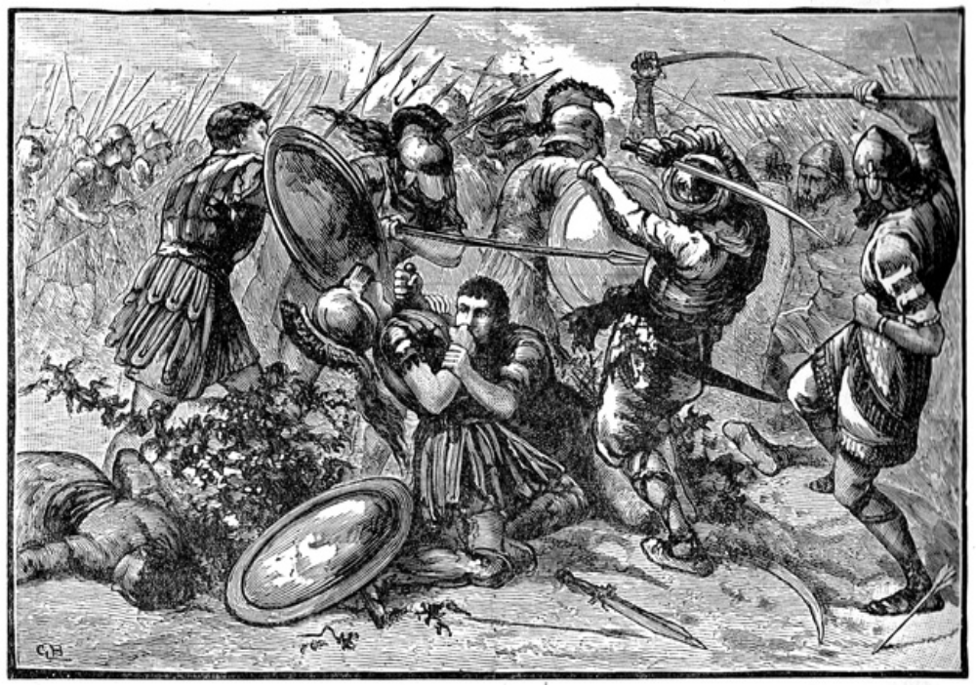

Roleplaying Skills
Skill | Skill Point Cost | Prerequisite | Notes
Druid 1 | 4 | -- | Speak with some plants and animals in limited circumstances
Druid 2 | 4 | Druid 1, GM permission | Charm spell for use on plants or animals once per game day
Druid 3 | 4 | Druid 2, GM permission | Barkskin
Druid 4 | 4 | Druid 3, GM permission | Elemental Dart produces two darts, can use free single dart 1/game day
Druid 5 | 4 | Druid 4, GM permission | Innervation
Medium 1 | 4 | -- | Speak with some undead and spirits in limited circumstances
Medium 2 | 4 | Medium 1, GM permission | Final Rest 1/game day
Medium 3 | 4 | Medium 2, GM permission | Ethereal Aura
Medium 4 | 4 | Medium 3, GM permission | Ghost Form
Medium 5 | 4 | Medium 4, GM permission | Spirit Subjugation
Nobility 1 | 4 | -- | Member of a Kingdom’s nobility with a title, privileges and responsibilities
Nobility 2 | 4 | Nobility 1, GM permission | Stipend of 1 silver per event
Nobility 3 | 4 | Nobility 2, GM permission | May buy up to 5 Production Points of non-permanent items at cost each event
Nobility 4 | 4 | Nobility 3, GM permission | Stipend of 2 silver per event
Nobility 5 | 4 | Nobility 4, GM permission | Pure Cognizance, may buy up to 5 Craft Points of permanent items at cost
Ordained 1 | 4 | -- | Ordained priest of one god with a title and shrine
Ordained 2 | 4 | Ordained 1, GM permission | Gain use of an innate magical power granted by your god once per game day
Ordained 3 | 4 | Ordained 2, GM permission | Smite 1/game day
Ordained 4 | 4 | Ordained 3, GM permission | Gain use of an innate magical power granted by your god once per event
Ordained 5 | 4 | Ordained 4, GM permission | Gain two extra Magic Power (to max of 22) and an additional Smite 1/game day
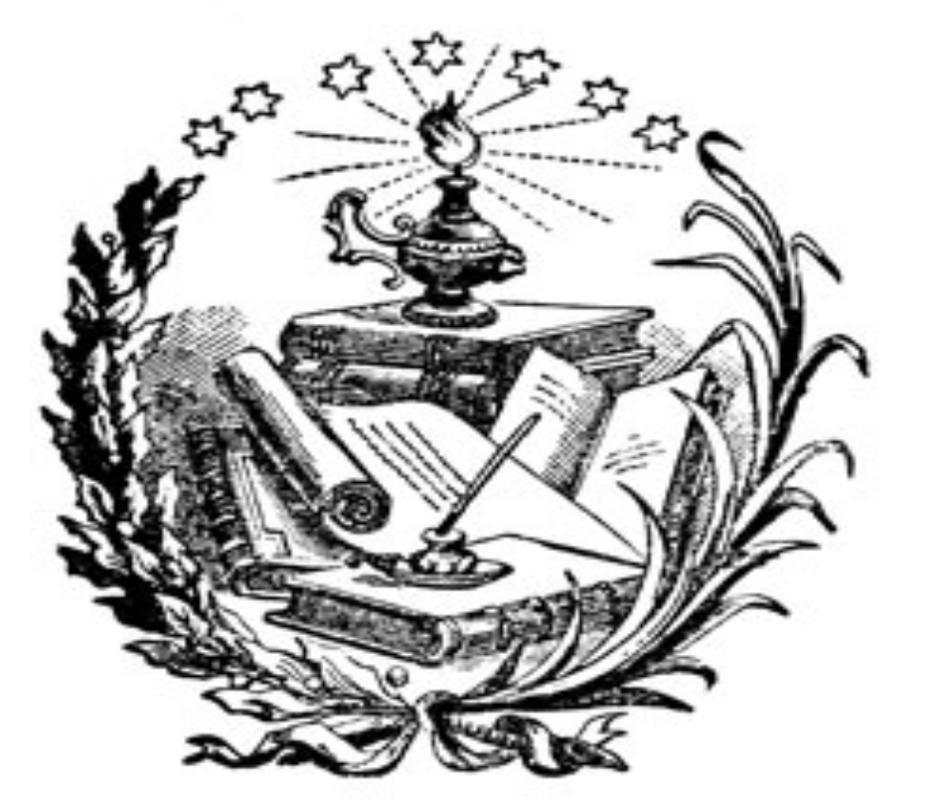

Magic Skills
Skill | Cost | Level | Prerequisite | Notes
Magic Power | 1 | n/a | none | Required for casting spells; maximum of 20
Aegis Magic
Rituals of Protection | 1 | n/a | 1 Magic Power Point | Participate in Aegis rituals
Magic Armor | 1 | 1 | 1 Magic Power Point | 2 point Magic Armor to target touched
Toughness | 1 | 1 | 1 Magic Power Point | Target touched gains +2 Body points
Spirit Shield | 2 | 2 | Level 1 Aegis Spell | Protects target touched against next poison attack
Anti-Magic Shield | 2 | 2 | Level 1 Aegis Spell | Next magical attack at target touched is nullified
Sanctuary | 3 | 3 | Level 2 Aegis Spell | 10’ impenetrable bubble around caster
Improved Magic Armor | 3 | 3 | Level 2 Aegis Spell | 4 point Magic Armor to target touched
Anti-Magic Aura | 4 | 4 | Level 3 Aegis Spell | Magical attacks at target touched are nullified
Poison Immunity | 4 | 4 | Level 3 Aegis Spell | Target touched is immune to poison
Mind Blank | 5 | 5 | Level 4 Aegis Spell | Target touched is immune to Compulsion magic
Aura of Reflection | 5 | 5 | Level 4 Aegis Spell | Next magical attack at target touched rebounds at enemy
Battle Magic
Battle Rituals | 1 | n/a | 1 Magic Power Point | Participate in Battle rituals
Magic Strike | 1 | 1 | 1 Magic Power Point | Caster’s next melee attack deals 4 points of magic damage
Strength | 1 | 1 | 1 Magic Power Point | Target touched gains +1 melee damage
Magic Swarm | 2 | 2 | Level 1 Battle Spell | Two magic darts dealing 4 points of damage each
Mana Burn | 2 | 2 | Level 1 Battle Spell | Two magic darts that drains 4 Magic Power points
Piercing Dart | 3 | 3 | Level 2 Battle Spell | One magic dart dealing 4 points damage, ignores Monstrous
Spellstore | 3 | 3 | Level 2 Battle Spell | Weapon stores a spell cast into it for later use
Maelstrom | 4 | 4 | Level 3 Battle Spell | Four magic darts dealing 4 points of damage each
Severance | 4 | 4 | Level 3 Battle Spell | Four magic darts that drain 4 Magic Power points each
Battle Immunity | 5 | 5 | Level 4 Battle Spell | Target touched is immune to magic damage
Battle Mastery | 5 | 5 | Level 4 Battle Spell | Use any weapon or shield, deal +1 magic damage, self only
Nature Magic
Rituals of Nature | 1 | n/a | 1 Magic Power Point | Participate in Nature rituals
Mend Armor | 1 | 1 | 1 Magic Power Point | Completely repairs armor damage on touch
Grounding | 1 | 1 | 1 Magic Power Point | Throw magic dart that prevents magical movement and escape
Dissipate | 2 | 2 | Level 1 Nature Spell | Caster dissolves into elements and disappears
Repel Insects | 2 | 2 | Level 1 Nature Spell | Throw four magic darts that repel insects
Elemental Dart | 3 | 3 | Level 2 Nature Spell | Throw one magic dart dealing 4 points of elemental damage
Elemental Binding | 3 | 3 | Level 2 Nature Spell | Throw magic dart that traps and protects one elemental
Elemental Weapon | 4 | 4 | Level 3 Nature Spell | Weapon touched deals elemental damage
Elemental Command | 4 | 4 | Level 3 Nature Spell | Throw two magic darts giving command of lesser elementals
Ley Lines | 5 | 5 | Level 4 Nature Spell | Magically move to your designated home
Elemental Immunity | 5 | 5 | Level 4 Nature Spell | Target touched is immune to elemental damage

Enchantment
Enchantment Rituals |  |  | 1 |  | n/a |  | 1 Magic Power Point | Participate in Enchantment rituals
Magic Lock |  |  | 1 |  | 1 |  | 1 Magic Power Point | Magically lock a door, window or box on touch
Enhance Armor |  |  | 1 |  | 1 |  | 1 Magic Power Point | Target touched gains +2 armor points to existing armor
Enchant Shield |  |  | 2 |  | 2 |  | Level 1 Enchantment | Shield touched absorbs next magic or alchemy attack
Silvershine |  |  | 2 |  | 2 |  | Level 1 Enchantment | Melee weapon touched deals silver damage for ten minutes
Magic Skills
Skill | Cost |  |  | Level |  | Prerequisite |  |  | Notes
Enchantments continued
Enchant Weapon | 3 |  |  | 3 |  | Level 2 Enchantment |  |  |  | Weapon touched deals elven steel damage
Eldritch Stone | 3 |  |  | 3 |  | Level 2 Enchantment |  |  |  | Throw one dart dealing 4 elven steel damage
Dispel Magic | 4 |  |  | 4 |  | Level 3 Enchantment |  |  | Nullifies a variety of magical effects on touch
Ablative Armor | 4 |  |  | 4 |  | Level 3 Enchantment |  |  | Armor touched absorbs next two magic or alchemy attacks
Greater Enchant Weapon | 5 |  |  | 5 |  | Level 4 Enchantment |  |  | Weapon touched does +1 damage and is elven steel
Shadow Skin | 5 |  |  | 5 |  | Level 4 Enchantment |  |  | Provides target touched with damage requirement: silver
Restoration
Rituals of Restoration |  | 1 |  | n/a |  | 1 Magic Power Point |  |  | Participate in Restoration rituals
Heal Body |  | 1 |  | 1 |  | 1 Magic Power Point |  |  | Heals all Body damage on touch
Diagnosis |  | 1 |  | 1 |  | 1 Magic Power Point |  |  | Reveals all non-magical ailments in person touched
Restore Limb |  | 2 |  | 2 |  | Level 1 Restoration Spell |  |  | Heals all limb wounds on touch
Purify Spirit |  | 2 |  | 2 |  | Level 1 Restoration Spell |  |  | Cures poisons, diseases, and physical afflictions
Heal Mortal Wound |  | 3 |  | 3 |  | Level 2 Restoration Spell |  |  | Heals one torso wound on touch
Group Heal |  | 3 |  | 3 |  | Level 2 Restoration Spell |  |  | All friendly beings within 10 feet gain Heal Body
Panacea |  | 4 |  | 4 |  | Level 3 Restoration Spell |  |  | Heals torso, limbs, body, poisons and disease on touch
Energy Darts |  | 4 |  | 4 |  | Level 3 Restoration Spell |  |  | Two magic darts that damage Undead or heal
Second Breath |  | 5 |  | 5 |  | Level 4 Restoration Spell |  |  | Caster receives Panacea before dying
Revive |  | 5 |  | 5 |  | Level 4 Restoration Spell |  |  | Brings a willing character back from death’s door

Necromancy
Necromantic Rituals | 1 |  | n/a | 1 Magic Power Point | Participate in Necromantic rituals
Final Rest | 1 |  | 1 | 1 Magic Power Point | Target touched cannot be revived
Ghastly Visage | 1 |  | 1 | 1 Magic Power Point | Target touched appears as undead to other undead
Repel Undead | 2 |  | 2 | Level 1 Necromancy Spell | Throw four magic darts that repel lesser undead
Creeping Rot | 2 |  | 2 | Level 1 Necromancy Spell | Magic dart grants immunity to Restorative Magic
Sanctify | 3 |  | 3 | Level 2 Necromancy Spell | Prevents undead from entering a building or structure
Curse | 3 |  | 3 | Level 2 Necromancy Spell | Magic dart causes target to have 1 Body
Lesser Command | 4 |  | 4 | Level 3 Necromancy Spell | Throw four magic darts giving command of lesser undead
Unhallow | 4 |  | 4 | Level 3 Necromancy Spell | Prevents living from entering a building or structure
Abomination | 5 |  | 5 | Level 4 Necromancy Spell | Target touched gains Monstrous type
Greater Command | 5 |  | 5 | Level 4 Necromancy Spell | Magic dart gives command of a greater undead
Compulsion
Rituals of Compulsion |  | 1 | n/a | 1 Magic Power Point | Participate in Compulsion rituals
Weaken |  | 1 | 1 | 1 Magic Power Point | Magic dart makes target hit for half damage
Disengage |  | 1 | 1 | 1 Magic Power Point | Magic dart makes target unwilling to attack caster
Charm |  | 2 | 2 | Level 1 Compulsion | Magic dart makes target your trusting friend
Silence |  | 2 | 2 | Level 1 Compulsion | Magic dart prevents speech
Pin |  | 3 | 3 | Level 2 Compulsion | Magic dart prevents target from moving his feet
Polyglot |  | 3 | 3 | Level 2 Compulsion | Target touched speaks and reads all languages
Fear |  | 4 | 4 | Level 3 Compulsion | Magic dart makes target flee from you
Memory Loss |  | 4 | 4 | Level 3 Compulsion | Magic dart removes last 10 minutes of memory
Dominate |  | 5 | 5 | Level 4 Compulsion | Magic dart gives command of a living creature
Stun |  | 5 | 5 | Level 4 Compulsion | Two magic darts make targets unable to act, move or speak

Skill Descriptions
Alchemy 1-5
Alchemy dabbles on the edges of magic, mixing science and mysticism to produce a variety of items, from the very useful to items of extremely narrow focus. An Alchemist is a jack of all trades, but a master of none. He is able to heal, open locks, slay enemies and a multitude of other skills - but never as efficiently as a specialized spellcaster can. An Alchemist is one of the best support players a party can buy.
The drawback of Alchemy is that it is extremely expensive, and often of very limited use.
Alchemy is broken into five levels of proficiency allowing the character to create increasingly powerful compounds.
To create a compound the player must possess knowledge of the formula and the ingredients called for in the compound’s instructions, and must expend Production Points. The Production Skills section of these rules contains many simple recipes assumed to be common knowledge, but most formulas are found during the course of normal game play. Ingredients are also found during the course of normal play and are harvested from the playing area or purchased from other characters. All Alchemy ingredients are Kingdoms of Novitas approved props and do not require the player have a working knowledge of actual flora or fauna. Any character is permitted to harvest and possess Alchemy ingredients even if they do not have the ability to create Alchemy compounds. Production of Alchemical compounds always takes place between games.
The full rules for the creation of Alchemy are included in the Production Skills section of these rules.

Brew Potion
Brew Potion allows a player to make magical potions and oils of limited potency between games. Potions are accessible magic for everyone, with no skill required to use them. They are cheap and universally useful, and the tradeoff is that they are of limited power. Potions are the most common of all magic items.
Full rules for Brewing Potions can be found in the Production Skills section of these rules.

Body 1-4
Body represents advanced physical conditioning that allows a character to take more hits in combat before succumbing to serious wounds. Body 1 grants the character a single Body point and characters without this skill have no Body points. Additional levels of the Body skill grant more Body points to a maximum of four.
A character’s Body may never exceed four points unless specific exceptions are made, such as the level three Druid skill Barkskin.

Buckler Fighting
Buckler Fighting allows a character to use small shields and bucklers in combat in conjunction with a hand weapon. The rules for Kingdoms of Novitas legal shields are included in the section of these rules dealing with Weapons and Armor. The weapon used in the player’s off hand must measure 42” inches in total length or less. Bucklers are defensive weapons only and should never come into contact with other players. Players without this skill are allowed to use a single buckler as long as no weapons (including spells, Alchemy and poisons) are used in the off hand.

Druid
Characters with the Druid skill are assumed to be sensitive to the wild nature of plants and animals and are able to communicate with them. They are often sought after by farmers to bless their crops and by others seeking safe travel through the wilderness. If blight or other natural calamity were to befall an area, Druids are called upon to help determine the nature of the problems and their advice on what to do to correct the issue is highly valued.
There are several ranks in the order of the Druids, and each one grants additional powers to them. The full rules for the purchase and use of the Druid skills are included in the Roleplaying Skills section of these rules.

Estimate Value
Characters with this skill are proficient in the appraisal of valuable objects such as gems and jewelry. Every valuable object in game is indelibly marked with a number that acts as a code for the object’s value. A master list in Logistics lists the codes and the corresponding values of every object in game. A character with this skill is allowed to take the object to Logistics during normal hours to have its value appraised. Logistics personnel will check the object’s code, and explain the value of the object to the player. Players are responsible to keep a list, log, or similar register of their item’s values, but are not required to tell other players the values of their items. It is the responsibility of the buyer/thief to have the object appraised again upon a change of ownership. It is possible to sell an object in game even if the value of the object has not been appraised.

First Aid
First aid represents a basic knowledge of mundane healing and allows characters to assist dying characters when magical healing is not available. A character with First Aid can attend to a character bleeding out from a torso wound delaying their death until help arrives. To perform First Aid on a dying character the player using First Aid must kneel next to the wounded person and place their empty hand on the person’s chest. Additional role-playing, such as the placing of bandages, which adds to the atmosphere of the First Aid is encouraged but not required. First Aid will sustain the dying character for an additional ten minutes giving the dying character a total of twenty minutes before they die. Neither the character using the First Aid or the victim is permitted to move or perform any other action than First Aid and speaking during this time. If the healing is character is forced to move or take an action, the wounded character they are treated automatically dies. A character may only use First Aid on one character at a time and may not use First Aid on themselves.
A character with First Aid is also allowed to administer potions or other substances to an unconscious character where other characters cannot.
In addition, First Aid allows a character to ask simple medical based questions of a Game Master if the opportunity arises. For example, a skilled character might ask, “Were the wounds on this corpse caused by weapons or the natural attacks of a creature”?
Furthermore, a character with First Aid can wake up a person unconscious from blunt damage. To do this, the player using First Aid must kneel next to the unconscious person and place their empty hand on the person’s chest. Additional role-playing, such as gentle shaking or administering vile-smelling substances, which adds to the atmosphere, is encouraged.

Great Weapon Training
This skill allows characters to use spears, claymores, pole arms, and other long weapons both hafted and bladed. These weapons must be longer than 42”, and are always used in both hands, precluding the use of a shield or off-hand weapon. Players without this skill are limited to weapons of 42” or less if they have Melee Training, and 30” or less without that.

Herbalist
Herbalist allows characters to safely handle, identify and use any Alchemical compounds, especially poisons. Players without this skill who attempt to use or handle poisons immediately suffer the effects of the poison they are trying to use. Unskilled players may only use Alchemical compounds marked “No” in the “Skill?” column of the table in the Production Skills section of these rules.
Herbalist also allows a character to determine what type of poison, if any, was used on someone, and is the prerequisite for all Alchemy skills.

Identify Magic
Characters with Identify Magic are proficient in deciphering the workings and purposes of magical objects. This skill does not allow a character to read scrolls nor is it needed for a character to drink a potion. Each magic object in game is marked with an indelible number that acts as a code for the object’s function. A master list in Logistics lists the codes and the corresponding abilities of every magic object in game. A character with this skill is allowed to take the object to Logistics during normal hours to have it identified. Logistics personnel will check the magic object’s code, explain the abilities of the object to the player, and give them a tag describing the same information. This tag is nontransferable and should not be given to any other player even if the object is stolen or sold. It is the responsibility of the buyer/thief to have the object identified again and they are not allowed to use the object until it is re-identified even if they know its function ahead of time.

Lore
Lore represents an advanced knowledge beyond what a player is able to gather from reading the rules. For example, a player might use the Lore skill to research ancient runes found inside a buried tomb. To use the Lore skill, the players must submit a written request for information to Logistics, or an email to lorerequest@kingdomsofnovitas.org.
Logistics will forward the request to a Game Master who may or may not provide an answer. There is no guarantee that a request will receive an answer in a certain amount of time or at all, but players can generally expect a reply, even if it is “No other information is available”. Lore questions are usually handled between events and players should not expect to receive an answer during the same event they submitted a Lore request. The player will be notified that an answer is ready and they may pick it up at Logistics. Lore does not permit a character to request objects or aid from outside sources, nor does it represent any sort of in-game contacts.
Lore may be taken multiple times; each time entitles the player to ask an additional question.

Magic Power
Magic Power represents an internal source of magical energy, or life force, used to cast spells. Unlike other skills, Magic Power can be purchased multiple times giving the spell caster a “mana pool” or “power pool”. A spell costs a number of Magic Power points to cast equal to the level of the spell. For example, casting a Stun spell (a fifth level Compulsion spell) costs five points of Magic Power to cast. When a spell is cast the Magic Power points used are temporarily expended, limiting the number of spells a magic user can cast in a game day. Characters are not permitted to purchase more than twenty Magic Power points; nor may a character’s power pool ever exceed twenty Magic Power points with the use of magic objects or other sources unless specific exceptions are made (such as the level 5 ability of the Roleplaying skill Ordained).
A character’s Magic Power points reset every six hours (usually 6 AM, noon, 6 PM and midnight), and at those times their pool is completely refilled. Magic Power is universal to all schools of magic and so it is not required to purchase separate Magic Power for each school of magic a character possesses.

Master Merchant
Characters with the Master Merchant skill are assumed to possess extensive experience as a trader or businessman. The Master Merchant skill allows characters to turn in three times as much money (up to 30 copper) for experience than normal characters, representing their ability to make the most of money they earn.

Medium
Characters with the Medium skill are assumed to be sensitive to spirits and are able to communicate with them. To the untrained, spirits simply remain silent or emit some form of unintelligible moan or scream. At times, more than simple conversation from a Medium is required to provoke a spirit to speak. Often the Medium must bring offerings or even remain with the spirit for extended periods of time. It is possible for spirits to speak languages other than common and the Medium skill does not allow the character to speak languages they do not know.
There are several ranks available to Mediums; each one grants additional powers to them. The full rules for the purchase and use of the Medium skills are included in the Roleplaying Skills section of these rules.

Melee Expert
Melee Expert increases the damage a character inflicts with a weapon in melee combat. Characters with this skill strike for a total of three points of normal damage in melee.

Melee Master
Melee Master increases the damage a character inflicts with a weapon in melee combat. Characters with this skill strike for a total of four points of normal damage in melee.

Melee Proficiency
Melee Proficiency increases the damage a character inflicts with a weapon in melee combat. Characters with this skill strike for a total of two points of normal damage in melee.

Melee Training
This skill allows characters to fight with a single melee weapon of up to 42”. These weapons are commonly referred to as “martial weapons”, and may be wielded in one hand. Characters without this skill are limited to using a single melee weapon with an overall length of 30” or less, commonly called a “non-martial weapon”. Melee Training is the basic warrior skill, and is a prerequisite for many other combat skills.

Merchant
Characters with the Merchant skill are assumed to possess experience as a merchant, fence, or similar trade-based profession. Characters with the Merchant skill are allowed to turn in twice as much money (up to 20 copper) for experience as normal characters, representing their ability to make the most of money they earn.

Missile Expert
Missile weapons shot by a character with Missile Expert inflict additional damage. Characters with this skill hit for a total of three points of normal damage with missile weapons.

Missile Master
Missile weapons shot by a character with Missile Master inflict additional points of damage. Characters with this skill hit for a total of four points of normal damage with missile weapons.

Missile Proficiency
Missile weapons shot by a character with Missile Proficiency inflict additional points of damage. Characters with this skill hit for a total of two points of normal damage with missile weapons.

Missile Training
This skill allows characters to use bows and crossbows in combat. Bows and crossbows are limited to a 35 pound draw weight as well as other restrictions which are explained in the Weapons and Armor section of these rules. Characters without this skill are not permitted to use missile weapons of any sort. This skill is not required to throw tag bags for Alchemy or magic.

Nobility
Characters with Nobility are members of some Kingdom’s social or governmental hierarchy. Initially, this grants them the right to be addressed with a title such as First Citizen, Chief, or milord, and also opens up other areas of role-playing that Game Masters may take advantage of. Often, NPCs will accord a Noble character more trust or respect depending on their racial or national background. Players choosing Nobility whose characters are from the Theocracy of Vlean must also be Ordained.
There are several ranks of Nobility, and each one grants additional abilities. The full rules for the purchase and use of the Noble skills are included in the Roleplaying Skills section of these rules.

Ordained
This skill allows a character to claim status as an ordained member of an established Kingdoms of Novitas religion. An Ordained character gains some direct advantages, but also opens an area of role-playing not allowed to every character. Many creatures, like spirits, can only be laid to rest after an Ordained character conducts certain rituals. Often players will encounter magic objects that only an Ordained character is allowed to use or areas only an Ordained character is allowed to enter. Often, NPCs will accord an Ordained character more trust or respect depending on their background, and only Ordained characters are entitled to be called “Septon” or whatever title is appropriate for their deity.
An Ordained character is required to pick an established Kingdoms of Novitas religion (listed in the Religion section of these rules) as their patron god or goddess and this choice may not change! It is acceptable for the character to cease worship of the deity; however this effectively renders their Ordained skill useless. The character is required to wear the vestments of their faith when performing their office.
There are several ranks in the hierarchy of the Ordained orders, and each one grants additional powers to them. The full rules for the purchase and use of the Ordained skills are included in the Roleplaying Skills section of these rules.

Ornamenter
This skill allows a character to create magical trinkets, clothing, jewelry, and the like. While this skill is a Production Skill, it also has strong elements of a role-playing skill. Characters will be required, by Ornamenter 3, to begin paying a guild fee. This will be role-played out to start, and then will be handled at logistics in most cases. This fee represents payment for supplies to create these fantastic items, and support from the guild. As an Ornamenter increases in level, she is able to create items that have greater powers, or take up less space and weight.
The full rules for the creation of Ornamenter items are included in the Production Skills section of these rules.

Production Points
Production Points represent the efficiency with which craftsmen can produce their products. Unlike most other skills, Production Points can be purchased multiple times, giving the character a “production pool”. Production Points, used in conjunction with Production Skills, allow a character to bring locks, traps, scrolls, potions or amalgams in game. The use of Production Points always takes place between games, and only resets at the end of each event. Characters are not permitted to purchase more than twenty Production Points, nor may a character’s production pool ever exceed twenty Production Points with the use of magic objects or other sources. Production Points are universal for all Production Skills, and cannot be purchased separately for each skill.

Racial Language
This skill allows a character to speak, understand, read and write a Racial Language. It may be taken multiple times. Each skill purchase counts for a different Racial Language, and should be marked as such on your character sheet. All characters are assumed to be literate and fluent the common language (English) but may portray an illiterate if it fits their background.
Racial Languages
Racial Language Skill | Description
Elvish | Spoken by all Elves
Terran | Spoken by Earthkin
Snow Goblin | Spoken by Snow Goblins
Draconic | Spoken by Drakes and some Lizardfolk
Sylvan | Spoken by Faekin and Light Fae
Diabolic | Spoken by Dark Fae
Canine | Spoken by Kazvaks and other intelligent predators
Apian | Spoken by intelligent insects
Black Speech | Semi-secret ritual language of the dark gods and their followers
Immortal | Spoken by High Fae
Andaranien | Scholarly dead language
Thieves’ Cant | Semi-secret language of criminals
Often, languages are represented by an envelope with “Racial Language: language name” written on the outside, and a tag inside containing the translation of the text. Players with the appropriate Racial Language skill are allowed to open the envelope and read the translation. In addition, players will often preface their words with “In Elvish, I say…” or something similar. Players hearing this sort of introduction who do not speak the stated language are honor-bound to ignore anything they hear said in this manner.
The Racial Languages in the table here are available to players. Languages listed in italics are only available with the permission of a Game Master.

Read Magic
Read Magic allows the character to decipher magical text such as those found in tomes of magic or scrolls. Most often, magical text is indicated by an envelope with “Read Magic” written on the outside and a tag inside containing the translation of the text. Players with the Read Magic skill are allowed to open the envelope and read the translation. Only characters with this skill are permitted to read and use spells contained on scrolls.

Rituals
Rituals are powerful spells too strong for a magic user to learn and cast through normal means. It is impossible for a mage to learn a Ritual and cast it in the same manner as a normal spell. The Ritual skill of the appropriate school is required for a character to use or participate in a Ritual. Casting a Ritual often involves long ceremony, rare Ritual components, and the combined power of several magic users. Rituals are described in more detail in the Magic and Spells section of these rules.

Schools of Magic and Spells
Schools of Magic and Spells are more fully described in the Magic and Spells section of these rules. Characters desiring these skills should read that section before making choices about their character’s skill selections. There is no limit to the number of schools or spells a magic using character is allowed to gain. It is possible for a magic user to possess forms of magic that might seem to conflict; for example, a character can possess both Restorative Magic and Necromancy at the same time with no penalty.

Scribe Scroll
The Scribe Scroll skills allow a player to make magical scrolls that act as storage for spells between games. Scrolls are a way for mages to bank their power against difficult encounters. They are also a way for first level characters to get fifth level spells. A fifth level scroll is one of the most powerful items in the game. They are often seen as the pinnacle of power for magical scholars, as much of a badge of achievement as a magic item.
Full rules for scribing scrolls can be found in the Production Skills section of these rules.

Shield Fighting
Shield Fighting allows a character to use shields and bucklers in combat in conjunction with a hand weapon. The rules for Kingdoms of Novitas legal shields are included in the section of these rules dealing with Weapons and Armor. The weapon used in the player’s off hand must measure 42” inches in total length or less. Shields are defensive weapons only and should never come into contact with other players. Players without this skill are allowed to use a single shield as long as no weapons (including spells, Alchemy and poisons) are used in the off hand.

Thrown Weapon Training
This skill allows a character to use coreless throwing weapons such as daggers or axes. Players without this skill are not permitted to use throwing weapons of any sort. Missile weapon skills do not affect damage done by thrown weapons.

Thrown Weapon Master
Thrown Weapon Master increases the amount of damage done by thrown weapons. Daggers and axes thrown by a Thrown Weapon Master deal two points of damage each. Missile weapon skills do not affect damage done by thrown weapons.

Tradesman
Tradesmen have a small regular income, the amount of which is determined by Logistics and disbursed at the beginning of each game session. As this skill is intended as a small reward for characters that set up shops or perform services rather than adventure, it is required that a character with the Tradesman skill actually have a trade that they perform in game. It can not be assumed they have ample time to perform their trade between events. Exceptional shops or role-playing in conjunction with this skill can sometimes lead to larger allowances or bonus Experience Point awards.

Trapsmith
A character with this skill has the ability to work with locks and traps. At first level, a character gains the ability to pick locks and to disarm traps. Higher levels allow a character to create locks, and traps with increasingly dangerous abilities. While this skill is a Production Skill, it also has strong elements of a role-playing skill. Characters will be required, by Trapsmith 3, to begin paying a guild fee. This will be role-played out to start, and then will be handled at logistics in most cases. This fee represents payment for supplies to create these fantastic items, and support from the guild. As a Trapsmith increases in level, she is able to create items that have greater powers.
The full rules for the creation of Trapsmith items are included in the Production Skills section of these rules.

Two Weapon Expert
Two Weapon Expert allows a character to use a weapon in each hand during combat. A player may use one martial melee weapon up to 42” in length with this skill. The other weapon must be non-martial. It is against the rules for player to carry two weapons at one time in hand without this skill and claim that they intend to use only one weapon at a time. Characters with damage increasing skills, such as Melee Expert, add their damage bonus to both weapons when attacking, however the maximum damage each blade is allowed to inflict is two instead of four.

Two Weapon Master
Two Weapon Master allows a character to use a weapon in each hand during combat. Both weapons may be martial melee weapons up to 42” in length with this skill. It is against the rules for player to carry two weapons at one time in hand without this skill and claim that they intend to use only one weapon at a time. Characters with damage increasing skills, such as Melee Expert, add their damage bonus to both weapons when attacking, however the maximum damage each blade is allowed to inflict is two instead of four

Two Weapon Training
Two Weapon Training allows a character to use a weapon in each hand during combat. A player may only use non-martial melee weapons 30” in total length or less with this skill. It is against the rules for player to carry two weapons at one time in hand without this skill and claim that they intend to use only one weapon at a time. Characters with damage increasing skills, such as Melee Expert, add their damage bonus to both weapons when attacking, however the maximum damage each blade is allowed to inflict is two instead of four.

Weaponsmith
This skill allows a character to create magical weapons. While this skill is a Production Skill, it also has strong elements of a role-playing skill. Characters will be required, by Weaponsmith 3, to begin paying a guild fee. This will be role-played out to start, and then will be handled at logistics in most cases. This fee represents payment for supplies to create these fantastic items, and support from the guild. As a Weaponsmith increases in level, she is able to create larger items, or items with greater powers.
The full rules for the creation of Weaponsmith items are included in the Production Skills section of these rules.
Skill Masters
Characters can become a Skill Master by buying every skill in any section (excluding Roleplaying skills). These sections are:

- Combat Skills
- General & Knowledge Skills (this category also includes Brew Potion and Scribe Scroll)
- Alchemy (including Herbalism and 20 Production Points)
- Ornamenter (including 20 Production points)
- Trapsmith (including 20 Production points)
- Weaponsmith (including 20 Production points)
- Any school of Magic (including the appropriate Ritual skill and 20 Magic Power)

Skill Masters are bestowed a minor title or honorific, and some further in-game benefits not detailed in this edition of the rules.
5. Equipment
Equipment is an unavoidable burden that all live action characters must face. For some players their equipment will consist only of a weapon and armor, a belt pouch, and perhaps a tankard for water. Other players, such as thieves, will carry many pounds of gear in order to ply their trade. Every piece of equipment in game is represented by a prop that the player is required to carry in order to claim use of the item. Padded weapons, for example, are carried to represent real weapons. Players do not spend in-game money to purchase equipment; they must simply provide an approved in-game prop. Described below are the most common forms of equipment used during the course of an average game.

Armor and shields
Many players employ the use of shields and armor to protect them during the rigors of combat. Shield use and construction is described in more detail in the section of the rules covering Weapons and Armor” and players with the skill Shield Fighting should read this section thoroughly. A player is allowed as many shields as they can provide props for; however, since shields are nearly indestructible spending resources on more than a couple shields might prove wasteful. Players may wear any armor they can provide and their character’s skills allow them to wear. Only real armor is permitted for use in game. Players are not permitted to wear facsimiles of real armor such as cloth woven to look like chain armor or plastic painted to look like plate. Similarly, for both aesthetic quality and safety, armor must be constructed in a realistic fashion - a player is not permitted to simply tape rough cut plates of steel to their body to get plate armor. It is required that a Game Master or Logistics official inspects all armor and shields before players bring them into game.

Weapons
In game, padded facsimiles called boffers represent weapons and only these weapons are allowed in combat. Instruction on the construction of a simple padded weapon is included in the section of these rules dealing with weapons. Players are allowed to bring as many weapons to the game as they feel necessary. Since weapons are somewhat fragile, and may break down or become damaged relatively quickly, it is always in the player’s best interest to have several back-up weapons. A character is only allowed to own weapons that their character is normally allowed to use. For example, a character without the skill Missile Training is not allowed to own a crossbow. It is required that a Game Master or Logistics official inspects all weapons before players bring them into game.

Ordinary equipment
Ordinary equipment describes any gear that does not grant the character any form of in game bonus, such as armor points. Examples of ordinary equipment include rope, costumes, pouches, food, water, tents, boots, and blankets. Ordinary equipment can also include items a player might wish to sell at the event for out of game cash such as costumes or armor. A player is allowed as much ordinary equipment as they think they need. Thieves’ tools are considered ordinary equipment and so a player is allowed as much gear as they deem fit. If a player is uncertain if a piece of equipment is “ordinary” they should ask the advice of a Game Master.

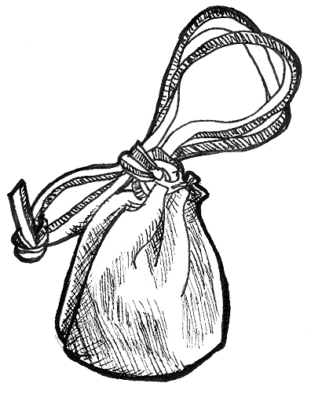

Out of game equipment
Out of game equipment describes items such as food coolers, bug spray, cooking stoves, and sunscreen. While items of this nature are required for comfort and safety, players are required to keep all out of game items out of sight to prevent ruining the atmosphere of the game for others.

Lights
Light sources are a very common piece of equipment but are subject to very strict rules in order to maintain both atmosphere and a safe playing environment. All lights are treated as ordinary equipment and a player is allowed as many lights as they choose.
While adventuring, only electric lanterns, chemical glow sticks, or non-glass candle lanterns are permitted. Adventuring is defined as any situation that places the player away from their campsite or dwelling. Players are not permitted to use flashlights at any time during normal play. Flashlights are permitted for use in emergencies and players are permitted to carry flashlights for this purpose only. Electric light sources in the shape of small lanterns are easy to purchase and do not disrupt the atmosphere too much. Coleman lanterns, or other propane or fuel lanterns, are too bright and can create a safety hazard during play, and so are not allowed. A Game Master is allowed to remove lights from play he or she deems too bright. If this is the case, players must dim the light with tape, cloth, or lens filters. Candle lanterns are permitted as long as they contain no glass and completely enclose their flames. Chemical glow sticks are a very safe and effective light source. In game glow sticks are referred to as “glow worms”, and are explained as phosphorescent worms that are indigenous to all areas of Novitas.
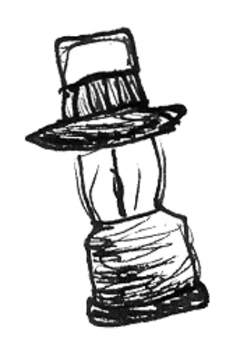

In camp players are allowed a bit more leniency with lights though the above examples are still very acceptable camp lighting options. While in camp players often use torches, ornate lanterns, and fire pits to light the area. Players should avoid using modern gas or fuel lanterns, as they are too bright and present a significant safety hazard. Players are not permitted to use open flame lights inside tents, and may use them in permanent structures only when they are present to monitor the light. Before leaving a dwelling, all open light sources should be extinguished. Players should NEVER turn on the overhead lights in the buildings at night unless there is an emergency.

6. Game Master approval
& starting coin
At Kingdoms of Novitas, a player’s character sheet is treated as an official document. After completely filling out their character sheet, players must submit the sheet to Logistics for approval. Logistics will approve the sheet only if it is filled out clearly, free of errors or corrections, and neat. Players should use only black or blue ink pens to fill out their final character sheet. The Logistics official will check the sheet for mistakes, line out any empty sections, and sign and date the sheet.
If at any time the player needs to update their character sheet (an increase in level, for example) they will need to repeat this process and fill out a new character sheet. This system maintains a mild level of control over cheating and character progression. If a player is accused of cheating, the character sheets of everyone involved are the first tool a Game Master will use to resolve the dispute. Presenting an improper character sheet during such a situation will not increase the chances of a ruling in the violator’s favor.
Players are required to carry their character sheet, intact and legible, at all times and failing to do so can result in the player’s removal from the game. It is suggested that character sheets be carried in a small Ziploc bag to protect it from moisture and damage.
Finally, when making a new character for Kingdoms of Novitas, you will begin play with 1 copper piece per character level and 1 copper piece for each Production point that the character has. This allows budding crafters to enter the game capable of plying their trade, and allows other characters to at least be able to afford a meal at the Inn and begin making some connections. Players are, of course, free to decline this starting handout if it furthers their character’s goals or background. This coin is disbursed at Logistics.

7. Archive characters
An archive character is a spare copy of a player’s character sheet stored at Logistics in the event the player’s copy is lost or destroyed. The Archive character records only the character’s skills, experience level, unspent and experience points, and personal information. Any information not recorded on the sheet is lost forever so players are encouraged to be thorough when filling out their archive character sheet. The archive does not record the character’s wealth or in game possessions such as magic objects.
It is up to players to submit archive characters to Logistics and they may do so whenever they feel it is necessary. The Logistics official will sign and date the archive in the same fashion as a normal character sheet, and file it.

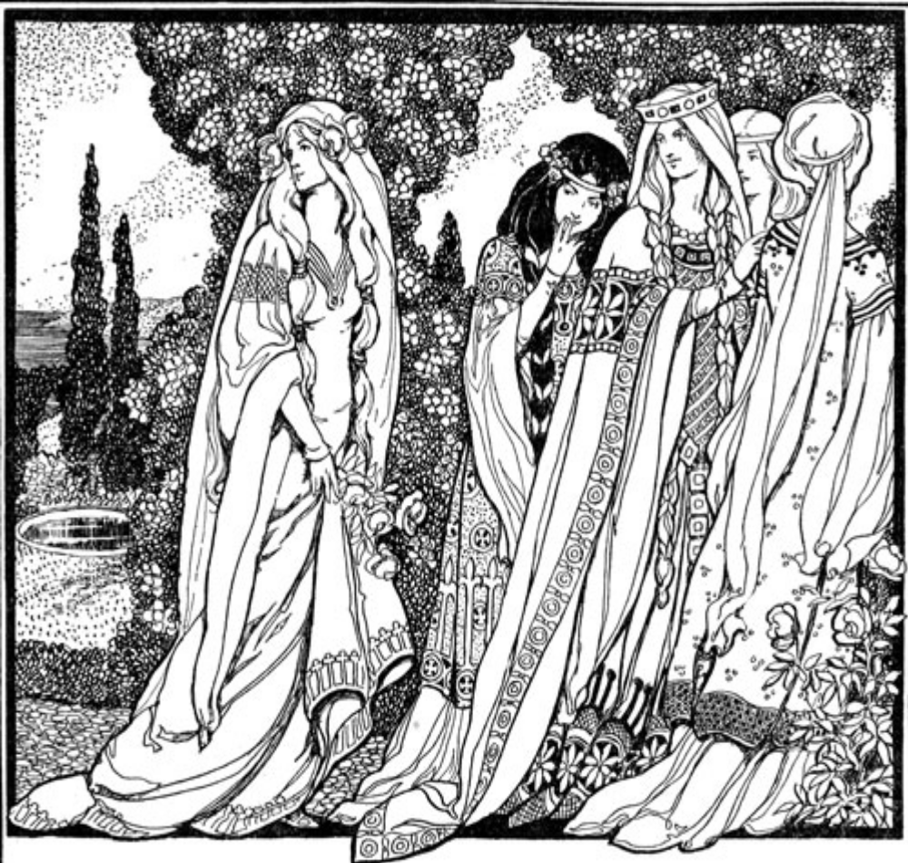

6. Magic & Spells

Magic and spell use
Magic is a common tool in Novitas but its origins and sources of power still remain a deep-rooted mystery. Though the effects of magic are universal, every caster attributes their powers to different sources ranging from science to religion. Magic is a very powerful weapon, but also a versatile tool, and though hard to learn is perhaps the most powerful force in the world. Spell casters go by many names: mage, magic user, wizard, cleric, and sorcerer, just to name a few.
Learning magic takes a long time and often leaves the magic user weak in other skills, such as combat, requiring that the mage make best use of the physical abilities they have. Unlike typical fantasy settings spell casting does not hinder the use of armor, weapons, or non-magical skills like trap disarming. Assuming the character possesses the proper skills they may use any weapons and armor they choose. Though expensive in regards to skill points it is very possible to have a powerful mage wearing plate armor, and wielding a pole-arm.
Unlike a fighter who can swing their sword all day long, a magic user has a limited amount of Magic Power at their disposal. A spell caster must choose when to cast their spells carefully or risk running out of magic at a crucial moment. However, unlike a sword, a single spell is capable of instantly dispatching even the most powerful of foes and changing the tide of a desperate battle. All mages are limited to twenty points of Magic Power per six hours and players may not exceed this number regardless of the source. In game it is explained that using more than twenty points of Magic Power in a six-hour period would result in the death of the caster and failure of the final spell, due to the caster’s body and mind being unable to harness that much eldritch energy. Magic Power typically resets at Midnight, 6 AM, Noon, and 6 PM. This point in time is known as “convergence”.
This section contains the most common spells of each school of magic but in no way encompasses the entire list of magic in the world. Many spells are far too powerful for a mage to learn and cast using their personal power. These powerful spells are known as rituals and require special skills, components, and conditions to cast. Characters may purchase the skills required to understand and cast rituals but it is required that the character find the rituals themselves during game play.
Magic is organized into seven schools of magic that include Aegis (protection), Battle (damage), Nature (elements), Enchantments (enhancements), Restoration (healing), Necromancy (death), and Compulsion (mind). Each school contains five levels of spells, each more powerful than the next, and players may learn as many schools and spells as they wish. There are no restrictions on combining schools and it is perfectly acceptable for a character to know what might seem like conflicting schools (i.e. Necromancy and Restoration). The only drawback to learning multiple schools of magic is that it will take the character a long time and many skill points to learn a large number of spells. Each school has advantages and disadvantages as summarized here.

The Schools of Magic
Aegis magic
Aegis magic creates powerful defensive auras that protect caster from magical and physical attack. Aegis magic is an exclusively defensive school and contains no offensive spells.

Battle magic
Battle magic allows the magic user to focus their power into destructive magic in the form of touch and ranged spells. High-level Battle magic spells allow the character to generate multiple effects creating a virtual storm of magical power. Battle magic is used mainly as a weapon and has few defensive spells.

Nature magic
Nature magic focuses the raw power of the elements into magical effects. Nature magic is balanced, offering the player an equal mix of utility, item enhancements, offensive and defensive spells. The offensive capability of Nature magic, though useful, is not equal in power to that of Battle magic. Nature magic also gives the caster power over certain elemental creatures and well as the power to deal elemental damage.

Enchantment
Enchantment magic allows the caster to bestow powerful temporary magic abilities on physical objects. Enchantment also grants the caster the access to the powerful Dispel Magic spell which allows them to tear down the magical defenses of other casters.

Restoration
Restoration magic is the purest form of magical energy, allowing the caster to heal the wounded, rid a person of ailments, and even revive the nearly dead. The Restoration magic school contains no defensive spells, and only one offensive magic spells (which is only usable against undead), often leaving the Restoration school specialist vulnerable to attack.

Necromancy
The school of Necromancy grants the character protection from, and limited influence over, undead creatures, as well as a limited ability to affect the living with curses and afflictions. Low level Necromancy spells are defensive in nature, used to repel undead creatures, disguise the living from the dead, and lay to rest the freshly deceased preventing their return to life as undead. Higher level Necromancy spells allow a caster to gain undead abilities, control the undead, and employ them for his or her own purposes. Specialist Necromancers will often find that they feel somewhat useless during the day. It is not until the sun goes down that the true power of a Necromancer becomes evident.
The use of high level Necromancy is frowned upon because it attracts the attention of wandering undead. The lands surrounding the lairs of habitual users of high level Necromantic magic are often infested with uncontrolled undead. Necromancers are often shunned and forced from settlements in fear that their magical arts will attract undead, and in many places law prohibits the use of high level Necromancy.
The four steps of casting a spell:

- Nominate target
- Verbal component
- Announce spell effects
- Expend power

Compulsion
Compulsion is the school of scholars and tricksters, and contains spells that affect the target’s mind in strange ways. Compulsion is highly aggressive - but none of the spells directly cause damage. Instead, they create effects such as stuns and mind crippling fear. Compulsion is very potent in the fact that armor and body points offer a target no protection from its effects. Because of this, Compulsion is very useful in defeating powerful foes like trolls or experienced adventurers. In addition, Compulsion magic contains the very useful Polyglot spell, which allows a person to read and understand any language.

Casting a spell
The casting of magic involves a calculated game process that prevents the spell caster from becoming a mobile magic machine gun. Unlike the careless abandon of swinging a sword, the mage must complete several steps before they are allowed to apply the effects of their magic. Players wishing to cast a spell must meet certain requirements first and failing to do so will result in disruption (failure) of the spell. Spell disruption does not result in the loss of Magic Power points.
Other than the conditions detailed later in this section, a spell caster is allowed to cast magic under almost any circumstance. It is legal for a magic user to cast magic while crawling, walking, running, or even swimming assuming they have a free hand to do so. A magic user is allowed to cast magic during combat as long as they are not hit with damage (or adverse effects like a stun or charm) during the casting of the spell. If a caster is hit by damage of any sort, including damage to armor and Magic Armor, during step three of the spell casting process (speaking the verbal component) the spell automatically disrupts and does not go off. This rule prevents a spell caster from casting healing or other defensive magic during the act of getting killed and hopefully prevents arguments and rules conflicts. Because of this rule spell casters must be vigilant when casting magic to prevent enemies from exploiting this weakness at a crucial moment. For purposes of this rule, Alchemy products are not considered to be magic. There are four steps to casting a spell and they are described as follows:

Nominate target
In order to cast a spell the caster must be within range of the spell’s target. There are only two ranges of spells in Kingdoms of Novitas magic, touch and dart (tag bag). It is not required to see the target in order to cast a spell and it is completely legal to cast magic in the dark in the hopes the spell will find a mark. Touch range spells are obviously less problematic than dart range spells when casting blind.
Touch range spells require that the caster touch the target in order for the spell to take effect. Excluding the spell Magic Strike, which is delivered with a weapon, all touch range spells are delivered with the caster’s empty hand. It is not possible to cast a touch range spell through a foot or other appendage. The caster must touch some part of the target’s body (clothing and armor do not hinder spell casting) and may not cast a touch range spell by grasping a piece of the target’s equipment. A wounded limb cannot be used to cast magic so a player with two arm wounds is unable to use spells of any sort, even to heal their own wounds. Binding a spell caster’s hands will not hinder their ability to cast touch range spells as long as they are able to touch the target.
Tag bags are small cloth beanbags used to represent concentrated darts of magical force. The range of a tag bag spell depends on how far the player can accurately throw the tag bag. With practice it is possible to reach ranges of twenty feet or better with a tag bag! The spell will only take effect if the tag bag strikes the target or any of the equipment they are wearing or holding, including equipment such as armor, shields, pouches, and weapons. For this reason, a tag bag cannot be avoided by blocking with a weapon or shield, requiring the player to dodge the tag bag in order to avoid the spell. If the tag bag strikes another player, the ground, or other object before reaching the intended target, the spell goes off and affects the accidentally hit target. Because of this it is possible for the spell caster to inflict friendly fire damage to companions if they are less than accurate with their magic. When a Battle magic spell strikes an object held or worn by a character, the damage is transferred to the area of the body where the object is held or located. For example, if a character’s shield is hit by a Battle magic spell the damage is applied to their shield arm (the exception to this rule is Magic Strike, which requires a valid hit to take effect). All other tag bag magic, such as Stun or Repel Undead, has an equal effect regardless of where the target is hit.
Examples of proper incants:

- “With the Sept’s power I grant you Heal Body”! (nine words)
- “By the essence of dust and bone I Repel Undead”! (ten words)
- “My foes are strong, please grant me Magic Armor”! (nine words)
- “Grak give me the power of Enchant Weapon”! (eight words)

Examples of illegal incants:

- “Baba Booey, baba booey, baba booey, Magic Armor”! (gibberish)
- “Hey Andri, have you seen my spell book, Magic Swarm”! (conversational)
- “Your mother was a %@#* and she *%$# Orcs, Charm”! (offensive)
- “Now grant me Magic Lock”! (too short)

Players may throw (drop, toss, etc.) tag bags in any fashion they like as long as they follow the general combat safety rules. Some spells, such as Repel Undead, create multiple darts of magic with one casting. The player must throw each tag bag separately and may not toss multiple darts in a chaotic wad. Casters are not allowed to carry tag bags openly in their hands unless they have cast a spell that requires tag bags in the last minute. It is required that tags bags be carried in a pouch or pocket until the tag bag spell is cast. Doing otherwise might mislead other players into thinking the mage is “armed” and ready to throw a spell, as a player with a tag bag in hand is assumed to be holding a glowing ball of eldritch energy!
These darts are magically created when the incant of a spell is completed, and have a duration of one minute from the completion of the incant. Darts that are not thrown after one minute elapses dissipate harmlessly into the air, and are wasted. Players are always required to actually toss or throw the tag bag at their target; it is never acceptable to simply hold it in your hand and touch your target.

Speak the verbal component of the spell
When casting a spell it is required that the magic user summons the spell by speaking an eight word (minimum) verbal incant. Each spell in the character’s repertoire is required to have an eight-word incant designed by the player. It is acceptable (and also very common) for incants to have more than eight words. Each spell can have a different incant but it is easier to recall the incant if the all the character’s spells share the same one. It is required that the name of the spell being cast be worked into the incant and can count as part of the eight words. An incant cannot be gibberish or in bad taste, nor can it be worked into common conversation.
Players are required to speak incants in a clear and loud voice. If players ten feet away from the caster are unaware a spell is being cast the caster is not speaking loudly enough. It is impossible for a spell caster to sneak a spell by muttering the incant under their breath. It is assumed that casting magic creates noticeable environmental disturbances like static electricity or an area of frigid cold making subtle or sneaky casting of magic difficult. Other players cannot disrupt a spell by simply screaming louder than the caster; a piercing battle cry is not a defense against magic! It is not important that other players understand what the caster is saying (battle can be a loud confusing place) as long as they are aware that a spell is being cast. Players are allowed to sing or chant incants as long as the song meets all the requirements of normal incants.
If, for any reason, the caster fails to finish speaking the spell’s incant the spell disrupts and does not go off. This includes players that are out of breath from running. Small interruptions like a cough or sneeze, or pauses in speaking for dramatic effect do not disrupt the spell. A character is unable to cast magic in a situation where they are holding their breath such as swimming underwater. Gagging a spell caster will also render the player unable to cast magic as it is assumed they cannot speak loud enough to summon magic. As with all disruptions, the character does not lose power points for failing to finish an incant. If the character is hit by any sort of offensive attack during this stage of casting the spell automatically disrupts.

Announce spell effects
Once the player finishes the incant the spell is complete and they must inform the target of the effects. There is no way to disrupt the spell at this point. The mage is required to inform the target of any effects the spell has, such as damage, healing, duration and so on. The target may also ask questions of the caster. All of this information must be communicated in a timely manner and with clarity. A target is expected to wait for a caster to explain their spell - but should not be put at a disadvantage due to an ill prepared mage. Five to ten seconds is a reasonable amount of time for a magic user to communicate the effects of a spell. If a player is new or confused, it is acceptable to call a Game Hold to explain the effects of the spell, but players may not abuse this rule to their advantage. Confusion in the heat of battle is not an excuse for a target to ignore the effects of a spell. While this process might appear to cause bottlenecks in play, the spells are simple enough that most players will find spell casting easy to understand. After playing for a short time most players learn the effects of the spells and require very little description before accepting the effects, and experienced players usually require only the name of the spell to recognize the effects. If the target has the ability to defend himself against the spell, such as with an Anti-Magic Aura, they must call out “NO EFFECT!” so the mage is aware their spell failed. If players fail to call out “no effect”, the mage may assume they are cheating by not accepting the spell effects and might contact a Game Master.

Expend power
At this point the caster should make a mental note of the number of points required to cast the spell and subtract that amount from their Magic Power pool. If the caster forgets the number of power points they have remaining they are honor bound to reduce their available power to one point until the end of the game day. Players who have a hard time remembering their power point expenditure should keep track of it on paper or with another form of record keeping. Using a blank paper book decorated to look like a spell book is a great way to do this and adds atmosphere to the game. Another common device is a cord or thong with large beads on it, one for each point of power the character has. As they expend Magic Power, they simply slide the beads from one end to the other.

General guidelines
Beanbags
All ranged spells, such as Grounding or Magic Swarm, require beanbags (commonly called “tag bags” or “spackets”) to represent the dart of magical energy created when the spell is cast. Players are required to provide their own beanbags to use when casting magic. Kingdoms of Novitas will provide some beanbags to starting players but players are expected to make their own by the second time they play.
Beanbags are constructed of cloth and birdseed so that beanbags lost during play will break down and prevent unneeded liter in the playing area. The size of the completed beanbag should not exceed a tennis ball and should be no smaller than a golf ball. Beanbags must be pliable and soft to prevent injuring other players when they are thrown. The material used to build the beanbag should be soft, smooth, and a have a tight enough weave that the birdseed does not spill out. A cotton t-shirt is a great material for building beanbags. Players are not permitted to use stiff or non-biodegradable materials like leather, rubber, plastic, tape, or foil. The material used to make the beanbag can be of any color, but light and bright colors are preferred, making them easier to find after being thrown during play. The ends of the beanbag should be sewn, tied shut with string, or closed with cloth tape. Never close the beanbag with staples, pins, plastic ties or tape.
Players are expected to keep their beanbags in good condition and old, damaged, or soiled beanbags must be removed from play immediately!

Blue flags
Some spells require the use of blue flags to indicate the presence of a magical field or effect. All blue flags must visibly be at least one inch wide and roughly twelve inches long. The shade of blue is not important as long as it is a solid pattern and easily distinguishable as blue. Using material that rolls or bunches up is discouraged, as it can make your flag hard to see.
With spells that require the player to wear the flag, the flag must be worn around either of the player’s arms so that it is visible to other players when they look for it. If a spell requires a blue flag and that flag is not present, or not clearly visible, other players are not required to accept the effects of the spell. A player need only wear one blue flag at a time even if they have multiple flag required spells active at the same time. Players must remove their flags within one minute of the spell ending and may not wear a blue flag continuously in anticipation of casting magic. In conditions where the flag is not easily visible, such as at night, it is legal for players to ask other players, “Do I see a blue glow on you?” in attempt to detect magical protection. Players are required to give an honest answer when asked this out-of-game question. This question may not be asked of hiding players since the blue glow from a spell would not emit enough light to betray their position.

Dispelling magic
Once a spell is cast it remains in play until the spell’s duration expires or a Dispel Magic spell is cast on the target bearing the spell. Magic users may dispel any spell that they have cast themselves. To dismiss a spell he or she has cast, the caster must touch the target and remove any previously placed flags. If the target is a conscious creature or is in the possession of a conscious creature, the creature or person must willingly permit the original caster to dispel the spell’s effect. In this instance the target must remove the appropriate flag in place. A caster may not dismiss a spell he has cast without the target’s permission. For instance, a caster cannot cast Improved Magic Armor on a target and later dismiss the effect unless the target agrees.

Faking spell casting
Players are not allowed to fake spell casting even if they have magical skills. In game, the casting of magic is assumed to create visible effects like glowing hands or a shroud of light that prevents “faking” a spell. This includes carrying blue beanbags and flags in an attempt to portray spells that are not actually there.
Along the same lines, players are not allowed to speak the incant for one spell and then call out the effects of another spell. Tactics of this nature are strictly against the rules and are considered cheating.

Spell Effect Precedence
Certain spells that may be active at the same time can have overlapping effects; for example a player may have Battle Immunity and Aura of Reflection cast on himself. In the case of overlapping protective effects, any spells that grant immunity take precedence over other spells (e.g. if a Magic Dart spell strikes a target protected by Battle Immunity and Anti-Magic Shield, the Magic Dart would be nullified by Battle Immunity and the Anti-Magic Shield would not be discharged). Examples of immunity spells include Battle Immunity, Creeping Rot, Elemental Immunity, Mind Blank, and Shadow Skin. For non-immunity spells the higher level spell will take precedence over the lower level spell (e.g. Aura of Reflection will take precedence over Anti-Magic Aura).

Stacking
Spells or magic items will sometimes have similar or even identical effects. Some general rules apply to these situations:
- Items or spells with the same name will not take effect at the same time. For example, if you cast Magic Strike on your weapon twice, you cannot then hit once for eight points of damage, nor can you cast Magic Armor on yourself twice to get four points of armor.
- Items or spells with the same name also do not queue together. Casting Magic Strike on a weapon twice will not allow you to strike twice for four points of magic damage without recasting the spell between successful hits.
- Items or spells with the same type of effect, but different names, will stack (but not queue) with each other. For example, a player casting Toughness, a level one Aegis spell that grants two Body points, who then drinks an Elixir of Toughness, an Alchemical compound that also grants one Body point, will gain three body points. Because the items have different names, they will stack. Improved or Greater versions of the same spell will not stack (e.g. Magic Armor and Improved Magic Armor will not stack).
- Stacking items will NEVER allow a player to exceed normal system limits. These limits are:

  - Four damage with a single weapon
  - Two damage with two weapons
  - Four damage with a ranged weapon
  - Two damage with a thrown weapon
  - Four points of Body
  - Twenty points of Magic Power
  - Twenty Production Points
  - Seven points of physical armor
  - Four points of Magic Armor

- Stacking effects that take place simultaneously will not grant both effects. For example, a player casting a Magic Strike spell on a weapon poisoned with Claw of the Beast could NOT then call “FOUR MAGIC POISON” damage. She would need to decide if she wanted to continue to call poison damage for the duration of the Claw of the Beast poison, or use the Magic Strike spell on the next successful hit. Whatever her decision, the Magic Strike spell would wear off on the next successful hit, regardless of whether or not the magic damage got called.

Invulnerable combinations
Creating a combination of spells or spell-like effects so that the target in question is completely invulnerable to all forms of damage is not permitted. For example a creature with damage requirement: elemental water cannot have Elemental Immunity cast on it. If at any time this is attempted by a player or NPC, the spell goes off, has no effect, and the power points are wasted.

Magic and role-playing
Spell casting, like every other aspect of the game, requires that all participants role-play through the situation. Players that witness or are affected by magic should act as their character would. A character hit by a dart spell should recoil as if hit by a bullet even if they are uninjured. Characters witnessing a Revive should stand in awe of the fantastic power being displayed. Magic is commonplace in the Kingdoms, but it is by no means trivial, and treating it as such ruins the atmosphere of the game. Spell casters should also share in the role-playing by exaggerating the casting of magic. For example, the caster might trace invisible magical gestures in the air or speak in a majestic voice that inspires thoughts of power and sorcery.

Additional sources of magic
Spells make up the majority of magic used during play, but by no means include the entire collection of magical knowledge in Novitas. The physical limitations created through the use of magic have given rise to several secondary forms of spell casting that allow players to use more magic than normally allowed or cast grossly powerful spells that cannot be contained in the mortal mind. Players do not start with any of these higher forms of magic when their character enters play. The four most common forms of secondary spell casting are potions, rituals, scrolls, and tomes of magic. Their use is described below.

Potions
Potions are liquid concoctions containing the essence and power of a low level spell. Because they can be used by anyone and cheaply made, potions take no special skill to use but are limited to spells of third level or lower. To use a potion yourself, simply role-play drinking the contents, and destroy the potion tag. To administer a potion to another person, even an unconscious or dying person, a player must possess the skill First Aid. All potions contain one dose, and getting multiple effects from one potion, or sharing the potion with another person will not work.
Potions provide their own Magic Power, and it is not necessary to announce that you are using one, or say an incant. Potions are limited to touch range spells; no potion will ever grant a tag bag range spell.

Rituals
Rituals are powerful magical spells too large in scope for a single mind to store and cast as personal magic. Rituals, sometimes referred to as high magic, are very rare and typically involve the creation of magic objects, magic portals, or more powerful versions of common spells.
Casting rituals requires special skills (outlined in character creation) limiting their use to more experienced or highly specialized spell casters. They typically come in the form of several pages of written text but have appeared in more unique forms, such as carvings on a stone door. The text contains specific instruction on the process required to cast the ritual spell and there is no guarantee that it will be written in a clear fashion or even in a language the players understand. The casting requirements vary from ritual to ritual and almost no two are ever the same. A typical requirement is the in game collection of components, both rare and mundane, and often results in months of work before a ritual is performed. In most cases, characters do not require magical skills to search for or possess ritual components. A Game Master will assist players if there is any confusion on this point. Besides components, the ritual might also require the caster to conduct it in a certain spot, at a certain time, or in the presence of other players.
Other Sources of Magic

Potions
Pro: no skill to use, no incant necessary, do not need to announce effects, provides its own Magic Power
Con: limited to low level spells with touch range, one use only

Scrolls
Pro: can hold any spell, provides its own Magic Power
Con: requires an incant, requires Read Magic, may require a Racial Language, must be able to read it, one use only

Tomes of magic
Pro: reusable, can hold any spell
Con: requires Read Magic, requires an incant, requires a spell in the school of the Tome, uses Magic Power, may require a Racial Language, often large and bulky

Rituals
Pro: has monstrously powerful effects
Con: requires long prep time, requires special components, horrible side effects if done incorrectly, requires appropriate Ritual skill, one use only
Once a player feels they are ready to conduct a ritual they must seek out the Game Master who put the ritual in play and inform them they are ready to proceed. The Game Master will oversee the ritual and inform the player of the results, good or bad. Failing to complete a ritual in a proper fashion can result in some monstrously dangerous side effects including flawed magical effects or even death of the characters involved! Once it is complete, all the components involved, including the instructions, burn away to ash. A ritual may never be cast more than once per set of instructions (unless specifically stated in the ritual) and players are not allowed to copy ritual instructions in order to reproduce the spell.

Scrolls
Scrolls are handwritten magical storage batteries allowing players to not only cast spells different than those their personal skills allow, but also do so without using Magic Power points. They are very hard to make and their creation is limited to magic using characters with Production points. Scrolls come in the form of decorated paper sheets typically rolled up and sealed with wax or ribbon.
In order to use a scroll the character must posses the skill Read Magic and any pertinent Racial Language skills (as it is possible to write scrolls in languages other than common). The player must have the scroll in hand and open to cast the scroll’s spell. The player must read the words directly from the scroll - even if they know what the scroll says it impossible to cast a scroll in darkness or when blinded. The scroll provides its own power and so the casting character is not required to have any personal Magic Power points. The scroll typically provides its own incant and it is required the player use the provided incant as opposed to one of their own creation. Other than these exceptions, the spell on the scroll follows all the normal rules for spell casting. Once the spell is cast the scroll burns away to ash and is rendered useless, so after using a scroll the player is required to tear up the scroll. It is not possible for players to create their own scrolls by copying scrolls found in game.

Tomes of magic
Tomes of magic are, in essence, large permanent collections of scrolls. Pages can never be added or removed from a Tome. Commonly, they take the form of bound books but occasionally take other forms, such as tablets or even ornately decorated weapons. Like scrolls, a player requires the Read Magic skill as well as any pertinent Racial Language skills to make use of a Tome. In addition, a player must possess at least one level in the school of magic represented in the Tome as well as the Magic Power required to cast the spell. For example, for a character to cast a level three spell from a Tome of Restorative magic written in common, they require the Read Magic skill, the Heal Body or Diagnosis spell, and three points of Magic Power. The player must read the page in the Tome even if they know what it says, so it impossible to cast from a Tome in the dark or other similar situation, and the player must have the Tome in hand and turned to the page of the spell. Aside from these additional steps spells cast from a Tome follow all the typical rules of spell casting.
Tomes of magic only ever contain spells from one school of magic. Tomes typically provide their own incants and it is required the player use the provided incants as opposed to one of their own creation. Unlike scrolls, the pages of a Tome do not burn away when used, allowing the caster to recast the spell over and over again. The primary advantage of possessing a Tome is that it allows the caster to cast spells of a higher level than they themselves personally possess. This useful advantage combined with the rarity of these devices make them highly sought after objects for magic users and collectors alike.

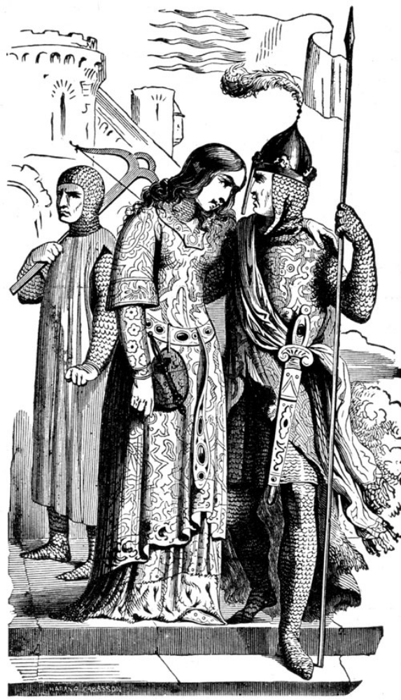

7. Roleplaying Skills

While Kingdoms of Novitas is a classless system, there are still some enduring fantasy archetypes that add flavor and consistency to the world. Druids, Mediums, Nobles and Ordained characters are granted titles and special abilities, but these bonuses come at a high cost in skill points, and a greatly elevated expectation of quality roleplaying and good garb.
While any player may take the first level of these skills for her character, levels beyond the first require the permission of the Game Masters. Players who do not meet the high standards of roleplaying and garb expected for these skills will not be allowed to progress further into the skill tree. Furthermore, the primary motivation of a player taking a roleplaying skill should NEVER be to gain the more powerful abilities granted to these special characters. If it becomes apparent that a player has done so, and has no intention of embracing the spirit and flavor of the skill, the player will lose the ability with no recourse. This loss will generally require a vote of the Game Masters, and will not be a decision made lightly, but it WILL happen.
The first level of each Roleplaying skill grants little more than a title and responsibilities. While the title is left up to each player to decide on, there are usually precedents to help with choosing your title. Your responsibilities are more broad, however, and how well you discharge them will be a major factor in the decision whether or not to allow you to progress farther into the skill tree.
There are four Roleplaying skills, which are detailed below.
Druid
Characters with the Druid skill are assumed to be sensitive to the wild nature of plants and animals. They are often sought after by farmers to bless their crops and by others seeking safe travel through the wilderness. If blight, plague, wildfires, earthquakes, or other natural calamities were to befall an area, Druids are called upon to help determine the nature of the problems and their advice on what to do to correct the issue is highly valued.
Druids are almost always students of Nature magic, and typically supplement it with Enchantment, Restoration, Aegis, or Battle magic. Only rarely does a Druid delve into the mysteries of Necromancy or Compulsion.
Druids often dedicate themselves to the Sept, particularly venerating the Elemental. Particularly warlike Druids, or those more dedicated to the destructive power of Nature, sometimes venerate Grak the Destroyer.
There are several ranks in the order of the Druids, and each one grants additional powers to them.

Druid 1
Characters with this rank are able to communicate with the flora and fauna of nature. To the untrained, most plants simply remain silent, and most animals bark, whinny, growl, or otherwise emit some form of unintelligible noises. At times, more than simple conversation from a Druid is required to provoke a plant or animal to speak. Often the Druid must bring offerings of food, or even remain with the creature for extended periods of time. It is possible for creatures to speak languages other than common and the Druid skill does not allow a character to speak languages they do not know.
The first level of Druid requires that the character show interest in nature and the elements, and react appropriately. A druid hearing of clearcutting in the forest, poisoned streams, a dryad in distress, or other offenses against nature should react very strongly. Some druids eschew buildings, choosing to live in the forest.

Druid 2
Characters that attain this rank are able to cast a Charm Plant or Animal spell, once per Game Day. This spell does not cost any of the Druid’s power to cast and can only effect creatures with animal intelligence or plants; otherwise it is identical to the Charm spell.

Druid 3
Characters that attain this rank see their skin harden to a bark-like toughness. This grants the druid 1 additional point of Body. Being a gift from nature, it allows the character to exceed the 4 Body limit.

Druid 4
Characters that attain this rank feel nature flowing through them more freely. As a result, any time the Druid casts the Elemental Dart spell, it produces 2 darts, instead of 1. If the Druid does not have the spell Elemental Dart, they instead gain use of the spell for free once per Game Day.

Druid 5
Characters that attain this rank of Druidism are one with nature. As a result, they can tap into power directly from the elements around them and recharge their used Magic Power. Once per game day, the Druid may cast Innervation. This spell requires an incant and allows the Druid to restore 2 points of used Magic Power. This ability, being a gift from nature, can allow the recipient to channel more than 20 points of power in a single game day.

Medium
Characters with the Medium skill are assumed to be sensitive to spirits. They are often sought after by those who have suffered a recent loss and are looking to be comforted, or are looking for information from their dearly departed. This is often a futile effort, as the spirits have moved on, but sometimes, if the spirit is not at rest, the Medium can provide results. Also, Mediums are welcomed by those that are being haunted or hunted by spirits of Darkness.
Mediums are generally students of Necromancy, and often supplement it with spells of Compulsion and Restoration. Less often do they delve into Battle Magic and Enchantment, as such spells are often of no use to the Medium.
Mediums who are dedicated to banishing evil spirits and helping the newly-deceased find their way often follow the Sept, usually venerating the Stranger. Those who wish to use their powers to command spirits for nefarious ends usually worship Darkness or Nox the Putrescent.
There are five ranks of Medium, and each one grants additional powers.

Medium 1
Characters with this rank are able to communicate with spirits. To the untrained, spirits simply remain silent or emit some form of unintelligible moan or scream. At times, more than simple conversation from a Medium is required to provoke a spirit to speak. Often the Medium must bring offerings or even remain with the spirit for extended periods of time. It is possible for spirits to speak languages other than common and the Medium skill does not allow the character to speak languages they do not know.
The first level of Medium requires that the character show interest in spirits, and, to a lesser extent, death, dying, and occasionally the undead. Some Mediums may combine their skills with those of a Druid, in pursuit of knowledge regarding elementals, the spirits of nature. Others may combine their skills with spells from the school of Necromancy, as some powerful undead are both spirits and undead. A Medium hearing of ghosts, poltergeists, or wraiths should be immediately interested in talking with those creatures to either help them, banish them, or both. Some Mediums even dabble in fortune-telling, calling on the spirits to grant them knowledge or insight.

Medium 2
Characters that attain this rank gain the ability to cast Final Rest, once per Game Day, without expending any magic power. This represents their ability to help spirits find their way to the beyond and release this realm’s hold on their essence.

Medium 3
Upon attainment of this rank, Mediums gain an Ethereal Aura. This aura acts as a permanent, undispellable Disengage spell that works on spirits only. It does not require an incant. So unless a Medium threatens a spirit, it will not attack him.

Medium 4
Fourth level Mediums gain the Ghostform ability once per Game Day. In this form the Medium is immune to all damage and spells but cannot attack or cast magic in turn. They can be seen and heard by both spirits and the living. There is no duration for this effect and the Medium can turn it off whenever desired. They are unaffected by Sanctify or Unhallow, and can pass through walls by calling a Timestop. This ability requires an incant.

Medium 5
At the pinnacle of a Medium’s power, she gains the use of the Spirit Subjugation ability. Once per Game Day, the Medium may command any one spirit, as the Dominate spell. Legal commands are not limited to attack, defend and follow, and the Medium may use this power to force the spirit to depart the mortal realms for a year and a day. This ability requires an incant, and a successful hit with a tag bag.
Noble
Characters with Nobility are members of their Kingdom’s social or governmental hierarchy. Often, may people will accord a Noble character more trust or respect depending on their racial or national background. Players choosing Nobility whose characters are from the Theocracy of Vlean must also be Ordained.
While the name of the skill, Noble, suggests to most the classic archetype of medieval nobility, this skill can just as easily represent the influence, power or wealth of an extremely wealthy merchant family, a crime lord, or the hereditary military commander of a Civenite legion. Players should feel free to invent as elaborate a backstory and title as they desire to justify the taking of this skill.
Because of the nature of the benefits of this skill, primarily providing the Noble with money and items at reduced cost, there may be a temptation for players to take levels of Nobility and combine them with other production skills. This will not work, as the items gained through Nobility are entirely separate from a player’s Production points and output from crafting skills such as Ornamenter or Alchemy. A Noble may not combine the items gained with Noble 5 with the Craft points he might gain from a production skill to create more powerful items than he would normally be able to. Players who are found to have taken levels of Noble primarily for the material benefits, and no intention of embracing the spirit and flavor of the skill, will lose the ability with no recourse.
The five ranks of Noble are described below.

Noble 1
Characters with this rank do not gain any direct in-game benefits other than the right to be addressed with a title such as Lord, First Citizen, Chief, Master, or Captain, but does open up other areas of role-playing that Game Masters may take advantage of.
Players should feel free to choose anything they wish as their title, but should leave themselves room to grow. A first level Noble who styles himself “King” should have justification for this. Perhaps he has been declared king of a small town by the grateful townsfolk, or perhaps he is acknowledged “king of thieves” by the underworld of a city. It makes much more sense to create for yourself a story where you are a more minor noble. A prince, getting away from your father’s Duchy for the first time, or a young merchant guildmaster whose skills have made him fabulously rich, or an elven Countessa fleeing an arranged marriage in Evenandra are the types of things a first level Noble should consider. Later on, as you advance in levels of Noble, your title, wealth and influence may become more grandiose. If you are having trouble with your title, or understanding where a Noble fits into life in the Free Lands, you should speak to a Game Master for guidance.

Noble 2
Characters that attain this rank earn a small stipend of 1 silver each event. These funds may be from the family coffers, earnings from his estates or from a mysterious benefactor. There are many options depending on the character’s history.

Noble 3
Characters that attain this rank are considered well known. The people either fear him, or love him, depending on his actions. Either way, at the start of each event, the Noble may purchase from Logistics up to 5 production points worth of non-permanent production items, (any scrolls, potions, or alchemy) at cost to represent people cutting him good deals to gain favor (or mercy).

Noble 4
Characters that attain this rank see an increase of their stipend to 2 silvers per event.

Noble 5
This is the pinnacle of the noble’s abilities. Years of court intrigue, shady dealings, or business negotiations have allowed the Noble to build up his defenses against certain mind-affecting effects. This ability is referred to as Pure Cognizance, and it grants an innate immunity to Charm, Dominate, Memory Loss, and Truth Serum. No incant is required, and the ability is not dispellable. It is always active, in the same way as the Ethereal Aura of a third level Medium. For clarity and consistency of play, this ability requires a "no-effect" call if it is used.
Further, at the start of each event, the Noble may purchase up to two Craft points worth of Ornamenter, Trapsmith and Weaponsmith items per game at cost. The Noble must also be able to cast any spells needed for the creation, or provide an appropriate reagent (potion, scroll, amalgam), or pay for the needed reagent at cost in addition to the base cost of the item.
Ordained
This skill allows a character to claim status as an ordained member of an established Kingdoms of Novitas religion. Often, NPCs will accord an Ordained character more trust or respect depending on their background, and Ordained characters are entitled to be called “Septon” or whatever title is appropriate for their deity.
An Ordained character is required to pick an established Kingdoms of Novitas religion (listed in the Religion section of these rules) as their patron god or goddess and this choice may not change! It is acceptable for the character to cease worship of the deity; however this effectively renders their Ordained skill levels useless. The character is required to wear the vestments of their faith when performing their office.
Ordained characters vary wildly in their portrayal of the priest of a god. Some are open about their allegiance, others are very secretive. The priests of benevolent aspects of the Sept, like the Mother or the Craftsman, are kindly and helpful individuals, while priests of the Soldier or Grak are warlike and dangerous. Priests of Darkness or Nox the Putrescent are terrifying manifestations of their god’s power in a mortal shell, performing horrible rites and sacrifices in their names, often in secret.
The following are the descriptions of the abilities and responsibilities of an Ordained character. All of these abilities can be revoked by the god if the priest falls out of favor with him.

Ordained 1
Characters with this rank gain the right to be addressed by a religious title such as Brother, Septon, or Tormentor. Many creatures, like spirits, can only be laid to rest after an Ordained character conducts certain rituals. Often players will encounter magic objects that only an Ordained character is allowed to use or areas only an Ordained character is allowed to enter.
Ordained characters are further empowered to create a sacred or unholy shrine to your god that creates a Sanctuary (for the Sept and Draconus) or Unhallow effect (for the Dark Triumvirate). This shrine must be inside a permanent object such as a building; ad-hoc shrines in the woods or in temporary tents are not acceptable. Typically, this shrine will be on a table in a corner of a cabin near the sleeping place of the Ordained priest, and should consist of suitable props and items, such as candles, statues, icons, plants, and the like, but there are other options. You should check with a Game Master to see if your shrine is acceptable. If the shrine is defiled from the inside the effect is disrupted, but it can't be dispelled. An unholy priest is immune to his own Unhallow effect. Each character can only have one shrine empowered this way in the game at a time.

Ordained 2
Characters who reach this level gain ONE of these four choices as an innate granted power from your god(s):

- Heal Body twice per Game Day
- Strength once per Game Day
- Magic Armor twice per Game Day
- Dissipate once per Game Day

These spells were chosen to give the Ordained character some utility in choosing a spell appropriate to their god, while avoiding any one granted spell marking out a character as a follower of a specific god.
These spells do not use the character’s Magic Power, and require an incant. The choice of spell must be chosen upon taking the second level of Ordained, and cannot change. The choice should be clearly marked on the player’s character sheet.

Ordained 3
Characters that attain this rank are considered to be the Weapon of their god. As such, they gain a Holy or Unholy Smite ability that allows the priest to hit a foe for 4 points of Smite damage once per Game Day. This damage automatically overcomes any damage requirements the target may have; put differently, Smite damage counts as every damage type in the game simultaneously. The priest must call this damage as “Four Smite!”, and can channel it through a melee or missile weapon. Note that if channeled through a thrown weapon the damage is reduced to two, as is the damage if channeled while Two Weapon Fighting. If the damage is channeled through a missile weapon or thrown weapon and misses, the ability is wasted with no effect.

Ordained 4
Characters who reach this level gain ONE of these four choices as an innate granted power from your god(s):

- Panacea once per event
- Maelstrom once per event
- Anti-magic Aura once per event
- Dispel Magic once per event

These spells were chosen to give the Ordained character some utility in choosing a spell appropriate to their god, while avoiding any one granted spell marking out a character as a follower of a specific god.
These spells do not use the character’s Magic Power, and require an incant. The choice of spell must be chosen upon taking the second level of Ordained, and cannot change. The choice should be clearly marked on the player’s character sheet.

Ordained 5
Characters that attain this rank are considered the most devoted and reverent of priests. Their reputation within their chosen church is well known and respected (or feared). As such, the priest gains 2 Magic Power points, permanently. The priest is allowed to exceed the 20 Magic Power system limit with this, as it is a gift from their god.
A fifth level Ordained character further gains an additional use of her level 3 Smite ability.

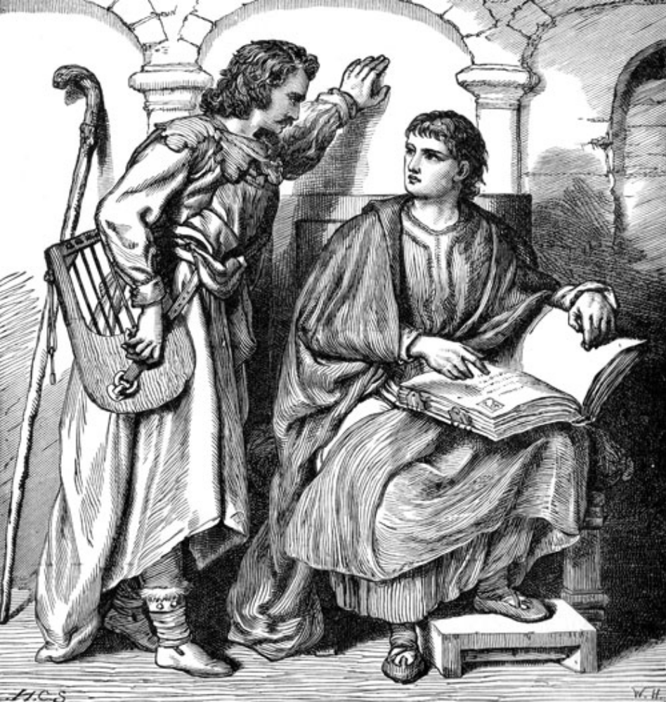

8. Production Skills

Crafted Items
Players at Kingdoms of Novitas have the opportunity to use the production skills system to create several types of items that can be used in game. All of these production skills use Production Points, a skill similar to Magic Power, which is expended to power their creations. No player may use more than twenty Production Points from any source per event, much like the limitation on use of Magic Power points per game day. In addition, most crafts require a monetary expenditure, and some have additional requirements of Magic Power, spells, props, or reagents found during play.
All crafted items (scrolls, potions, locks, traps, weapons, ornaments and alchemical compounds) MUST be signed in at Logistics BEFORE the character enters play. These items are too time consuming to be created during play, and are ALWAYS created in between game events. Any items without the signature or marking of a GM or Logistics official are invalid, and not to be used, purchased, or sold. To knowingly use a fraudulent item is cheating.
Many of these items require the player to purchase or make physical representations of the objects. As a general rule, only the signed slip of paper that describes the object will be provided at Logistics, including scrolls. This helps maintain consistency. Potions require the player to bring bottles, locks require locks, some Alchemy compounds require props to represent them, and so on.
At the time of sign in, the Game Master or Logistics official will ensure the character bringing in newly created items has the appropriate Production Points, Skills, and any required Magic Power points, money, and focus. At this point, in-game loot worth Production Points can also be turned in to make additional items, as if they were Production Points the character had purchased as skills. Remember that NO MATTER WHAT, no more than 20 Production Points can be used per character, per game.
Scrolls
Scrolls are an important part of the armament of Kingdoms of Novitas’ magic-wielding denizens. Scrolls provide many benefits, as they have an effectively unlimited shelf life, and are relatively simple to produce, allowing a mage to ‘bank’ his abilities for times of need.
Scrolls are not without their limitations, however, and require long hours of additional study to master the secrets of writing a scroll. Scroll production requires special inks, quality parchments, and ritual quills (and occasionally more than that), costing a mage out-of-pocket expense to acquire these items, or the components with which to make them. Scrolls also require a certain minimum level of ability to use successfully. Scrolls also take hours to create, so proper preparation is essential for those wishing to use scrolls to maximum efficiency.
Production Skill
Prerequisites:

Scribe Scroll:
- Production Points
- Read Magic
- Any 1st level spell

Brew Potion:
- Production Points
- Any 1st level spell

Alchemy:
- Production Points
- Herbalist

Ornamenter:
- Production Points

Trapsmith:
- Production Points

Weaponsmith:
- Production Points

To use any scroll, players must have the skill Read Magic.
Scribing Scrolls
Production Points are used to make scrolls, at a cost of 1 Production Point per level of the spell stored on the scroll. Remember that no more than 20 Production Points can be spent per event, so even if a mage has Alchemy 5, Brew Potion, and Scribe Scroll, she will not be able to bring more than 20 Production Points worth of created items to any game.
Sometimes, players will find components (supplies for scribing scrolls) while adventuring, or for sale. Use of components provides a one-use increase to the character’s Production Points at logistics. Note that no character can make use of more than 20 points of Production per event, no matter how many components they have.

Scribe Scroll
Prerequisite: Read Magic, one Production Point, any first level spell

This skill allows the user to scribe scrolls of any spells that the caster knows, for a cost of 1 copper’s worth of components, 1 Production Point, and 1 Magic Power point per spell level.
In addition, the scribing of fourth level and higher scrolls requires a Ritual Quill. Ritual Quills are produced by Alchemists, and it is the scroll scriber’s responsibility to acquire one. This item must be presented at Logistics whenever a player brings a fourth or fifth level scroll in-game. A Ritual Quill is a numbered, stealable item, and must only be obtained once by a player needing one, barring loss or theft. Each player with Scribe Scroll must have their own Ritual Quill; players may not share quills.
Furthermore, the scribing of fifth level scrolls requires Ritual Ink. Like a Ritual Quill, Ritual Ink may be acquired from Alchemists. One bottle of Ritual Ink is enough to scribe five fifth level scrolls. After that, the scriber must obtain another bottle. When a player brings a fifth level scroll in-game, he will be required to present his Ritual Quill and Ritual Ink at Logistics. The Logistics Official will then cross off a box on the signed item slip of the Ritual Ink. When the fifth box is crossed off, the logistics official will tear up the slip.
Also note that when the fifth level Nature spell Ley Lines is cast from a scroll, it will only work for the person who scribed the scroll, and it will always return the caster to the same place that the caster has designated for normal castings of this spell. It is not possible to alter the spell to allow the caster to re-designate the point of binding.

Potions
Potions play a vital role in the everyday lives of adventurers. Adventurers unskilled in magic can use potions to their advantage with no training at all – simply pop the cork, drink, and charge. Because they are inexpensive to make, requiring no special components or tools beyond a bottle and some pure, distilled water, they are generally inexpensive to buy. All of these things make potions a staple of the adventurer’s gear.
Potions are not without their limitations, however, and the drawback to all this liquid goodness is that potions are of limited power. The liquid medium of a potion, as opposed to the expensive parchments and inks used to make scrolls, is simply distilled water. This means that potions can only absorb the energy of low level spells – up to third level, to be exact. The fact that a potion must be drunk to take effect means that generally only spells with a touch range can be contained in a potion. In addition to all that, the nature of some spells (such as Repel Undead) and some schools of magic (such as Compulsion) make many potions from those sources nearly impossible.

Brewing Potions
Potions are created in the exact same way as scrolls, as detailed above, requiring a skill (Brew Potion), Production Points, Magic Power, and money. Some potions, called “oils”, are not drunk, but instead rubbed upon the target object.

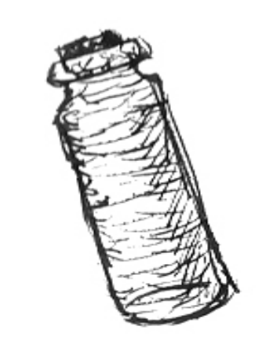
Creation of a potion requires the player to provide his own prop to represent it. This can be nearly any small bottle or container that does not look too modern or anachronistic. Logistics will provide the actual slip of paper inside the container. This prop must be presented and approved at Logistics at sign in. It is an in-game, stealable item.
For safety reasons, a player at Kingdoms of Novitas is never required to actually drink any liquid. The only thing that will be inside a potion bottle is the signed slip of paper from Logistics, which should be torn up when the player ‘drinks’ the potion. Players should, however, role play drinking the potion or applying an oil.
Sometimes, players will find components (supplies for brewing potions) while adventuring, or for sale. Use of components provides a one-use increase to the character’s Production Points at logistics. Note that no character can make use of more than 20 points of Production per event, no matter how many components they have.

Brew Potion
Prerequisite: One Production Point, any first level spell from the list below

This skill allows the user to brew potions of any of the following spells that the caster knows, for a cost of 1 copper worth of components, 1 Production Point, and 1 Magic Power point per spell level.

First Level
- Magic Armor
- Toughness
- Magic Strike (oil)
- Strength
- Mend Armor (oil)
- Magic Lock (oil)
- Enhance Armor (oil)
- Heal Body
- Diagnosis (oil)
- Final Rest (oil)
- Ghastly Visage

Second Level
- Anti-Magic Shield
- Spirit Shield
- Dissipate
- Silvershine (oil)
- Enchant Shield (oil)
- Restore Limb
- Purify Spirit
- Creeping Rot (oil)

Third Level
- Improved Magic Armor
- Spellstore (oil)
- Sanctuary
- Enchant Weapon (oil)
- Heal Mortal Wound
- Sanctify (oil)
- Polyglot

NOTE: A potion of Heal Mortal Wound cannot be self-administered, and requires the First Aid skill to administer it to a player suffering from a Torso Wound.
Alchemy
Alchemy is a scientific art, requiring careful mixture of chemicals and reagents. Alchemists come in many flavors, from the evil poisoner to the absent-minded professor, and an alchemist often has a compound for every occasion. While Alchemy is usually not the most efficient way to accomplish a goal, an alchemist is something of a jack-of-all-trades, useful in nearly every situation.
Alchemical products are interchangeably called compounds, admixtures or amalgams. They are made by players with the skill Alchemy 1 (or higher) by expending Production Points and money.
Some Alchemical compounds take the form of thrown tag bags. Unlike thrown magic spells, admixtures can be successfully blocked by a shield. Poisons and other compounds that impact on a shield have no effect unless the description specifically states that they ignore or affect shields.

Using Alchemical Compounds
People unskilled in the creation of amalgams can safely use them if they purchase the Herbalist skill. Any character without Herbalist may only use amalgams marked “No” in the “Skill?” column on the table in this chapter, and may not ever use any poisons (including ingested poisons). Attempts to handle poisons without the Herbalist skill result in the player taking the effects of the poison himself.

Making Alchemical Compounds
Production Points are used to make Alchemical compounds, at a cost of 1 Production Point per level of the compound. Remember that no more than 20 Production Points can be spent per event, so even if a skilled thaumaturgist has Alchemy 5, Ornamenter, and Scribe Scroll, he will not be able to create more than 20 Production Points worth of items per event.
Alchemical Compounds also cost money to make. The cost in coppers is equal to the level of the compound.
Compounds above first level require the presence of a material focus to create, in addition to money and Production Points. This is a permanent aid or reagent that can be created with lower level Alchemy. Players will be required to present this prop at Logistics when bringing Alchemy compounds of second level or higher in-game.
Creation of an Alchemy compound requires the player to provide his own prop to represent it. For most compounds, this can be nearly any small bottle or container that does not look too modern or anachronistic. Logistics will provide the actual slip of paper inside the container. This prop must be presented and approved at Logistics at sign in. It is an in-game, stealable item. If you are in doubt as to what form your Alchemy prop should take, please speak to a Game Master or Logistics Official.
Sometimes, players will find components (ingredients for Alchemical compounds) while adventuring, or for sale. Use of components provides a one-use increase to the character’s Production Points at logistics. Note that no character can make use of more than 20 points of Production per event, no matter how many components they have.
Each level of Alchemical knowledge allows an alchemist to create any Alchemical compounds of that level. Some examples are shown below, and others may be added into the game as GMs desire them.

Alchemical Compounds by Level
Compound | Level | Type | Skill? | Description
Bug Repellent | 1 | Item | No | Keeps insects away
Garlic Paste | 1 | Item | No | Keeps lesser undead away
Minor Power Elixir | 1 | Ingested | No | Restores 2 Magic Power
Corruption | 1 | Melee | Yes | Blade poison adds poison damage type to weapons
Mirror of Sophistry | 1 | Permanent Item | Yes | Mirror acts as a focus for 2nd level Alchemy
Ritual Ink | 1 | Permanent Item | No | Used to write Ritual Scrolls and 5th level scrolls, 5 uses
Anesthesia | 2 | Ingested | No | Knocks creature out for 1 hour
Elixir of Wisdom | 2 | Ingested | No | Grants 1 extra Magic Power point for event
Hermetic Rod | 2 | Permanent Item | Yes | Rod acts as a focus for 3rd level Alchemy
Rejuvenation Elixir | 2 | Ingested | No | Restores 2 Magic Power, heals missing Body points
Ritual Quill | 2 | Permanent Item | No | Used to write Ritual Scrolls, 4th and 5th level Scrolls
Vermin Bane | 2 | Ingested | Yes | Ingested poison
Wolfsbane | 2 | Ingested | No | Cures Lycanthropy
Elixir of Toughness | 3 | Ingested | No | Grants 1 extra Body for game day
Explosive Charge | 3 | Item | No | One use item opens a single lock
Hand of Death | 3 | Thrown | Yes | Thrown poison deals 2 points of poison damage, ignores armor
Madweed Extract | 3 | Ingested | No | Grants +1 melee damage for 10 minutes
Ritual Candle | 3 | Permanent Item | No | Generic candle that may be used in rituals
Smelling Salts | 3 | Permanent Item | No | Revives insensible persons
Thaumaturgist’s Mortar | 3 | Permanent Item | Yes | Bowl acts as a focus for 4th level Alchemy
Vial of Acid | 3 | Thrown | No | Thrown compound deals 4 points of acid damage, destroys shields
Claw of the Beast | 4 | Melee | Yes | Blade poison adds +1 poison damage
Magic Power Elixir | 4 | Ingested | No | Restores 4 Magic Power
Mind Expanding Elixir | 4 | Ingested | No | Grants 2 extra Magic Power points for event
Philosopher’s Stone | 4 | Permanent Item | Yes | Stone acts as a focus for 5th level Alchemy
Theriac | 4 | Ingested | No | Universal poison antidote
Truth Serum | 4 | Ingested | No | Imbiber cannot lie for one minute
Balm of Vigor | 5 | Ingested | No | Grants +2 melee damage for 10 minutes
Catholicon | 5 | Ingested | No | Restores 4 Magic Power, heals Body, Limb and Torso wounds, cures all poisons
Elixir of Cosmic Power | 5 | Ingested | No | Grants 3 extra Magic Power points for event
Ogre Extract | 5 | Ingested | No | Grants 2 extra Body for game day
Transmutation | 5 | Melee | No | Change mundane weapon to silver, Goblin Iron or Elven Steel for game day
Two-step Venom | 5 | Melee | Yes | Thrown poison deals 4 damage to torso, ignores armor

A Word on Poisons
Poison is a much maligned substance in many of the Kingdoms - and for good reason! While it is true that there are legitimate uses for poisons, such as killing vermin, the mortal potential of poisons in the hands of a skilled assassin gives even the most heavily armored warrior a chill. Poison is a particularly deadly facet of Alchemy in Novitas, and as such, it has a few special rules.

The Basics of Poison
Poison is an insidious damage causing agent. As such, thrown poisons flow through and around armor, affecting the flesh beneath rather than the armor itself. Thus, thrown poison damage goes straight to an individual’s Body points (unless blocked by a shield). Ingested poisons also ignore armor. Blade poisons, such as Claw of the Beast, however, do NOT ignore armor, as they are a much thicker consistency than thrown poisons, and depend upon breaches in the opponent’s physical and magical armor to gain ingress into his system. Poisoned weapons of any sort are affected by armor normally.
Poisoned wounds indicate massive trauma to the affected area from a large concentration of toxins within the wound. As such, Body damage, Limb and Torso wounds caused by poison will require an antidote, a Purify Spirit spell, or some other poison nullifying effect before the poisoned wound or Body can be healed.
Some poisons must be ingested by the victim to have any effect. To simulate this in game, ingested poisons use a small green sticker, to be no smaller than ½ inch in diameter. The sticker must be placed on or in a food or drink container. If that food container is then eaten from, that person is potentially poisoned.
For the poison to take effect, the poisoner must bring the signed Alchemy slip of the poison to a Game Master, and explain who was poisoned and how. The Game Master will then find victim of the poisoning, inform them that they are poisoned, and that they have the duration listed on the Alchemy slip to seek vengeance, find an antidote, or set their affairs in order. A player who is poisoned will always be aware that he is in such a state!
If the victim of the poisoning is able to nullify the poison in his system, he will be fine, as he has prevented the poison from doing its work. If the Game Master has no time, cannot find an NPC or Assistant Game Master to send to the player, or the poisoned player cannot be located, the poison has no effect (but is still expended).
If, however, the duration time expires before a chemical or magical antidote is obtained, then the poison will take effect immediately. Any damage caused as a result of an ingested poison ignores armor, and any wounds caused are considered to be torso wounds.
Weaponsmith
Whether you are considering a stout hammer or an elegant blade, Weaponsmiths are those with the skill to craft weapons both magical and mundane. They are the people that supply soldiers, mercenaries, and adventurers the tools required to make their livelihood.
This skill allows a character to create and bring magical and extraordinary weapons into game. As a Weaponsmith increases in level, she is able to create larger items, or items with greater powers. They are granted one Craft point per Weaponsmith level. These Craft points represent the skill to create certain types of items. It also costs four Production points and forty copper pieces for each Craft point represented in a specific item. A character’s Craft points are per event, just as Production points.
The chart below shows the range of items and their craft point cost:

Non-Martial Weapon | 0 craft points
Arrows or Bolts | 0 craft points
Martial Weapon | 1 craft point
Bow | 1 craft point
Masterwork (+1 damage) | 1 craft point
Magical Weapon | 1 craft point
Imbue with 1st-level spell * | 1 craft point
Silver Weapon | 2 craft points
Goblin Iron Weapon | 2 craft points
Imbue with 2nd-level spell * | 2 craft points
Provide 1 production point * | 2 craft points
Provide 1 magic power * | 2 craft points
Elemental damage type * | 3 craft points
Imbue with 3rd-level spell * | 3 craft points
Great Weapon | 4 craft points
Elven-Steel Weapon | 4 craft points
Provide 2 production points * | 4 craft points
Provide 2 magic power * | 4 craft points

* Weapon must be made magical to add this ability

Weapons imbued with spells or that provide Magic Power may be used to provide those abilities once per Game Day. Items that provide Production Points can be used only once per event. It is possible for a Weaponsmith to craft a weapon with duplicate properties, for example a magic dagger that casts Heal Body four times per Game Day, as long as he does not exceed five Craft points worth of powers in a single item.
For example, a player wishing to create a 42” Elven Steel longsword would need five Craft points, twenty Production Points and 200 copper. A player wishing to create a Silver dagger that casts Final Rest once per Game Day would need three Craft points, twelve Production Points and 120 copper, and be able to cast Final Rest or have a scroll of Final Rest and Read Magic.
Players may only charge their weapons with spells they cast themselves, either through use of magic skills or scrolls. Other players may not be enlisted to charge magic weapons. Note that if a scroll is used to charge a weapon, the player must have the skill Read Magic to utilize the scroll, and the scroll is expended
It must be noted here that the player is responsible for providing their own props for these items. They must be items that would be considered items of quality. For instance, a Weaponsmith should never bring a tape weapon into game, as the quality of a tape weapon does not match up to the look and quality of a latex weapon. Furthermore, all weapons created by Weaponsmiths must conform to the standard rules for the appearance of exceptional weapons in this rulebook. Certain colors have certain standard meanings, as listed in the table here:

Blade or head is white | Silver
Striking surface is green | Goblin Iron
Blade or head is black with white veins | Elven Steel
Striking surface is blue | Magic
Striking surface is blue | Elemental damage
If the items crafted by this skill pass the quality test in logistics, they will be marked with a number and entered into the treasure log. The items will then be sellable, stealable and usable in game. As these items are being brought in for a player’s character to use or sell, the player will not receive XP for the cost of the item as is often done for items created for use by the Game Masters.
While this skill is a Production Skill, it also has strong elements of a role-playing skill. Characters will be required, by Weaponsmith 3, to begin paying a guild fee. This will be role-played out to start, and then will be handled at logistics in most cases. This fee represents payment for supplies to create these fantastic items, and support from the guild.
Ornamenter
If the Weaponsmiths are the ones to supply adventures with the tools to fight their foes, it is the Ornamenters who supply them with the tools to stay alive. Crafters of trinkets and armors, the Ornamenter’s skill tends to be more broad than that of the other crafters.
This skill allows a character to create magical trinkets, clothing, jewelry, and the like, often referred to collectively simply as “trinkets”. While this skill is a Production Skill, it also has strong elements of a role-playing skill. Characters will be required, by Ornamenter 3, to begin paying a guild fee. This will be role-played out to start, and then will be handled at logistics in most cases. This fee represents payment for supplies to create these fantastic items, and support from the guild.
As an Ornamenter increases in level, she is able to create items that have greater powers, or take up less space and weight. Ornamenters receive one Craft point per level, just as Weaponsmiths, however the cost in coin to create Ornamenter trinkets is half that of a Weaponsmith’s cost to create weapons. It costs four production points and twenty copper pieces for each craft point represented in a specific item.
In contrast to Weaponsmiths, an Ornamenter’s Craft point costs vary based on the location on a character where they will use the item, as well as the abilities. Smaller items are harder and more expensive to make than large ones, as they are easier for characters to wear and use, and are usually easier and cheaper for the player to buy the props for. It is much easier for a player to obtain a necklace or ring for use as a game prop than it is a chainmail shirt or helmet.
The chart below shows the range of locations and abilities and their craft point cost.

Torso slot | 0 craft points
Back slot | 0 craft points
Shield slot | 0 craft points
Head slot | 1 craft point
Waist slot | 1 craft point
Imbue with 1st-level spell | 1 craft point
Face slot | 2 craft points
Leg slot | 2 craft points
Imbue with 2nd-level spell | 2 craft points
Provide 1 production point | 2 craft points
Provide 1 magic power point | 2 craft points
Neck slot | 3 craft points
Ears slot | 3 craft points
Arm slot | 3 craft points
Feet slot | 3 craft points
Hand slot | 3 craft points
Imbue with 3rd-level spell | 3 craft points
Provide 2 production points | 4 craft points
Provide 2 magic power points | 4 craft points
Gender/Racial restrictions | +1 craft point per restriction

A description of the slots and the number of items allowed are explained below:

- Torso slot: Only one item is allowed to be on the torso. This item can be a shirt, vest, robe, armor, or other item worn on the chest.
- Back slot: Only one item is allowed to be worn on the back. This item can be a cloak, cape, shawl, backpack, or other item worn on the back.
- Head slot: Only one item may be worn on the head. This item can be a circlet, hat, helmet, headband, head scarf, or other item worn on the chest.
- Waist slot: Only one item may be worn on the waist. This item can be a belt, sash, or other item worn on the waist.
- Face slot: Only one item may be worn on the face. This item can be a mask, goggles, glasses, facial piercing, or other item attached to the face.
- Leg slot: Two different items may be worn on the legs. These items can be an anklet, greaves, skirt, pants, tassets, cuisse, or other item worn on the leg.
- Neck slot: Only one item may be worn around the neck. This item can be a necklace, choker, gorget, or other item worn around the neck.
- Ear slots: Two items may be worn on the ears. These items may also be a pair that counts as one item, or two individual items. These items can be earrings, ear clips, ear cuffs, or other items worn on the ears.
- Arm slots: two items may be worn on the arms. These items can include bracelets, bracers (often counting as 1 item), arm bands, cuffs, spaulders, rerebrace, or other item worn on the arms.
- Feet slot: Only one item may be worn on the feet. This item may be a pair of boots or shoes, sabatons, an anklet or pair of anklets, or other item worn on the feet.
- Hand slots: Two items may be worn on the hands. These items are usually rings or gloves.
- Gender/Racial restrictions: It is possible to restrict who an item would work for. For instance, an item could be worn only by Elven females, and it would cost an additional two craft points. Other restrictions may exist, please consult a GM with questions.

Trinkets imbued with spells or that provide Magic Power may be used to provide those abilities once per Game Day. Items that provide Production Points can be used only once per event. It is possible for an Ornamenter to craft a trinket with duplicate properties, for example a magic belt that casts Heal Body four times per Game Day, as long as he does not exceed five Craft points worth of powers in a single item.
For example, a player wishing to create a magic helmet that provides two Magic Power would need five Craft points, twenty Production Points and 100 copper. A player wishing to create a magic tunic that casts Magic Armor once per Game Day would need one Craft points, four Production Points and 20 copper, and be able to cast Magic Armor or have a scroll of Magic Armor and the Read Magic skill.
Players may only charge their trinkets with spells they cast themselves, either through use of magic skills or scrolls. Other players may not be enlisted to charge trinkets. Note that if a scroll is used to charge a trinket, the player must have the skill Read Magic to utilize the scroll, and the scroll is expended
It must noted here that like Weaponsmiths, players are responsible for providing their own props for these items. They must be items that would be considered items of quality.
If the items crafted by this skill pass the quality test in logistics, they will be marked with a number and entered into the treasure log. The items will then be sellable, stealable and usable in game. As these items are being brought in for a player’s character to use or sell, the player will not receive XP for the cost of the item as is often done for items created for use by the GM’s.
Players should make every attempt to incorporate some blue coloration into all Ornamenter items brought in-game, to represent the magical nature of these items. Jewelry should have blue stones, clothing or armor should be blue, or at least incorporate blue trim, leather items should be made of blue leather, dyed blue, or be studded with blue gems, metal armor should be painted blue, and so forth. The Game Masters may reject your items if they are not sufficiently extraordinary looking.
Trapsmith
At times, players may wish to secure their belongings or property with a lock – or more! Canny players know that while locks only keep honest people out, traps make sure everyone stays out – or else!
Kingdoms of Novitas has several types of traps: Alarm Traps, Magic Traps, and Alchemy Traps (usually poison). They are similar in construction, but vary in their effects. NOTE: Throughout this section, the rules refer to a single step mechanism. This means a single tripwire, button, lever, or other mechanism that must be bypassed to disarm a trap. Each single-step mechanism is a single application of trap making skills, and must be paid for separately.
Be advised that the Heroic Safety rule does not apply to traps. If you discharge your own trap while arming or disarming it, or spring it yourself by any method, you receive the harmful effects of the spell yourself, the trap is spent, and you must pay again to re-arm it.
Traps can be bought and sold, but only a player with the Trapsmith skill may set the trap or disarm it. Unskilled players will automatically trigger the trap.
A character with the Trapsmith skill has the ability to work with locks and traps. At first level, a character receives the ability to pick locks and to disarm traps. They also gain one Craft point per Trapsmith level. This skill is a Production skill and a role-playing skill in one. Characters will be required, by Trapsmith 3, to begin paying a guild fee. This will be role-played out to start, and then will be handled at logistics in most cases. This fee represents in-game payment for tools and supplies to create these fantastic items, and support from the guild.
The chart in the next column shows the range of items and the craft point cost.

Alarm Trap | 1 craft point
Imbue with 1st-level spell * | 1 craft point
Apply a 1st-level alchemy amalgam ⁺ | 1 craft point
Lock | 2 craft points
4 point generic magic damage * | 2 craft points
4 point generic poison trap ⁺ | 2 craft points
Imbue with 2nd-level spell * | 2 craft points
Apply a 2nd-level alchemy amalgam ⁺ | 2 craft points
Imbue with 3rd-level spell * | 3 craft points
Apply a 3rd-level alchemy amalgam ⁺ | 3 craft points
Imbue with 4th-level spell * | 4 craft points
Apply a 4th-level alchemy amalgam ⁺ | 4 craft points
Imbue with 5th-level spell * | 5 craft points
Apply a 5th-level alchemy amalgam ⁺ | 5 craft points

* Must have 1 magic power point and any level 1 spell
⁺ Must have Herbalism

Additional costs for these items include 2 production points per Craft point and 4 copper per Craft point.
It must noted here that like the other Production skills, players are responsible for providing their own props for these items. Players who wish to craft traps are responsible to supply the traps they are bringing in-game. While Game Masters will not provide traps or materials to players, they will assist new Trapsmiths with instruction in construction and deployment of their creations.
All traps crafted by players must be checked in at Logistics upon sign in, just like any other crafted item. At this time the crafter (or other player) is responsible to demonstrate that the trap can be disarmed using standard Novitas-style tools. Traps that cannot be disarmed will not be allowed into play. If the trap is legal, the Game Master will mark the trap tag with his initials and a date. Traps without a label marked by a Game Master are illegal and will be removed from play if discovered by a Game Master. Note that it might be possible for a player to cheat and bring illegal traps (without tags) into the game, and have it assumed they are Alarm traps due to their lack of tag. Players discovered doing this will be dealt with most harshly.
Traps other than Alarm traps have but a single charge, and are removed from play after they are sprung once. Players do have the option to spend Production Points and money multiple times at Logistics but only check in one trap mechanism. This would allow the player to re-arm his trap again after it is sprung. A player could do so once for each legal tag he received at sign-in.

Labeling Traps
Traps must be labeled with their effects, and the responsibility to place the label belongs to the player crafting the trap, not to the Game Masters or Logistics officials. Logistics will provide players with blank trap labels at sign-in if needed. Common places to label a trap are inside the lid of a box, or on a tag attached to the buzzer of a trap.
In the absence of such a label Game Masters and players are free to assume that the trap is an Alarm trap with no other effects, but players should make an honest effort to find a tag before assuming this. In no event should a trap label take longer than thirty seconds to locate, and it is permissible to call a Game Hold while conducting a quick search for a label. If after a reasonably thorough search no tag is located, the trap can be ignored.
The following is a description of the various types of Traps at Kingdoms of Novitas.

Alarm Traps
An Alarm trap is a single step mechanism that does nothing when triggered but make a noise. They are commonly constructed of buzzers, bells, horns or similar devices, and can incorporate a tripwire, lever, button, or anything else approved by a Game Master or Logistics official. Alarm traps never cause damage, and can be freely re-armed after they go off.

Magic Traps
A Magic Trap is a single step mechanism that has been charged with magical energy. These can have a variety of spell effects, and no amount of rationalization will avoid these effects. A player cannot, for example, open a box with a stick to avoid the damage, or even hide behind a wall while opening a door with a rope. The effect is magic, and it magically overcomes any obstacles to instantly strike the target. Obviously, a character protected by magical protections, such as Anti-magic Aura or an immunity spell may apply those protections as appropriate after reading the trap tag.
Magic Traps have one charge, and must be paid for again to re-arm them once sprung. It is not necessary to re-deploy the actual mechanism, only to replace the tag with another valid one.
While there is a generic Magic Trap that deals four points of magic damage to the target’s torso, players with Magic skills and Magic Power points (or potions, or scrolls and Read Magic) have the option to charge their Magic Traps with other, more powerful spells. By spending additional Craft points and coin, players can imbue a Magic Trap with any spell except for those that target items. Magic Traps may NOT be charged with rituals of any kind, nor the following spells:

- Spellstore
- Elemental Weapon
- Magic Lock
- Enhance Armor
- Enchant Shield
- Silvershine
- Enchant Weapon
- Ablative Armor
- Greater Enchant Weapon
- Sanctify
- Unhallow

In addition, the following spells are difficult to adjudicate when used with Magic Traps, and their use should be carefully evaluated before use:

- Disengage
- Charm
- Dominate

For example, a player wishing to create a Magic Damage trap that casts Maelstrom at its target would need four Craft points, eight Production Points and sixteen copper, and be able to cast Maelstrom or have a scroll of Maelstrom and Read Magic.
Players may only charge their traps with spells they cast themselves, either through use of magic skills or scrolls. Other players may not be enlisted to charge Magic Traps. Note that if a scroll is used to charge a trap, the player must have the skill Read Magic to utilize the scroll, and the scroll is expended
Only one effect may be discharged from each single-step mechanism in a trap. If you desire a trap that has multiple effects, you must either build the trap with multiple single-step mechanisms, or build two traps.

Poison Traps
Players skilled in the use and manufacture of Alchemical compounds may wish to charge their traps with their own handiworks. A Poison Damage trap is a single-step mechanism that does four points of poison damage to the torso of whoever springs it.
This damage follows the normal rules for poisons, and if it causes Body damage or wounds the player must be treated with an antidote or Purify Spirit spell before receiving healing. No amount of rationalization will avoid this damage. A player cannot, for example, open a box with a stick to avoid the damage, or even hide behind a wall while opening a door with a rope. The damage is magically delivered, and it magically overcomes any obstacles to instantly strike the target.
Poison Damage traps have one charge, and must be paid for again to re-arm them once sprung. It is not necessary to re-deploy the actual mechanism, only to replace the tag with another valid one.
While there is a generic Poison Trap that deals four points of poison damage to the target’s torso, players who make or acquire more powerful compounds may wish to charge their traps with those. By spending additional Craft points, Production Points and copper, players can charge traps with any Alchemy amalgams, with the following EXCEPTIONS:

- Any items
- Any permanent items
- Corruption
- Claw of the Beast
- Transmutation

For example, a player wishing to craft a trap that afflicts its victim with Two-step Venom would need to five Craft points, ten Production Points and twenty copper, and have a single dose of Two-step Venom to charge the trap with. He would also need to have the skill Herbalist to avoid falling victim to his own creation.
Only one effect may be discharged from each single-step mechanism in a trap. If you desire a trap that has multiple effects, you must either build the trap with multiple single-step mechanisms, or build two traps.

Locks
Trapsmiths may also create their own locks, and bring them into game to secure their own belongings, or to sell to other players.
Players are responsible to obtain their own locks for this skill; Kingdoms of Novitas will NOT provide locks to players. Locks created with the Trapsmith skill are not considered to be In Game items, and have no treasure numbers. This means they may not be stolen from other players. They may, however, be bought and sold for game currency.
Created locks must be presented at Logistics upon sign-in. At this time they will be painted a certain color by a Logistics official or Game Master, and inscribed with a date.
Players creating a lock with Trapsmith must be able to prove that it is a legal lock – that is, that it can be picked using standard Novitas-style tools. This is accomplished by having someone (not necessarily the Trapsmith) pick the lock in the presence of a Game Master. Until this has been demonstrated, the lock is not legal, and will not be accepted.
Created locks may or may not be accompanied by keys, at the creator’s pleasure. It is entirely possible to create a lock with no key. It is also entirely possible for the Trapsmith to keep back a key to a lock he has made, so caveat emptor!
Logistics will not keep track of nor replace lost locks or keys.

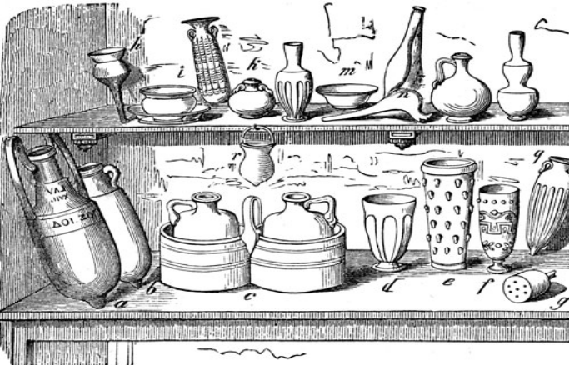

9. Weapons & Armor

Nearly every character will carry some sort of weapon and with good reason – the Free Lands are a dangerous place to the unwary! Many characters will also don some sort of protection, whether it is just a leather jerkin and a buckler, or plate armor from head to toe. This section of the rules deals with rules for construction and use of weapons and armor at Kingdoms of Novitas.
It’s called a what?
Weapons at American LARP games are generally called “boffers,” and Kingdoms of Novitas is no exception in that. Where we do differ from other games is in the construction of our weapons. The typical Novitas boffer sword is a hollow fiberglass rod sandwiched between two or three layers of dense foam and covered with duct tape or latex. The advantage of these weapons is that they are very light and very stiff, which makes them safer in combat and easy to control. Longer weapons sometimes use PVC pipe in place of the fiberglass, stiffened with a wooden core, but while still legal, these weapons grow less and less common every year. Round pipe insulation is used to pad the shafts of weapons like hammers and maces, and is also used in boffer arrow construction.
Rules of Weapons

- Flails, punch daggers, slings, ball and chain weapons, whips, and blowguns are not legal weapons. Any weapon with a flexible component is forbidden.
- Striking surfaces should have a minimum of 5/8” of padding.
- Any area of a weapon not used as a handle or a striking surface should be padded with at least ½” of foam.
- Pommels and butt spikes should always be padded, or covered in a ball, such as a racquet ball or tennis ball.
- Weapons should be constructed in a manner so as to eliminate (or at least reduce) “whip”. The longer a weapon gets, the more flexible it becomes. While a wooden dowel inside the PVC can cut down on this for a time, over time the dowel will splinter and crack, and the weapon is just as whippy, and now more heavy as well. Take care to make your weapon as stiff as possible. Weapons exhibiting excessive whip, as determined by a Game Master, will be removed from play.
- Weapons should be constructed in such a manner as to reduce the weight as much as possible. Weapons that are too heavy will be removed from play by a Game Master.
- Never use a metal pipe, broomstick, or similar dangerous materials for a core. Wooden cores not encased in PVC can break and splinter, causing a dangerous situation in combat. Metal pipe is far too heavy and strong. PVC and fiberglass cores are used because they are weaker than bones, and will break before a person’s arm or leg.
Making a boffer
This is a long section of writing with a lot of pictures. Please don’t let it scare you off from trying to make your own weapon. Making a boffer is a time consuming process, and requires some degree of craftsmanship and practice to get good results. Having said that, they are easy enough to make that any player should be able to obtain good results with a few tries. If you absolutely cannot make one, there are usually other players who are willing to make you one, either for in-game or out-of-game money. There are also many sources for fine-looking latex weapons online, which can be had for prices varying from $50 to well over $200, with the average martial-length weapon costing around $100.
Start by deciding what kind of weapon you are making, and the size of the weapon: non-martial, martial, or great. For now, we’ll assume you’re making a non-martial short sword with a hollow fiberglass core, which will be 30” long when completed and resemble a Roman gladius. If you only have a CPVC core, the directions are the same. Look for fiberglass cores online from several sources, generally websites for kite hobbyists. They are Glasforms Fiberglass Rods, stock number FL505L being the standard weapon-sized core. They cost about $10 each with shipping, and are each long enough to make two weapons from.
Now gather your materials. While the initial outlay for materials will be between $50 and $75, many of the items will have enough material to make many weapons. Sometimes it helps to make weapons with a group and share materials and cost. You will need:

From Wal-Mart or any camping supplies store:

- blue camping mat / sleeping bag pad
- several cheap disposable foam brushes
- Sharpie marker
- poster board
- scissors

From a good hardware store:

- DAP (or similar) contact cement
- electrical tape
- brand new cheap extendable snap-tip utility knife
- ruler
- electrical tape
- hacksaw
- Through the Roof brand clear rubberized roof sealer
- Mineral spirits
- Squeeze clamp

From an online retailer:

- Glasforms fiberglass rod # FL505L

From a craft store, such as Michael’s or AC Moore:

- Mold Builder liquid latex
- acrylic craft paints in black and silver
- small piece of thin leather

Safety first!
There are several concerns you should be aware of while making latex weapons:

- A sharp knife is less dangerous than a dull one. While either kind of blade will cut you, it takes less force to work with a very sharp blade, as it cuts easier than a dull one. Ensure that your blades are always extremely sharp.
- The liquid chemical compounds used to make latex weapons are toxic and can make you ill if used in a poorly-ventilated area. Always read and follow the safety and use instructions on the containers of Dap, Mold Builder, and mineral spirits.

First, make your blade template on the poster board. Your blade can be whatever shape you wish, but MUST follow the following rules:

- NO pointy protrusions that could impact someone's eye
- The blade MUST be at least 2" wide. 2 1/2" is recommended to start with, and that is what we will build in this example. The wider your blade, the longer it will last, but wide blades handle poorly.

Hack off a rough section of poster board about 5” wide and 35” long. Using your ruler and pencil, draw a line in the middle of the poster board. This is your center line. Mark off 1 1/4" on either side of your center line. Make one end rounded - your duct tape roll works well for this – or mildly pointed. Draw a 2" line in heavy pen from the rounded tip down the blade center. Draw a 3" line in heavy pen from the flat end down the blade center. Cut this shape out with scissors.
If you desire a very simple blade, you may instead skip this part, and later draw your blade shape directly onto the “cricket bat”.
Then, cut your core down to size with your hacksaw. A 30” non-martial weapon requires a core 26”-27” long. Once you have cut it cleanly, tape over the exposed ends with the electrical tape to cover the sharp edges.

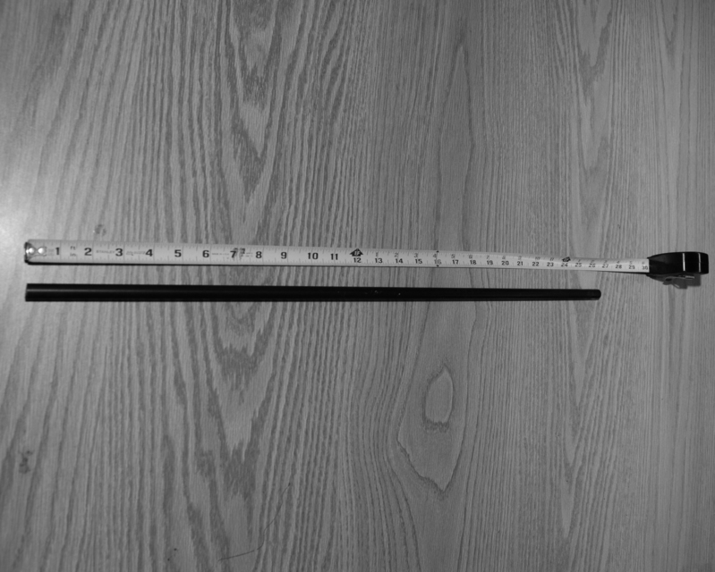

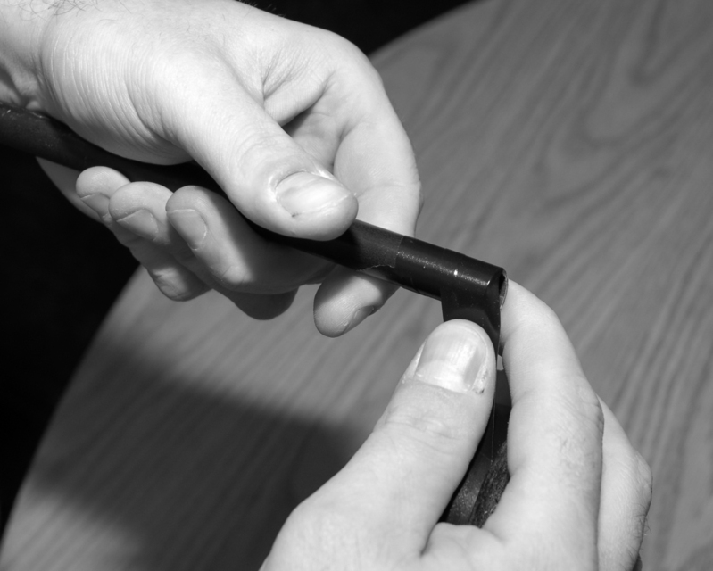

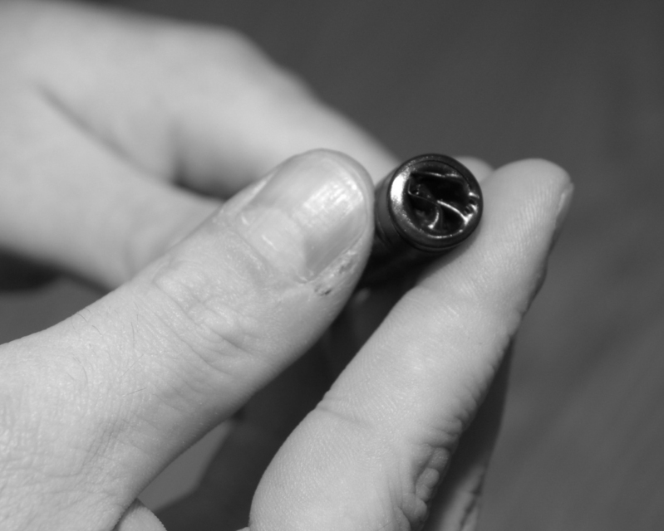

Making your blade is probably the most difficult part of the weapon. We start by making what is referred to as a “cricket bat”, a blank that we will cut our blade from.
Cut out three long rectangles of camping mat, 4" wide and 25" long. These measurements need not be exact, as they are designed to allow you room to make errors. The exact sword blade dimensions will come from your template.

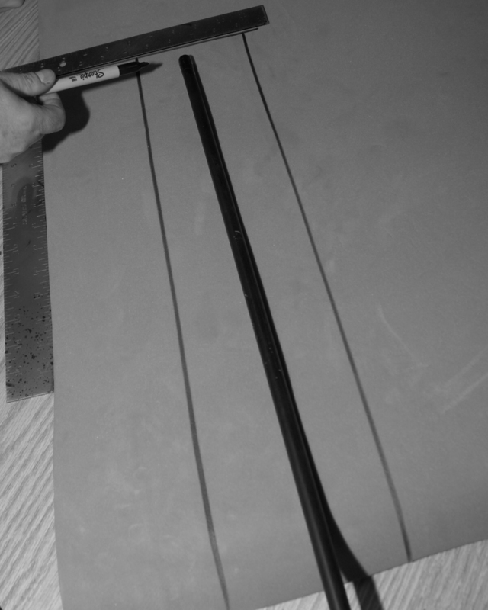

Lay one section of the foam on a flat table, and trace your core onto it. Then, using your knife, cut out the resulting channel.

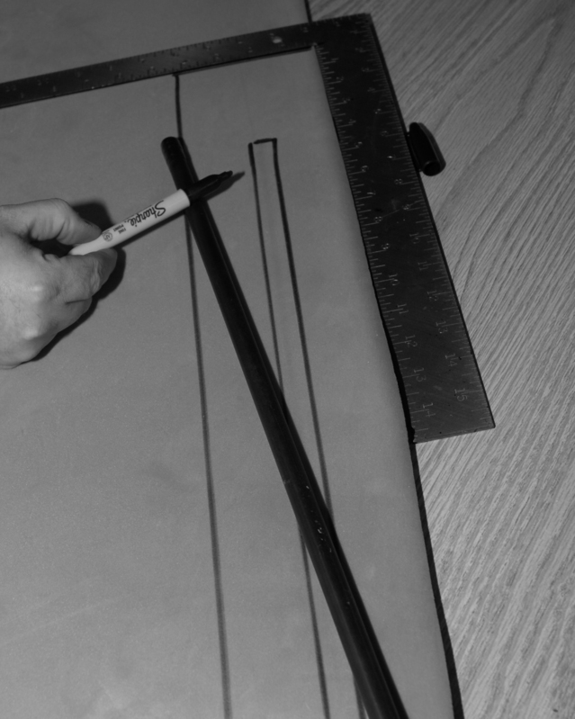

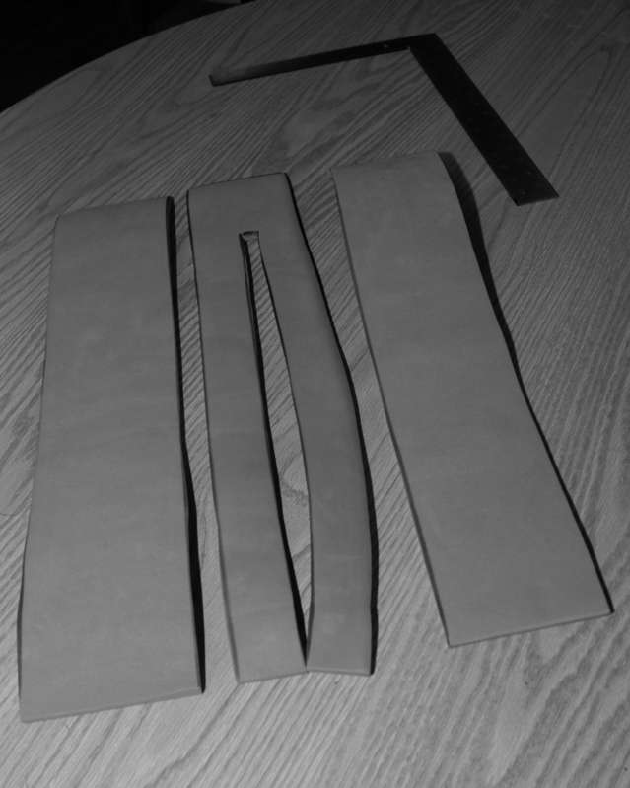

With DAP, lightly coat the blade end of your core and the inside of this channel, as well as one side of each of the two unaltered rectangles.

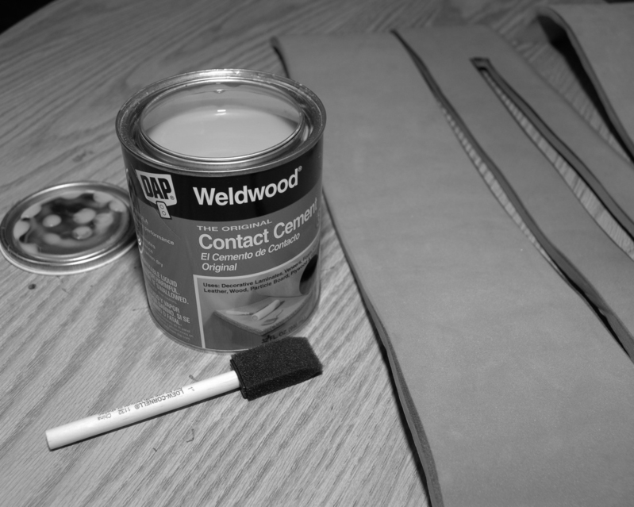

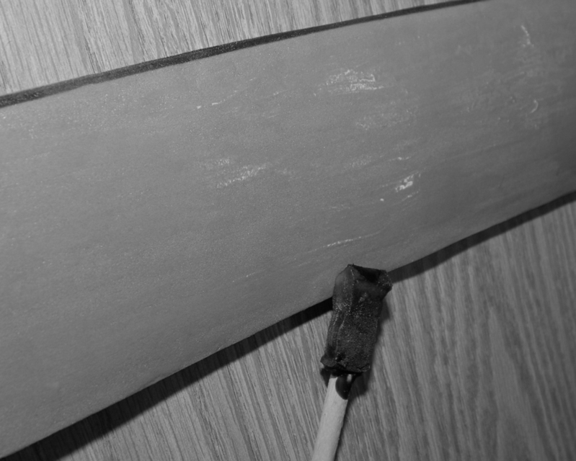

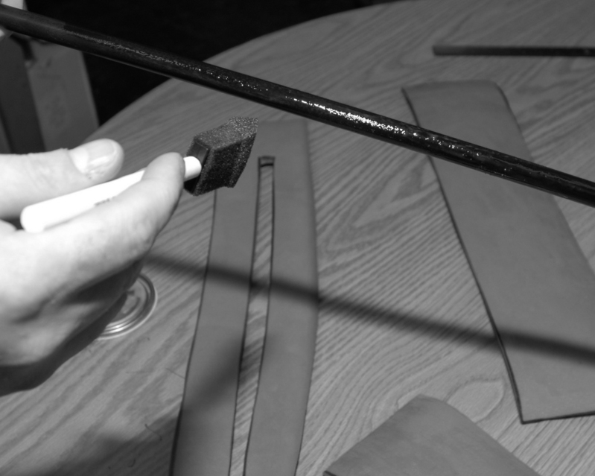

Let it dry. You MUST let the cement dry 10-15 minutes before attempting to stick pieces together. Use your clamp to hold the core upright while drying.

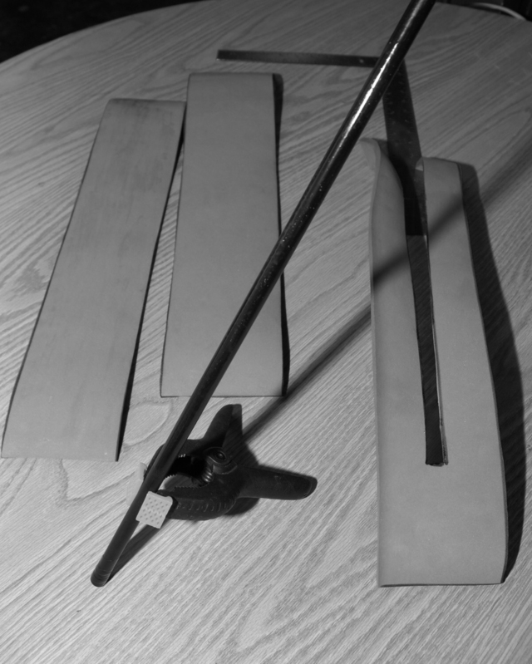

Next, carefully attach the slotted center piece of foam to the core. Make sure to try and keep it straight; if it is not straight down each side of the core, your blade will have a twist to it.

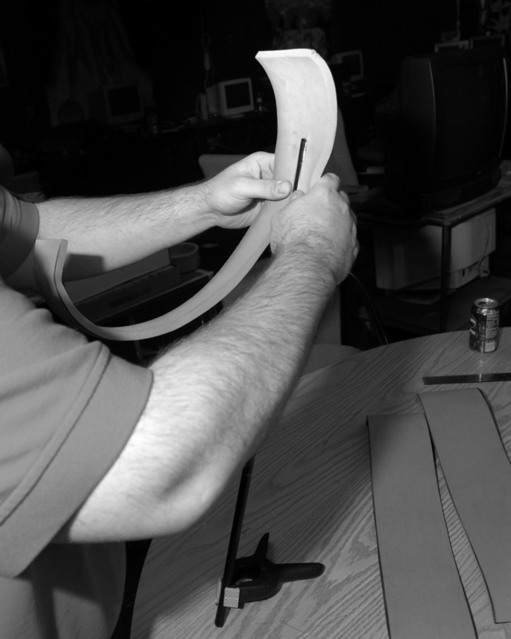

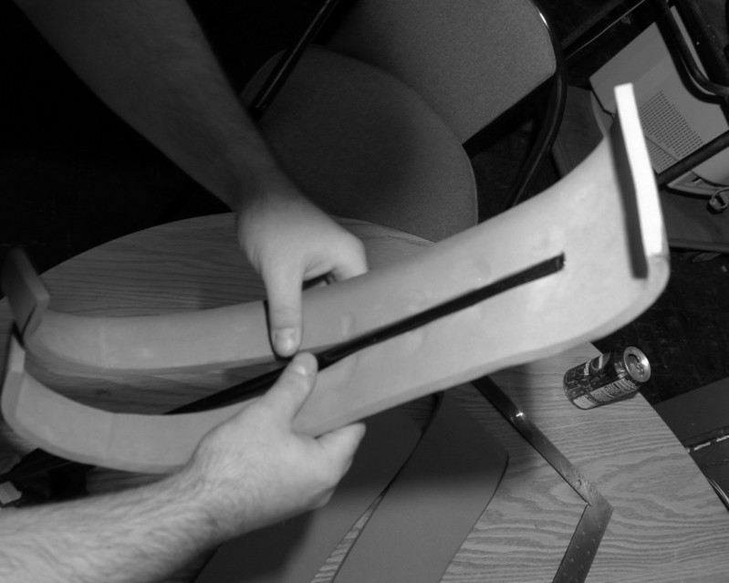

Lay the blade flat on a table, and carefully squeeze the foam against the core to remove any gaps. Once that’s done, coat both sides of this center piece of foam with Dap, and let it dry.

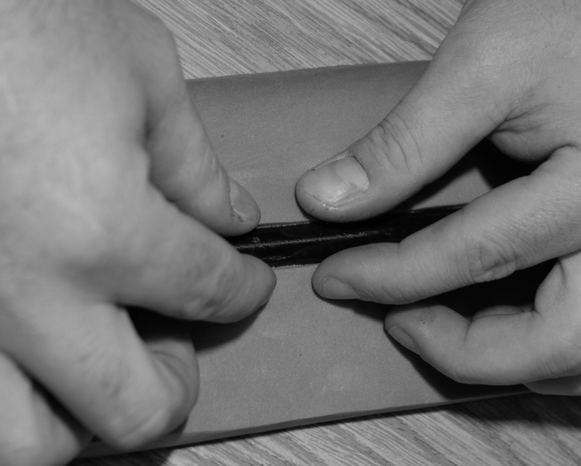

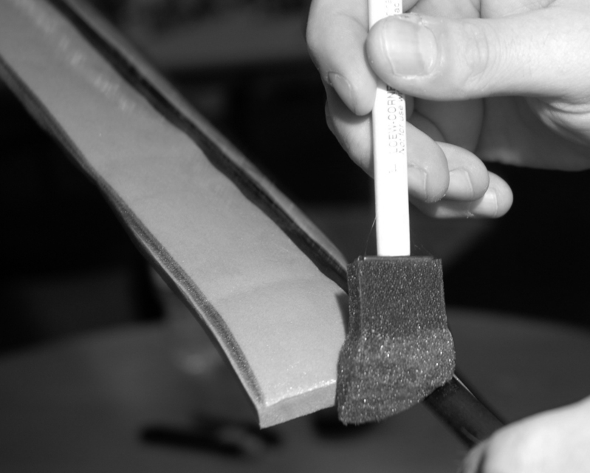

Once the Dap on the center piece is dry, cut out two small pieces of leather, and coat one side of each with Dap. These patches will be placed over the tip of the core and sandwiched between the outside layers of foam. They should only be about an inch wide, or you risk exposing them when you cut the blade out. These patches prevent the core from ripping through the tip of your blade. Once you’ve stuck them on, cover them with Dap and let them dry.

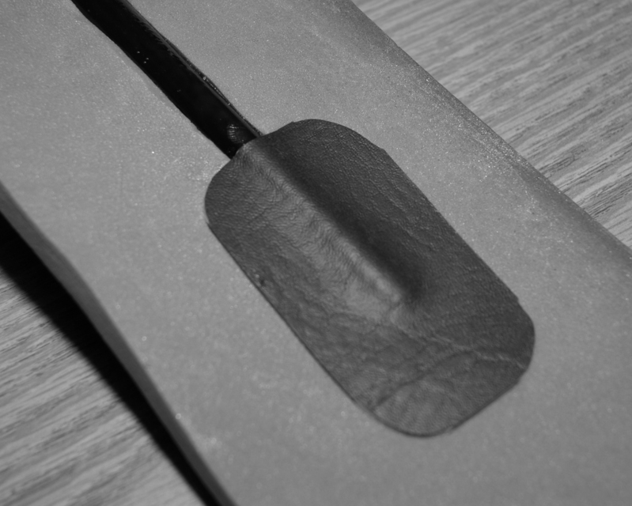

Once everything has dried, it’s time to finish your cricket bat. To do this, place the blade flat on a table, and carefully stick on the outer layers of foam.

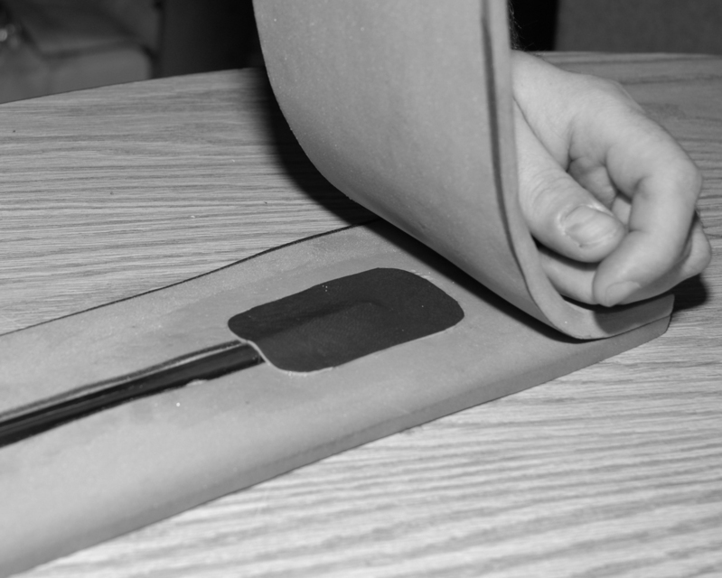

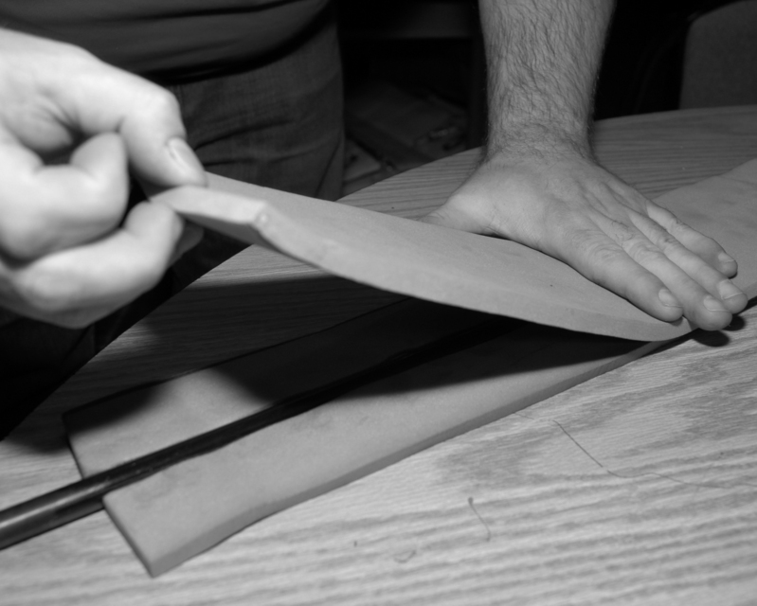

Once that’s done, you have your cricket bat. It should resemble a three-layer block of foam on a stick. Leave this alone for the Dap to set for an hour. Go read the forums or something...
Next it’s time to draw your blade shape on the cricket bat with your Sharpie. If you’re using a template, place your template on the blade. The point should be two to three inches from the end of the core. Trace it, making sure it is centered. Sometimes an extra pair of hands helps here.
If you’ve chosen a simple shape, you can draw your blade directly on the cricket bat with your Sharpie. Draw two long lines the length of the cricket bat, each about 1.25” from the core. The end of the core should be easy to find, make sure you mark exactly where it is. Then draw a point on the end. This point should be two to three inches from the end of the core. Remember that if it is too pointy, it will be a safety hazard, and so will not pass inspection by the Weapons Marshals.

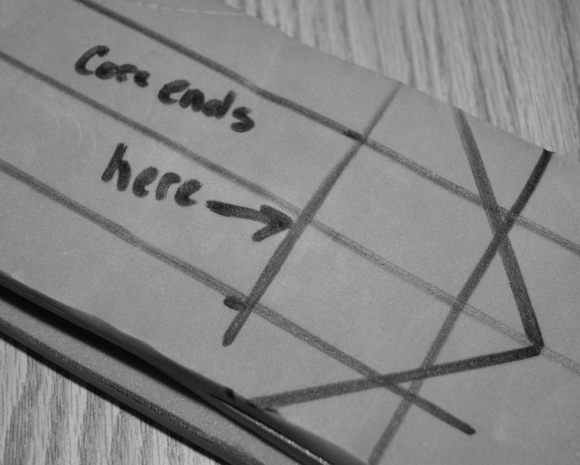

Keeping the sword flat on the table, slice your blade out along the lines using your utility knife.

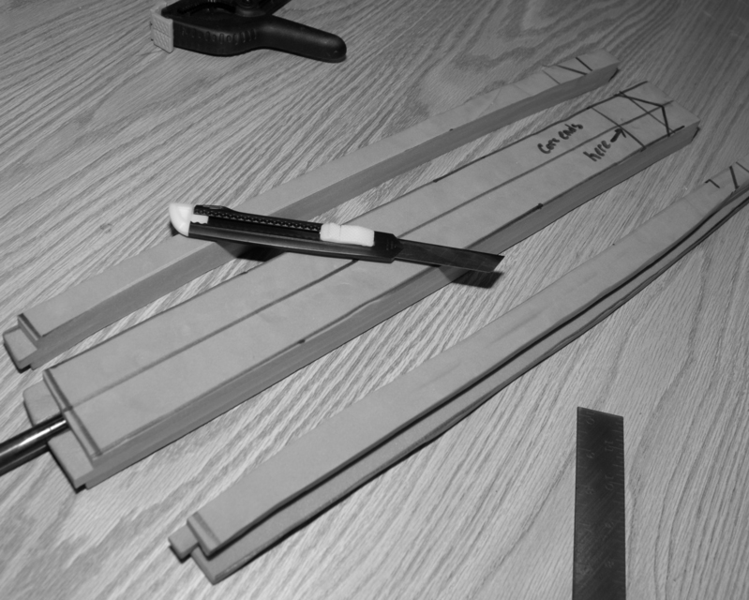

If you make a mistake, leave a lump, etc., you can use the hot tip of a glue gun to smooth it out. A hot iron works also, but the iron will be ruined for use on clothes after that. And BE CAREFUL! You can easily ruin your blade doing this too much, or give yourself a nasty burn. Some types of foam are more receptive to this sort of shaping, and some will not shape at all, so take care when cutting it the first time – you may not be able to fix any mistakes you make at all.
Next, shape the edges of your blade. The goal here is to pare away the outside layer of foam, but to leave the center layer mostly intact. Trying to cut down the edges to an actual thin edge is usually too hard to do, and raises safety issues, so don’t try unless you’re very experienced.

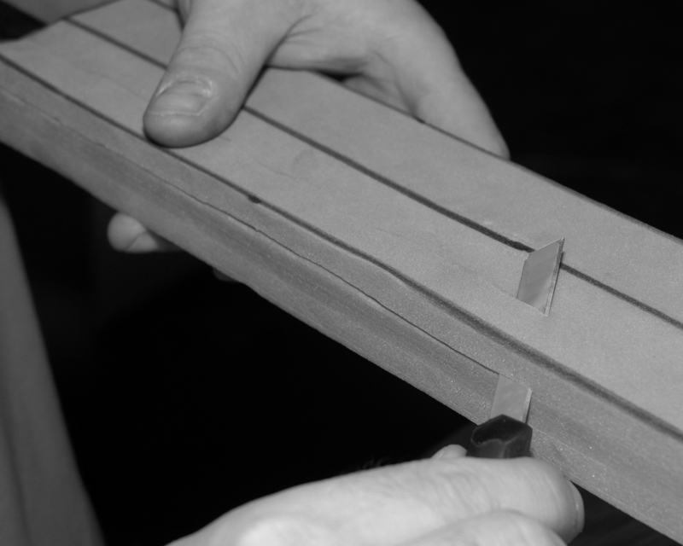

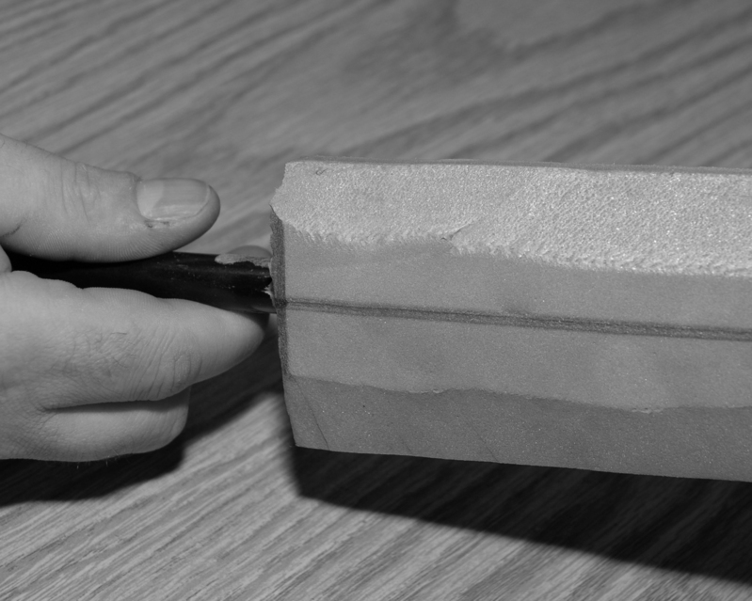

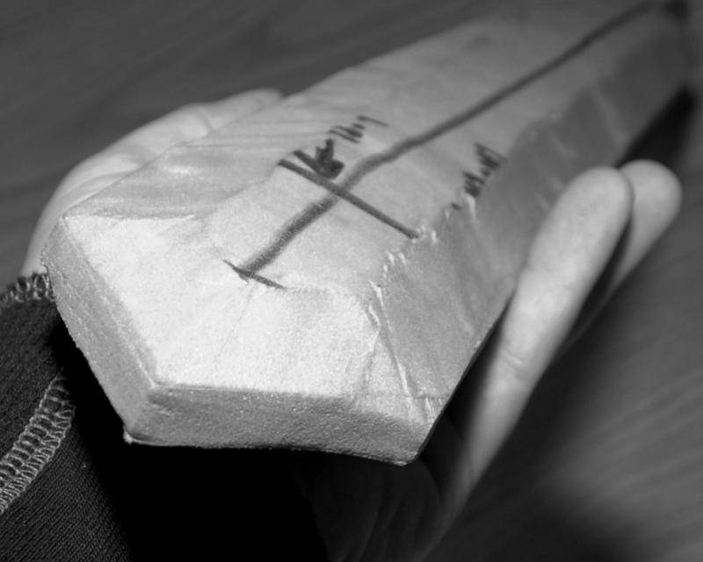

Now your basic blade is finished, and it is time to move on to the hilt. There are many construction methods for a hilt, but probably the simplest one is to make it of more layers of foam.
Begin by cutting out four rectangular pieces of foam, roughly 6” by 3”.

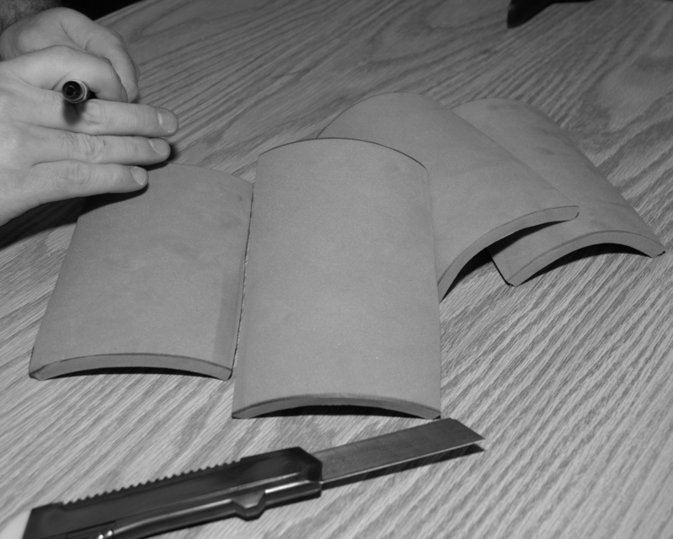

Use Dap to stick them together in pairs, then use your knife use a sharp knife to cut a channel in the middle of each double-width foam block. Coat the inside of those blocks, including the channel, with Dap. Also coat the section of core right below the blade, and the top of the foam blocks where they will touch the bottom of the blade. Give a final coating to the bottom of the blade, where the core sticks out.

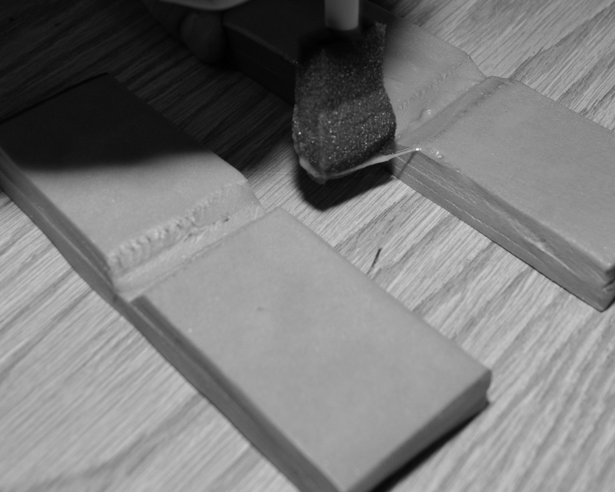

Once the Dap is dry, squeeze the two blocks together around the core, directly below the blade. You should also ensure that it presses against the bottom of thee blade, fusing the entire assembly together.

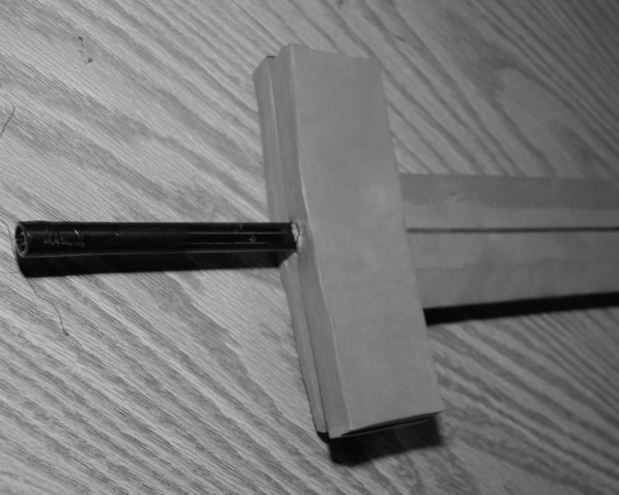

Draw the shape of your hilt onto the foam block. A roll of tape makes a good template.

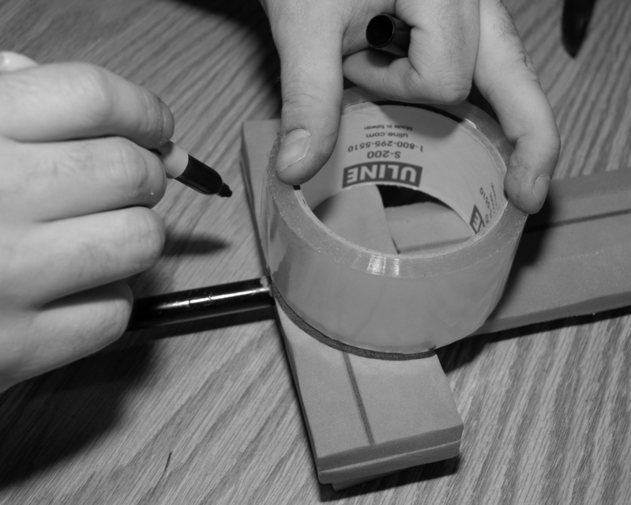
Carefully cut the shape out with a sharp knife, and then pare the edges just like you did your blade.

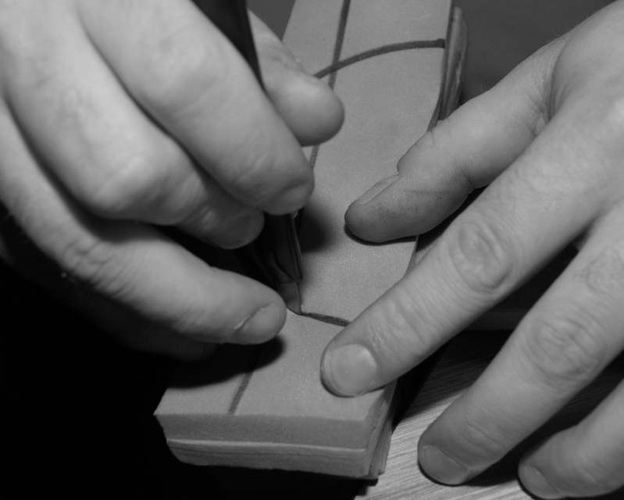

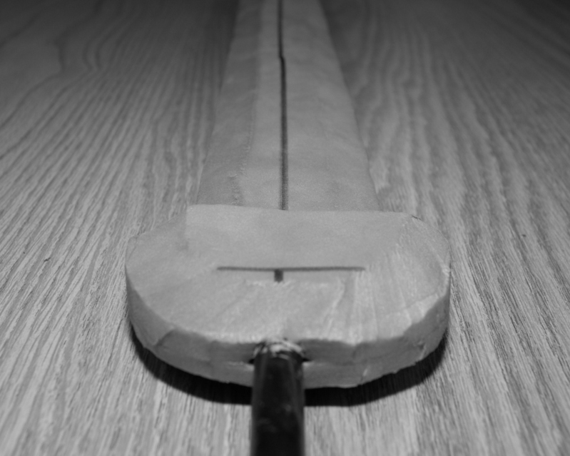

If you desire a foam pommel, construct it in a similar fashion, ensuring that there is at least 1” of foam past the end of the core. While the pommel of a weapon is not a legal striking surface, for safety reasons it should still be either padded, or constructed of something larger that the orbital socket of the eye to avoid accidental injuries.
Now we begin coating your sword with layers of latex and sealants. Step one is to coat the entire blade with a layer of Dap. The Dap adheres well to the foam, and forms a base layer to start applying your liquid latex to.
The next step is to coat the weapon with two or three heavy coats of liquid latex. Brush it on with a foam brush, and be sure to coat all exposed foam, and to push the latex into all cracks and crevasses on the weapon.

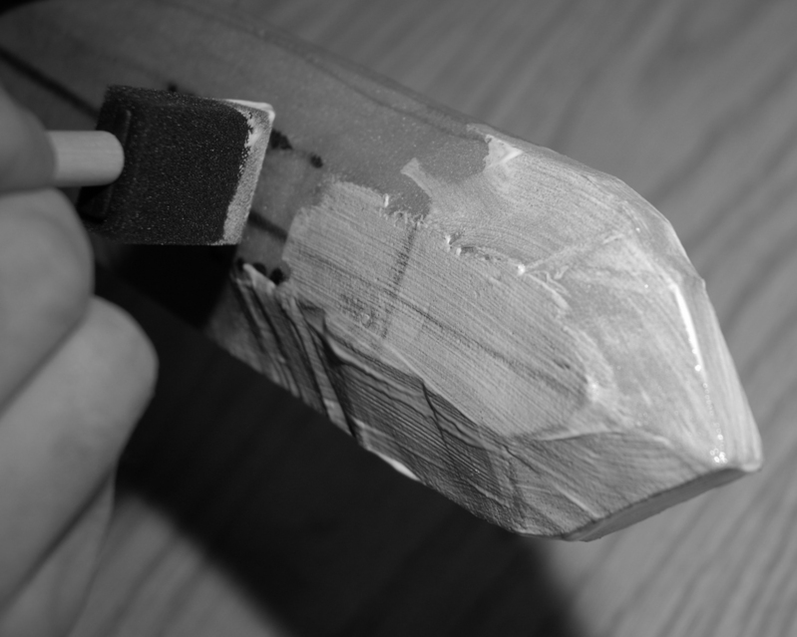

When liquid latex initially goes on, it is a white color. As it dries, it will turn a translucent yellow and harden. Liquid latex is not self-leveling, that is, it will not form a level surface on it’s own. If you brush it over lumps and protrusions, it will only emphasize those imperfections. This is why it is important to correct any such flaws before starting the coating of the blade. Each initial coat of pure latex will take at least an hour to dry, so do not move on to the next one until there are no white spots visible anywhere on the weapon.

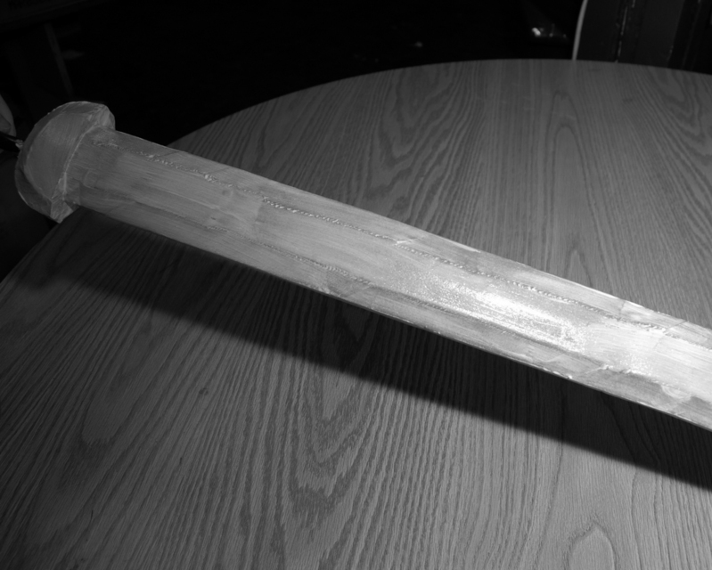

Once you have completed the initial two or three coats of raw latex, you can move on to the next step: using colored latex.
To make colored latex, simply pour some latex into a cup or other container, add acrylic paint, and stir well. You are looking for a ratio of approximately four parts latex to one part paint. Once you have achieved the shade you want, apply it in the same manner as the raw latex, but in a lighter coating.
Most weapons should first receive two or three layers of black-tinted latex as a base coat. This thoroughly covers the color of the foam underneath. After the weapon is entirely opaque black, move on to silver- or grey-tinted latex for the blade, and a metallic brass or gold color for the quillions and pommel. This coloration typically requires another three to five coats.
Each of these coats takes about a half hour to dry completely, and you should not move on until they have dried thoroughly.
Once the layers of latex are complete, the final step is to apply a sealant. While some people simply dust the weapon with talcum powder or hair spray, a more durable and professional method is to use a clear rubberized roof sealer. The brand we have found to work best is called “Through the Roof”, and is commonly sold at Ace Hardware stores and online at Ace’s website.
Use a plastic spoon to dip some of this sealer into a disposable container, and then dribble in a small amount of the mineral spirits to cut the thick sealer and make it brushable. Stir well, and apply it liberally to all latex surfaces of the weapon, then let it dry overnight.
The final step in the construction of your weapon is to add the hilt. Build up the hilt with leather, hot glue sticks, cardboard, dowels, or whatever else you desire. Tape helps a lot to hold things in place, as does a hot glue gun. Once your hilt is the shape you desire, cover it with leather, cloth, wire, tennis racquet tape, or hockey grip tape. Super glue is very helpful in securing your hilt covering.
.
Construction tips

- LET YOUR DAP DRY!!
- Often, it helps to lubricate the blade of your cutting knife a little. Silicone spray works well.
- Use combinations of colors to make your sword stand out, or all black for a sneaky weapon.
- The more twisties and curvies your blade has, the harder it is to make cleanly.
- Keep your knives sharp. The utility knife you use for this sword SHOULD NOT be used for another. It is already too dull. Don't be cheap, they cost 45 cents each.
- Experiment with different materials for your hilts and pommels.
- A strip of leather from an old coat or backpack bottom makes a great hilt grip.
- Try substituting a ping pong ball, racquetball or tennis ball for a pommel. Fill it with hot glue for a counterbalance, and paint it like a huge gemstone.
- Use a three, six, or nine inch lag bolt to counterbalance your hilt.
- To make a curved blade, use CPVC for a core. Heat the CPVC gently with a blowtorch and bend it AWAY from the heated side.
- You can make basket hilts for cutlasses or rapiers using foam strips or leather.

Armor
The mortal body is a fragile shell easily broken under the assault of everyday life in a world such as Novitas. While it is possible for a character to condition their body through physical training (represented by the purchase of Body points) there is a limit to the body’s ability to absorb damage. To counteract this limitation, many characters opt to wear physical armor such as leather tunics or suits of chain or plate.
Physical armor is very strong and allows the character to gain more points than magical armor can offer, but often weighs a great deal and slows the player down. Unlike Magic Armor, physical armor is not affected by the spell Dispel Magic, assuring the character will not lose their protection to a quickly tossed beanbag!

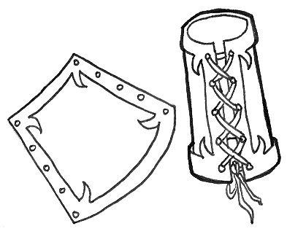
The maximum number of physical armor points any character can obtain is seven. To gain seven points of armor the character would have to wear five points of articulated plate armor and a heavy helm. This limit does not include the Magic Armor spells, which allow the character up to four more points of armor for a total of eleven (seven physical and four magical).
The first question typically asked after hearing the limit of seven points of physical armor is, “What if I wear more armor on other locations of my body, will this increase my armor points”? Armor in Kingdoms of Novitas is based on coverage - meaning a player is not allowed to claim their armor points against hits that strike an unarmored area. For example, if a character wearing a waist length chain shirt is hit in the shin, the damage goes to their Body points and not their three points of armor. This rule has two effects on game play: it rewards players that own and are fit enough to wear lots of armor, and lets skilled fighters exploit openings in an opponent’s defenses.
For game purposes, an area is considered totally covered if the armor in that area covers 75% or more of the location. It is not possible to skip through an opponent’s armor by hitting small gaps in protection such as the skin between a player’s glove and forearm armor.
Mixing armor to gain a greater amount of coverage is a common practice and often allows a player to develop a highly protective and adaptive style of armor. For example, wearing a chain shirt under a metal breastplate allows the character to have the protection of plate combined with the flexibility of chain. Layering or combining armor types never allows a player to increase the number of armor points they have above seven.
Combining or layering armor does not give a player more than one armor point value. The character still has a single, main armor value that is based on the armor they are wearing on their torso. In order to wear other armor, such as legs and arms, and have it count as coverage, that armor must be no more than one level lower than the player’s torso armor value. A player is, however, free to count his torso armor as lower than its listed value to get his arm and leg armor to count. So, a character wearing a metal breastplate (four points) would need to combine this with three-point armor (chain, thick studded leather, or hide) and no less to receive the full armor point value for his armor. If a player wore a metal breastplate with heavy leather vambraces and greaves, only the breastplate would count towards the character’s armor points and coverage. The player would, however, be free to count his breastplate as three point armor, which would let his arms and legs now count towards his coverage. This rule also applies to helmets.
Bear in mind that players may never count any part of their armor as being worth MORE than its listed armor point value – it is only possible to count something as less. The full rules for how armor affects combat is included in the Combat section of these rules.

Rules of wearing armor

- A Game Master has the right to inspect a player’s armor at any time and is not required to give a reason.
- A Game Master is allowed to remove armor from play for any reason they deem fit and at any time they feel necessary. In most cases armor is removed because it is unsafe or damaged.
- A Game Master is allowed to declare a player unfit to wear armor and order them to remove their armor at any time. Typically a player is declared unfit due to health reasons.
- The more armor a player wears the harder their opponents might need to hit them. Players are not allowed to wear large amounts of armor then complain that opponents are hitting them with more force.
- If a player is wearing armor so rigid that there is no chance they will feel a legal blow they must practice and train themselves to acknowledge shots by other means such as sound or visual spotting. If a player is unable to take their hits they will not be allowed to wear the armor in question.
- Armor must never impede the normal movement of a player’s body in a fashion that endangers the wearer or prevents the player from following the rules of the game. For example, if a player is wearing armor that prevents them from kneeling, they are unable to properly accept leg wounds and are cheating.
- Armor must be attached or fitted on the body with proper integral closures such as buckles, laces, or snaps. Players are not allowed to jury-rig armor to their body with tape, string, or similar temporary means.
- Players in armor must respect the safety of all other players when in combat and avoid physical contact at any cost. Two armored foes making unexpected contact in combat can cause severe physical injury!
- The wearing of a helmet does not permit players to hit the armored character in the head.
- Wearing armor does not count as a costume and players are required to wear a proper costume under their armor at all times. This includes racial make-up EVEN if the player is wearing a helmet.
- Armor that is proven to cause unreasonable damage to weapons will be removed from play.

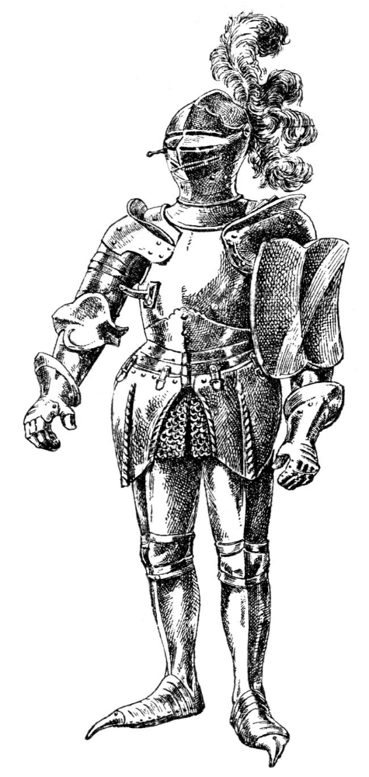

Helmets
Helmets are an enigma in a location based armor system that does not allow for head shots. Since wearing a helmet in no way adds to the coverage area of legal strike zones, they are handled differently than normal armor. A player wearing a helmet gains one or two additional armor points that are considered “universal”.
Headbands, leather bandannas, leather hats, and crowns are generally not counted as helmets. Helmets must be constructed of materials that conform to the requirements for other armored areas, i.e. within one point of the torso armor value. Players may always count a piece of armor as less protection than its material construction would allow, so a player wearing light leather can still wear a steel helmet and count the armor points for it, but a player wearing a chain shirt cannot wear a helmet made of light leather and gain any value for it.

Light Helmet
A light helmet is a helmet that does not cover the back and sides of the head and neck or the face.
This means that a character wearing a light helmet can count that single armor point no matter where they get hit - even if the area hit is not covered by armor. This applies even if the player is wearing no other armor than the helm. For example a character wearing a studded leather tunic and a leather helmet is hit in the leg for three points of damage. The helmet absorbs one point of damage and the rest of the damage goes to the character’s Body points. The player is not allowed to apply the two points of armor from their studded leather tunic because the blow did not hit that area.

Heavy Helmets
Heavy helmets are helmets that cover the entire head, neck and face and are usually held on with a chin strap. This encompasses chain coifs, sallets, bascinets, and so forth.
This means that a character wearing a heavy helmet can count those two armor points no matter where they get hit - even if the area hit is not covered by armor. This applies even if the player is wearing no other armor than the helm. For example a character wearing a steel breastplate and helmet is hit in the leg for three points of damage. The helmet absorbs two points of damage and the rest of the damage goes to the character’s Body points. The player is not allowed to apply their four points of armor from their steel breastplate because the blow did not hit that area.
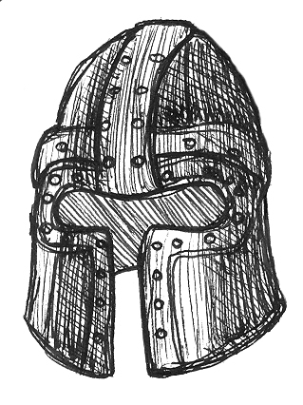

Armor values
1 point armor

- Full Costume: A player dressed in a full costume, free of anachronisms, from head to toe, is granted one point of complete armor coverage. This allowance may not be combined with a helmet or other armor. Players who wish to claim this point of armor must present themselves in full garb to Logistics to be inspected.
- Padded armor: ½” of padding (foam, horsehair, batting) covered with or sewn into cloth, such as a gambeson. This does not include multiple layers of normal garb.
- Light leather: Flexible leather 1/16” thick or thinner. Includes light leather with external fur. Also called garment leather.
- Light Helmet only

2 point armor

- Reinforced padded armor: As padded above reinforced with metal studs, rings, or plates set no farther than 2” apart and covering 100% of the armor’s surface. Also includes suits of padded armor with 1” of padding or more.
- Reinforced light leather: As light leather above but reinforced with metal studs, rings, or plates set no farther than 2” apart and covering 100% of armor’s surface. Also includes armor made from overlapping leather pieces such as scale armor.
- Heavy leather: Heavyweight flexible leather 1/8” to ½” thick. This would include armor made from heavy garment leathers such as latigo, and armor made from stiff vegetable tanned tooling leather.
- Any 1-point armor with a light helmet
- Heavy Helmet only

3 point armor

- Reinforced heavy leather: As heavy leather above, but reinforced with metal studs, rings, or plates set no farther than 2” apart and covering 90% of the armor’s surface. Also includes armor made from overlapping heavy leather pieces such as scale armor.
- Chain armor: Armor made of interlocking butted or riveted metal rings no larger than ½” in diameter.
- Hide: Inflexible leather 1/4 inch or thicker. Also includes waxed or water hardened heavy leather.
- Any 1-point armor with a heavy helmet
- Any 2-point armor with a light helmet

4 point armor
The qualification for 4-point armor is rigidity - the ability to withstand blunt force trauma. 4-point armor grants the wearer the Monstrous ability, meaning the wearer will usually take only 1 point of damage from any source, regardless of the amount of damage called.

- Reinforced hide: As hide above, but reinforced with metal studs, rings, or plates set no farther than 2” apart and covering 100% of the armor’s surface. Also includes armor made from overlapping hide pieces such as scale armor.
- Chain and plate: Armor made of interlocking metal rings no larger than one half inch in diameter and containing solid metal plates covering at least 50% of the armor’s surface. Also includes metal armor worn over a separate chain shirt. Metal plates must be made of metal 1/16 of an inch thick or thicker.
- Plate: Armor made from solid pieces of formed metal. The metal in plate armor must be 1/16 of an inch thick or thicker.
- Any 2-point armor with a heavy helmet
- Any 3-point armor with a light helmet

5 point armor

The qualifications for 5-point armor are rigidity and articulation - pieces of the armor hinge and move with the joints of the body while providing complete, rigid coverage over 75% of the covered areas. 5-point armor grants the wearer the Monstrous ability, meaning the wearer will usually take only 1 point of damage from any source, regardless of the amount of damage called.

- Articulated plate armor: Armor made from solid pieces of formed metal. The metal in plate armor must be 1/16 of an inch thick or thicker. The joints of articulated plate armor are hinged or strapped, and can bend and move with the movements of the player while still providing complete coverage.
- Any three point armor with a heavy helmet.
- Any four point armor with a light helmet

6 point armor

- Any 4-point armor with a heavy helmet
- Any 5-point armor with a light helmet

7 point armor

- Any 5-point armor with a heavy helmet

Some further notes: The Monstrous ability is only granted to areas covered with 4-point or 5-point armors, not to areas covered by 3-point armors being counted as 4 points because of the player wearing 4-point torso armor.

Shields and Bucklers
Players are allowed to use shields if they have the skills Buckler Fighting or Shield Fighting. Shields must be made of a material strong enough to endure the rigors of combat, but not so solid and heavy that they pose a danger in combat. Shields should generally be constructed of lightweight aluminum, heavy plastic or ¼ inch plywood. Steel and plywood or planks thicker than ¼ inch are usually too heavy to be safe.
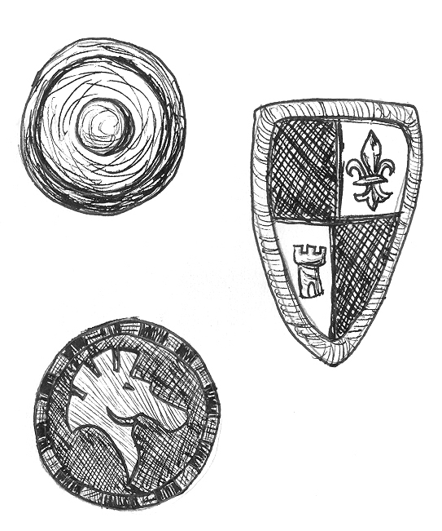
Shields made of plastic MUST be covered to hide all plastic surfaces. This can be done with cloth, leather, and paint. The edges of a shield must be covered in one half inch of foam (pipe insulation works well) to prevent the hard edge of the shield from injuring other players or damaging weapons. The foam should be snugly secured to the shield with tape, glue, or cord to prevent the foam from falling off during combat.
The shield must be controlled with a hand to count as a shield. Shields and bucklers that simply strap to the arm are not allowed. Shields worn on any other part of the body (back, side, etc.) does not count as a shield or armor. The face of the shield should be free of hazards like exposed screws or splinters that might cause an injury in combat.
Since head shots and physical contact are not allowed during combat, many of the techniques designed to defeat shields are not possible during play. For this reason, shields are restricted in size. No non-round shield can exceed 720 square inches. No single dimension of the shield may exceed 40 inches. The largest round shield allowed in play may not exceed a 36 inch diameter circle.
Bucklers are limited to 24" diameter round shields or 324" non-round shields. No single dimension of any buckler may exceed 24”.
To save the Game Masters and Logistics personnel from needing to do trigonometry, the size limitation is measured very simply. Non-round shields will be measured across their two longest lines, and those numbers will be multiplied. This means that a triangular shield that is 30” high by 24” wide is, as far as Logistics is concerned, the same size as a rectangular shield 30” high by 24” wide, and both are 720 square inches. Cutouts and irregular shapes are never taken into consideration when determining if a shield is of legal size. As far as Logistics is concerned, all shields that aren’t round are rectangular.
Remember when making your shield to allow for padding on the edges as well. A half inch of padding is required on all shield edges to prevent damage to weapons.
Special mention should be made about “turtling”. Turtling is when a player crouches down behind a shield, exposing only their head, and no legal target areas in their front 90 degree arc. In real battle, this tactic is entirely unrealistic, as your opponent would simply rain blows on your head and neck, or kick you over with his foot. At Kingdoms of Novitas, however, that would be illegal as the head is not a legal striking area, and bodily contact is illegal. Because of this, the tactic of turtling is cheating. Regardless of your actual shield size, if a Weapons Marshal deems you are so small that you are effectively turtling with your legal shield, you will be required to reduce the size of your shield.
A final note about shields: in-game, they are vulnerable to the damage call of “Acid!” Any shield or buckler can stop three points of acid damage with no ill effects, but the fourth point of damage from acid will destroy the shield, rendering it useless. The player with the shield must immediately discard the shield, and it is of no further use until it receives a casting of the Mend Armor spell. A single Vial of Acid, which does four points of acid damage, will destroy a shield or buckler.

Armor construction
All armor worn by players must be REAL armor constructed in a traditional fashion and made of authentic looking materials. It is not acceptable for characters to tape plates of metal to a shirt and call it plate or spray paint a wool sweater silver and call it chain. Lacrosse gloves, football pads, hockey helmets, or plastic motocross torso guards are all unacceptable. Players are allowed to use unauthentic materials such as plastic or aluminum to save on weight or cost, but armor of this nature MUST be constructed in a fashion that conceals the unauthentic nature of the materials. Kydex armor, while wonderful for the SCA, has no place at Kingdoms of Novitas, even if it’s been spray painted silver. While we’re talking about the SCA, it should be mentioned that duct tape and carpet are not armor. There should be no tape visible on your armor. Armor that ruins the atmosphere of the game will be forbidden and removed from play!
Players have a large amount of leeway in the design of their armor, how it looks, and is constructed. Kingdoms of Novitas is a fantasy game, so players might employ components not normally seen in “medieval” armor such as snaps or nickel-plated buckles. Many players stick to authentic armor designs because it presents the image of typical fantasy armor and patterns and examples of construction are easier to find.

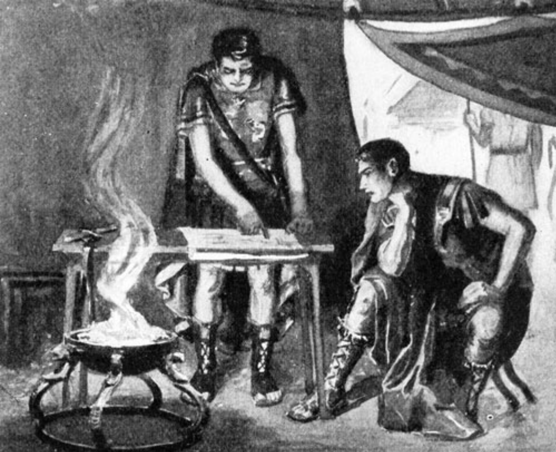

10. Adventuring
The Neonoviteum, or, Tools for the New Player

Hi! Welcome to Kingdoms of Novitas. This isn’t really a chapter on roleplaying, what a fantasy LARP game is, or any sort of theoretical mumbo-jumbo. What follows are a bunch of tips and tricks, a handful of "what to expect", and information that should help a new player get acclimated to the Kingdoms of Novitas game. While this is intended for the new player, even our veterans may find something here that will help them with their game play.
The most basic advice? Make use of the game lexicon, found in the back of this rulebook. Knowing the communal language is the key to understanding what's going on, here and in the game.

Kit, Gear, Garb, and Weapons
"You don't understand, an army doesn't just roll out of bed and run into the swamp. Hell, I've gotta get dressed, climb into my gambeson, pour on the chainmail, gotta be squired into my bindings and bracers, shake out the tunic, strap on my beltpouches, oil the sword, make sure all the potion stoppers are tight, coil my rope, fuel up my lantern, police my bunk, drink down a liter of water, choke down some rations, review the orders coming down from Command, pass the word to the men, help the recruits into their gear, muster the squads, assign marching order, and then bake in the sun and wait for Command to decide it's time to march. We're not Adventurers, Runt, we're the Legion." -- Sgt. Meridius Drace, Nightmare Legion

The first step in LARPing is looking the part. Other sections of this rulebook discuss the particulars of dress and bearing for the particular races and societies of Novitas. Here we'll discuss two things: why garb is important, and how to build your kit.
The question of why is answered by one example: Imagine seeing your favorite movie, and having someone in the theater talking on their phone behind you. It’s distracting, rude, and inconsiderate. Kingdoms of Novitas strives to create an atmosphere where the players can get a sense of “really being there.” When something is visible that wouldn’t belong in our fantasy setting (such as plastic cups, sneakers, jeans, candy bars, etc), it breaks the suspension of disbelief. Putting effort (and money) into your character’s kit (and your NPC kit) helps your fellow players forget the real world in favor of our shared fantasy. While we may compete in-character with each other, out-of-character everyone shares this experience. We are all responsible for each other’s fun, and your garb is the first best way to fulfill that responsibility.
Every player is responsible for two sets of garb; one for their own individual character, and one to wear while they are NPCing. Kingdoms of Novitas has a wide range of historical influences available to draw from while putting together your garb. While your PC garb should be personalized to your on tastes, your NPC garb is a little trickier. It should be both period appropriate as well as generic. This lets the Game Masters add small pieces to your garb to make you suitable for a variety of NPC roles. Those people who have terrible NPC garb tend to be cast as Orc raiders, over and over and over and over. While this can be fun for a while... you'll soon notice that other people are getting better parts. Bad garb also limits the Game Master; if Game Masters only have NPCs wearing minimally acceptable garb, this means that the Game Master may have to abandon certain plots that call for something other than Orc raiders, for example.
Building your kit can be a tricky affair, but there are plenty of resources to help you. The steps usually follow in this order:

Get inspired
Find some clothing or equipment from a movie, History Channel special, novel, comic book, encyclopedia, or painting that you want to borrow for your character. Run a Google Image search for what you’re trying to portray; “elf warrior”, “barbarian scout”, “roman gladiator”, and see if any of the images are something you’d like to wear. Mix and match, make mental alterations, sketch out your designs. Not sure what a particular piece of clothing is called? Check your local library and see if they have any visual encyclopedias of historical or ethnic costume. Most four year colleges have a theater department, and that means they should have library materials to support that department. Even if you’re not a student, you should still be able to go use the resources in their building. Bring a notepad, and take notes. Make sure to jot down what particular articles of clothing you like are called. “Trews”, “hakama”, or “Lorica Segmentata”, for example. Having this written down will make the next step easier.

Use the Internet
The Kingdoms of Novitas forums have a number of resources that your fellow players have used to build their own kits. Browse them, see if there’s anything that approximates your desired garb. If not, use the Internet again to search for particular pieces of garb. While there are some gorgeous pieces of work available, they can also be somewhat expensive. But places like eBay.com and etsy.com can sometimes surprise you with what they’re offering. The trick in using the internet to search for your garb is in using synonyms -- different words that mean the same thing. “Medieval pants” could also be “trews” “slops” “trousers” “hose” or “tights”, for example. If one search doesn’t find anything, try a different one. You only lose when you give up.

Check local thrift stores
The Salvation Army, Military Surplus, or Goodwill. While the clothing there is decidedly modern, you might be able to make alterations to make it less anachronistic. Cultivate an ability to browse the other gender’s section, as well. If it fits, and you’re planning to cut it up anyway, what does it matter? (For various odds and ends like wooden bowls, forks, etc, check Walmart or Target.)

Contract a local artisan
We have a few people in the game who have learned to sew, stitch, leatherwork, and the like. Some may be willing to practice their skills on something you’re interested in. The key here is to be polite, and understanding -- while Kingdoms of Novitas is a fun hobby, it is still a hobby. The artisan in question might have real life things in the way that will keep you from getting your garb immediately. Additionally, they won’t do as good a job if it isn’t fun for them. Make them part of the process – get their input, see if they have suggestions, and be willing to help out. Ask around at game, everyone knows who does what work.

Renaissance Fairs
This is a great but expensive place to find garb, and talk to people who know what they’re doing. You might slowly save up over the course of the year, so you can have enough cash on hand to get a few pieces of garb at the fair. Or, you could visit the fair on the last day it’s open. Some merchants would rather sell their stock at a discount rather than pack it all back up and haul it away.

Learn to sew, stitch, and the like
There’s a long list of specialized skills that would benefit the average LARPer: leatherworking, making chainmail, blacksmithing, ceramics, knitting, electronics, and carpentry are a few. Eventually, most committed LARPers end up going this way. Finding patterns, cloth, and hardware at craft stores is easier than one would think. And if your first pieces come out looking a little rough, that’s actually not a bad thing. Most authentic period clothing would be hand stitched, be a little worn and torn, and generally appear “lived in”. Imperfections only add to the authenticity. Just remember that someday there might be a new guy who was in the position you were in. Be sure to help them get started.
Lastly, build your kit piece by piece. Or, in other words, never stop shopping. Looking at some of the kits in Kingdoms of Novitas can be intimidating. We have painted barbarians wearing furs and leathers, warriors in full metal armor, druids and elves arrayed in forest garb, etc. All of these players also have appropriate weapons, pouches, forks, mugs, and the like.
The lessons here are three-fold: Don’t be intimidated by what you see, these kits are the product of years of collecting individual pieces. Slowly build your kit as you can, using all the resources above. And remember that what makes a fantastic kit are the small touches. Authentic forks, chopsticks, mugs, candles, rope, incense, instruments, knick-knacks, quills and journals can all say much more about your character than one might expect. In fact, when your current kit is done, start thinking ahead to your next PC, and start collecting things for that character slowly. Having some extra garb ready to go if your current PC suddenly dies will make the transition easier.
Latex weapons can usually be found and purchased online, though we do have a few people at game who build their own as well. Directions for building your own basic LARP weapon can be found elsewhere in the rulebook. All weapons must pass an inspection before being allowed into the game. No matter how you get your weapon -- build it, buy it, or barter it -- it'll be an investment, so be sure to devote time to upkeep on your weapons. Keeping them dry, cool, and out of the sun when not in use will make them last longer. Spraying down a weapon with silicone helps preserve them from the elements. Repairing a damaged quillion or pommel keeps them safe. Don’t just leave your weapons in the back of your truck for a month, and expect them to be perfectly fine. Warriors kept their sword oiled, sharpened, and clean so it wouldn’t fail them on the battlefield. Follow that example with your own kit, and your investment will last longer.
No matter how good your LARP kit, it is perfectly reasonable to need to have some anachronisms on your person. Glasses are always forgiven, but be sure to secure them with a strap. An accidental face shot at night might end up with a player losing their glasses for good. For other things, though, the rule of thumb is to hide what you can. A wristwatch can be worn under a leather band, for example. A water bottle can be hidden in a hip bag, if you cannot find a waterskin for sale. Medicines can likewise be kept in a pouch for emergencies. For the cold months, wearing thermals under your garb is advisable. If you must have some artifact of modern living on your person, spend some time figuring out a way to keep it hidden -- a scarf will cover the collar of thermals, burlap will cover sneakers, etc. Your fellow players will thank you for the effort.
This last part of your kit is optional: your encampment. Decorating a cabin to as though someone lives in that setting helps the entire game. Kingdoms of Novitas has one permanent encampment, and that is the Inn. However, individual adventuring parties sometimes spend some effort in assembling their encampment to their particular flavor as well. Walk around either before or after game to see what people have done, if you don’t get to see it while playing your character.

Sample first timer’s kit:

- PC garb. Includes: Boots, burlap boot wraps, trousers/skirt, blouse/tunic, belt, beltpouch, cloak.
- NPC garb. Includes: Boots, burlap boot wraps, neutral colored trousers, tunic.
- Electric lantern
- Food for the weekend
- Drink for the weekend
- Medications (if applicable)
- Boffer weapon
- Sleeping bag/blankets
- Pillow
- Matches
- Pocket knife
- Wooden bowl
- Spoon, fork
- Mug/goblet
- Toiletries
- Towel
- A few pairs of socks
- Seasonal gear: bug spray, thermal underwear, wool socks, gloves, hat, scarf, extra drink, a fan for the cabin (some have electricity, some don’t), firewood.

Later additions to your kit might involve things like armor, rucksacks, a trap kit, rope, canteen, extra weapons, magical treasures earned in the game, your coin and gems, a journal, quill and ink, chalk, candles, encampment props, etc. If you think you can use it, and you can carry it... go nuts.
What will happen at my first event?
Your first event can be intimidating, here’s what you should expect, in a handy checklist format.

Before game:

- Check the weather. Is it going to be cold? Hot? Wet? Muggy? Windy? Will you need winter weather equipment: gloves, hat, scarves, thermals, wool socks, etc? Will you need to bring a towel for a shower, after running around in the heat? Think ahead and it will save you a lot of misery while at the site itself.
- Check the game forums online. If there’s any sort of notice, update, or information regarding the game these forums are the first (and sometimes only) place where this information will be located. Ideally, you should be checking these forums once a week, more often as game time approaches to be sure you catch all updates.
- Make (and use) a checklist for your kits. Having a checklist to work off of makes it less likely that you’ll leave something critical behind, only to remember it while a mile into the woods and ankle-deep in mud. Use this list not only when you’re packing up to go to game, but also when you’re packing up to come home from game (because the Lost and Found posts on the forums illustrate how often people forget to take home everything they brought). List both PC gear, NPC gear, and camping gear on this list - everything that you’ll need.
- Have an idea of what kind of PC you’d like to play. At this point, you don’t have to have specific skills chosen. But having a concept of your character will help you, once you get to the point where you need to formally choose skills, spells, and race later on.

Arriving at game:
Follow the signs into the campground, and park. Before unloading, locate Logistics. This is the building that has the red sandwich board in front of it, and is a short walk away from the cabins themselves. Head on over, and introduce yourself to the players and Game Masters there. They’ll be able to give you advice on sign-in, building your PC, etc.

Important Questions to ask at your first event:

- Ask for some fighting pointers. You will not be swinging a sword like a baseball bat, for example, but rather you will be delivering a firm tap. Getting some practice in before the game begins can give you a sense of what to expect.
- Ask for a tour of the grounds. The campground is large, and there are particular locations that the game uses over and over. Getting a sense of where these are before the game begins can help you navigate later on.
- Ask where you should make camp. Mostly, the game uses either the cabins in “Pinedale” themselves, or else people tend to sleep in Logistics. Some players do, however, pitch a tent and make camp.
- Ask if there’s anything specific going on in the game that you should know about. Your fellow players love to tell their stories, be ready to hear them.

Make sure to sign in, pay the site fee, and build your character on a character sheet. A Game Master will have to sign off on your build before your new character is official -- a Game Master or another player should be able to guide you through this process. Having a rulebook on hand during character creation makes the process go MUCH more smoothly.
If you have any real-life medical conditions, please let someone know ahead of time. As part of this information, let them know what to do in an emergency and where any relevant medications are located.

Bunking in
After following whatever directions the Game Masters have for you, and introducing yourself to the other players, go find a bunk and unpack your stuff. It shouldn’t need to be said, but please respect other players' things. Don’t eat their food or borrow a blanket without asking. When playing a PC or NPC, you may ONLY steal coin, gems, or numbered treasure items. If the cabin you’re bunking in has been set up as an encampment, please be respectful of the wall hangings, furniture, and gear left there. Do introduce yourself to your cabin mates, and perhaps ask them which shifts they’re playing. Some people play late into the night, some finish early and go to bed. Recognizing that the cabin is a shared space, and doing your best not to disturb your cabin mates is a good solid step toward being regarded as a thoughtful and respectable player.
Also, remember that in all likelihood you’ll be changing clothes in front of some people. Be respectful about this. If you’re sharing the cabin with someone of the opposite gender, offer to go outside while they change. While some people may not care, it is best to offer rather than forcing them to ask. In certain cases, some of the encampments may have a curtain or wall hanging you can go behind while changing. In some cases, this isn’t possible.
As you unpack, make sure to do your best to hide any anachronisms. Cabins are used for IC space, and secret meetings or brave sieges will lose some of their impact if your candy bars, soda bottles, or bags of groceries are left lying about. Hide anachronisms as best as you can under your bunks, beneath a burlap cloth, or even under your blankets as a last resort. Remember, sleeping bags are an anachronism.
After you’re done with your stuff, see if anyone needs a hand. This could mean helping other people carry their stuff in, sweeping out a cabin, hiding garbage cans from view, gathering firewood, starting a campfire, helping someone into their armor, carrying furniture into position, or even running out for an errand. There is no better way to introduce yourself and to make friends than to volunteer to help someone else out.

NPCing
Once it starts to get a little dark, game will begin to move forward. You will be NPCing your first shift of your first game. Get into your NPC garb, and head over to Logistics. Please note that due to the game schedule, your first NPC shift will likely be at night. Bring an appropriate light source!
Arriving at Logistics ahead of time will make things easier on the Game Masters. Usually, game is held up until enough people willing to NPC show up. Getting there, and waiting for Game Masters instructions, can be a real help to the game. While waiting, you might want to browse the NPC bins and see what kind of masks, weapons, and garb is available. Please don’t make a mess, or "decide" that you're going to be something in particular -- the Game Masters figure out what the NPCs will be doing. This is also a good time to get in some more fighting practice, but please do so outside. By this time, Logistics has gotten quite chaotic already.
Every new player is expected to NPC for two shifts before being allowed to play a character of their own. This is intended to show you the ropes and give you a feeling for what kind of characters are already in game. If you were intending to come to game and play a terse northern barbarian, but while you NPC you find the game already has seventeen terse northern barbarians, you can re-imagine your character rather than coming in and being just another face in the crowd. This is also the time when you should be working to understand the rules: how combat works, what spells do what, how exactly one gets to the Shrine of Draconus, etc.
NPCing can involve any number of activities: dialogue, fighting, sneaking, bribing, ambushing, stealing, are just a few of the options you will face. Very likely, a Game Master will send you out as part of a group to begin with. This helps you take your cues from more experienced players. Make sure that if a Game Master grabs you for a particular role that you tell them you’re new to the game. This way, they’ll make sure to give you additional instruction as needed.
When NPCing, the key is to follow the Game Masters instructions as well as you can. Sometime there is a staged conflict, or a planned betrayal, or NPCs waiting out in the woods. If you improvise radically when NPCing, the plotline the Game Master has put together might fall apart simply because you did not follow instructions. Remember, the Game Master might only be telling you your part. You may not know the entire story, and your really creative idea may be a problem when the entire plot is revealed. If in doubt, ask the Game Master what the intent of your NPC is. It might be to get the party to a specific spot, or to fight a party, or to betray someone. If the players do something unexpected, keep the intent of your NPC in mind as you improvise.
Fighting deserves some additional time here, and this is a lesson for both newcomers and veterans of Kingdoms of Novitas alike. When fighting as an NPC, you are there to provide a challenge, not necessarily to win. For example, zombies are slow shambling creatures. As a zombie, you should never suddenly fight Florentine, run at top speeds, or go “all out”. As a PC, you may certainly have those skills, but when playing a monster or brigand NPC, those skills may not be appropriate. Too often, the spirit of competition arises and NPCs suddenly feel that they need to defeat the players regardless of any other information. Guard against this, as it leads to angry feelings and a loss of fun. Your Game Master should tell you what your relative fighting level should be before they send you out. If they don’t, ask.
Sometimes plots overlap, and the NPCs from one Game Master will stumble over the NPCs from another Game Master. If no players are present, the best thing you can do is just pass each other and continue along on your own business. NPCs exist to entertain and challenge the PCs. If two sets of NPCs mutually annihilate each other, no PCs will be entertained at all.
Most of the time, NPCs eventually meet their doom and are cut down by players. Playing dead well is a skill -- playing dead is still roleplaying. Being dead means that you should lay still, as much as possible. This means no breaking character, no OOC chatting to your fellow dead NPCs, no moving about (except if your safety is jeopardized), and always laying still until the PCs disappear. We have a few players who are remarkably heroic in playing dead and will lie in a mud puddle, or a snowbank, or get stepped on if good gameplay demands it. NPCs who play dead with integrity help maintain the illusion that “we are really there” while in game. Breaking your ‘deadness’ is incredibly frustrating for those folks still playing around you. Once the PCs have moved on, get up, dust yourself off, and head back to Logistics. (Note: Try to avoid active PCs if you can. If you can't avoid a PC party, raise your weapons above your head and declare yourself to be out of game – as described elsewhere in this rulebook)
After you've completed an NPC role (died, finished your task, etc), report back to Logistics. Briefly report back to your Game Master what happened. Keep in mind that they may be coordinating three or four plots at the same time, and will only be able to give you a few moments of attention. Be as concise but thorough as you can. If your Game Master asks for more details, give them. How the PCs react to an NPC plot is sometimes just as important as what they did -- were PCs excited by your NPC merchant's offer? Did the PC party seem really frustrated after battle? The Game Masters can adjust gameplay based on what they learn from PC-NPC interactions.
If you need a break, need to warm up, need to cool down, or need to get something to eat and drink – let the Game Master running the shift know. They may send you to the Inn as a farmer to get food, or to warm up by a fire. If you disappear without telling anyone where you went, people may come looking for you.
Repeat until the shift is done! The Game Masters will be sure to release you when there is a shift change. Remember, new players need to NPC for two shifts before they can play their own characters. Usually, these two shifts are Friday night and Saturday morning.

PCing
Get into your PC garb, and adopt your new persona. LARPing certainly involves fighting and treasure, but it also involves roleplaying. Sometimes, the most fun can be had in a conversation between two characters. Part of developing this sense of character is deciding on what personality your PC will have. What is your character ‘about’ and how does your character go about doing that? (More information on characterization and such can be found later on in this chapter).
Be sure to put your character sheet into a pouch and carry it with you -- you may need to consult it to remind yourself of your new character's stats.
Enter the town as your new persona. While you may have met people before, remember now that it is your character meeting their character, and introduce yourself accordingly -- is your character outgoing? Shy? Grumpy? Be sure to bring that attitude to your introductions, to give the other players a sense of who your character is.
As a new player, you might want to adventure with a group beforehand. If you do not feel as if you have a good working knowledge of the campground layout, it is highly suggested that you do not go off and wander into the woods alone. If you do, please tell someone you trust where you’re going. If you do get lost, remember that if you find a trail (all trails are marked with reflectors nailed to trees), to stay on it – all trails lead somewhere. Also, make as much noise and light as you can. If you feel the need, bring a gym class whistle.
Sometimes the action can get very intense. If you are unused to fighting, running, and hiking remember to keep an eye on what your body is telling you. Staying hydrated, getting warmed up/cooling down, and eating real food regularly are all essential. In the hot months, bug spray will also make your game much more enjoyable.
Combat math is a difficult skill to learn at first. If you lose track of how many points you have left, but are getting hit repeatedly, it is best to play it fair and fall down. Your first time playing, you are awarded a free newbie death – feel free to use it!
For your first character, one strategy is to play to your strengths and comforts. For example, if you’re not interested in fighting, play someone who isn’t interested in fighting either. If you eventually become interested in it, your character can change and grow to follow your new interest as well.
Learn to adapt to the distinction between IC and OOC. For example, while you may be good friends with someone outside of the game, that friendship does not necessarily transfer to your characters being good friends. An IC betrayal can be frustrating, for example, but that shouldn’t mean that the person playing the character is now your enemy. This is probably the trickiest skill to learn, for both new players and veterans alike.

Wrapping up and going home
At some games, there is a Sunday morning shift. This is usually used to tie up loose ends to plots, hunt down some treasure that was overlooked, and what not. However, most of the time the last shift is Saturday Night, and game winds down Sunday morning.
After a weekend of acting, fighting, running, and challenging weather, players can be fairly drained by Sunday morning. Some people will sleep in, other will be up early (or perhaps never went to bed at all). Again, be sure to be considerate of your cabin mates. If you’re up at 6am, and are ready to pack up, it might be kinder to let some time pass, not turn on the lights, and not disturb your fellows. Go find someone else who's awake early, and relive the glory moments of the weekend -- soon enough, everyone else will wake up, too.
The first step of wrapping up is packing up your own gear. Again, this might be a good time to break out your checklist and make sure you have everything. If you’ve lost something, there is a loose lost-and-found at Logistics, and your things will be held until the next game. Make sure to post to the forums if you get home and find something is missing.
The next step is to clean out your cabins. One of the reasons the game has use of the campsite is because we have earned a reputation as reliable renters -- we clean up (and in fact improving in certain cases) the campsite every time we leave. This involves patrolling the cabin and surrounding outside area for garbage and tagbags, sweeping out the cabin, putting the trash can back on the porch and closing up the bag once everyone is out. Far too often, not everyone pitches in to help. This is an easy way to lose some respect from your fellow players. While it may seem like a lot of work, it goes easier when many people are pitching in. The more people who shirk this responsibility, the more work is left for those who stay behind.
Lastly, there is cleaning up Logistics. Game Masters usually award bonus XP for those players who take the least desirable parts of this process: sorting sweaty dirty garb, hauling crates, gathering up trash. All these tasks need to be done. Some players run over to Logistics to do this first, before cleaning up their own area. This isn’t wrong, but often leaves their cabin mates in a lurch while they reap the ‘free XP’. Consider this carefully.
Say goodbye to folks, and make sure to thank the people who provided you with a fun time. This could mean favorite NPCs you interacted with, players who helped you figure out the tricks and intricacies of the game, or the Game Masters. Hearing praise always helps players look forward to the next game, even when they’re sore and unwashed from the weekend. The last people leaving the site will usually congregate in front of one of the cabins and will shoot the breeze for awhile, as well.
At home, be sure to check the forums. Sometimes IC conversations will continue there, OOC news will be posted, and the like. Also, it may be to your benefit to post when is known as a ‘PEL.’, a Post Event Letter. In this, you will detail what you did as an NPC, what you did as a PC, and give feedback on how things went, what plots might be fun to be involved in, etc. These PELs, if submitted with some thought, will typically earn you two XP as well.

Emergency situations
Make sure that if you have a pre-existing medical condition, you alert both Game Masters and your fellow players. Be sure to include what to do in case of an emergency, where any medications are located, etc. Kingdoms of Novitas does not have any professional medical staff, and by signing the gaming waiver you are acknowledging this fact. If you have any medical issue which may endanger your well being, you should consider carefully if you should be playing this game. The Kingdoms of Novitas game site has unreliable cell phone reception and accidents may occur in areas of the campground that aren’t easily accessible. The first best safeguard to your health is making good informed decisions about your activity. In short, you are responsible for your own condition and safety.

Shift times and Convergence
Shifts typically run for a few hours, and convergence is every 6 hours. Convergence is discussed elsewhere in this rulebook. This schedule means that our shift schedule generally looks like this:

- Friday Night shift: 8pm - 2am or later. Convergence occurs at Midnight.
- Saturday Morning shift: 9am or 10am - 2pm. Convergence occurs at Noon. There is sometimes an unspecified lunch half-hour around 1pm, when plots will slow a little bit.
- Saturday Afternoon shift: 2pm - 6pm or 7pm. Convergence occurs at 6pm.
- Saturday Night shift: 7pm – 1am or later. Convergence happens at Midnight.
- Sunday Morning shift (if applicable) 9am or 10am – Noon. Convergence at Noon.

Pinedale, its environs and its landmarks
There are a number of sites and locations used over and over for different plots in Kingdoms of Novitas. These locations can be a little tricky to get to, may be called various things, and the physical locations don’t always represent the same things IC. This can all be a little challenging. Here, we are providing you with a brief list of locations, their various names, and how to get there. Please note that as the game evolves, and more interesting spots are discovered by our Game Masters, that this list may change. Feel free to update this list, and make your own notes.

- The Covered Bridge: Currently, there are no other names. The covered bridge is, in fact, a covered bridge. To get there, starting from the Pinedale cabins, walk towards and past Logistics. Keeping your eyes to the right, you will see a small field where the forest retreats for a hundred paces. There is a path there that leads back into the woods. Stay on this path, and within five minutes you will reach the Covered Bridge, which spans a small creek. Beware of trolls.
- The Climbing Wall: Sometimes used as a bandit camp, a farmers cottage, or a monster’s lair. While walking along the path to the Covered Bridge through the forest, look to the left. You should spot a lone wooden wall with a rickety ladder. It is off the trail, in the woods, about 40 feet in.
- The Dryad’s Lover: This is a large tree. Just before the Covered Bridge, there is a tree near the path, set up on a small root bundle. In years past, the campground had installed a ceramic face on the tree, which the Kingdoms of Novitas game decided was the face of a man who had fallen victim to a dryad and had been turned into a tree. Since then, the face has disappeared, but the name and the mythology has stuck.
- Bandit forest: Only known as the bandit forest, currently. This is a small copse of pine trees just before the lower bridge. In Pinedale, there are three trails that lead into the forest. These three trails all meet up and turn into one trail. Taking this main trail into the forest, you will come to a fork in the road. You may continue straight ahead, or turn right and downhill. To the right and downhill, you will see the pine trees of the bandit’s forest. This is typically a place where ambushes, waylaid caravans, and other plots happen.
- The Upper (Swamp) Bridge: Sometimes also called the Pinedale graveyard. In Pinedale, there are three trails that lead into the forest. These three trails all meet up and turn into one trail. Taking this main trail into the forest, you will come to a fork in the road. You may continue straight or downhill to the right. If you go straight, you will continue along the winding trail (also known as the Gersh road) for a few minutes of casual hiking. This trail will end in a narrow planked walkway that winds through a bog. This is known as the Upper Bridge. This bridge can be a little treacherous, be careful.
- The Lower (Swamp) Bridge: In Pinedale, there are three trails that lead into the forest. These three trails all meet up and turn into one trail. Taking this main trail into the forest, you will come to a fork in the road. You can go straight ahead, or downhill and to the right. Going downhill will lead you through the Bandit’s forest. Continuing along the trail you will come to a wide wooden bridge that crosses the bog. Congratulations, you have found the Lower Bridge.
- The Lumber Pile: Sometimes used as a distant farmer’s cottage or a ruin, the lumber pile is on the way to the Shrine of Draconus. In Pinedale, there are three trails that lead into the forest. These three trails all meet up and turn into one trail. Taking this main trail into the forest, you will come to a fork in the road. Continue straight, travel to and across the Upper Bridge, and continue hiking till you come to a fork in the road. From the top of this fork, look to your right and along the left side of the trail a small chest-high pile of lumber should be seen along the left hand side of the road. If you continue along this path, it will eventually lead you to the Lower Bridge.
- The Shrine of Draconus: Also known as the Temple to Draconus, or the Lean-To. This is one of our further locations. In Pinedale, there are three trails that lead into the forest. These three trails all meet up and turn into one trail. Taking this main trail into the forest, you will come to a fork in the road. Continue straight, travel to and across the Upper Bridge, and continue hiking till you come to a fork in the road. To the right, you will see the Lumber Pile, but continue along the left hand trail. This trail will continue for some time, and will cross a few single-plank bridges. This area can be very muddy and buggy. The trail will split, and it is a tricky split to catch. Keep looking for the right hand leg; this will lead you up and around to the top of a small rise where there are a few wooden lean-to’s. This is the Shrine of Draconus area.
- The Logging Camp: Probably one of our farthest locales, the Logging Camp is also known as the Ruins of Lootsville, or sometimes as the Dungeon Crawl area. To get there, head down to the lake and take the trail that hugs its shoreline. There will be numerous forks in the trail; always bear right. Stay on this trail until you see a small crumbling stone chimney off to the right. This is your landmark. Once at this landmark, look for a rough trail heading away from the shoreline. It will probably be a few paces back along the way you came. This trail heads up to a series of small shelters that are badly in need of some repairs. This is the Logging Camp. It is usually known IC as a camp where Civen lumberjacks come to log the forest and transport the natural resource back to the south.
- The Sluice Gate: Also known as Iga’s Folly. Follow the directions to the Lumber Camp, but rather than stopping at the old stone chimney, continue ahead. You will eventually reach a small bridge crossing the stream that feeds the lake. This is the Sluice Gate.
- The Pine Row: The closest landmark to Pinedale, this is the double row of pine trees that runs parallel to the road near the bath-house. There is a subtle narrow trail between these rows of trees, sometimes used as a distant forest road.
- Storage Shed: Walk the road away from the bath-house. This road will intersect with the main campground road. Across the street will be a large barn. This is the storage shed. You will note that there are trails running behind it, and these are often used as plot locations as well.

Note: Sometimes you will be required to make your way to these locations in the dark. If you do not have a proper light source and moon light isn’t available, focus your eyes on the treetops. Where you can see the sky through the gap in the trees means that’s where the trail is below.
A word should be said about the size of the Novitas map. To look at the map without a sense of scale, places such as Gersh, Vlenoa, and such seem relatively close. However, it should be mentioned that the land of Novitas is a huge place. From the east coasts of Vlean to the west coasts of the Kingdom of Terra is roughly three thousand miles. Using horses, carriages, and rough unpaved trails it easily takes three to four months to make such a journey. Likewise, traveling from Pinedale to Civenopolis is easily a distance of several hundred miles and would nominally require weeks of travel. Should your character travel IC to this city, it may be required to have your character “miss” a game, to represent the length of time it takes to travel both there and back again.
Adventuring at Kingdoms of Novitas
Adventuring is a clouded term. It covers everything from hunting orcs, defending towns, repulsing bandits, triggering traps, picking pockets, plotting intrigue, surveying ruins, guarding caravans, rescuing princesses, assassinating nobles, robbing graves, running for your life, and either serving or defying alien and monstrous powers. Anything and everything done along the path to glory, justice, wealth, power, wisdom, or revenge usually involves adventure of one type or another.
Adventure doesn’t come naturally in this modern age. We are taught to be careful in our risks, be prudent, be civil, save our money, do the right thing, and be dispassionate and thoughtful. While these virtues build a civilized society, the Kingdoms of Novitas setting is a frontier expanse. Lawlessness vies with order, violence confounds healing, and sometimes passion overcomes sense.
As with all things, the more you (and your character) put into the Kingdoms of Novitas, the more fun you will have. If there was one motto to keep in mind while playing Kingdoms of Novitas, it would be this: Go out of your way to get your character in trouble. Playing quiet and safe means that your Kingdoms of Novitas experience, in turn, will be quiet and safe. Playing risky, means your game will be dramatic, tense, and exciting. Your character certainly may not survive the experience, of course. Finding your own balance between risk and longevity is a choice each player determines with time.
This section deals with a variety of adventuring aspects, and is intended for both the new player and the veteran alike.

Playing Risky
The following advice, proverbs, and strategies are culled from adventuring veterans and various forums across the Internet. The trick here is to use what works for both you and your character. Decide just how lively you want your game to be, and just how much trouble you want to get yourself into -- then try some of these tips out and see how they work for you.

- Submit a Character History – Submitting a character history to the Game Masters allows a number of things to happen. First, it sets up some backstory, personality, and goals for your character. These characteristics help determine what your character responds to and how. Second, it creates plot hooks for Game Masters to use in future games. For example, if you lost a duel to a Viceroy of Vlean in your character’s history, the Game Masters might decide to have the Viceroy show up in Pinedale looking for satisfaction. In this way, you can decide what kind of trouble (and therefore, adventure) you’d like your character to have. If you want to fight, create bitter enemies who hate your character and whom your character hates right back. If you want to run and avoid, create crimes against unstoppable foes who may come looking for you. Perhaps a romance? Maybe an ancient curse? Rebellion against authority? Even something as mundane as having killed a tax collector can bring plots to your characters doorstep eventually. An interesting character background is the first, easiest, and best way to begin playing risky.
- Free your rich internal landscapes.“I don't see why we shouldn't show them the courtesy they've shown us the last few months... I'll bring a shovel.” – Atticus, Healer. After creating a backstory, find ways for your stories to leak out to other players. Having a fabulous history does you no good if you are the only one who knows it, after all. Your character can accomplish this in a multitude of ways: Perhaps having too much to drink at the Inn and regaling patrons with your daring exploits, creating someone in your backstory who has something to gain by letting people know what a brigand you are, to hiring a local bard to write a song in your honor, to confiding your terrible secrets to a trusted ally as you lay wounded on the field of battle. Putting your story out there IC will start rumors, plots, and maybe get you support from people you otherwise wouldn’t have expected help from.
- Insult/Praise other people – “I saw the innkeeper's woman cast sanctify multiple times. Clearly she is a necromancer and therefore evil. I will be arranging a witch-hunt and subsequent burning. Who's with me!?” – Atticus, Healer. Make your feelings known. Is that farmer who just ran to town for help someone who should be sheltered and protected, or did he abandon his family to the monsters in the forest to save his own cowardly skin? Are the prices too high at the Inn? Did someone cheat you at gambling? Is a particular character a hero? Making boasts, buying a round of drinks for some feat of daring, or insulting a craven individual who has no honor can speak volumes about who your character is, what he or she wants, and what they consider worthwhile. This lets you be blackmailed, cajoled, recruited, and the like. A note of caution here, that if you plan to do this with fellow PCs, the kind action would be to quietly clear this OOC with that other character’s player first. While not necessary, it does reinforce to that player that it’s all in good fun.
- Rely on your flaws to guide you – While fantasy heroes have magic, might, and guile, they may also have flaws that dictate their behavior as well. Perhaps your character automatically trusts Elves, no matter what they say. Maybe they have sworn an oath to injure Dellin barbarians whenever possible. Maybe your character has a lucky token that they cannot adventure without. Is your character a drunk who cannot face the horrors of the night until they’ve drained a tankard of mead? Maybe they consider themselves the highest authority in the land, and damn the consequences. All of these examples can be used to dictate your character’s behavior, and usually in the worst possible circumstances.
- Make (deliberate) mistakes – “I'm against deviating from the party line we have established. We're sticking to that story for our own protection. No amount of truth-telling is going to bring the dead guy back, and if we had to do it again, I'd do the same thing - or kill him faster. But if I'm overruled and the rest of the group feels some sort of silly moral obligation to endanger ourselves, Drace is as good a person to come clean to as anyone.” – Adimo Decido, Necromancer. This is a close cousin of relying on your character’s flaws. Decide to have your character suspect people of being spies, even if you know they are not from an OOC perspective. Perhaps place your faith in dark powers, since they seem to be the only ones willing to deal with you. Be loyal, even when the person to whom you are sworn is doing terrible things. Lose your temper and kill the messenger, then figure out a way to fix it. Hold a grudge, despite any attempts to fix the issue. Split your party, if you have a lot of people in your group. Absolutely, you can come back and make amends to these mistakes – you don’t need to stick to them forever. But you cannot redeem your character unless your character is first lost.
- Pursue your goals – “Spending thousands of years as an immortal, powerful lich is pretty appealing. Spending them as a ghoul is less appealing.” – Adimo Decido, Necromancer. Build something that your character wants, and make it big. If you character wants to amass a hundred coin to pay the bride-price for his girl back home, once you earn the coin why would your character stay in Pinedale? Instead, make it a bigger (and likely an impossible) goal. To establish the Freelands as your own personal Kingdom. To duel one of the gods, and win back the soul of your long dead mother. To become an immortal being of supreme magical power. To redeem yourself from your own tragic backstory. Once you have decided on this goal, keep it in mind as you play; there may come opportunities to slowly make your way towards those goals. For example, if you’re looking to clear your family name, perhaps you’ll send a false message to a distant Lord or Senator, drawing them in close. Once they arrive, you can try abducting them, and forcing them to see your side of the story. In this way, you actually begin to create plots for yourself rather than waiting for a Game Master to throw something your way. (Though, make sure to let the Game Masters know what you’re doing, so they can stir the pot as well.)
- Welsh on debts – Incur a debt, then foreswear it. Make an oath, then break it. Borrow more money than you can possibly pay back. Remember the crazy adventures a certain tramp freighter smuggler and his shaggy co-pilot had to sign on with, just to try to pay back the fat slug of an intergalactic crimelord? That’s the principle, here.
- Get a job, join a guild – Becoming part of a group or a faction can help trigger roleplay and events that your character can respond to. Especially if that job or guild is fraught with peril, has already made powerful enemies, or puts your character at odds with his or her friends. Also, there are times in game when plots are in full swing, and there are only a few people left in town. Having a job or being part of a guild will give you something to do at these quiet times.
- Explore – Many times, Game Masters will set up encounters in the forest without sending someone in to town to alert everyone to the presence of adventure. Sometimes, adventurers need to explore, patrol, go hunting, or wander about to find these hidden scenarios. Watch where other adventurers are headed, then go the opposite way. Have there been a lot of plots down by the lake? Well then, maybe you should explore up towards the swamp instead. You might get lucky.
- Spend your money unwisely – Buy trinkets, bribe people, lose it gambling. Sometimes trinkets are a clue to a plotline, sometimes bribing an NPC (rather than killing them) means that they can come back later, and sometimes reaching the bottom of your coin purse is just the thing to start up a drunken tavern brawl. There are some players who enjoy hoarding coin and treasure for dark times ahead. This is a safe, prudent, and respectable thing to do. But it might not be adventurous. Money in a pouch does nothing but make you a target for thieves.
- Talk the bad guys – “I find it odd that such a well-spoken tree chooses to end one of its verses with a preposition. Tisk, tisk” – Alia Xeal, Enchantatrix. Oh sure, in the end they’re going to meet the dangerous end of your blade, but before you dispatch them try bantering with them. See what they know. See if you can trick that information out of them. Keep doing this, and you might start to put together the pieces of a larger pattern. Not all plots are just little raids, you know. Sometimes world-changing events can happen right below your nose if you’re not paying attention.
- Follow clues – Sometimes plot hooks will be subtle: drumming deep in the woods, tracks leading off from a trail, a light shining out in the shadows where their shouldn’t be one, bags left unattended near the side of the trail. Certainly, these may be traps – but how are you going to know unless you go have a careful look?
- Be weird – “Have I mentioned that sometimes they talk to me? They tell me to do things sometimes. I don't listen, but it's getting a bit disturbing.” – Atticus, on a set of Necromantic items he carries. If you’re playing a race or culture that is usually not seen in the game, run with it. If you’re a homesick barbarian, start a tribe. If you’re a Snow Goblin, take on a host of mutations and associated problems. If you’re an herbalist, brew strange teas, dab yourself with strong perfumes, burn incense. Maybe an alchemist should have a lab of boiling beakers, strange elements, and be constantly stopping to examine a rock or wild plant along the trail. If you’re a medium, talk with spirits casually that aren’t really there. If you’re a Faekin, maybe pull pranks, steal babies, speak in rhymes, or ask riddles. If you’re a slave, never make eye contact; refer to yourself in the third person, cast spells by the power of the chain links that bind you. Be creative here, and make the game world bigger all by yourself.
- Build things – What’s missing from the game? What would you like to see? Then go ahead and get started on making it happen. This can be something as simple as making stone soup outside of the Inn and getting a usual crew of characters that each contribute an ingredient, to forming a new adventuring party, to setting up a guild (thieves, or otherwise), to brokering deals between rival factions with diplomacy and bartering. Maybe founding a magical school. Maybe starting a conspiracy. Building things can create plot all of it’s own, but at the very least it adds flavor to the game and makes it more ‘real’.
- Stay in Character – “All I want is a damn apple. Every time I try to eat something, there's a farmer needing his sheep saved, or some woman looking for her dead husband, or orcs trashing the inn. It never ends!” – Renorrae, Ravenwatch Captain. It’s easy to drop character, when someone else has dropped character in front of you. However, if you can maintain your character, you’ll get those around you to hold it as well. If you have a simple question, simply ask it in character. Just like it’s the small details of garb that really stand out, it’s the small questions and interactions that can contribute to your character’s persona. Do you ask, “Pardon me, good Lady, but where does… um… one of our gender… tinkle?” or do you instead ask, “I, Boudacia, Queen of All Things Under the Sun, have feasted and drank, and now I must relieve myself! You there, you are my slave! Take me to this festering pisshole’s privy. NOW!” The first question contributes to your characterization as a proper Lady who’s a little embarrassed to be asking about such things, while the second question (really, a demand) vividly portrays a combative Amazon. That’s right, even while asking where the bathroom is, you can still roleplay.
- Mix and Match – Generally, players usually play with the same people all the time. Their party, their band, their own circle of OOC friends. While this is of course a valid and fun thing to do, try shaking it up on occasion. Invite (or blackmail) another character to come with you. Or try and worm your way into another group for a particular mission. Perhaps you or they have specific qualifications, spells, items, or knowledge that can help. Perhaps the rest of your party needs a scapegoat to blame if the adventure goes terribly wrong. You can manufacture a reason, with enough creativity. Having someone new along on a mission can change the feel of the game, and make it new all over again.
- Improvisation and saying Yes – A good rule of thumb when roleplaying is to always say “yes”. This keeps dialogues going, where saying ‘no’ tends to stop them cold. If you’re an NPC, and someone asks you if you’ve heard of a certain Lord – as long as it doesn’t clash with your assigned NPC duties – say yes. When that PC asks you what you’ve heard, you can continue to improvise by saying something like ‘I hear he likes to raise taxes to support his gambling habit.’ In this way, you’re giving the players something to talk about. Likewise, this can be done within adventuring parties. If a party mate mentions something about your backstory that you’ve never thought of (“Where did you learn to read, Ragnar?”) don’t shut them down, make it up right there on the spot (“I learned my letters from the soldiers my father captured in battle. He wished me not to, but I thought it best to learn my enemy’s tongue.”)
- Keep a journal – and let it get stolen. This is a great way to let your character’s internal thoughts, goals, and history get let loose. Make sure to track down the thief and make him pay, of course. Maybe recruit some others to help, without telling them exactly what you’re looking for. Mysteries are almost always intriguing.
- Develop an IC skill – Maybe learn to play an instrument, or teach yourself to read the runes used for in game languages, or play around with special effects (always with Game Master approval, of course) to make your magic seem more grandiose. The crafting skills in this game are a perfect opportunity to develop an actual craft OOC, and bring it IC as your character. Knitting, ceramics, leatherworking, hauling firewood (etc.) are examples of routine period appropriate skills that your character might know.
- Adopt a duty – Rather than waiting for something to come along plot wise, decide to have your character assume a duty. Perhaps they have watched trees get burned down, and the lake poisoned, and they then assume the title of Nature Warden. Maybe they’ve noticed that the rich keep getting richer while the farmers are starving, and they then become a Robin Hood type character. Maybe something as simple as guarding a bridge as a natural choke point, or tending to the restless spirits of a forgotten graveyard. Make a story for yourself.
- Prepare a crazy maneuver – "Hello again master ogre, have you met the gentlemen over by the inn yet? They've been saying some rather rude things about your mother."- Lord Percival of Civen. Jump out from underneath snow, or drop down from a hidden perch, or learn to walk silently, jump through your party’s shield wall to deliver a spell, maybe learn some modern illusionist’s tricks and use them as examples of your own magical prowess. Be sure not to exceed your own safety levels, of course. But a daring move might just outlast your character’s life as the story is retold down the years.

Playing Safe
Likewise, sometimes you’re in enough hot water, your game is exciting enough, and your character will need some help staying alive. Here are some tips to upping your character’s life expectancy. Again, these aren’t mandatory. Pick which ones work for you and your alter ego.

- Build trust – Having some other characters who will have your back is sometimes worth more than any magic item, or treasure. Trust is built by helping another player out, without asking reward. Or admitting a secret to someone else. Or going out of your way to include someone on the big picture. Or sharing the wealth rather than keeping loot for yourself. Or healing the wounded on the battlefield, and making sure they live to see another day. Some characters are scumbags who might not feel indebted to you at all -- that happens. However, would you really want to trust a scumbag anyway?
- Adventuring party – “Sir, why does this keep happening on payday?” – Corporal Gaius, Nightmare Legion. The rule of thumb here is not to defecate where you eat. If you have a group of fellows that your character routinely goes exploring with, don’t start drama within the group. While you might be able to get away with provoking other characters, your adventuring party is your adopted family. They’ll have your back as long as you have theirs.
- Build a balanced character – At the beginning early levels, your character is going to be weak. This is accepted. But as you start to advance in levels, you should strive to cover your own needs. Usually, this means being able to buff yourself with various magic spells (magic armor, spirit shield, etc), repair your own damage (mend armor, heal body) and contribute something to the whole group (perhaps additional healing power, or being able to read a language no one else can).
- Sell unneeded magic items to other newbies – Kingdoms of Novitas uses a slot-system for magic items. For example, you may only wear one magic necklace at a time. Additional necklaces have no effect on your character. If you have two necklaces, pick your favorite to keep, and pass the extra loot on to other newbies (who themselves are struggling to keep up), you may find that you’ve earned an ally that can come in handy later.
- Lock up your valuables – If you have some gear that you keep stowed in a chest elsewhere, make sure to purchase an IC lock (and maybe cast magic lock on it as well) for it. While only numbered items and treasure can be stolen, thieves can still read any notes, poison any cups, etc. If you don’t have a chest to lock, casting magic lock on an entire building is also possible. This isn’t completely fool-proof, but it does make theft harder to do. For extra punch, hire a Trapsmith to build a trap for your chest!
- Eat your own food, drink from your own cup – Worried about poison, and don’t have Herbalism? The easiest way to avoid being dosed is to only consume that which you yourself have stashed away. Likewise, the spell Spirit Shield can help in this regard as well.
- Include others on plots – If you’ve been hired on to solve a particular plot, bring in some characters that haven’t seen a lot of action. The will appreciate being given a chance to participate, and you’ll have some extra muscle should the going get tough.
- Run! – It is not a requirement to fight until your character is dropped. Keep this in mind in a melee. If you find you’re being beaten badly, run for it. It’s not cowardice, if you come back with more help later. Likewise, sometimes a monster you have no chance of beating will be attacking the town. If you cannot defeat it, hide from it.
- Use the IC forums on the game website – Sometimes, characters will share information, ideas, and coordinate between games on these boards. If you contribute good ideas, offer to help, and generally be a team-player, you’ll be better equipped to handle situations later.
- Keep notes – Sometimes keeping IC notes on plots and discoveries will help you see a pattern to what’s going on in the wider world. If you can see this pattern before it affects you, you can work to either undo it or protect yourself from it.
- Beware lingering monsters – If monsters aren’t charging you right away, it might be a good idea to look for tripwires or pits. Even veterans forget to do this.
- Don’t stare at fires – On night shifts, it becomes very easy to blind yourself by sitting huddled around a fire. Having your eyes on the campfire means your backs are exposed - and that’s when lurking monsters love to attack. Keep your night sight by focusing on dark spots in the woods, or relying on moonlight instead of fire for illumination. Likewise, if you’re carrying a lantern, be kind and don’t blind your companions with it if they’ve been struggling to develop their night vision.

This list is just the beginning of the options that are available to you, in terms of playing risky and safe. This isn’t a checklist; you don’t need to do all of these in order to have a great game. Consider it instead a tool box to use to tune your game like an engine. Or a spice rack to season your fun. Determine which ones work for you, and put them to good use. And enjoy the consequences that roll out around you.

Coins and Commerce
The glint of coin, the sparkle of gem, this is the reason many mercenaries and adventurers frequent Pinedale. It seems that even the most base and addled monsters also understand the lure of coin on some primitive level, as they usually keep small caches of treasure hidden on their person as well. Kingdoms of Novitas has a few types of currency available:

- Copper coins. These are mixed with a bit of brass to give them a golden luster, but are resistant to a good solid bite. These are the most common coins found and used throughout the Kingdoms. To date, every nation mints the same copper coins; a curious mystery, isn’t it?
- Silver coins. Rarer, these silver coins are worth ten copper each. These heavy silver marks are usually used by nobility or merchants of high standing.
- “Exotic” coins. The rarest of the coins, these are typically only found in national treasuries. One exotic is worth ten silver coins or one hundred copper coins. Examples include the Indurium Malta of Evenandra, the Bloodgold coin of the Terran Kingdom, the standard Imperial gold ducat, and Gersh Slave tokens: A heavy steel coin, imprinted with an image of a slave’s likeness and runes of ownership, these discs are an invention of the Kingdom of Gersh, though most nations accept them in trade. A slave token is equivalent to the price of one hardworking slave, which usually is estimated to be worth ten silver or one hundred copper coins.
- Uncut gemstones. Natural wonders of the earth, usually found by miners, scavengers, or farmers tilling their fields. When uncut, these gems are usually only worth one to five copper coins in truth, though a good bargainer might be able to fetch more for them.
- Cut gemstones. The worth of cut gemstones varies wildly from a few copper to a handful of silver. Especially coveted by Ornamenters, Nobility, jewelers, and all persons of wealth and means, some of these gemstones occasionally are imbued with magical properties – raising their worth from expensive to nearly priceless.
- Jewelry. Gold rings, necklaces of gems, pearl anklets, golden crowns, and the like. Again, depending on the artistry, materials, and particular cunning of the merchant these treasures can fetch anywhere from a handful of copper to a few exotics themselves.
- Favors. In the right situation, having a favor to call in can be worth more than a chest of gold. Favors are usually kept through a bond of trust, though sometimes these favors are witnessed by trusted members of the community as a precaution against betrayal. In rare cases, these favors are recorded on parchment and signed within the presence of witnesses whose names are also recorded into the document. These treaties are usually reserved for nations – who sometimes manage to conveniently forget they exist, of course.
- Magical goods and consumables. Potions, oils, and scrolls to be precise. These items temporarily create a magical effect without draining the user’s own supply of magical energy. The cost to create such items usually involves special ingredients such as rarified water, ritually-created paper, or alchemical inks as well as other sundries costing, on average, one copper coin per level of the spell effect rendered. However, the cost for buying these items can be exorbitantly more than these costs. Some merchants charge three coin per level of effect, some five, others as high as seven! The Civen notion of “Let the buyer beware” is especially handy here. For items with a permanent magical enchantment, such as rings, swords, or necklaces – the worth is easily a few hundred copper coins each. Only bartering, promises, and negotiation might lower the price to a more attainable cost.

To retrieve these treasures, some individuals toil in the fields, scribe books, work as drovers, or tax their serfs. In Pinedale, the primary occupation is adventuring. As an adventurer, you will be forced to risk life and limb in pursuit of this wealth. A primary tool in gathering loot is rolling a defeated enemy for coin. The rules for searching corpses are covered elsewhere in this rulebook, but take note of these tips:

- Make sure to shake all loose clothing
- Check boot laces for tucked away treasure
- Sometimes, stupider monsters will swallow gems; when announcing a detailed search a truly ruthless adventurer might open up its innards
- At night, the blue glow of magic items might not be seen; make sure to have plenty of light handy when doing a hands-on search at night
- If in doubt if an item or piece of equipment can be taken from a body, look for a number on the item. If it’s numbered, it can be taken.
- NPC weapons, unless numbered, cannot be taken.
- NPC garb and armor, unless numbered, cannot be taken.
- After a particularly long battle, search the ground around where the fight took place. Very likely, you might find some loose coin or dropped treasures from your comrades. Now, whether you give them back to them or not is up to you…
- If the monsters were stationary, that might mean they were protecting something. Kick over leaves, look in branches – there might be a hoard hidden nearby. Or a pit trap.

When and if you shelve your character, rather than keep all your financial loot (coin, jewels, jewelry, etc) with your PCs gear, return them to Logistics and get a Game Master to write you out a voucher. In this way, the props can re-circulate into game. When you bring this particular PC back into game later, make sure to submit this voucher and your treasure will be returned to you at Logistics.

Fighting!
While the specifics of combat rules and fighting in Kingdoms of Novitas are covered elsewhere in the rulebook, there are a number of tips and tricks that might be of use to the new player and veteran alike. These tips are as follows:

- Sparring. Practice, practice, practice. Nothing teaches you how to fight like practicing. This can involve formal fighter practices with the game, arranging some sparring matches with other nearby players casually, or even running drills by yourself. Even the most veteran player loses their edge when they stop practicing. Also, when possible, fight against different people. If you practice against the same person, you’ll become a good fighter against THAT person. Since everyone fights differently, the more exposure you get, the better prepared you’ll be.
- Teaching tools. There are a number of ways to teach yourself new tricks and moves. Youtube.com, thearma.org, and other websites often have videos that demonstrate different fencing styles and weapons. There have been manuals on fencing throughout many different cultures for hundreds of years that can be researched on the Internet. Watch your favorite fantasy movies for particular attacks or defenses – these are usually scripted by fencing masters and educators. However, keep in mind that most of these resources are intended for one-on-one duels, not the mass battles that occur at Kingdoms of Novitas. Additionally, while these tools are intended for a sport, we are a game. Take away what you can, and see what you can incorporate into your style when you spar.
- Footwork wins fights. When practicing, don’t forget to move your feet. Lumbering forward and holding your ground while swinging your weapon will not work against an opponent who’s fast on their feet and can reposition themselves quickly. Practice moving on the balls of your feet, and not stomping down on your heel in a planted position.
- Bind your glasses, or go with contacts. At some point, your glasses will get knocked from your face. Accidents will happen, eventually. Make sure to use a band to keep them on your face, or better yet switch to contacts. Also, it’s not a bad idea to use an old pair at game, saving your ‘good glasses’ from any damage or loss.
- Change the line for a quick defense. Two fighters are two points that form a line. If you’re being overwhelmed, or need to disengage, step right or left to change that line. This will give you a moment while your adversary has to move to re-engage you. It’s an easy defensive trick to keep handy.
- Patterns are the enemy. A lazy fighter will develop a pattern that is easily spotted. If you watch someone fight, and learn their pattern, you can predict what they will do. If you can predict what they’re going to do, you can plan an appropriate defense. If you develop a pattern, work to change it up.
- Develop heat management. Professional athletes train not only for strength, but also for endurance. Part of this endurance is growing accustomed to elevated body heat. Nothing slows a fighter down like getting hot and tired. If you can outlast a fighter, you can beat them. The way to develop this tolerance is to train. Running, exercising, and cardiovascular work will slowly build your natural ability to push yourself for longer and longer periods.
- Weapon grip. Depending on the weapon you’re using, there may be a specific grip that will help you. For example, European broadswords were sometimes gripped with the index finger being hooked over the guard for better control. Japanese swords worked with a two-handed push/pull grip for additional speed. Vikings held their swords toward the pommel like an axe for added power. The same is true for archers; the European grip is different than the Arab grip, for example. Doing a little research may lead to some useful discoveries.
- Ask for pointers. After a conflict (or the game) is over, ask people who fought with you what you did wrong. Even a layman might be able to point out something that allowed them to win. Some Kingdoms of Novitas players are also current or veteran military, competition level martial artists, or college fencers as well. These particular folks will have the expertise to give you especially useful advice.
- Throwing tagbags: Flick, chuck, lob, and pump fake. Using tagbags is a big part of the game. Tagbags are used to represent either vials of toxic substance or the representation of a magic spell streaking across a battlefield. Throwing them, however, can be a little tricky. The most common tactics are to flick a tagbag by pinching a corner and throwing it like a Frisbee, balling it up in your hand and throwing it like a snowball, or arcing a tagbag like a softball pitch. Also, some players like to fake a toss to see which way their opponent is planning to dodge, and then release. Watch for this!
- Archery: Sighting down the arrow. Beginners should remember to sight down the arrow, rather than firing from the hip. The arrow is a straight line, and if fired correctly, should fly in a straight line. LARP arrowheads make can make this a white lie, at times. Still, the proper way to fire a bow is to sight down the arrow; thousands of years of development won’t lie to you.
- Forgive the heat of the moment. Some players fight with zeal, and don’t recognize it until the fight is over. If this becomes a pattern, a Game Master will seek them out and talk to them. But immediately after a fight, they may come over and apologize. Fighting can sometimes pull the sense of competition out of us; be sure to forgive this as it may someday be you asking for forgiveness later.
- Accept hits, or get hit harder. Take your hits. Not taking your hits is called “rhino hiding”, as in having skin as thick as a rhinoceros. Not taking your hits is unfair, and earns you a bad reputation (in addition to being cheating). Some players will take it upon themselves to hit rhino hiders a little harder. This is cheating as well, as it becomes a safety concern for Kingdoms of Novitas participants, but it does happen. To help create a safe game for everyone involved, make sure to take your hits legally. Players who are called out by Game Masters for unsafe fighting can be penalized by being assigned a torso wound, with loss of XP, being banned from using weapons, or being ejected from the game entirely.
- Head shots are illegal. Accidents happen, granted, but repeated shots to the head will earn you a penalty from Game Masters, and may indicate a problem with your fighting style. If you are caught bragging about delivering head shots, you will be banned from Kingdoms of Novitas. To help create a safe game for everyone involved, make sure to watch your swings, and avoid the head. Repeated fighting violations for unsafe fighting can be penalized by being assigned a torso wound by a Game Master, with loss of XP, being banned from using weapons, or being ejected from the game entirely. This, however, can work both ways. If you find yourself consistently the recipient of head shots from multiple opponents, you should seek help with changing your fighting style to better avoid this in the future.
- Everything stops for an injury. There is a distinction between “hurt” and “injured”. Someone who is hurt is in discomfort, but will rapidly recover, and can still play. If you fall and bruise your elbow, you are hurt. Game play should not stop for people who are hurt. Someone who is injured, on the other hand, requires medical attention. If someone is actually injured, the game is suspended while medical attention is administered. If needed, there is a medical kit available at Logistics. If another player is injured, they will call a game hold. If the injured player is hurt so badly they are unable to call their own hold, call it on their behalf, loudly and quickly. To date we haven’t had anything more serious than a black eye or a twisted ankle occur at the game, largely because Kingdoms of Novitas and Kingdoms of Novitas players follow a strict safety code. Continuing to game while someone nearby is in pain is so egregious in violating this code that it is likely that you would be asked to not come back to Kingdoms of Novitas. Don't just be a good player -- be a good person, and look out for others.

Traps, Damage, and Dying
“Tell me, have you made arrangements for the disposition of your mortal remains?” – Adimo Decido, Necromancer.
There are a number of things that can injure your character. Monsters, magic, and brigands aren’t the only things that can drop you. Occasionally mechanical traps are placed near doorways, under leaves, in chests, and across trails. These traps can take a number of forms.
The tripwire trap is a fishing line or string hooked into some electronics. When the wire is pulled, it toggles a switch that then emits a buzzer. If at any point your character trips a trap, you MUST locate the trap device, and search it for any notes. These notes will detail the effects of the trap upon your character. Usually this will be in the form of damage, although it may be a magical or alchemical effect as well. In some cases it will be a series of effects, with them resolving in the order in which it is written on the note. If there is no note, it was just an alarm trap. Which means, of course, that there’s something nearby listening for an alarm…
There is also the pit trap. The pit trap is usually a tarp covered by leaves or is otherwise hidden. If you step into a pit trap, there should be someone nearby to call a Time Stop to alert you to your new pit-trapped status. On occasion, these traps will cause wounds, but usually they merely serve to remove you from a fight. While suffering a pit trap, you must kneel or lay down, to give your other compatriots a chance to see around you. You must also close your eyes, as you cannot see what is going on around you. Characters stuck in a pit may not use any weapon to attack enemies, nor any spells, unless someone stands along the edge of the pit. PCs or NPCs standing along the edge of the pit may be attacked with thrown weapons, bowshot, or spell packets (though please adjust your strength to accommodate the real world close range). Likewise, while trapped in a pit, you can only be attacked by thrown weapons, archery shot, or tagbag attacks by people standing along the edge. Lastly, you cannot be rescued from the pit unless one of your comrades has rope, a long branch, or some other means of getting you up and out of the pit. Assume a fifteen to twenty foot reach is required.
Whatever the cause of damage, remember that it isn’t just mathematical reduction of your character’s points; it hurts them. Playing out your injuries is required. A trap that deals four damage to your chest is like being hit by falling cinderblock. Having a sword wound to your leg means that tendons are slashed and your leg isn’t just hurting, it won’t work—it’s dragging behind you like an anchor. Gut wounds are some of the most painful things to suffer through. Even if you’re still alive, and have body points left, you still may be suffering wounds. Without asking if you’re injured, passersby should be able to tell that you’re hurting.
Character death is also a reality in this game, as is the possibility of revivification. A good trick to roleplaying this experience out is to look at those people who have had a near-death experience. How does it change them, what do they see, how do they face their own mortality afterwards?
However, sometimes revivification is impossible, and your character dies. This might be a traumatic event for you as a player, or it might be a relief to play something new. If you as a player need to take time out, to come to terms with the loss, that’s encouraged. In this event, it’s also recommended that you remember the necessary difference between IC and OOC, and wait till you’ve calmed down before talking with your character’s murderer. Sometimes this will be the Game Master on duty. Other times, this will be a player. If you have questions, it’s best to ask them in person – don’t do this over the Internet, where things can get confused, and unduly emotional. Several of the Game Masters have lost characters, and might be able to talk to you frankly about the situation, as well. Getting your character taken from you can suck, but it is the reality of this type of game. Make your peace with that eventuality before playing.
Tactics!
“So, you want to win a fight? Hah, I doubt you could start one looking like that. Keep your enemies at a distance, running in stabbing is going to land you a nasty cut... and remember that very few wander alone.” – Scyriss, Wanted Man.
Each player, adventuring party, and band of monsters will employ different tactics. Learning what works and what suits you best can take a long time. There are a number of historical precedents that can be adopted, but a good creative mind can come up with something new and useful as well. The following are some concepts to consider when deciding on your tactics.
Sending scouts ahead of the party is a good tactic if you have a group that consists of a few sneaky people and a few not sneaky people. This way, the scouts can see what’s waiting for the main party, and can return to the group. With the new information, the group can then decide on the best course of action.
Similarly, using people to act as flanking outriders is a time tested tactic. As the main body of the group proceeds along, there are two “wings” that walk parallel to the party, but off ten of fifteen feet into the woods. These outriders keep the main group safe from ambushes, and should be fast enough to return to the main group for protection.
Some groups prefer to keep strict noise and light discipline, allowing them to close with a target without provoking an encounter until they are ready to do so. This tactic works well with an organized unit, and is best employed under the cover of gloom or mist. For additional value, make up and use a set of hand signals to communicate without making sounds.
One of the ways in which scouts and ranger-types move silently in the woods is to move only when there is covering noise. While people are talking, a fire crackling, or noisy adventurers tromping through leaves, for example. Rain makes the woods especially useful for stalkers, as there is noise everywhere. The key to this is patience, and knowing the layout of the area you’re stalking through. Kingdoms of Novitas has a number of ‘ninjas’ who are adept at this, so be careful.
The historical evolution of combat has been in developing range. Essentially, this means hitting them before they can hit you. Either through use of archery, thrown weapons, or tagbags (and sometimes all three) some fights are over before swords are ever drawn.
Another tactic is to bait enemies into a killing zone. This involves setting up an area where the group will lay in wait while another member tries to lure the enemy into chasing him or her into this area. In essence, this is an ambush. However, clever groups will lace the area with traps and natural defenses to greatly increase their effectiveness.
Sometimes, a loud fast charge can work wonders. When using this tactic, the key is to be as loud and intimidating as you can, to intimidate and worry your enemies. Also, before you charge, plan what to do once you’ve entered the fight. Is the charge a distraction so your mage can Pin the enemies while their backs are turned? Is everyone trying to reach a better defensive position? Make sure to communicate what the plan is. A reckless charge will typically lead to a messy encounter.
Siege tactics are an entire matter on their own. If defending against a siege, this can mean placing adventurers in places to ambush attackers, using fallen trees as natural walls, patrolling the woods looking for scouts, etc. A usual tactic of defending against a siege involves precise placement of light sources. Putting a torch or lantern out to watch for enemies is essential, but putting a tree or other obstruction between that light source and the defenders allows the defenders to keep their night vision while blinding any attackers.
Lastly, no matter what the situation, be sure to make sure everything is dead before lowering your guard. Having a dead body suddenly spring up and attack can end character’s lives.
Remember to do your research, there are plenty of tactics available to emulate from real world sources. History Channel specials, Military guides, and stories told by vets can help inspire a new tactic or a put a new spin on an old one.
Special calls
There are a number of verbal calls that are made in Kingdoms of Novitas. The following is a list of these calls. Please bear in mind that as new effects, spells, and monsters are incorporated into Kingdoms of Novitas, these calls may change!

- “Magic!” – This means the damage type inflicted is of the magic type. Some monsters are only vulnerable to this kind of damage. Usually said in conjunction with a number, i.e. “2 magic!”
- “Silver!” – This means the damage type inflicted is of the silver type. Some monsters are only vulnerable to this kind of damage. Usually said in conjunction with a number, i.e. “2 silver!”
- “Elven Steel!” – This means the damage type inflicted is of the magic, silver, and elven steel type. Monsters vulnerable to silver or magic are also vulnerable to elven steel, while monsters vulnerable to elven stel are NOT injured by magic or silver damage. Usually said in conjunction with a number, i.e. “2 Elven Steel!”
- “Fire!” – This means the damage type inflicted is of the elemental fire type. Some monsters are only vulnerable to this kind of damage. Usually said in conjunction with a number, i.e. “2 fire!”
- “Earth!” – This means the damage type inflicted is of the elemental earth type. Some monsters are only vulnerable to this kind of damage. Usually said in conjunction with a number, i.e. “2 earth!”
- “Air!” – This means the damage type inflicted is of the elemental air type. Some monsters are only vulnerable to this kind of damage. Usually said in conjunction with a number, i.e. “2 air!”
- “Water!” – This means the damage type inflicted is of the elemental water type. Some monsters are only vulnerable to this kind of damage. Usually said in conjunction with a number, i.e. “2 water!”
- “Wind!” – This means that the person in front of you is not really there IC, just passing through OOG. Characters are often startled by the wind, and just ignore it once they know what it was.
- “Acid!” – This means the damage type inflicted is of the acid type. Some monsters are only vulnerable to this kind of damage. Shields hit with an acid attack will be destroyed, unless they are protected somehow (usually through Enchant Shield). Usually said in conjunction with a number, i.e. “2 acid!”
- “Poison” – This means the damage type inflicted is of the poison type. Some monsters are only vulnerable to this kind of damage. Usually said in conjunction with a number, i.e. “2 poison!” Disease damage is also counted as ‘poison’ damage in Kingdoms of Novitas.
- “Pierce!” – This call means that the attack skips your armor defenses, both worn armor and the ‘magic armor’ spells, and directly attacks your body points. If you have no body points, then the damage counts as an immediate wound. This call replaces the former call ‘armor skipping’, and is usually used in conjunction with another damage call, such as “Two pierce poison!”
- “Slay!” – This call means that the attack ignores the Monstrous ability, and does full damage to the victim. Usually used in conjunction with a number, such as “3 slay!”
- “Smite!” – This call means that the attack ignores any damage requirement, and does the full damage to the victim. Usually used in conjunction with a number, such as “4 Smite!”
- “Detect Life” – When called, everyone who hears this call must answer loudly with “Life!” This ability may be specified, such as “Detect Elves!”, which would force all Elves who heard this call to reply loudly with “Elf!” While you will then know, as a player, that something out there can Detect Life, your PC does not know they've been detected. You should continue on with gameplay as if you had not just shouted loudly.
- “Blunt!” – This damage type is temporary knock-down damage. While it does destroy armor and magical protections, the body points it removes are automatically regained after 10 minutes. Usually said in conjunction with a number, such as “One Blunt!”
- “No effect!” – This call means that the attack, be it a damage attack or other magical attack, had no effect. This is typically because of a specific damage requirement or because of some magical protections. Players who are unaffected by a specific type of damage MUST CALL “No effect!” loudly. Otherwise, the damage counts against the victim’s scores.
- “Reflect!” – This call means that whatever effect or damage hit the victim is both ignored by the target as well as immediately reflected back onto the person who did the damage or affect. For example, a player tosses a magic dart at a monster, hits it, and calls “4 magic!” The monster, in reply calls “Reflect!” The monster suffers no damage while the player takes 4 damage of the magic type.
- “Brains” – This call means that the player appears to be a low level Undead.
- “Garlic Paste!” – Means that all lower undead (zombies, skeletons, ghouls, and gravespawn) must avoid this character unless attacked. This call has no effect on greater undead.
- “Bug Repellant!” – Means that all creatures of the insect type must avoid this character unless attacked.
- “Compulsion!” – Means that the damage type is from the Compulsion school of magic. If your character has any defenses that allow them to ignore Compulsion effects (such as the spell Mind Blank) they do not suffer the damage from this attack. Usually said in concert with a damage number, such as “4 Compulsion!” Note: This is an unusual call, and is used in cases where the relevant school has no damaging attacks of its own. In this case, it generally represents a damaging telepathic attack. Likewise, you may be subject to “2 Enchantment!” attacks; the same principle applies here. If you can stop the type of damage, you stop the damage.
- Spell effects – Each spell has an affect, certain of which will be called by name rather than a damage type. For example, while Creeping Rot has no unique damage call, it still has an affect. Every player is responsible for knowing the effects of all spells, even if they cannot cast them personally.
Monsters
An example from the Game Master’s Encounter Codex is below. Game Masters use the Encounter Codex as a resource for what monsters can do, what their limits are, and their general goals and demeanor. In certain cases, however, Game Masters are empowered to bend or break nearly all Kingdoms of Novitas rules. Typically, Game Masters try not to do this as it creates a sense of helplessness in players, or frustration with the lack of consistency. However, to make encounters more fun, or to allow certain plots to go off, certain of the monsters in the Encounter Codex may be changed.

Here, we see a typical example, the Orc.

Orc
Type: Goblinoid
Armor: 0-5 worn
Body: 0-4
Damage requirement: None
Weapons allowed: Any
Damage: 1-2, bonus once per game day
Movement: Normal
Intelligence: Primitive
Treasure: 1-3 small items worth little each. A larger group of orcs may carry a magic object.
Frequency: Common
Number appearing: 1 - 10
Skill use: Any

Description: Orcs are a nomadic race of simple creatures that move across Novitas. Orcs have never excelled at craftsmanship or trade skills and survive mostly through theft and plunder. As orc tribes often break apart only months after forming, orc leadership is chaotic and progress is difficult. Orcs are known for their savagery, and raiding parties often commit unspeakable acts upon their victims simply for their own amusement.
Orcs are incredibly hardy creatures and their thick hides are hard to damage. Because of this, orcs are always treated as having two points of armor on their body in addition to any magical or physical armor they may wear.

Costume: Orcs have large protruding canine teeth, and all NPCs playing orcs must wear fake teeth to represent this. Orc garb is often worn and mismatched, and often makes heavy use of furs, skins, and hides on their costumes and armor. A typical costume includes a black fur tabard and a disheveled black wig.

Special: Orcs are savage fighters but rely mostly on strength as opposed to skill. Because of this, orcs are allowed a special +1 damage bonus once per game day. This damage is in addition to any skills the orc may have but still will not raise the orc’s maximum damage above four (two for twin weapons). Before using this skill the orc MUST let out a howling battle cry. The bonus lasts for ten minutes.

The Encounter Codex is not available for public consumption, and is a resource to be used by Game Masters only. This example is intended to demonstrate the resources and parameters available to the Game Master cadre.
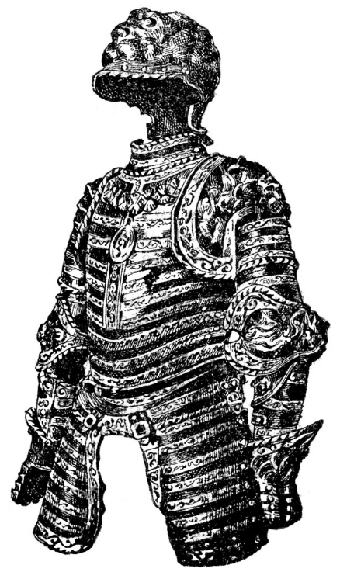
11. Combat

One of the most exciting parts of live action role-playing is the battles. In Kingdoms of Novitas, there are no dice, rock-scissors-paper or mouse buttons to work out the victor of a fight - players must face each other in real battle! Blows are exchanged and parried, missiles are dodged and thrown! Combat at Kingdoms of Novitas is acted out with padded weapons called boffers. A boffer is a piece of tubing covered with foam, and decorated to look like a medieval or fantasy weapon. Almost any type of weapon can be created from halberds to daggers. This is covered in detail in the section on Weapons & Armor.
Combat is very much a real life skill that requires practice on the part of the players. While there are skills and abilities that can artificially boost the combat abilities of a player (Body points, armor, or weapon proficiencies) they will never compensate for a lack of skill. Players must always keep in mind that the Kingdoms of Novitas system is VERY LETHAL and death is only ever one or two steps behind most characters! The best way for players to learn how to fight, without losing a half dozen characters, is to play non-player characters. Organizing your own fighter practices is also useful - and good fun as well.
Combat is governed by a strict set of rules which players must follow without question. Of all the rules in the game, the combat system is most important to understand fully. Violation of combat rules can lead to loss of fighting privileges or even suspension or expulsion from Kingdoms of Novitas. Despite the high level of intensity, boffer fighting is very safe and injury is very uncommon - usually limited to minor bumps and bruises. Players are much more likely to injure themselves running from a fight than participating in one.
Many players choose to play characters that avoid violence at any cost, and given the lethal nature of the system this tactic is often a viable one. It is important to note however that there is no way for a player to officially remain out of combat or non-combative during the course of the game. Simply participating in the game places a player at risk of getting caught up in combat and struck by weapons. It is perfectly legal for players to ambush each other without prior warning, strike from behind, and use similar “first strike” tactics. If for some reason a player feels in real life danger by participating in combat (medical condition, anxiety, etc.) they need to take steps to protect themselves while playing in the game. Protection might include always traveling with a group, wearing safety gear (kneepads, teeth guards), or simply practicing their powers of observation. The use of missile weapons and magic is a great way for players with concerns about combat to participate at a safe range with minimal risk of contact with enemy weapons. Players that have conditions that are easily aggravated by combat activities should never take skills that increase the time they will remain engaged in combat, such as body points. It is perfectly acceptable for players to simply give up when confronted with combat - with the understanding that this might mean a quick end to their character! Players with combat aggravated conditions are encouraged to communicate their concerns with the Game Masters and other players so that they can remain safe and still gain maximum enjoyment out of the game.

The rules of combat
The following rules are the basic core rules of fighting in Kingdoms of Novitas. All players are expected to know these rules and follow them to the letter! If any rule is misunderstood a Game Master should be consulted immediately! When in doubt, players should always rule in favor of safety. No battle is worth winning if someone must be hurt to do it.

- Respect all other players. Keep things friendly. After all, it’s a game and we’re all here to have fun.
- The Game Master is always right. Do not argue their decisions.
- When “GAME HOLD!” is called, all action must stop and does not start again until the person who called the original hold calls off the hold.
- The Game Master has the right to inspect any weapon (including beanbags), shield, or piece of armor at any time, and remove them from play if they are damaged or otherwise unsafe.
- The Game Master has the right to remove any player from the game they feel is mentally, emotionally, or physically incapable of playing safely. The player is free to protest their removal AFTER the game or immediate encounter is over, but in most cases the Game Master’s decision is upheld, since safety is paramount over opinion or hurt feelings.
- The head, neck, throat, groin, and hands holding weapons are not valid targets. Players are not required to accept hits in these areas. Players should not deliberately target these areas. An empty hand is a legal target. All other parts of the body are legal targets.
- Players must not strike any blow that uses excessive force, or is struck in a manner that is inherently dangerous.
- The rule of thumb when being struck is to accept any blow that impacts any legal part of you or your equipment regardless of the force behind the blow. If you felt it or saw it, it was a legal hit.
- The rule of thumb when striking someone is to strike an opponent with as much force as is needed to make them acknowledge the blow, and never more.
- Never fire a bow or crossbow at full draw if a target is within five feet of the shooter.
- Players who wear glasses should secure them to their head with a safety strap. Players who do not secure their eyewear do so at their own risk.
- Only the padded striking surface of a weapon should ever strike an opponent. If you consistently hit people with unpadded areas of your weapon, it will be removed from play.
- Players may not block or parry with missile weapons such as bows and crossbows.
- At no time should a player carry real weapons of any sort. This includes walking sticks, canes, and torches. Players who need mobility assisting devices like canes should consult a Game Master on what to do during play.
- Players may not grab or pin weapons or shields. The Game Master will remove any weapons that are suspected of pinning.
- Shields are defensive weapons only. No shield rushing, shield bashing, or body blocks are allowed.
- Physical bodily contact should never occur in a fight. Opponents should never have to backup to avoid physical contact with another player.
- No unarmed fighting is allowed. Players may not punch, kick, trip, or grapple. Threats of real physical violence are not tolerated.
- Never use a full power blow against an unaware opponent. Instead use only a light touch to start and alert them of the attack.
- A player who has fallen to the ground from a wound or stun should never be hit. If the fallen must be dispatched, only a killing blow (explained later in this chapter) is required.
- Only legal arrows, bolts, or thrown weapons are allowed as missiles.
- Arrows and bolts are illegal to use as thrown weapons or melee weapons.
- All bows and crossbows must have a thirty-five pound pull weight or less to be legal. Compound bows are prohibited. Use of modern equipment such as peep sights or weights is not allowed.
- Blocking weapons with a limb will always result in damage to that limb. This includes catching missile weapons like arrows or bolts.
- A player is required to use a weapon as intended by its design and make full use of the weapon’s handle. For example a player may not hold an eight-foot spear by the last foot of the shaft and swing it like a two-handed sword! Any areas of a weapon not used as a handle should be padded.

Hitting with weapons
There are very few rules governing how a player may swing with a weapon. They must avoid hitting invalid targets such as the head and must use as little power as required by the situation. Otherwise players are free to experiment with all sorts of swings and blocks.
What constitutes a good hit is based on several factors. It is not required to throw powerful shots to score a hit, however the blow must deliver adequate force so that opponent can feel it. How an opponent is clothed or armored may have an effect on a player's force. It requires more force when hitting opponents in heavy armor than it does for people wearing normal clothing. Clear distinction between swings is required to avoid ultra-light blows, also known as machine gunning. Machine gunning (or drum-rolling) is a series of low power swings with a weapon that more closely resemble bouncing a weapon up and down on a foe as opposed to striking them. Machine gun attacks are not legal and count only as a single hit.
What is a good hit?
- It strikes a legal target
- It is felt by the target
- No excessive force
- It is a single, distinct blow
A blow must make physical contact with a player's body or immediate possessions. Immediate possessions include clothing, belt pouches, cloaks, armor, sheathed weapons, long belts, and so on. For example, a player may not ignore a shot if their cloak first stops it or if it hits a belt pouch. Players are on their honor to accept any such shots as if they had hit the nearest section of their body. For example, a shot stopped by a bloused shirt sleeve would hit the arm. A shield worn on the back or other part of the body does not block shots to that area. A shield not controlled by a player’s arm is called a “passive shield” and does not grant the player any protection.
Arrows and bolts only cause damage if the head of the weapon strikes the target. Thrown weapons cause damage if any part of the weapon hits the target, including the handle. Any missile that first hits a solid object, such as the ground or a tree, before it hits its target will cause no damage. Hand weapons cause damage when any padded part of the weapon hits the target. Swinging a weapon with excessive force with the intention of powering through an opponents attempt to parry is not permitted and is very dangerous! Just because the target of an attack is a weapon or shield is not an open invitation for careless use of power and using excessive force in this manner only breaks down the padding of the weapons involved. Striking, or feinting to strike, an illegal target area (head, groin, etc.) in an attempt to force your opponent to drop their guard is not permitted. While a player’s intention might be to pull back such “trick” shots, one or two unexpected moves can result in illegal contact and possible injury!
Avoiding weapons
There are two ways to avoid a weapon, blocking and dodging. A dodge is simply the act of moving the body, or part of the body, out of the way of a hit, and for the most part this is self-explanatory. When dodging arrows, players should step to the side only. Since arrows travel in a downward arc from the bow, ducking will only place a player’s head in a position where it is vulnerable to hits.
A block, or parry, is the act of stopping a hit with another weapon or shield. A block is only considered good if the attacking weapon makes no solid physical contact with the target's body. If, at any time, a weapon touches the target with adequate force it will cause damage. A player may not claim that a weapon was blocked simply because their own weapon made physical contact with their targets weapon (this is known as passive or “tap” blocking and is not legal). This is what makes the extended heads of axes and pole arms so dangerous -- while the shaft is blocked, the weapon’s head will often carry through and hit the target – but remember that swinging a weapon with excessive force with the intention of powering through an opponents attempt to parry is not permitted and can cause injuries. It is possible to block a weapon with a bare hand, arm, or leg, but doing so always causes damage to the blocking limb or area. Taking damage to a limb is sometimes deemed worth avoiding a lethal shot to the torso. It is important to note that catching an arrow causes damage even if the player catches the arrow on an unpadded section of the weapon. This rule is required to prevent players from breaking arrows in an attempt to catch them. You’re not a ninja.

Weapon damage
All weapons inflict a base damage of one point and a maximum of four points of damage. The number of hands used to wield a weapon, or its size, has no bearing on the weapons’ damage. Used by the same character, a pole arm inflicts the same damage as a sword, and a sword as much as a dagger. Skills like Melee Proficiency, spells, poisons, or magic objects are the only way to increase weapon damage.
Each time a player HITS with a weapon they must call out the weapon's damage. Players should not call out damage each time the weapon is SWUNG because the opponent might confuse the damage call for a hit.
When calling damage, the amount and type of damage is communicated. For example, if a weapon would cause one point of damage, the player would call out, "One!” If the same weapon was instead magical, the call would be, "One-magic!" When an opponent is hit, they will deduct this amount of damage from their armor or body points. Special types of attack (magic, silver, magic fire) are called in the event an opponent is only harmed by special weapons. Trolls, for example, are only harmed by magical fire and will only accept damage followed with the call “magical fire”. Damage is also called for spells and poison; spells cause magical damage, poisons cause poison damage.
Any attack that hits a player will cause a minimum of one point of damage, even if the damage is not called. Players may not ignore weapon hits when no damage is called but likewise are not required to accept any additional or special damage if it is not called. It is not required that a player hit for the maximum damage they are capable of inflicting but must always hit for one point of damage. This is a perfectly legal tactic to fool an opponent into thinking a character is weaker than they actually are. It is cheating to call out a higher number of damage points than a character is capable of inflicting.
Players are also free to call out a lesser damage type than the weapon they are using is capable of inflicting. For instance, a player wielding an Elven Steel longsword enchanted with Elemental Weapon (Fire) could call Elven Steel damage, Magical Fire damage, Silver Damage, Magic Damage, normal physical damage, or Blunt damage, all with the same weapon and as he wished.

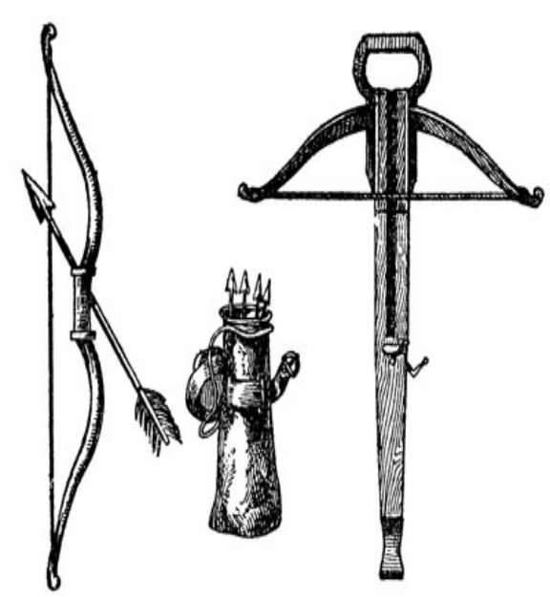

Accepting hits
When a player is hit it is considered good form to alert their opponent that the hit was good. Most often simply saying "Good" does this and players comfortable with the combat system will often call out “Good-arm” or “Good-leg” to let their opponent know where they are taking their blows. Since combat is not real, and opponents cannot see your wounds, this is considered good form and good sportsmanship.
Taking Damage

Magic Armor and magic defenses
Physical armor
Damage Requirement
Body
Wounds

If the player is hit in an invalid target area they should inform their opponent by saying "Head" or "Weapon hand". If a hit was saved against or had no effect, the target must say "No-effect" so the opponent is aware that their attacks are having no effect. This will also make it clear that an opponent is not cheating and ignoring shots.
When a shot hits a target it must rely on its defenses, such as armor, to protect it from damage. Damage is deducted from a target in a certain order and every time a shot hits a target they must go through this order to determine what effect the shot had on their character. Some attacks will skip the order of defenses, for example, if a character takes a hit on an unarmored spot they may skip steps one and two. Characters will often not have every step of protection – for example, some characters will not have body points. In this case this step would be skipped over when determining damage. All damage goes through the following steps. Players may not skip over a step in order to preserve their armor or magical defense. A character’s defenses are always involuntarily deducted in a preset order as indicated below.

1. Magical armor and defenses: The first defense an attack must bypass is a character’s magical spell protection such as Magic Armor and Anti-Magic Aura spells. Unlike physical armor, all spell protections cover the character’s entire body. When a character’s magical protection is expended, further damage goes to their physical armor, Damage Requirement, Body points, and wounds. This step only covers spell-generated defense and not physical armor with magical properties.

2. Physical armor points: Characters who choose to wear physical armor are granted armor points. Physical armor points are always the second thing a character loses when they get hit. If a character is not wearing armor, or is hit in an area not covered by their armor, the damage automatically goes to a character's Damage Requirement, body points, and or wounds. The universal armor point granted by a helmet is always expended first. Each time a character is hit in an area covered by their armor, they deduct the amount of damage from their total armor points. When a character's armor points reach zero, the armor is useless and all further damage goes to their Damage Requirement, body points, and wounds. Armor points automatically reset to their normal value in between events or can be repaired immediately with the spell Mend Armor.

3. Damage Requirement: Some creatures require certain types of damage in order to suffer damage. Ghouls, for example, are immune to all physical attacks other than those caused by silver. This protective ability is called Damage Requirement. If an attack does not meet a creature’s Damage Requirement it will have no effect. A creature’s Damage Requirement has no effect on its physical or magical armor. Armor, which is always hit first, will still be damaged by the attack regardless of it source. Damage Requirement does not stop attacks that do not cause damage. A Repel Undead spell still repels a Ghoul even though the attack does not involve silver.

4. Body points: Body points are a measure of how much damage a character can take before suffering serious wounds. Body points represent heightened physical training allowing the character to endure pain and injuries and increasing the amount of time they can spend in a fight.
Each time a character is hit in combat, and has no armor, they deduct the damage from their Body points. When a character's Body reaches zero, the next damage causing hit they receive causes a wound. If a hit inflicts so much damage that it reduces a character's Body points to a negative value in a single shot, a wound is automatically caused. For example, if a character with three Body points is hit in the arm for four points of damage their arm will suffer a wound. A character's Body points heal back to their normal level between events, or may be healed immediately with the Heal Body spell.

5. Wounds: When a character that has no other form of protection is hit in combat they suffer a Wound. Wounds represent serious injuries such as deep cuts, broken bones, and severed muscles. Wounds are divided into two types, limb and torso. Players are on their honor to role-play Wounds to the best of their ability, and should role-play Wounds as if they were causing great pain. Players who have just had both legs Wounded should not scuttle around on their knees as if nothing is wrong. Dead characters should gasp out final words and then act dead. Nothing ruins the atmosphere of the game quicker than a bunch of dead people who just stand up and wander off the battlefield.
Limb Wounds are caused from hits to the arms from the point of the shoulder to the tip of the fingers and or the legs from the hip joint to the tips of the toes. A character cannot use a Wounded limb to perform any actions and any objects held in the limb at the time of the Wound are automatically dropped. It is illegal to block with a Wounded limb and any further hits to a Wounded limb are treated as if they had hit the torso. For example, a character receives a leg Wound, forcing them to drag the leg. If moments later the same limb is hit again, the hit transfers to the torso, and causes a torso Wound. Excessive damage to a limb will never force the Wound to transfer to the torso. For a Wound to transfer to the torso through a Wounded limb, the limb must be hit two separate times! Limb Wounds are considered to heal completely in between events, or may be immediately healed with the Restore Limb spell.
Torso Wounds place the character in a helpless state of near unconsciousness and a great deal of pain. Characters with torso Wounds must fall to the ground. They may not move, can make no actions (move, drink potions, use magic objects), and cannot use any non-automatic skills. Characters with torso Wounds are allowed to feebly cry out for help in a last desperate attempt to save their life, and may speak, albeit haltingly, to other players.
Characters that receive a torso Wound have ten minutes to get healing or they will die. The skill First Aid can extend this time to twenty minutes once per injured character. The spell Heal Mortal Wound is required to fix a torso Wound and prevents the character from passing away. Once dead, a characters only chance of returning is to have a Revive spell cast on them. Torso Wounds do not heal between events, as the character is dead.
Killing blows
Killing blows are used to dispatch characters that are incapacitated or near death, representing a throat slit or some similar instantly lethal coup de gras. A player may killing blow a character that is suffering from a torso Wound, bound, faking death, or unconscious. It is impossible to killing blow a character under the influence of Charm, Pin, Fear, or Stun. A killing-blow ignores all forms of protection the character may have, including magical and physical armor. To deliver one, the attacker must place a weapon on the victim's chest and loudly announce “KILLING BLOW!”
A weapon (boffer, spell, poison beanbag, etc.) is required to deliver a killing-blow, so an unarmed character is incapable of giving a killing blow. Only the chest is a legal spot for a killing blow; it is impossible to deliver one through a character’s leg or other appendage.
Once the attacker announces a killing blow, the victim instantly dies regardless of Body points or other Wounds. They cannot be healed with any Restorative spells but may be raised with the spell Revive. If the killing blow call is interrupted in any way, such as the victim admitting they are faking death, or another player knocking the attackers’ weapon away, the killing blow is unsuccessful.
The damage of the weapon has no bearing on a killing blow, but creatures with Damage Requirements require that a weapon that would normally affect them give the killing blow. For example, a silver weapon is required to killing blow a Ghoul. It is possible to deliver a killing blow with a spell or poison as long as the spell or poison inflicts physical points of damage. The spell must be cast as normal and will expend the required amount of power. A poison used to deliver a killing blow will be expended.
Blunt damage
To cut down on the need to kill during the course of the game, characters are allowed to inflict non-lethal damage rendering a target unconscious instead of dead. Blunt damage can only be inflicted with hand held weapons like swords and axes. It is not required to use blunt weapons like clubs or staves to inflict non-lethal damage, as it is assumed that the flat side of an edged weapon can be used with equal effect. Spells, missile weapons (including thrown weapons), and poisons (including weapons coated with blade poison) are incapable of inflicting blunt damage.
When a player wishes to inflict blunt damage they must call out the damage of the attack followed by the word “BLUNT” so the target knows the attack is non-lethal. Blunt damage affects a target’s defenses in the same manner as normal damage so it is still required to beat through a target’s armor and so forth. The only difference between blunt damage and normal damage is that all lost Body points and Wounds recover after ten minutes. Restorative Magic spells will heal this damage as normal, though waiting for the effects to wear off will conserve magical power.
It is possible to inflict limb wounds with blunt damage and it assumed that the hit temporarily renders the area hit useless. Armor destroyed by blunt damage does not recover and must be repaired through normal means. Non-lethal damage cannot be inflicted on a target that is receiving lethal damage attacks at the same time. Everyone hitting the target must choose to inflict blunt damage or all damage is treated as lethal. Some creatures like undead are immune to blunt damage and treat all blunt attacks as lethal damage.
The Heroic Safety rule
Kingdoms of Novitas is a fantasy game, and with fantasy comes the natural suspension of disbelief. One such rule in favor of fantasy is known as the Heroic Safety rule. Under the Heroic Safety rule it is not required that a player count self-inflicted damage such as dropping weapons on their feet, smacking their own leg with a weapon due to a very bad swing, and so on. Kingdoms of Novitas is dangerous enough as it is, so we discount damage from such sources. This rule does not, however, protect other players from careless hits or from friendly fire. If the party's magic user hits a fellow party member with a beanbag that damage will count!

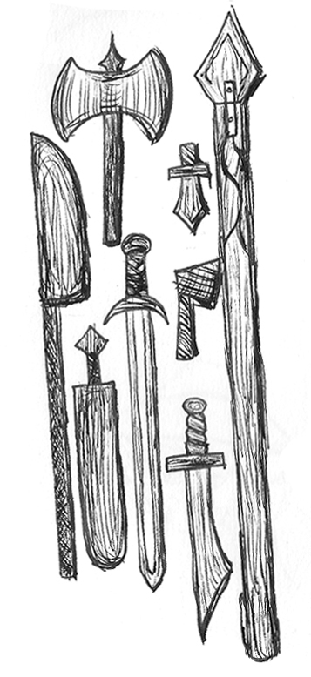
12. Traps & Locks

No treasure ever goes unguarded. At times, in place of monsters or magic wards, some treasures are protected by more mundane means: locks and traps. Characters with the Trapsmith skill are skilled in the bypassing and disarming of such hazards.
Characters with these talents are very often referred to as thieves. While some characters employ their trade for underhanded reasons, this is far from the whole story. Characters with these skills often use their knowledge to disarm traps in old tunnels or just to assist absent-minded characters that have lost the keys to their personal treasure chests. This section covers all aspects of picking locks and disarming traps.
Picking locks
Locks are common obstacles encountered in most games, often used to secure doors or chests. Sometimes locks can be a major part of the adventure leading to the success or failure of a mission. In game, small simple luggage locks represent real locks. Real locks are never used, as they are far too complex. Characters with the Trapsmith skill may attempt to open locks encountered during the game.
Tools of the Trade

Accomplished thieves will carry a multitude of tools and implements to carry out their skill. While many of these tool kits are highly personalized, most of them share a few items:

- Dental picks. These are the primary tools used for picking locks, and most thieves have a variety of them.
- Forceps
- Tongue depressors
- Needle nose pliers
- Stiff wire of varying gauges
- A thin object, such as a strip of steel or a playing card, to probe the edges of boxes and doors.

In addition to these few items, each thief will develop his own special tools over time. With experience and practice, your tool kit will be able to handle almost any situation!
Locks cannot be physically broken in-game - players may not declare they are breaking the lock with their sword. Players also may not remove hinges or clasps in order to bypass the lock, but any player may use the lock’s normal key to open the lock. Any number of characters with the Trapsmith skill may assist in picking the same lock, but non-skilled players may only assist with non-technical help such as holding a light.
In order to pick a lock, a player will need tools. The same tools used to pick locks can also be used to disarm traps. Some tools are described in the “Tools of the Trade” sidebar in this section. While picking a lock, players must make their best effort not to damage the lock with their tools, or by their methods. Players who are discovered willfully destroying a lock will be removed from the game. Once a lock has been picked, the player should leave the lock where it was found. This is unrealistic, but all locks are the property of Kingdoms of Novitas, and must be returned. If the player chooses, they may re-lock the portal when they are finished - but the same player would need to pick the lock again if they wished to open it again.

Disarming Traps
Traps are very commonplace in Kingdoms of Novitas, and come in many forms. Almost any object can be trapped, including doors, chests, roads, and even goblets! In-game, traps make use of mechanical triggers to spray acid, shoot spikes, launch magical effects, crush, etc. Out-of-game, traps are represented by electronic buzzers or other noisemakers. The trapped object will be set up in such a way that an artificial noise will be made if the trap is triggered. Only characters with the skill Trapsmith may attempt to disarm traps. As with locks, non-skilled players may only assist in a non-technical manner such as holding a light
Disarming traps is a combination of quick senses, keen observation, and manual dexterity. Players must always be on the lookout for signs of traps; small bits of wire hanging out from under the lid of a box, an unseen resistance when opening a door, or a string running across a tunnel are all good examples of trap sign. Players who move around unaware or throw open doors are bound to be the victim of a trap one day.
Once a trap has been spotted, it can be disarmed. This is done with tools in the same manner as locks. Trap disarming tools are described in the "Tools of the Trade" sidebar of this section. In order to disarm a trap, its ability to make noise must be eliminated. It is important to remember that if at any time the trap makes an artificial noise, it has gone off. Depending on the trap, this can be done several ways. Some traps are set up so that their power source can be removed from the buzzer, others can have their switches locked in place by inserting tools in the right hole. Traps are never designed so that they can't be disarmed or avoided. No parts of the trap can ever be broken, cut, or permanently damaged in an attempt to disarm the trap, with the exception of string or wire tripwires, which may be freely cut if discovered.
Once a trap has been triggered the effect is applied as dictated by the trap tag or a nearby Game Master. It is the option of the player to rearm the trap once they have bypassed it. However, if the trap is set off while rearming it, the effects of the trap must be applied as normal. In the absence of a trap tag or Game Master, the default trap is a simple Alarm Trap

Zero Level Traps
Zero level traps are simple hazards that can be avoided by any players even if they do not have the skill Trapsmith. Examples of zero level traps could include open pits (see below) or buckets of acid (water, confetti) propped over a half open door. Players may avoid these hazards with common sense. Place a board over the pit, or remove the bucket from the door. A Game Master should be consulted if players are unsure if a trap is zero level or not, so if possible, have a skilled character deal with the hazard to be safe.
Trip wires or trigger wires are not zero level traps, however, an unskilled player may always avoid the wire by stepping over it, crawling under it, or otherwise avoiding it. Only Trapsmiths may cut a tripwire though.

Pit traps
Open pit traps are represented in game by black plastic sheets or tarps. Players who see any such obstacle should inquire to a Game Master as to its nature. At times, tarps may be used for mundane reasons, such as the walls of a tunnel, and may be mistaken for pits, so it is always better to be safe than sorry. If at any time, the player touches the plastic representing the pit with any part of their body, they fall in. Pits may inflict damage from the fall and also from secondary sources such as spikes, or may simply trap a character until rescued. This can cause any number of points of damage, or even deliver poison or magic attacks. Pits can also kill instantly with no recourse.
A normal trap, such as a trip wire or pressure plate, can represent collapsing pits that have concealed covers. This will give players a chance to spot the hidden pit and avoid it. In this case the pit can be disarmed as normal allowing players to walk on its surface. Players who fall into pits and don’t die will be stuck there unless the Game Master allows them to climb out. Often this is role played by another player lowering a rope and hauling them out.

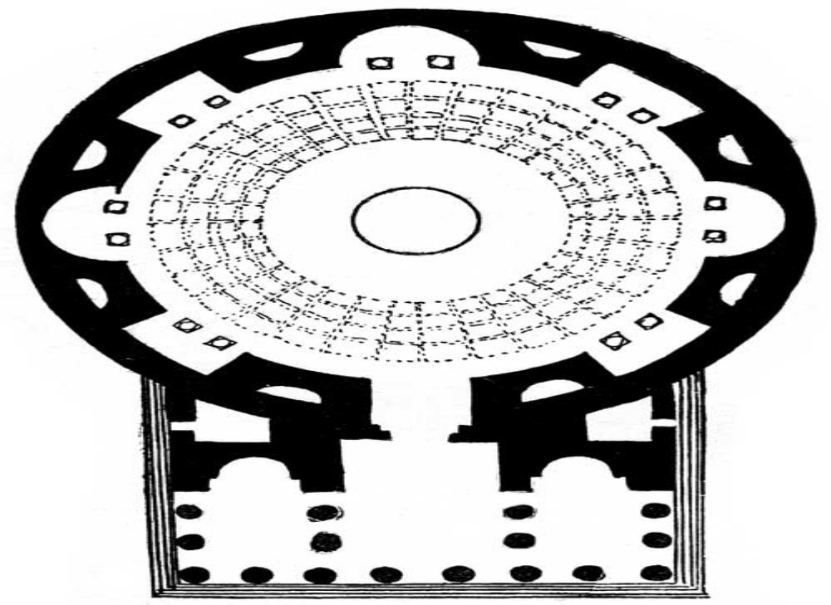

13. LOOT!

General Treasure Rules
The collection of treasure is a common goal of many adventures, and can be a quick road to increased power and influence in the world. Players gain treasure in several ways, such as hiring out their services, working as merchants, or liberating it from other characters through means both honest and foul!
A physical prop represents each piece of treasure in-game. Gems, for example, are represented by small plastic gems marked with numbers to indicate their value. This section covers the basic forms of treasure available to characters in game and the rules that govern their use and authenticity.
10 copper = 1 silver
10 silver = 1 exotic coin
100 copper = 1 exotic coin
All treasure in game can be taken by players to keep and use as they see fit. If the player loses or destroys the treasure prop the treasure is lost to the character. Players are responsible for keeping treasure between games; there is no need to turn it in between games. They need only return treasure if their character dies or they plan to leave the club permanently.
All treasure is considered property of Kingdoms of Novitas so other players can steal it during the game. A player may not withhold a treasure prop because they wish to keep the prop for themselves. All props will be provided by Kingdoms of Novitas so players will have no concern about losing personal property if their treasure is stolen. Under no circumstance may players provide their own props for treasure found in game.
Players in possession of a weapon treasure must maintain it, and weapons given as treasure are allowed in-game only as long as they are safe for play. Any weapon that does not pass inspection will be removed from play and the player will lose the treasure. Some weapons will have a limitation on the life of the item, that is, when the prop is worn out, the weapon leaves game permanently. This is done for game balance, as powerful enchantments often have a limited lifespan.
Coins
Coins are the most common form of treasure in Kingdoms of Novitas. Coins are represented by brass or aluminum tokens with a generic illustration on both sides. No special skills are needed to identify coins and every coin has a value of one regardless of its shape or size. Because coins are made of precious metals they tend to have an equal value, even in remote areas.
The common money standard in Kingdoms of Novitas is the copper piece, and a copper piece is assumed roughly equivalent to an American dollar when trying to draw a comparison of values between in-game and out-of game standards. Coins generally come in two types: copper and silver. There are also coins of other more exotic metals, such as the Indurium Malta of Evenandra or the Bloodgold coins of Earthhold. These coins rarely make their way as far as the Free Lands, but if encountered can be assumed to be worth roughly ten silver each, but their value varies from place to place and trader to trader. They can be distinguished by their strange iridescent colors and metallic hues.
In game, the coins are made of the metal described by their value and players should treat them as such when role-playing. Out of game, players should be wary of any coin that appears to be counterfeit. It is possible for underhanded players to slip in non-Kingdoms of Novitas tokens, passing them off as Kingdoms of Novitas money. This is cheating. If a counterfeit coin is encountered, do not accept the coin and report the player to a Game Master. Players caught carrying counterfeit money will be removed from the game for cheating.
In the unlikely event a coin should break it is still worth its full value if it is a least 75% intact. Coins that are broken in half or smaller should be brought to Logistics to be replaced.

Jewels & Gems
Precious stones are a very common and universal form of treasure. Due to their small size and high value, large sums of money can be carried in a belt pouch or concealed on a player's person. Gems are accepted as wealth even in the most remote of places and are sometimes preferred over coin as a means of payment. Gems are also a very common component in magic rituals and are often more valuable to the right mage then their listed value indicates!
Small plastic gemstones represent in-game gems. Each gem is inscribed with a treasure number that allows a character with the skill Estimate Value to identify the value of the gem. The color or size of a gem has no bearing on its value. A small gem can be worth thousands of gold and a large gem can be worth one piece of copper. A gem with no inscribed treasure number is assumed to be counterfeit. If a counterfeit gem is encountered, do not accept it and report the player to a Game Master.

Valuable objects
Valuable objects can include works of art, fine tapestries, or rare works of literature. Though not as compact as gems, valuable objects can still be very high in value. On the down side, valuable objects are often hard to sell and make converting the wealth into useable funds problematic.

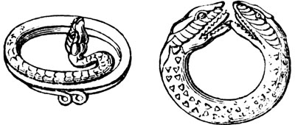

All valuable objects are marked with an inscribed treasure number allowing for their identification and are covered by the same guidelines as gems. The skill Estimate Value is required to identify their value. Often, valuable objects not only offer a source of wealth but also be an important part of the plot, such as a treasure map. It is also possible for a valuable object to possess other properties at the same time. For example, it is possible to have a silver short sword that is so ornately carved it is also worth a great deal of money.
Created objects
Non Player Characters very often carry the same common created objects, such as potions, carried by player characters. Created objects include Alchemy substances, potions, and scrolls. These objects follow the same rules of use as described in their individual chapters. These objects cannot be traded in for experience points but may be sold or traded to other characters for cash or services. Characters still need any special skills normally needed to posses these objects, for example, a character that does not posses the Herbalist skill may not handle poisons.

Magic objects
Magic objects are objects which have been endowed with magical properties. They come in almost any shape and size, from rings to weapons, and are some of the most coveted types of treasure in Novitas. Many a character has found himself face down in a ditch after having been forcefully relieved of his silver dagger.
All magic objects give off obvious magical signs such as a dull warmth or light blue glow that can be perceived by anyone who touches them. These signs do not allow a character to identify the exact properties of the object, only that it is magical. Because of these minor magical signs, players may not hide the fact that an object is magical. During a search, for example, a player may not deny that an object on their person is magical in nature.
Each magic object is inscribed with a treasure ID number allowing a character with the skill Identify Magic to determine the properties of the object at Logistics. If players encounter a magic object with no treasure ID number the object may be counterfeit. If a counterfeit magic object is encountered, do not accept it and report the object and player to a Game Master. Besides their treasure ID number, all magic weapons must be covered with blue tape or paint allowing the weapon to be identified as magical from a distance. It is only required that the blade or striking surface of the weapon be colored with blue, so players may decorate the handle and cross guards as normal. There are four types of magic object: temporary, permanent-per-game-day, permanent, and enchantments.

Temporary
Temporary, or charged, objects have only a few uses. Once the charges have been expended the object is useless. Temporary objects can never be recharged. The player is on their honor to keep track of the object's uses. If a Game Master feels the object is being abused they will remove it from play.

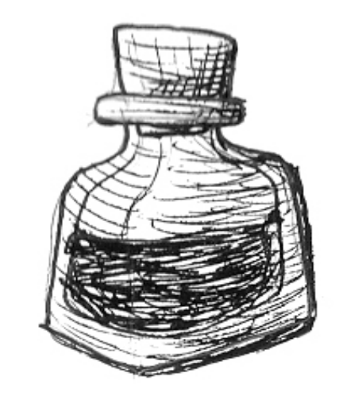
All temporary items require an incant to activate their abilities, just as if casting a spell, unless specifically excepted from this requirement. The incant is generally specified in the description of the item, and will be given to the player at Logistics when they identify the item for the first time.

Permanent-per-game-day
Permanent-per-game-day objects have limited charges per game day. Once the object's charges have been expended it is useless until the next game day. At the beginning of the next game day the object returns to its full charge. The player is on their honor to keep track of the object's uses per day. If a Game Master feels the object is being abused they will remove it from play.
All permanent-per-game-day items require an incant to activate their abilities, just as if casting a spell, unless specifically excepted from this requirement. The incant is generally specified in the description of the item, and will be given to the player at Logistics when they identify the item for the first time.

Permanent
Permanent objects are infused with strong Ritual magic. The object's powers are never expended. Objects of this nature are very rare.
All permanent items require an incant to activate their abilities, just as if casting a spell, unless specifically excepted from this requirement. The incant is generally specified in the description of the item, and will be given to the player at Logistics when they identify the item for the first time.

Enchantments
Enchantments are magical powers that become inherent to a character. Enchantments are recorded on a player's character sheet. Enchantments are not represented by any sort of prop. They cannot be stolen or traded. Enchantments come in the same variety as all other magic objects, so an enchantment could be permanent-per-game-day, for example.
All Enchantments require an incant to activate their abilities, just as if casting a spell, unless specifically excepted from this requirement. The incant is generally specified in the description of the Enchantment, and will be given to the player at Logistics when they identify the item for the first time.
For the most part magic objects are indestructible and never show signs of tarnish or age. For example a magic sword will never rust even if left at the bottom of a lake for centuries. Magic objects can never be perverted from their original function despite any logic offered. A magic dagger cannot be taped to a pole to make a silver spear; a ring of spell storing cannot be taped to an arrow to make the arrow magical; a Wraith cannot be beaten to death with a Tome of Magic. If a Game Master observes a player abusing a magic object the object will be removed from play.
Special mention should be made of items that are purchased at auction at the annual February Feast event. These items are bought out-of-game for real money as part of a fundraising event held at the feast. February Feast items have the following properties:

- You may use them with any/all characters you have. They need not be turned in upon retirement/death, and cannot be stolen or looted from the player who bought them.
- February Feast items are still the property of Kingdoms of Novitas; you are buying the permanent use of a game function as represented by an in-game numbered prop, not the item itself. If you ever decide to stop attending KoN, the item should be returned to Logistics.
- You may hand off or loan out feast items to other players in-game. If you do so and it is lost to theft or looting, you lose use of the item for the remainder of the time you are playing your current characters (their in-game lifespan).
- You may permanently give the item to another player, but this must be done in-game and in-character. Once a feast item is given away like this, it loses all special properties as described above and becomes a normal, stealable and lootable item (but does not lose it's magical properties in-game). In other words, these properties are only applicable to the person who paid cash for the item at the fundraiser.

Elven Steel weapons
Elven Steel weapons are created through powerful rituals that mix steel with pure silver and then sheath the weapon in an aura of pure magic. Elven Steel blades appear as jet-black weapons crisscrossed with veins of silver.
Elven Steel weapons posses the properties of both a magic weapon and a silver weapon allowing the weapon to hurt creatures only affected by silver, magic, and/or Elven Steel. Because of the silver in their composition, Elven Steel weapons suffer from the same restrictions as silver weapons.
Elven Steel weapons do not need to be identified, as their properties are readily apparent. Each Elven Steel weapon in game has a treasure ID number only for reasons of authentication and if players encounter an Elven Steel weapon with no number it is not a legal weapon. The blade or striking surface of all Elven Steel weapons must be covered with black duct tape or paint decorated with lightning-like lines of white crisscrossing its surface.

Goblin Iron weapons
The Snow Goblins of Gersh are not known for their craftsmanship, but in one area they do excel: the making of poisons. In the frigid forges of The Fissure, their smiths make weapons crafted of cold iron and infused with insidious properties.
In game, weapons made of Goblin Iron strike for poison damage. This means that any limb or torso wounds (not Body point damage) done with a Goblin Iron weapon must be treated to neutralize the poison before the wound can be healed. These cunning weapons also double the duration of blade poison applied to them. A player using Claw of the Beast on a Goblin Iron weapon can strike for +1 poison damage for twenty minutes instead of ten. Blade poisons normally good for one hit would now be good for two.
Goblin Iron weapons do not need to be identified, as their properties are obvious. Each Goblin Iron weapon in game has a treasure ID number only for reasons of authentication, and if players find a Goblin Iron weapon with no number it is not a legal weapon. All Goblin Iron weapons must have the blade or striking surface of the weapon covered with green tape or paint.

Silver weapons
Silver weapons are rare weapons designed to harm creatures such as Ghouls that are harmed only by weapons of pure silver. They are not simply normal weapons coated in silver but are instead crafted entirely of silver and bound with a powerful ritual to give the weapon strength. It is thought that the weapon’s pure aura is what allows it to rend the flesh of powerful evil creatures, and for this reason a silver weapon may not bear poison. Any poison placed on a silver weapon immediately becomes inert. For the same reason they may not transmit a Magic Strike spell.
Silver weapons do not need to be identified, as their properties are obvious. Each silver weapon in game has a treasure ID number only for reasons of authentication, and if players find a silver weapon with no number it is not a legal weapon. All silver weapons must have the blade or striking surface of the weapon covered with white tape.

Masterwork Terran weapons
The smiths of Earthhold are the undisputed masters of forging and metallurgy. Their legacy from the Craftsman grants them unsurpassed abilities and artistry when making items from metals. Even the youngest Earthkin soon trade their rattles for small hammers, merrily pounding away at miniature anvils to their parent’s delight.
But even among this race of natural craftsmen, some Earthkin stand above their kinsfolk. The weapons crafted by these master artisans are superbly balanced, wickedly keen, and surpassingly strong. Often, they are as beautiful as they are serviceable, being constructed of precious metals and encrusted with rare gemstones. Such weapons are referred to as Masterwork Terran Weapons.
In game, these weapons are visibly ornate and well crafted. While possessing no magical qualities, their perfect balance and finely honed edges allow the wielder of a Masterwork Terran weapon to strike for +1 normal damage.
Masterwork Terran weapons also have a significant monetary value. Most of them are family heirlooms, crafted to commemorate specific occasions. In Novitas, the swords of state carried by the rulers of Civen, Vlean, Evenandra, Terra and Gersh are all Masterwork Terran weapons. All Masterwork Terran weapons are marked with a treasure ID number, and their value may be identified with the Estimate Value skill rather than Identify Magic. They can, of course, be used without identification. If used without identifying them, they will not strike for the extra damage.

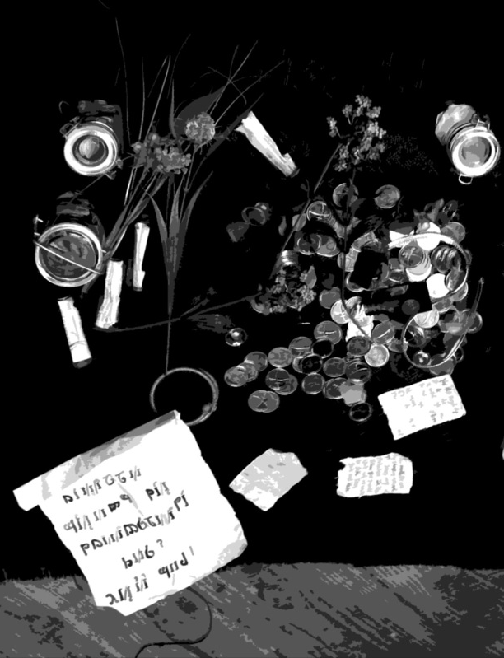

14. Other Jobs

NPCs & Game Masters

During the course of an event, you won’t just get to be your Player Character. Some LARP games charge large admission fees, often $80, $100 or more for a weekend game, and then allow other people to come for free – as long as they forgo their right to play as a Player Character. These people are then put to work slaving for the enjoyment of the wealthy players who can afford expensive weekends.
Kingdoms of Novitas doesn’t agree with this approach. Everyone at our events is expected to share the load to make the game fun for everyone else. Players at Kingdoms of Novitas are expected to assist Game Masters by playing NPC roles for them at least once over the course of a weekend event. This egalitarian system has several beneficial results:

- Players facilitate each other’s good time, resulting in a sense of community and camaraderie.
- Site fees for weekend games are kept at a manageable level for nearly everyone.
- All the players at Kingdoms of Novitas are of equal worth to the staff – no one is more valuable because they have more money, and no one is dismissed because they’re “just an NPC.”
- Everyone has the opportunity to try out different races, skills and fighting styles.

Playing a Non Player Character
Non Player Characters, or NPCs, are the very backbone of the game. While a great deal of the game's intrigue revolves around the Player Characters, the action would not be complete without a supporting cast. Non Player Characters can come in almost every form, from mindless undead lead by a wizard to nobles of the Kingdoms.
Playing an NPC is a great opportunity for players to learn the game without risking their character’s life, and they are also awarded experience points for their participation. The more a player NPCs the more experience he will gain. These experience points can be applied to the player's regular character. Playing an NPC is a great way for players to demonstrate their role-playing talent and creativity without many of the restrictions of a Player Character.
The ultimate goal of any NPC is to increase the enjoyment of the players in which they are participating. An NPC part does not need to be big for it to have a huge impact on the game, and at times the smallest parts are the most memorable. Players who put a lot of effort into their NPC roles will find that Game Masters will come to them when they have special parts to be played. Players who desire to play complex NPC roles and provide costumes for them should tell the Game Master before the game. Game Masters will use resources like this to their advantage as well as yours. Playing an NPC is a matter of experience and practice. Below are a few hints that might help the novice NPC improve their performance.

- Be patient: Playing the part of an NPC can often mean long waits as the players are notorious for being late. Don't become impatient waiting for the Player Characters. Avoid reminding the Game Master that the players should hurry, the Game Master already knows, and will only become frustrated with an unruly NPC. If other obligations may require an NPC to hurry they should volunteer for a quicker role or not play the part.
- Be helpful: The second job of an NPC is to help the Game Master. If the Game Master needs help please offer it. NPCs often help setting up props or dressing complex monsters, running for forgotten bits and pieces, and cleaning up when the game is over. Teamwork makes the game run smoother for everyone.
- Bring supplies: Bring essential supplies to the game site. Drinking water and snacks are good choices. Also bring sunscreen; bug spray, medication, cameras, film, and other supplies. Constant trips back to bunks or cars will only slow the game down. A Non Player Character should always bring at least one pouch to place OOG items or props in.
- Stick to the plan: NEVER deviate from the Game Master’s plan for the game. Improvise only if the Game Master gave instructions to. If the part requires attacking the players, do so. When an NPC begins to improvise, the game can go haywire really fast. For example, an encounter may require that a bunch of goblins get killed and a treasure map found on their bodies. If the goblins decide to talk to the players instead, the fight may never happen, the map may not be found, and the game may be ruined. Don’t assume you know everything that’s going on, because you probably don’t, so stick to your part. It’s even possible that there are other groups of NPCs out with instructions to encounter YOU!
- Play the parts given: NEVER add to the part given by the Game Master. Do not add Body points to a monster or give it new spells. If the role calls for the monsters to be slow, be slow. If it is not a speaking role, do not speak. Nothing is more anticlimactic than a bunch of zombies running at full speed chanting battle hymns.
- Remove all Player Character gear: It is important to leave all Player Character gear behind when playing an NPC. Objects like gold or gems can get lost or looted by players who mistake it for Non Player Character treasure. Any Player Character objects that are lost while playing a Non Player Character will not be recovered or returned.
- Change costume: Without exception, a Non Player Character should change or cover their normal Player Character costume. This will add to the atmosphere of the game a great deal. Making unique costumes for Non Player Character roles is a great way to gain additional experience points and will make the Game Master's job easier. A simple tunic of burlap or a change of hats is sometimes all it takes to break up a normal Player Character costume. Avoid wearing the same armor as a normal Player Character, and do not expect the Game Master to grant an NPC armor points just because the player showed up wearing armor.
- Change weapons: Without exception, players should change weapons when fighting as a Non Player Character. Try to pick weapons that fit the role - a battered club for an Orc, a long staff for a wizard. This is also a great way for players to practice with new fighting styles, and most Game Masters will have a store of weapons for use by their NPCs.
- Wear the costume given: If the part requires that a costume be worn, it should be worn. Masks should be worn at all times, fake noses worn on the nose, makeup in the right spots. Nothing ruins the mood of a game faster than a bunch of undead wearing their masks pushed up on their foreheads. If wearing special costumes is difficult because of the heat or medical problems, please ask for another role.
- Be realistic: Play an NPC like it was a normal character. Very few monsters fight to the death without reason. Players will grow weary of a steady stream of suicidal goblins. An NPC should be as three-dimensional as the part will allow.
- Set up the scene: An NPC encounter can be made into so much more if the scene matches the encounter. Here are two examples. Example one: A bunch of goblins are playing tunnel guards. They must attack the players when they come through. They line up by the door they are guarding and wait for the players. This will make for a good fight, but the atmosphere is horrible. Example two: The same group of goblins is acting as tunnel guards. This time they pretend to be in the middle of a heated card game. When the players approach, the game turns ugly and a fight starts. Same result, but example two adds so much more to the game.
Important People
The staff at Kingdoms of Novitas are the overseers of the game, dictating plot, monitoring safety, explaining rules, and taking care of the small tasks that make the game function. They act in a fashion similar to a referee at a sporting event, remaining always present, but for the most part letting the players act freely in the game. During the course of normal events there are many staff members on duty, sometimes acting as a team, but in most cases working as individuals.

Marshals
Marshals are the absolute authorities at Kingdoms of Novitas. They hold this position because they put way too much time and money into making the game happen than any sane person should. Additionally, many of them hold positions of responsibility within the MVGC, although this is not a requirement.

Game Masters
Game Masters are mature adult individuals who are empowered to run a shift and otherwise take charge of stuff that needs doing. Their responsibilities include rules editing/creation, monster creation, scenario writing, weapon approval, PEL/background approval, rules adjudication, and many other crappy jobs.

Masters at Arms
Masters at Arms are mature adult individuals who have demonstrated a commitment to safety, innovation and craftsmanship in the construction of boffer weapons and/or appropriate armor. A Master at Arms is empowered to proactively inspect all weapons and armor for safety and rules compliance, issue rulings on the usability and/or safety of such items, and determine the game armor points value of worn protective armor. They are also authorized to and responsible for removing any weapons or armor that they, and they alone, deem hazardous or dangerous, at any time, and for any reason.
Apprentice Game Masters
Apprentice Game Masters are individuals who have stepped up to help run events, design scenarios, provide props, and give intelligent, reasoned advice about rules. Apprentices will generally have a Game Master or Marshal as a mentor for three to twelve months before they are considered for promotion.

Logistics Officials
While not Game Masters, Logistics Officials are players who volunteer to help Game Masters keep order and sanity in logistics. They assist with signing in players, doing paperwork, collecting money, helping new players, dressing NPCs, and many other menial and undesirable tasks.

Who is that guy with the orange headband?
Game Masters do their best to remain as unobtrusive as possible so as to not detract from the enjoyment of the game, stepping in only if a problem or question arises. Overseeing the activities of the entire game and the conduct of individual Game Masters is a Chief Game Master. The function of a Chief Game Master is to settle disputes between individual Game Masters and deal with complaints from players about the conduct of individual Game Masters.
With the exception of safety concerns, the Chief Game Master will never overrule the decision of another Game Master during the course of the game. Players who feel they have received a bad ruling or have been mistreated by another Game Master must wait until the game ends to bring it to the Chief Game Master.

The primary duty of the Game Master is to act as a walking rulebook and arbitrator, explaining the rules of the game and making snap decisions when the rules fail to cover an unusual situation. Despite this, most Game Masters do not wish to spend every waking minute explaining the rules to players who should have read the rulebook. Veteran players should make every effort to learn the basic rules so the Game Master is free to spend more time running the plot encounters or assisting new players who are expected to need help with the rules. A player with three or more games under their belt should have a complete working knowledge of their character’s skills and abilities (without referencing a rulebook) and a basic understanding of everything else.

Players vs. the GM
The Game Master's word is law. Players should deal with Game Masters in a calm, respectful manner. The middle of a game is not the time to argue with the Game Master. Players should remember that the Game Masters are volunteers, and give up a great deal of their time and effort to make the game possible. Often Game Masters will also be participating as characters, stepping in only when needed to settle disputes or questions. Players can call upon a Game Master should they need a dispute settled. The Game Master who first arrives will be the one in charge until the problem is solved. If a Game Master is already running a plot or encounter, they are in charge; no other Game Master should be called. The word of any other player, even another Game Master, has no bearing, and no other Game Masters should interfere with their decisions.
A Game Master should never make decisions that affect their own character. Game Masters cannot create plots or scenarios for their own character or adventuring party. Players should not play Game Masters against each other. If a Game Master gives a player a ruling, it is final! Do not take the problem to a second Game Master for another ruling. Players caught doing this will be removed from the game. A Game Master should always be called if there has been an injury or if safety has been compromised.
If a player feels that they have been dealt with inappropriately or unfairly they should report this to a different Game Master when the game has ended. Only then will the situation will be reviewed and a decision made. When reporting a problem, players should have as much information as possible. At the very least they should know the full name of the Game Master in question. It also helps to have witnesses. When bringing paperwork to a Game Master to sign, also bring a pen, since they may not have one.

GMs vs. the Players
Game Mastering is more art than science, and the best tricks are only learned with experience. The Game Master has two major goals. First, make sure the players are enjoying the game. Second, make sure that the players are safe. Game Masters must remember that the players are looking to them for direction, and must keep their head at all times. Players can get upset, often irate, when they have a dispute, and the GM must always strive to be the calming force in any confrontation.
Game Masters should make every attempt to stay out of the player's way. As long as the players are not cheating, they should be allowed to play the game. On the flip side, Game Masters should not feel compelled to assist players when they get frustrated. Players can often get grumpy and pout when things do not go their way. This frustration, as tense as it can get, is all part of the game. Game Masters should avoid forcing rules on players. All that is important is that the game is running smoothly, safely, and everyone involved is having a good time. No one is going to care if one or two rules get overlooked.
When rules must be enforced, the Game Master must remember to be calm and even-handed. Yelling at players will only make matters worse. Game Masters must listen to every side of the story and gather all possible information, but should only listen to eyewitnesses and ignore rumors. Game Masters should never interfere with other Game Masters, even if the other GM is misquoting rules. When Game Masters contradict each other, the players lose faith in their ability to lead. If Game Masters must have a dispute, it should be done calmly and in private.

Becoming a Game Master
Any player may become a Game Master. In order to qualify to be a Game Master a player must shown themselves to be competent in the rules, fair, level headed, and dependable. Players interested in becoming Game Masters should make their interest known to another Game Master. Prospective candidates should make every attempt to observe other Game Masters at work. Offer to help organize games or work at the Logistics desk. The more experience a player has, the more likely they will be asked to be a Game Master. Game Masters are expected to set an example for all other players. If at any time, a Game Master fails to meet these requirements they will be removed from their position. Being a Game Master is no easy task. It can be a lot of hard work, and often requires a substantial outlay of real money for props and costumes. It can also be very rewarding and a great way to improve the game in ways that a normal player cannot.
We offer the following guidelines for becoming a GM:
First, you should examine your motivation for becoming a Game Master. If you're doing it for attention, or self-aggrandizement, or to gain knowlege your character shouldn't have for use in-game (such as access to the Encounters Codex), you're not going to be successful.
Second, you should realize that running a shift is like playing twenty PCs. Those PCs need garb, names, backstories, motivations, accessories, props - the list seems endless (especially three days before an event!). If you're a player who's still showing up to NPC in jeans and a T-shirt, you're probably not prepared to run games. The single biggest factor that's going to make your shift successful (after an active imagination) is your personal garb/prop box. It should go without saying that any player who wishes to start GMing should have a PC that looks great and is garbed extraordinarily well.
If your motives are pure, and you have the garb and props issue well in hand, then you need to satisfy the following requirements:
1. Only players who have regularly attended events for one entire season will be eligible to become Game Masters. This doesn't mean perfect attendance, but if you miss more than one (maybe two) game(s) you're not showing the dedication we'd like. Come on, KoN only runs 6-7 events a year...
2. Players who satisfy the attendance requirement will be administered a written test on the rules and mechanics of the game system. A firm grasp of the rules is a requirement. Game Masters are expected to be the final arbiter of any rules issues that come up on their shift, and will need to arbitrate disputes with consistency and accuracy. This test will include a selection of multiple choice and short answer questions (15-30 of them), and will require a grade of 80% or better to pass.
3. Players who are successful on the written rules test will then be required to find an existing Game Master willing to mentor them. Do not expect the GMs to seek you out - you should show initiative in seeking out them. Honestly, you should already have an idea who you want to work for before you ask to take the test - and should have spoken to that GM to apprise them of your intentions. If, for whatever reason, no GM is willing to mentor you, you'll have to wait until one is.

Once you have found a mentor, you'll be given access to some private forums and start working as an Assistant Game Master and Logistics Official.
Assistant GMs who demonstrate reliability, maturity, imagination, and integrity will eventually be given more and more responsibility. Over time, those people will become full Game Masters, with all the time- and wallet-draining responsibilities that go with that.

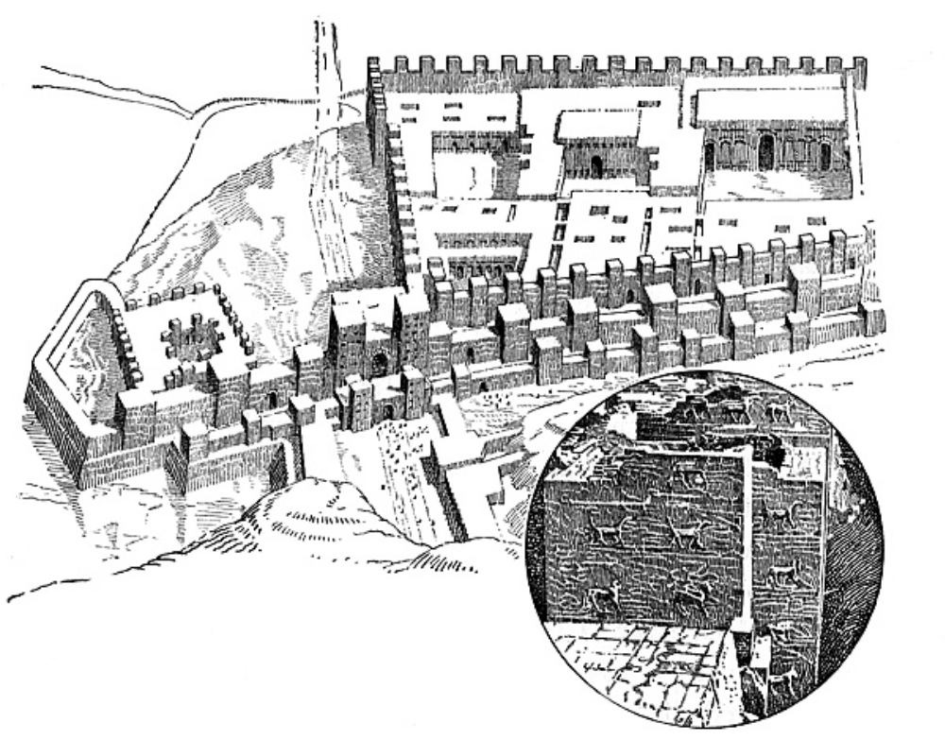

15. Crime & Punishment

In order to make the systems in this book as realistic and free form as possible, a great deal of responsibility is placed on the individual player’s honor. Games of this nature offer the temptation to cheat, and this inevitably tempts people with less than honorable conduct. Luckily, in most cases such conduct is a matter of quick tempers or absentmindedness, and not a concerted effort to cheat the system. No amount of rules or Game Masters will ever replace simple integrity and fair play.
Crime
When cheating occurs, violators are quickly discovered and dealt with. Players who suspect someone of cheating should privately take their concerns to a Game Master. Players should never confront each other directly, instead let a Game Master decide what action to take. Ignorance is no excuse for cheating and players are expected to learn all the rules of the game and follow them. The following are actions that are viewed as cheating:

Disregard for the rules
Players will often ignore the rules of the game. Hitting for more damage, drinking alcohol on site, or not expending uses of magic objects are all examples of disregard for the rules.

Disregard for safety
Safety should be the foremost concern of all players. Swinging with too much force would be an example of disregard for safety. The game will no longer be fun if people are getting hurt.

Disruption of atmosphere
Players who disrupt the atmosphere ruin the game for everyone. Walking around out of costume, driving cars through the game site, or playing radios are examples of disruption.
This includes “playing possum”, which is playing dead when your character is not, and then popping up to rejoin the action at a more opportune time. Were LARP combat real, you would be able to see the state of people's injuries at a glance. Instead of three guys laying on the ground, you'd have one guy moaning in pain with an arrow in his guts, one guy screaming with his hand hanging from his arm by a bit of skin and viscera, and one guy with the side of his head caved in. You would also know immediately if your spiked mace caved someone’s head in, or merely winged their helmet. When we're all pretending, you can't see the difference. This is why playing dead is cheating.

Disrespect for authority
Players that refuse to follow or argue the orders of a Game Master or other officials cannot play the game properly and ruin it for others.

Disrespect for players
Players should treat other in a civil manner. Players should not be rude, offensive, or violent towards other players.

Loop-holing
Loop-holing is using gaps or holes in the wording of the rules, contrary to the spirit of the rules, in order to gain an advantage in play. If you find what you think is a loop-hole in the rules, please bring it to the attention of a Game Master so the problem can be fixed.

Meta-gaming
Use of out-of-game information or abilities for the benefit of a character. For example, as a non-player-character a player watches to see which player gets the treasure on a module. Later, acting as their player character they kill that character and take the treasure.

New player predators
Experienced players who take advantage of new players due to their lack of out-of-game knowledge of the rules. Telling a first time player incorrect values for coins, or abusing a player’s inexperience in any other manner, is frowned upon.

Abuse of property
Players who abuse the property of Kingdoms of Novitas or facilities being used by Kingdoms of Novitas are cheating. This could include littering, breaking windows, destroying props, and similar acts of vandalism.

These are only examples of in-game offenses, and players are still bound by all state and federal laws of the area the game is held. Players who are accused or caught breaking such laws will be handed over and dealt with by the appropriate authorities.
Punishment
Players who are discovered violating in-game rules can expect the following disciplinary actions.

In-game penalty
In-game penalties are the quickest form of punishment. Any Game Master can enforce an in-game penalty at any time. An in-game penalty affects a player's character and not a player themselves. For example, a character refusing to take hits could be given a torso wound. In-game penalties are usually for people who cheated unintentionally, first time offenders, or new players.

Out-of-game penalty
Out-of-game penalties affect a player directly. Any Game Master can enforce an out-of-game penalty at any time. Out-of-game penalties could include loss of fighting privileges or being required to sit out of the game for an amount of time. Out-of-game penalties are usually for people intentionally cheating, or repeat offenders.

Suspension
In extreme cases, players can be suspended from the game. While suspended, the player may not attend Kingdoms of Novitas events. Suspended players may attend public demos, but only as spectators. Suspension can last from one to three full events. Site fees and/or donations will not be refunded to a player if they are suspended. A panel of three Game Masters most vote unanimously to enforce a suspension. Suspensions are best reserved for habitual offenders.

Expulsion
Expulsion permanently removes a player's privileges to participate at Kingdoms of Novitas. Expulsion usually cannot be reversed. Expelled players may attend public demos, but only as spectators. Site fees and/or donations will not be refunded to a player if they expelled from play. A panel of three Game Masters voting unanimously is required to enforce an expulsion. Expulsion is reserved for players who have become physically violent towards another player or a Game Master, has been suspended multiple times, or committed a real world crime while at Kingdoms of Novitas.
Kingdoms of Novitas strives for a playing environment relatively free of cheating. While it is necessary to discuss the topic, few of these disciplinary actions have ever been enforced. No players have yet been suspended or expelled, and we don’t foresee it happening anytime soon, but it still needs to be discussed.

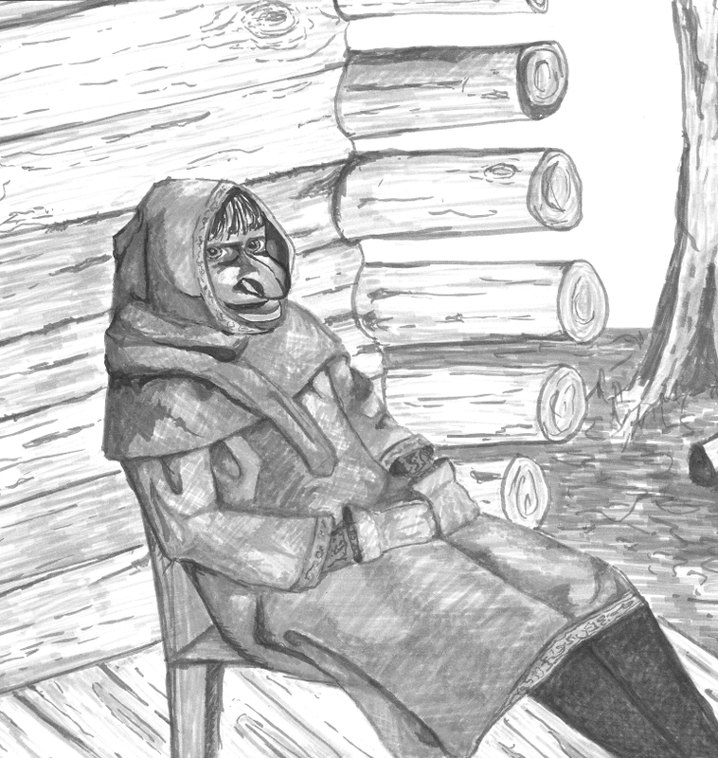

Appendix A
Spell descriptions
Ablative Armor
Type: Enchantment
Level: 4
Duration: game day until discharged
Range: touch
Dispel: yes

This spell, when cast on a character’s physical armor, empowers that armor to ignore the next two damaging attacks that hit it. The player should call “no effect” against the next two damaging attacks that hit his areas of armor coverage.
This spell can only be cast on armor, not on the player herself. If the character is wearing no armor, or only costume armor, then the spell has no effect. It also has no effect if the character is wearing only a helmet.

Abomination
Level: 5

Type: Necromancy
Duration: ten minutes
Range: touch
Dispel: yes

This spell causes the recipient to become resistant to damage as they take on some undead traits. The target gains the Monstrous type from the Monster Manual.
The massive body of a monstrous creature is capable of withstanding damage that would instantly kill lesser creatures. Because of this monstrous creatures never take more than one point of damage from any source (with one exception, see below).
Monstrous creatures possess super strength. Normal and magical restraints often prove too weak to restrain a monstrous creature. A monstrous creature with super strength can rip free of ropes or chains by taking two points of body damage. A monstrous creature with super strength can rip free of a Pin spell (or similar effect) by taking five points of damage.
Note that this Monstrous effect mitigates all future damage done to the Abomination, including damage done to armor and Magic Armor. In effect, anything that deals damage to the recipient will only deal one point. Note also that creatures under the effects of an Abomination spell may freely enter an area under the effects of an Unhallow spell for the duration of the Abomination effect.

Anti-Magic Aura
Level: 4

Type: Aegis
Duration: one minute
Range: touch
Dispel: no

This spell crates a powerful magic field around the recipient of the spell that absorbs all magic spells, harmful or beneficial, including Restorative magic. The spell lasts for one minute and automatically negates any magic effects that hit the character, including Dispel Magic. The player is required to announce “No effect” in a loud voice when they use this aura to ignore a spell. Characters protected by this spell are required to wear a blue armband as described in the chapter on magic and spell use. Anti-Magic Aura has no effect on attacks from magical weapons or creatures. Anti-Magic Aura does stop creature special abilities if they are defined as a “spell effect” such as the fear ability of a ghost.

Anti-Magic Shield
Level: 2

Type: Aegis
Duration: game day until discharged
Range: touch
Dispel: no

This spell crates a powerful magic field around the recipient of the spell that absorbs offensive magic spells. The spell has one use and automatically negates the first offensive magic attack that hits the character, including Dispel Magic. The character has no choice in this matter and may not choose to save the Anti-Magic Shield for a later, perhaps more powerful spell. The player is required to announce “No effect” in a loud voice when they use this aura to ignore a spell. Characters protected by this spell are required to wear a blue armband as described in the chapter on magic and spell use. Anti-Magic Aura has no effect on attacks from magical weapons or creatures. Anti-Magic Aura does stop creature special abilities if they are defined as a “spell effect” such as the fear ability of a ghost.

Aura of Reflection
Type: Aegis
Level: 5
Duration: game day, one use
Range: touch
Dispel: no

This spell crates a powerful magic field around the recipient of the spell that reflects offensive magic spells. The spell has one use and automatically reflects the first offensive magic attack that hits the character, including Dispel Magic. The spell is automatically reflected back at the character that cast the original spell and does not require the use of a tag bag or weapon (in the case of touch ranged attacks). If the original caster of the spell is also protected by an Aura of Reflection, the spell is dispelled and has no further effect. If the original caster is no longer in range of the spell or out of the vision of the character with Aura of Reflection, the offensive spell simply ends. The character has no choice in this matter and may not choose to save the Aura of Reflection for a later, perhaps more powerful spell. A player is required to announce “Reflect!” in a loud voice when this spell is used. Characters protected by this spell are required to wear a blue armband as described in the chapter on magic and spell use. Aura of Reflection has no effect on attacks from magical weapons or creatures. Aura of Reflection does reflect creature special abilities if they are defined as a “spell effect” such as the fear ability of a ghost. Some creatures are immune to their own special abilities and in this case a reflected ability is simply dispelled.

Battle Immunity
Type: Battle
Level: 5
Duration: game day
Range: touch
Dispel: yes

This spell creates a powerful dampening field around the subject which nullifies all offensive Battle Magic that strikes him. When struck with an offensive Battle Magic spell, the player must call out in a loud voice “No effect”. The recipient of Battle Immunity is still free to cast Battle Magic, and may be the target of spells such as Strength or Spellstore. Note that a weapon that is being used to channel a Magic Strike spell will still deal its normal damage as per the player striking, but it is the immune persons responsibility to find out how much damage this is, otherwise they must take 4 points. A player protected by this spell is required to wear a blue flag as explained in the Magic & Spells section.

Battle Mastery
Type: Battle
Level: 5
Duration: game day
Range: self only
Dispel: yes

This spell grants use of the following skills, regardless of prerequisites or actual character skills:

- Great Weapon Training
- Melee Training
- Missile Training
- Buckler Fighting
- Shield Fighting
- Thrown Weapon Training
- Two Weapon Fighting Master

Battle Mastery also allows a player to hit for one additional point of magic damage in addition to their normal damage. A player enhanced by this spell is required to wear a blue flag as explained in the Magic & Spells section.

Charm
Type: Compulsion
Level: 2
Duration: ten minutes
Range: tag bag
Dispel: yes

This spell creates a shimmering dart of energy that the caster throws at a target in an attempt to transfix and charm it. A target that is hit by this dart is overcome with a powerful feeling of friendship towards the caster. If the dart strikes a target’s weapon or shield the spell still takes full effect. The spell lasts for ten minutes during which the target will not harm or conspire to bring harm to the caster.
Charm does not allow the caster to issue commands to the charmed target or otherwise compel it to act in any other way. The charmed target will not act in a fashion that will bring harm to themselves or their party members in an attempt to protect the caster. For example, the caster cannot ask a charmed person to set their weapons down in the middle of a battle! In most cases, the charmed target will simply move away from the caster and leave them alone. The charm ends immediately if the caster attacks or facilitates an attack on the charmed target (e.g. if the caster orders his or her party to attack the charmed target). Simply drawing a weapon or starting to cast an offensive spell in the presence of the charmed target does not warrant the charm being broken unless the caster directly voices their intention to attack the charmed player. A charmed target will not give up its possessions without good reason, though they might sell or barter them away to the caster for a better price than they would under normal circumstances.

Creeping Rot
Type: Necromancy
Level: 2
Duration: ten minutes
Range: tag bag
Dispel: yes

This spell calls into existence a pulsing black dart of magical energy that prevents a struck target from being the recipient of any magic from the Restoration school for ten minutes. A player affected by this spell is required to wear a blue flag as explained in the Magic & Spells section. Any Restoration magic targeted on the creature afflicted with Creeping Rot is expended and wasted. First Aid can still prolong the life of a creature with a torso wound for the usual time.

Curse
Type: Necromancy
Level: 3
Duration: ten minutes
Range: tag bag
Dispel: yes

This spell creates a glowing green dart of ill will and hatred, cursing a target. Creatures struck by a Curse are reduced to one point of Body. If they have no Body Points, they remain at zero Body. When the ten minute duration expires, the target regains any Body points lost due to the Curse. Players do not recover Body points lost due to other sources of damage during the duration of the Curse.
For example, a warrior with four Body is stuck by a Curse. During the next ten minutes, he takes one point of damage, reducing him to zero Body. When the duration of the Curse ends, he will return to a total of three Body (his original four, minus the one point of damage he took while cursed).
Players who receive wounds while cursed will still have the wounds when the duration ends, even though they may regain Body points.
In the first example, if the warrior also took a limb wound while cursed, when the ten minute duration of Curse ended, he would be at three Body with a limb wound.
A player afflicted by this spell is required to wear a blue flag as explained in the Magic & Spells section. The player who casts Curse is responsible for providing blue flags for his victims. Failure to provide a blue flag at the first opportunity results in the spell ending immediately.
Diagnosis
Type: Restoration
Level: 1
Duration: instant
Range: touch
Dispel: n/a

This spell allows the caster to immediately discern all ailments afflicting the target, including poisons, disease, madness, magical afflictions or sickness. If the spell is cast upon a corpse, it will reveal the cause and means of death.

Disengage
Type: Compulsion
Level: 1
Duration: one minute
Range: tag bag
Dispel: yes

Disengage creates a red ball of compulsive power that can be hurled at a target to prevent them from attacking you. When struck with this spell, a target will not engage the caster with physical or magical attacks for one minute. During this time they are free to attack other people or take other actions, and they do not forget that the caster cast a hostile spell on them.
If at any time the caster attacks the target or even moves within five feet of the target with an unsheathed weapon or active spell, the effect is broken and the target is free to once again attack the caster if it wishes.
The target is also afflicted with a mild compulsion to avoid the caster. This is not the effect of a Fear spell, but does prevent the target from breaking the effects of Disengage simply by moving towards the caster when they unsheathe a weapon or cast another spell. If it is clear the caster is forcing the target to move closer to him or herself, the spell will break. It is impossible for the caster to herd the target around the battlefield with this spell, and any attempts to use Disengage in a hostile manner will break the effects of the spell.

Dispel Magic
Type: Enchantment
Level: 4
Duration: instant
Range: tag bag
Dispel: n/a

This spell creates a powerful dart of focused anti-magic that the caster can use to disrupt the magical defenses of a target. When a target not protected by Anti-Magic Shield, Anti-Magic Aura, or Aura of Reflection is hit by this spell, all magical effects currently active on the person (but not their items) are dispelled. The caster must throw the dart for the spell to take effect and may not simply touch the tag bag to a target. Examples of magical effects include Curse, Magic Armor, Battle Immunity, or Abomination. It is also possible to target a magical field with Dispel Magic, such as a Sanctuary or Sanctify. To do so simply requires the caster hit the object protected by the field or anywhere inside the field’s area of effect. Magical fields gain no benefit from any magical auras their caster might have active at the time. Once defenses are dispelled, they may be recast at any time assuming the target has the means to do so. It is possible for this spell to affect other scenario specific magic, but a Game Master will deal with these situations on a case-by-case basis.
Dispel Magic will also counteract the effects of any other single individual spell marked as able to be dispelled in the rules, assuming the caster can hit the target with a tag bag. If there is more than one effect that can be affected by Dispel Magic the caster must know and designate the one he wants dispelled. As a rule of thumb, Dispel Magic affects only creatures and their spells.

Dissipate
Type: Nature
Level: 2
Duration: ten minutes
Range: touch
Dispel: no

This spell allows the caster to magically merge with the surrounding elements of air, water, earth and fire, becoming one with his or her surroundings. The caster and any belongings carried appear to all others to disappear into thin air. While the spell is in effect the caster is required to hold a blue flag over his or her head. Lowering the blue flag ends the spell. A dissipated character is invulnerable to the outside world but also cannot interact with the outside world in any fashion until they leave the dissipated state. No action may be taken while dissipated (drinking potions, casting spells, or drawing a weapon).
Other characters are required to ignore the dissipated character even if they see the caster disappear into thin air. Witnesses dismiss this magic effect as losing sight of the caster in the woods or some other rationale. The spell ends if the caster decides to reform, if the blue flag drops below their head or the when the duration of the spell expires. The character must reform in the same spot they dissipated. This spell does not allow the caster to move to a new location. Only the character’s personal and carried objects dissipate with them and all those objects reform with them. The caster may not dissipate another person by carrying them or other such means.
Players who cast Dissipate in combat situations are required to move out of the way of the action, and not return until it's safe and non-disruptive to game flow to do so. Players should mark their location with a tagbag or flag during the day, and with a glowstick at night. The glowstick is NOT optional, players who plan to use Dissipate at night should ensure that they have a glowstick available to mark the position that they Dissipated from.

Dominate
Type: Compulsion
Level: 5
Duration: ten minutes
Range: tag bag
Dispel: yes

This spell creates a softly glowing pink dart of concentrated willpower. A target struck with a Dominate spell falls under the direct control of the caster, much in the same manner as an undead under the control of a Lesser Command spell. Only three commands are legal to use with the controlled being. They are, “Attack”, “Defend”, or “Move”. See the spell description for Lesser Command for full explanation of these commands.
In addition, living creatures who are Dominated are allowed to deal themselves a killing blow at any time to represent their final act of defiance to their controller, or to avoid taking an action they cannot morally accept, such as murdering someone.

Eldritch Stone
Type: Enchantment
Level: 3
Duration: instant
Range: tag bag
Dispel: n/a

This spell creates a single shimmering dart enchanted with eldritch power. The dart deals four points of elven steel damage to the area hit on the target. Hits to an opponent’s shield or weapon count as hits to the arm holding the weapon or shield. The player is not allowed to pass the dart off to other players unless they have the Magic Hands spell active. The player is also not allowed to set the dart down (this includes dropping the dart) and doing so will dispel the dart. The dart must be thrown to activate so the caster may not simply touch a target with a dart to inflict damage. One minute after casting this spell the dart automatically dispels and so is wasted.

Elemental Binding
Type: Nature
Level: 3
Duration: ten minutes
Range: tag bag
Dispel: yes

This spell creates a single dart of elemental anti-magic that traps an elemental creature struck by it for ten minutes. During the spell’s duration, the elemental may not move, see, hear or communicate, and may not be physically harmed or affected by any magic other than Dispel Magic. It is effectively trapped in a separate plane of existence. At the completion of the spell’s duration, the elemental is free to act as if nothing had happened to it.

Elemental Command
Type: Nature
Level: 4
Duration: instant
Range: tag bag
Dispel: yes

Elemental Command creates two darts of elemental power that allow the caster to exert control over lesser elementals. The spell has no effect on greater elementals. If the dart strikes a lesser elemental it then falls under the direct control of the caster for ten minutes or until destroyed. Only three commands are legal to use with the controlled elemental. They are “Attack”, “Defend”, or “Move”.

Attack: The attack command allows the caster to point at a target and compels the elemental to attack it. The commanded elemental will attack any target, including other elementals. It will attack the target without question or concern for its own preservation and will use every available power and ability to carry out the attack. It is possible to word the attack command in a fashion that will compel the creature to attack multiple targets. For example the caster could order the elemental to “attack all humans”.

Defend: A defend command works like an attack command but the caster orders the elemental to defend a specific person, place, or thing. In this case the creature will attack anything that comes near the object or person it was ordered to defend. It will never move more than five feet from the object it was ordered to defend. Like an attack command it is possible to word the defend order in a fashion that will compel the elemental to defend multiple targets or large areas (e.g. the caster could order the elemental to “defend all living things in the town”).

Move: A move command simply compels the creature to move in a direction of the caster’s choice for the duration of the spell. It is legal for the caster to order the elemental to follow them or walk in front of them. It will move at any speed the caster desires and it is physically able to do. The creature will not perform even the simplest of actions such as the opening of a door or dropping of weapons.

The controlled elemental will not attack the caster that controls it unless ordered to do so by the controlling caster.

Elemental Dart
Type: Nature
Level: 3
Duration: instant
Range: Tag bag
Dispel: n/a

This spell creates a single dart of focused elemental power in the form of fire, earth, water, or air that is primarily intended to harm elemental creatures. The caster may choose which of the elements the dart will manifest as when they cast the spell. The spell inflicts four points of the element of choice in damage to the target. For example a dart of elemental fire would inflict four points of magical fire damage. This damage is magical and does affect creatures only harmed by magic. Elemental Dart cannot perform any other function other than inflicting damage (e.g. an Elemental Dart of fire cannot start fires or serve as a light source). The player is not allowed to pass an Elemental Dart off to other players (unless they have a Magic Hands spell currently active) or set a dart down (this includes dropping them) and doing so will dispel the dart. The Elemental Dart must be thrown to activate so the caster may not simply touch a target with a dart to inflict damage. One minute after casting this spell the Elemental Dart automatically dispels and is wasted.

Elemental Immunity
Type: Nature
Level: 5
Duration: game day
Range: touch
Dispel: yes

This spell creates a powerful magic field around the caster (or target he/she selects) that absorbs offensive elemental attacks, including elemental dart, elemental weapon, and any elemental-based attacks of creatures such as fae. The spell lasts for a game day, negating any amount of damage incurred. The player is required to announce “No effect” in a loud voice when they use this immunity to ignore an attack. Characters protected by this spell are required to wear a blue armband as described in the chapter on magic and spell use.
This spell may not be cast on a creature or with other spells if that combination would render the target invulnerable to all forms of physical and magical attack (e.g. this cannot be cast on a creature with a fire damage requirement). Any attempts to do so result in the spell having no effect and the caster losing the five points of power spent.

Elemental Weapon
Type: Nature
Level: 4
Duration: game day
Range: touch
Dispel: yes

This spell channels the caster’s choice of elemental energy (Air, Fire, Water, or Earth) through any non-magical weapon. The spell will function on any size hand weapon or missile weapon, but the caster using the weapon to channel elemental power must still possess the necessary skills to wield a weapon of that size and type. The spell will not work on shields or non-weapon objects.
For the duration of the spell, the weapon hits for elemental damage. This spell does not increase the damage of the attack. When cast on a missile weapon, all shots fired from the enchanted weapon assume the appropriate elemental quality. Elemental damage allows a weapon to damage certain creatures normally unaffected by any form of physical attack, such as trolls, certain fae, and the various elementals. It also causes extra damage to certain other creatures. Elemental weapons cannot bear blade poisons or any other enchantments while in an elemental state.
The caster must choose which element they will be wielding when the spell is cast and it strikes for that type of elemental damage for the duration of the spell. A blue flag must be visible, attached the lower part of the blade or cross guards (lower shaft of pole arms and maces), the staff of the bow, or stock of the crossbow of the Elemental Weapon, and without the flag it is considered a normal weapon.

Energy Darts
Type: Restoration
Level: 4
Duration: instant
Range: tag bag
Dispel: n/a

This spell has two different effects. One use creates glowing white darts of Restorative energy that may be flung at targets to heal them at range. This use of the spell functions in several ways: it creates two darts that function exactly as Heal Body, Restore Limb, or Purify Spirit. When the caster strikes a target with this spell, they should announce loudly “Heal Body!” or “Restore Limb!” in the same way as damage is announced in combat. The decision must be made before throwing a dart which effect to use, although this choice need not be announced.
The other use is to create two brightly glowing dart of pure life energy. These darts deal four points of elven steel damage to any undead struck, and ignore armor. These darts have no effect on living creatures, and only harm undead.
A player must decide before throwing the first dart if they are to be healing or harming darts, and is not allowed to use one dart to heal and another to deal damage.

Enchant Shield
Type: Enchantment
Level: 2
Duration: game day until discharged
Range: touch
Dispel: yes

This spell enchants a normal shield or buckler with mystical energy protecting it and its wielder from harm. The size of the shield does not matter in regards to this spell; it will work on any game legal shield. When cast on a normal shield the shield is immune to the very next magic or Alchemy attack that strikes it, including Dispel Magic, Vial of Acid, and any other Pierce, Smite, and Acid effects. Normally, tag bag delivered attacks, such as Battle Magic darts, count as hits to the arm when they strike a shield. The wielder of the shield is required to announce “No effect” in a loud voice when they use the shield to ignore a tag bag. This spell does not allow the caster to use a shield if their character does not normally have the skill to do so. A shield protected by this spell is required to have a blue flag visibly attached to it surface, and without the flag is considered a normal shield.

Enchant Weapon
Type: Enchantment
Level: 3
Duration: ten minutes
Range: touch
Dispel: yes

This spell endows a single, non-magical weapon with a sheath of magical energy. The spell will function on any size melee weapon or missile weapon, but the character using the weapon must still possess the necessary skills to wield a weapon of that size. The spell will not work on shields or non-weapon objects.
For ten minutes the weapon hits for elven steel damage. This spell does not increase the damage of the attack. It is legal for a character to fight with two endowed weapons, one in each hand. Endowed weapons cannot bear blade poisons or other enchantments while enchanted. A blue flag must be visible, attached the lower part of the blade or cross guards (lower shaft of pole arms and maces), attached to the staff of the bow, or stock of the crossbow of the endowed weapon. Without the flag it is considered a normal weapon.

Enhance Armor
Type: Enchantment
Level: 1
Duration: game day
Range: touch
Dispel: yes

This spell reinforces and strengthens a suit of existing armor, raising its armor value by two points for the duration of the spell. For example, a two point suit of leather armor would be worth four points when affected by this spell. Armor that is enhanced can be targeted by Mend Armor, which will repair the armor to its enhanced value rather than its original value for the duration of the spell.
At the end of this spell’s duration, an enhanced suit of armor loses two points of armor value. In the example above, the suit of leather armor would again be worth two armor points, but if it had lost two points of armor value (leaving it with none remaining while enhanced) it would have no value left at the expiration of this spell. In other words, the armor point gained from Enhance Armor is always deducted last, not first (as with the Magic Armor spell).

Fear
Type: Compulsion
Level: 4
Duration: ten minutes
Range: tag bag
Dispel: yes

This spell creates a focused dart of howling spirits that flit around and terrorize its target, frightening them away from the caster. A target that is hit by Fear is so gripped with terror that they must flee without hesitation from the caster’s sight until the spell ends, at which time they may return. The victim is not permitted to hide behind an obstacle or another player to avoid the sight of the caster; they must flee with all possible speed. If other players try to block the fleeing player, they will attack friend or foe without mercy or restraint in their attempt to continue escaping. The target will flee in a direction even if it means possible harm or death. For example a fleeing target would run straight into a pit if it were the only viable avenue of escape. It is legal for the caster to chase after the target forcing them to continue running if they feel it is necessary. If for some reason all possible means of escape are blocked, such as in a locked room, the target will fall to the ground helpless and should role-play digging through the very floor to attempt escape! If at any time the caster attacks the target the spell immediately ends and the target is free to act as normal. Other players may attack the target without ending the spell though the target is permitted to attack back assuming the attackers are blocking their route of escape. The fleeing target will not stop to make use of magic objects or spells while they are running; they must wait for the spell to end.

Final Rest
Type: Necromancy
Level: 1
Duration: instant
Range: touch
Dispel: no

This spell purifies the life force of dead or dying creatures, freeing them from their earthly bonds to Novitas and allowing their complete passage into death. When cast on a character that is dead or dying, they die immediately regardless of the time remaining before death. No level of healing or Revive will return them to life and they never return as an undead. This spell will also work on the fallen remains of undead creatures preventing their reanimation at a future time. Many powerful undead creatures, such as greater vampires, can only be permanently destroyed if a Final Rest spell is cast on their resting form. Anti-Magic Aura and Aura of Reflection will only protect a character if they are still alive (in the process of dying) when the spell is cast. Since the target character is still required to announce “No effect” when using magical protection, the caster will know the Final Rest failed, allowing them to cast it again.

Ghastly Visage
Type: Necromancy
Level: 1
Duration: ten minutes
Range: touch
Dispel: yes

This spell makes its target appear to be a lesser undead to other undead. To other living creatures, the target appears normal. The target gains no undead abilities, benefits or drawbacks. The recipient of the spell must choose what type of lesser undead to appear as when the spell is cast.
Note that creatures under the effects of Ghastly Visage may freely enter an area under the effects of an Unhallow spell for the duration of the Ghastly Visage effect.

Greater Command
Type: Necromancy
Level: 5
Duration: ten minutes
Range: tag bag
Dispel: yes

Greater Command creates two darts of necromantic power which allow the caster to exert control over greater undead creatures. The spell has no effect on unique undead lords, but will affect lesser undead if the caster deems it necessary to waste a higher-level spell to do so. If the dart strikes a greater undead it falls under the direct control of the caster for ten minutes or until destroyed. They can then be commanded in the same manner as Lesser Command allows.
The controlled undead will not attack the caster that controls it unless for some reason they order it to do so. Since greater undead are very often highly intelligent they are able to remember the actions they took while under control of the caster.

Grounding
Type: Nature
Level: 1
Duration: ten minutes
Range: tag bag
Dispel: yes

This spell creates a dart of magical energy that is hurled at a target. If struck, the target is unable to utilize extraplanar movement and effects or magical disguises. Grounding prevents or dispels the following spells:

- Dissipate
- Elemental Binding
- Final Rest
- Ghastly Visage
- Ley Lines

Note that Grounding can only prevent the effects of casting Dissipate, Final Rest or Ley Lines, it cannot dispel those spells.

Group Heal
Type: Restoration
Level: 3
Duration: instant
Range: ten feet centered on caster
Dispel: n/a

This spell functions as Heal Body, but will instantly affect everyone within ten feet of the caster.
Group Heal will not affect anyone with a weapon or active spell in their hands, effectively preventing it from being cast in combat situations.

Heal Body
Type: Restoration
Level: 1
Duration: instant
Range: touch
Dispel: n/a

This spell fills the recipient with pure life force that is capable of healing minor injuries. This spell restores a character to their full number of Body points but has no effect on limb or torso wounds. The spell will never raise a character’s Body points above their current maximum or grant Body points to a character that has none. It is not possible to heal a character’s Body if they are still suffering from a limb or torso wound, or from the effects of any damage dealt by a poison, as those injuries must receive healing or an antidote first. This spell will not heal a character that is suffering from disease unless they are first cured with a Purify Spirit spell, or poisons unless they are first treated with an antidote or a Purify Spirit spell.

Heal Mortal Wound
Type: Restoration
Level: 3
Duration: instant
Range: touch
Dispel: n/a

This spell fills the recipient with an incredibly pure, powerful life force that is capable of healing mortal wounds. When cast on a character with a torso wound, they are healed of this injury and are no longer in danger of bleeding to death. This spell has no effect on a character that has already died, does not heal limb wounds, and does not restore Body points. A character suffering from a torso wound cannot use this spell since a torso wound automatically disrupts their ability to cast magic even before they die. It is possible to heal a character’s torso wound even if they are suffering from other injuries such as wounded limbs or lost Body points. This spell will not heal a character that is suffering from a disease or the effects of poison unless they are first cured with a Purify Spirit spell.

Improved Magic Armor
Type: Aegis
Level: 3
Duration: game day or until expended
Range: touch
Dispel: yes

This spell functions as Magic Armor, but grants the recipient four points of protection. Improved Magic Armor always overlaps Magic Armor; it will never stack to grant more than four points of magical protection. If Improved Magic Armor is cast on a target that already has Magic Armor, this spell effectively dispels and replaces the Magic Armor spell already active, wasting it.
Note that the Armor Proficiency skill is not required to make use of this spell.

Lesser Command
Type: Necromancy
Level: 4
Duration: ten minutes
Range: tag bag
Dispel: yes

Lesser Command creates four darts of necromantic power that allow the caster to exert control over lesser undead creatures. The spell has no effect on undead lords or greater undead. If the dart strikes a lesser undead it then falls under the direct control of the caster for ten minutes or until destroyed. Only three commands are legal to use with the controlled undead. They are, “Attack”, “Defend”, or “Move”.

- Attack: The attack command allows the caster to point at a target and compels the undead to attack it. The undead will attack any target, even other undead. The undead will attack the target without question or concern for its own preservation and will use every available power and ability to carry out the attack. It is possible to word the attack command in a fashion that will compel the undead to attack multiple targets. For example the caster could order the undead to, “attack all zombies”.
- Defend: A defend command works like an attack command, but the caster orders the undead to defend something such as a person. In this case the undead will attack anything that comes near the object or person it was ordered to defend. The undead will never move more than five feet from the object it was ordered to defend. Like an attack command it is possible to word the defend order in a fashion that will compel the undead to defend multiple targets or large areas. For example, the caster could order the undead to, “defend all living things in the town”.
- Move: A move command simply compels the undead to move in a direction of the caster’s choice for the duration of the spell. It is legal for the caster to order the undead to follow them or walk in front of them. The undead will move at any speed the caster desires and it is physically able to do. The undead will only walk/run/float when under orders to move. The undead is not capable of climbing, crawling, swimming or any other sort of movement. The undead will not perform even the simplest of action such as the opening of a door or dropping their weapons. The undead will move into a situation that might cause it harm or injury, such as ordering a zombie to walk into an open pit.

The controlled undead will not attack the caster that controls it unless for some reason they order it to do so.

Ley Lines
Type: Nature
Level: 5
Duration: instant
Range: self
Dispel: no

By binding a tiny portion of the caster’s life spark to a physical location, Ley Lines allows the caster to instantly travel back to that location by dissipating their body into natural energies that travel along the ley power lines of Novitas.
Upon learning this spell, the caster performs a small ceremony (it may be role-played if desired) that binds himself to the physical location he is at. This location may be changed at will, but only between events (except with GM permission). It must be a static physical location, such as “this large rock” or “this big tree”, and not another person or object.
When casting this spell, upon completion of the incant the caster is instantly removed from that particular encounter and may not rejoin it for the duration of the event. If necessary call a game hold to remove yourself from the area. The caster is now out of game until he reaches his binding location, at which time he reappears. The caster should be marked with orange to signify that he is out of game. A Game Master may require you to remain out of game for a longer period of time.
You must have empty hands when traveling. Any items that are to travel with you must be secured on your person. Only you may travel along the ley lines and you may not carry another person, or cast this spell upon another person.
The spell Grounding prevents this spell from functioning, and completing this spell while under the effects of a Grounding spell wastes the Magic Power with no effect.
While it is possible to scribe Ley Lines onto a scroll, there are limitations to this because of the magical mechanics of the spell. Once scribed, such a scroll will only work for the caster who produced it, and no one else.

Maelstrom
Type: Battle
Level: 4
Duration: instant
Range: tag bag
Dispel: n/a

This spell functions exactly as Magic Swarm, except it makes four missiles instead of one. This is one of the most feared spells in Novitas, and enables the caster to slay multiple enemies, or take down powerful opponents with a single spell.

Magic Armor
Type: Aegis
Level: 1
Duration: game day or until expended
Range: touch
Dispel: yes

This spell surrounds the recipient with a skintight magic field that acts as two points of armor. The Armor Proficiency skill is not required to make use of this spell. Magic Armor is considered to cover the character’s entire body allowing them to claim armor points regardless of where they are hit. Stacking this spell is not permitted and no character may have more than one Magic Armor spell of any type on their body at a time regardless of the source, and no player may ever have more than four points of Magic Armor active on their body at any time. When the armor points of this spell are expended, the spell ends and no longer protects the character. Magic Armor does not protect against poison or Alchemical attacks. A player protected by this spell is required to wear a blue flag as explained in the Magic & Spells section.

Magic Lock
Type: Enchantment
Level: 1
Duration: game day
Range: touch
Dispel: yes

This spell will hold shut any one portal such as a window, door, or trunk lid for the duration of the spell. A caster cannot use a magic lock to hold a portal open, only closed. Magic Lock renders the portal invulnerable to damage or tampering for the duration of the spell. A portal protected by a Magic Lock must have a visible blue flag attached to it with the words “Magic Lock” and the time when the spell was cast written on it. Without this flag the portal is considered unsecured.

Magic Strike
Type: Battle
Level: 1
Duration: instant
Range: touch
Dispel: yes

This spell sheaths a single melee weapon with powerful magical energy. The next target the player strikes receives four points of magical damage to the area hit. The spell will channel through any size weapon so long as the character has the skills necessary to wield them. Anti-Magic Aura and Anti-Magic Shield will protect a target from this spell, negating all damage done with the strike. Aura of Reflection will also negate the damage, but it will not reflect. The spell does not function with missile weapons, non-weapon hand held objects (a potion bottle, book, etc.) or shields, and may not be delivered with the caster’s bare hand. The spell does not go off if an opponent hits the caster, only if the caster strikes a target. The caster has no choice when to use the spell and it activates on the very next target they strike. The spell does not go off if the opponent blocks the caster’s weapon with a weapon or shield nor is the spell wasted. This spell cannot be combined with any other damage increasing ability or power; four points is the maximum damage of any attack.

Magic Swarm
Type: Battle
Level: 2
Duration: instant
Range: tag bag
Dispel: n/a

This spell creates two magic missiles to be thrown at a target inflicting damage. The target hit by a Magic Swarm receives four points of magical damage per dart to the area hit. Hits to an opponent’s shield or weapon count as hits to the arm holding the weapon or shield. The player is not allowed to set the dart down (this includes dropping the dart) and doing so will dispel the dart. The darts must be thrown to activate so the caster may not simply touch a target with a dart to inflict damage. One minute after casting this spell the darts automatically dispel and so are wasted.

Mana Burn
Type: Battle
Level: 2
Duration: instant until game day
Range: tag bag
Dispel: no

This spell creates a two focused darts of anti-magic that drain four points of Magic Power per dart from a struck target. If the target has less than four points of Magic Power remaining, it is reduced to zero points of Magic Power. Magic Power can never go into negative numbers. The caster should loudly announce “Lose four power” when he strikes a target with this spell.
This spell’s effects are not dispellable; the Magic Power is lost until the next Convergence, at which time the target regains all his Magic Power up to his maximum. This spell never results in a permanent loss of skills paid for by skill points from experience points.

Memory Loss
Type: Compulsion
Level: 4
Duration: permanent
Range: tag bag
Dispel: yes

A being struck by a Memory Loss dart instantly loses all recollection of the events of the previous ten minutes. This effect is permanent unless dispelled. Physical damage remains, power points expended are still used, and items used or destroyed are still gone. The target will simply concoct some reason why things are the way they are, and no amount of logic or reasoning will ever make the subject remember the lost ten minutes.
This spell takes some amount of cooperation from the target. Players who are failing to play in the spirit of this spell will be directed by a Game Master how to better roleplay their loss of memory.

Mend Armor
Type: Elemental
Level: 1
Duration: instant
Range: touch
Dispel: n/a

This spell draws upon the raw power of the elements to restore damaged armor to working condition. When cast on a character wearing damaged physical armor (not spell created armor), the armor is restored to its normal number of armor points. Mend Armor will not raise a character’s armor points above their original value or grant armor points to a character that is not wearing armor.
Mend armor can be used to repair a shield that has been damaged by a Vial of Acid. The shield must be taken of the arm and set down on the ground for the spell to be cast effectively.

Mind Blank
Type: Aegis
Level: 5
Duration: game day
Range: touch
Dispel: yes

This spell creates a powerful magic field around the caster (or target he/she selects) that absorbs Compulsion attacks, including Compulsion spells and any Compulsion-based attacks or abilities of creatures such as fae. The spell lasts for a game day, negating any number of spells or attacks. The protected character may not use Compulsion spells or items that duplicate or simulate Compulsion spells while under this spell. The player is required to announce “No effect” in a loud voice when they use this immunity to ignore an attack. Characters protected by this spell are required to wear a blue armband as described in the chapter on magic and spell use.

Panacea
Type: Restoration
Level: 4
Duration: instant
Range: touch
Dispel: n/a

Panacea is one of the most powerful of all Restorative spells. It simultaneously heals the target of all torso and limb wounds, heals any missing body points, and cures them of poisons and diseases.

Piercing Dart
Type: Battle
Level: 3
Duration: instant
Range: tag bag
Dispel: n/a

This spell creates a single concentrated dart of magical force to be thrown at a target to inflict damage. The target hit by a Piercing Dart receives four points of magical damage to the area hit. Hits to an opponent’s shield or weapon count as hits to the arm holding the weapon or shield. The player is not allowed to set the dart down (this includes dropping the dart) and doing so will dispel the dart. The darts must be thrown to activate so the caster may not simply touch a target with a dart to inflict damage. One minute after casting this spell the darts automatically dispel and so are wasted.
Darts created by the Piercing Dart spell ignore the Monstrous ability. Because of this, targets under the effects of Abomination, wearing plate armor, or monsters that naturally possess the Monstrous ability take the full four points of damage from a Piercing Dart. The damage call for this spell is “four pierce!”

Pin
Type: Compulsion
Level: 3
Duration: ten minutes
Range: tag Bag
Dispel: yes

This spell creates a focused dart of magic that can be directed at a target to firmly adhere both feet to the ground. The target is otherwise unhindered and may turn and twist in any fashion they like so long as they do not move their feet. The surface the character is standing on has no effect on this spell it will adhere the target’s feet to anything, nor will standing on one foot, jumping in the air, or any other form of acrobatics, protect against this spell. It is assumed that the magic forces the player’s feet to the ground the second the spell hits them. If the player is on their knees the spell will adhere their knees to the ground in place of their feet. There is no way the target can tear their feet from the ground, dig their way out, cut off their feet, or remove their shoes.

Poison Immunity
Level: 4

Type: Aegis
Duration: ten minutes
Range: touch
Dispel: yes

This spell crates a powerful magic field around the recipient of the spell that absorbs all diseases and poisons. The spell lasts for one minute and automatically negates any disease or poison effects that hit the character. The player is required to announce “No effect” in a loud voice when they use this aura to ignore an attack. Characters protected by this spell are required to wear a blue armband as described in the chapter on magic and spell use. Poison Immunity does stop creature special abilities if they are defined as a poison or disease such as the venom of an insect.

Polyglot
Type: Compulsion
Level: 3
Duration: ten minutes
Range: touch
Dispel: yes

The Scholar’s power manifests itself in the target, making them able to read and understand all languages for ten minutes. This includes magical writings, racial languages, and even pictograms or hieroglyphics. It does not impart deep understanding of what is read or said, only a mechanical ability to translate speech or writings, and does not allow the target to speak or write a language he does not know.

Purify Spirit
Type: Restoration
Level: 2
Duration: instant
Range: touch
Dispel: n/a

Purify Spirit purges a character’s body of dangerous forces, such as poisons, returning their body to healthy state. Purify Spirit cures the character of the effects of poison, disease, and being magically weakened. This spell does not heal Body points, limb wounds, or torso wounds. Purify Spirit does not reverse the effects of offensive magic spells like Stun and does not remove the effects of curses. A caster is permitted to heal their own character with this spell assuming they are still able to cast magic. A Game Master may authorize the use of Purify Spirit to counter act scenario specific effects.

Repel Insects
Type: Nature
Level: 2
Duration: ten minutes
Range: tag bag
Dispel: yes

This spell creates four focused darts of natural power that the caster can use to repel individual insects of any size. An insect hit by this spell must move away from the caster at their fastest possible speed. This effect is not properly described as fear, but instead is a strong desire to avoid the caster. The target must make every effort to leave the line of sight of the caster but can attack other targets that get in their way. Unlike the Fear spell, the insect is not compelled to attack friendly targets that block their route of escape but will not allow them to block their flight. The insect will still attack the caster if they are blocking the only open means of escape, such as the caster standing in the mouth of a cave.

Repel Undead
Type: Necromancy
Level: 2
Duration: ten minutes
Range: tag bag
Dispel: yes

This spell creates four focused darts of necromantic power that the caster can use to repel lesser undead creatures. An undead hit by this spell must move away from the caster at their best possible speed. This effect is not properly described as fear, but instead is a simple compulsion to avoid the caster. The target must make every effort to leave the line of sight of the caster but will attack other targets that get in their way. Unlike the Fear spell, the undead is not compelled to attack friendly targets that block their route of escape but will not allow them to block their flight. The undead will attack the caster if they are blocking the only open means of escape such as the caster standing in the doorway of a tomb.

Restore Limb
Type: Restorative
Level: 2
Duration: instant
Range: touch
Dispel: n/a

This spell fills the recipient’s body with a powerful life force capable of healing all but the most mortal of wounds. When cast on a character suffering from limb wounds, they are healed of these injuries and may use their limbs as normal. The spell heals all limb wounds on a character and it is not required to cast the spell for each limb wound the character has. The spell does not heal body point or torso wounds. A caster may use this spell to heal their own wounds assuming they have one working arm to cast the spell. This spell will not heal a character that is suffering from disease or the affects of poison, unless they are cured with a Purify Spirit or Panacea spell first.

Revive
Type: Restorative
Level: 5
Duration: ten minutes
Range: touch
Dispel: no

Revive is the most powerful of healing magic and is capable of returning a character from the edge of death. A character must receive a Revive before the end of the game day when their character fell from a torso wound, and if they fail to do so the character moves on to permanent death. When Revive is cast on a fallen character the character returns to consciousness free of all previous injuries and illness. The spell heals all lost body points, limb wounds, the effects of disease, poison, and most other ailments. Revive does not restore a character’s expended power points if they had any before falling, nor does it restore a player’s expended scrolls, poison, Alchemy products, or magic objects. All protective spells, such as Magic Armor, end when a character falls, and are not restored when they are Revived. The character feels no ill effects from this recovery and may continue on as normal. They retain their complete memories up to the point of their collapse and are permitted to act on this information assuming they do not meta-game details they may have discovered after that. For reasons of in game consistency, it is assumed that Revive is unable to reverse the effects of normal aging.
Revive will not raise a character that has had a Final Rest spell cast on them. The entire body is required for Revive. If any part of a character’s body had Final Rest cast on it, then the entire body is ineligible for Revive and the character is permanently dead.

Sanctify
Type: Necromancy
Level: 3
Duration: game day
Range: touch
Dispel: yes

Sanctify seals a building with magical energy that prevents the undead from entering. A building is defined as any permanent structure with four walls, a roof, floor, and some sort of portal such as a door or window. Sanctify will not protect temporary buildings such as a tent or open air extensions to buildings such as a porch. When cast on a building, all of the building’s doors and windows glow with magical energy and no undead regardless of their level may enter. Anti-Magic Aura, Anti-Magic Shield and Aura of Reflection will not allow an undead to pass through the barrier, but a Dispel Magic spell will drop the Sanctify. This spell does not prevent undead from casting spells or firing missile weapons into the protecting building. The caster must be inside the building when the spell is cast but may come and go as they please once the spell is in place. The spell will force out any undead that are in a building once the spell is cast.
With in one minute of casting this spell every ingress and egress point of the building must have a blue flag visibly attached to it. If the caster fails to do this, the spell fails and undead may freely move in and out of the building. It is not legal to hang blue flags on portals in preparation to cast this spell, however it is not required that the caster hang the flags personally and may employ as many free hands as needed to get the flags in place.

Sanctuary
Type: Aegis
Level: 3
Duration: ten minutes
Range: touch
Dispel: yes

Sanctuary creates a twenty-foot diameter bubble of magical force, focused on a spot indicated by the caster. Even though the bubble appears as a dome, it in fact is assumed to form a complete bubble with the lower half manifesting below the ground. This prevents attempts to tunnel under the Sanctuary in order to attack the people inside. In order to use this spell, the caster must place a blue flag or tag bag on the ground indicating the center of the Sanctuary. The Sanctuary does not move from that point and the caster must stay within the spell’s area effect or the Sanctuary will drop. The caster may move around inside the Sanctuary without ending the spell as long as they stay in its area of effect.
The Sanctuary can enclose other people as long as they remain inside the spell’s area of effect. If an occupant other than the caster decides to leave the Sanctuary, the spell does not end and that player may not reenter the Sanctuary. Players, friend or foe, within ten feet of the Sanctuary's center at the time of its creation are automatically enclosed in the bubble. A caster is not permitted to cast a new Sanctuary until the old one has ended so there is always a gap in protection between castings of this spell. If the Sanctuary is raised in a place where a twenty-foot diameter bubble would not have room to form, such as a tunnel, it is assumed to manifest completely but will not effect adjoining areas that might contain other players.
Once cast, only magic spells can enter or leave the Sanctuary. This allows magic users to cast from inside the bubble but also makes them vulnerable to magical attack from the outside. All other forms of attack and people who attempt to enter the Sanctuary are forcibly repulsed away. Gasses will not enter the Sanctuary but it is assumed that the bubble contains enough air to support any number of people for the duration of the spell.

Second Breath
Type: Restoration
Level: 5
Duration: game day or until expended
Range: self
Dispel: yes

This spell is the ultimate insurance policy for a Restoration mage. With Second Breath active, ten minutes after receiving a Torso wound, the Second Breath spell ends, and the caster is affected by Panacea, rather than dying.
The spell fails if the caster receives a Killing Blow, or is affected by a Creeping Rot or Dispel Magic.

Severance
Type: Battle
Level: 4
Duration: instant until game day
Range: tag bag
Dispel: no

This spell functions exactly as the spell Mana Burn, except that it creates four darts rather than two.

Shadow Skin
Type: Enchantment
Level: 5
Duration: ten minutes
Range: touch
Dispel: yes

This enchantment creates a dark and wispy magical barrier around the figure of target touched. Shadow Skin covers the target’s entire body. The barrier makes the target immune to all damage causing attacks except for those that deal silver or elven steel damage. A player protected by this spell is required to wear a blue flag as explained in the Magic & Spells section.

Silence
Type: Compulsion
Level: 2
Duration: one minute
Range: tag bag
Dispel: yes

This spells manifests a small dart of magical energy that prevents a struck target from speaking for one minute. Spellcasters who are unable to speak their incants cannot cast spells. Players should still call damage in combat as normal, but may not call out to warn their allies or give messages to others. It is possible to still make noise through other means, such as banging two objects together.

Silvershine
Type: Enchantment
Level: 2
Duration: ten minutes
Range: touch
Dispel: yes

This spell endows a single, non-magical weapon with a sheath of magical energy. The spell will function on any size melee weapon or missile weapon, but the character using the weapon must still possess the necessary skills to wield a weapon of that size. The spell will not work on shields or non-weapon objects.
Weapons affected by Silvershine hit for silver damage. This spell does not increase the damage of the attack. It is legal for a character to fight with two enchanted weapons, one in each hand. Enchanted weapons cannot bear blade poisons or other enchantments while enchanted. A blue flag must be visible, attached the lower part of the blade or cross guards (lower shaft of pole arms and maces), attached to the staff of the bow, or stock of the crossbow of the enchanted weapon, and without the flag it must be considered a normal weapon.

Spellstore
Type: Battle
Level: 3
Duration: event until expended
Range: touch
Dispel: yes

When cast upon a weapon of any kind, Spellstore allows the weapon to hold a single magical spell within it. The spell may be of any level, but must be cast within one minute of the completion of the Spellstore spell, expending Magic Power and components as needed. Popular choices are Mend Armor, Heal Limb, Dispel Magic and Purify Spirit.
The wielder of the weapon may at any time recite the incant for the spell to cast it as if he was able to do so. The user of the Spellstore weapon must provide all necessary components for the spell, such as blue flags or tag bags or else the spell fails.
If the spell is not discharged by the end of the current event it is wasted.

Spirit Shield
Type: Aegis
Level: 2
Duration: game day, one use
Range: touch
Dispel: yes

Spirit Shield bolsters the life force of the recipient increasing their resistance to poison and disease. The shield will stop the very next poison or disease attack that hits the character, negating all damage or effects. Spirit Shield is expended on the very next poison or disease attack that hits the character and the player may not choose to save the shield for use at a later time. This spell requires the player to wear a blue flag on their person.

Strength
Type: Battle
Level: 1
Duration: ten minutes
Range: touch
Dispel: yes

This spell strengthens the recipient, enabling them to deal +1 damage with melee weapons for the duration of the spell.
Note that players can never hit for more than four points of damage, or two if fighting with two weapons.

Stun
Type: Compulsion
Level: 5
Duration: ten minutes
Range: tag bag
Dispel: yes

This spell creates a dart of focused magical energy that the caster can throw at a target, stunning it. A target hit by this dart falls to the ground paralyzed. If the dart strikes the target’s weapon or shield the spell still takes full effect. While stunned, the target may take no actions (move, speak, cast spells, draw weapons, etc.) and must simply fall to the ground and act stunned. The player is not allowed to call out or make any other noise while stunned. If at any time the stunned player is attacked, the stun immediately wears off and they are free to act. The player is not allowed to pass stunning darts off to other players (unless the magic hands spell is used) or set a dart down (this includes dropping them) and doing so will dispel the dart. The stunning dart must be thrown to activate so the caster may not simply touch a target with a dart to stun them. One minute after casting this spell the stunning dart automatically dispels if not cast and is wasted.

Toughness
Type: Aegis
Level: 1
Duration: ten minutes
Range: touch
Dispel: yes

This spells toughens the recipient, granting them +2 Body points for the duration of the spell.
Note that players can never have more than four points of Body. During the duration of this spell the extra point of body granted can be healed as normal.

Unhallow
Type: Necromancy
Level: 4
Duration: game day
Range: touch
Dispel: yes

Unhallow seals a building with foul magical energy that prevents the living from entering. A building is defined as any permanent structure with four walls, a roof, floor, and some sort of portal such as a door or window. Unhallow will not protect temporary buildings such as a tent or open air extensions to buildings such as a porch. When cast on a building, all of the building’s doors and windows glow with magical energy and no living creatures, regardless of their level, may enter. Anti-Magic Aura and Aura of Reflection will not allow a creature to pass through the barrier but a Dispel Magic spell will dispel the Unhallow spell. This spell does not prevent creatures from casting spells or firing missile weapons into the protecting building. The caster must
be inside the building when the spell is cast but may come and go as they please once the spell is in place. The spell will force out any living creatures that are in the building once the spell is cast.
With in one minute of casting this spell every ingress and egress point of the building must have a blue flag visibly attached to it. If the caster fails to do this, the spell fails and creatures may freely move in and out of the building. It is not legal to hang blue flags on portals in preparation to cast this spell, however it is not required that the caster hang the flags personally and may employ as many free hands as needed to get the flags in place.
Living creatures under the effects of a Ghastly Visage or Abomination spell may enter an Unhallowed area.

Weaken
Type: Compulsion
Level: 1
Duration: ten minutes
Range: tag bag
Dispel: yes

This spell creates a dart of focused magical energy that the caster can throw at a target sapping the target’s strength for the duration of the spell. A target hit by this dart strikes for half their normal damage (rounding down with a minimum of one) for the duration of the spell. For example, a character that normally hits for four points of damage is limited to two points while weakened. Additional Weaken spells will not further reduce the damage of the target. Only one Weaken spell can affect the character at one time. Weaken does not reduce damage caused by Battle Magic spells or Elemental Dart. Weaken does not reduce the damaged caused by thrown poisons, but toxins placed on a weapon or weapon enchantments (magic weapons, weapon with Enchant Weapon cast on them, etc.). If the dart strikes a weapon or shield the spell still takes full effect. The player is not allowed to pass Weaken darts off to other players (unless Magic Hands is used) or set a dart down (this includes dropping them) and doing so will cause the spell to disrupt. The Weaken dart must be thrown to activate so the caster may not simply touch a target with a dart to Weaken the target. One minute after casting this spell the Weaken dart automatically dispels and is wasted. A Purify Spirit spell will remove the effects of a Weaken spell.

Wraithbane
Type: Enchantment
Level: 5
Duration: game day
Range: touch
Dispel: yes

This spell functions exactly as Enchant Weapon, except that the weapon hits for +1 extra damage in addition to elven steel, and has a longer duration.

Appendix B
Alchemical Compound Descriptions

Anesthesia
Level: 2
Duration: 1 hour or until struck violently
Range: ingested
Skill: none

When administered to a helpless target, anesthesia knocks the person unconscious for 1 full hour. This can allow prisoners to be transported with lower risk of escape, or other purposes. Anesthesia is NOT chloroform - it cannot be administered to an able opponent, even if he is unaware of your presence. If the target takes ANY damage (including blunt damage), the anesthesia wears off.
Note that Anesthesia can be administered from a trap.

Balm of Vigor
Level: 5
Duration: 10 minutes
Range: ingested
Skill: none

Balm of Vigor builds the imbiber’s musculature and physique, allowing her to hit for two additional points of normal damage for the next 10 minutes. It is important to remember that a player can usually NEVER hit for more than 4 points of damage, or 2 points of damage when using Two Weapon Fighting, regardless of the source of the damage.

Bug Repellent
Level: 1
Duration: 10 minutes
Range: touch
Skill: none

This potent-smelling concoction is the refined essence of several naturally occurring plants, of which several foul-smelling flowers are the most obvious component. Bug Repellent is smeared onto the body, taking one full minute, and requires the wearing of a flag. While a character is under the effect of Bug Repellent, any creatures of the Insect type will not approach the user. The wearer is required to announce "Bug Repellent" if such a creature approaches him. Bug Repellent lasts 10 minutes before its potency diminishes, leaving the user slightly stained and vulnerable to future attacks from insects.

Catholicon
Level: 5
Duration: instant
Range: ingested
Skill: none

Catholicon restores 4 points of Magic Power when drunk, heals any missing Body, Limb or Torso wounds, and cures all poisons. It is important to remember that a player can usually NEVER use more than 20 points of Magic Power per game day, regardless of the source of the points.

Claw of the Beast
Level: 4
Duration: 10 minutes
Range: melee
Skill: Herbalist

Claw of the Beast is one of the vilest of all poisons, a runny, greasy green paste that is spread along the length of a blade, causing even the least of cuts to fester and ooze. If the wielder of a weapon coated with Claw of the Beast poison hits anyone in melee damage, that blow counts as having a +1 to its damage (remember damage from combat hits can never exceed 4). In addition, any wounds caused by the poisoned blade count as being poisoned wounds. Blade poison does not ignore armor as thrown and ingested poison does.
Any blade poisoned with Claw of the Beast poison must be identified with a flag tied around the quillions of the weapon (a weapon without quillions should have the flag tied just below the striking surface). Poisoning a blade is possible to do in a very short period of time (represented by tying the flag around the weapon). Successive applications must have the old flag removed, and a new one tied on (or the same flag tied on again).

Corruption
Level: 1
Duration: 10 minutes
Range: melee
Skill: Herbalist

Corruption is a toxic substance that is spread along the length of a blade, causing even the least of cuts to molder and putrefy. If the wielder of a weapon coated with Corruption poison hits anyone in melee and deals a wound, that wound must be treated as a poisoned wound. Blade poisons do not ignore armor as thrown and ingested poisons do.
Any blade poisoned with Corruption poison must be identified with a flag tied around the quillions of the weapon (a weapon without quillions should have the flag tied just below the striking surface). Poisoning a blade is possible to do in a very short period of time (represented by tying the flag around the weapon). Successive applications must have the old flag removed, and a new one tied on (or the same flag tied on again).

Elixir of Cosmic Power
Level: 5
Duration: 1 event
Range: ingested
Skill: none

An Elixir of Cosmic Power amplifies the imbiber’s psyche to an amazing level, granting them three additional points of Magic Power for the duration of the event. It is important to remember that a player can usually NEVER have or use more than 20 points of Magic Power per game day, regardless of the source of the points.

Elixir of Toughness
Level: 3
Duration: 1 game day
Range: ingested
Skill: none

An Elixir of Toughness fortifies the imbiber’s body, granting them an additional point of Body until the next Convergence. It is important to remember that a player can usually NEVER have or use more than 4 points of Body per game day, regardless of the source of the points.

Elixir of Wisdom
Level: 2
Duration: 1 event
Range: ingested
Skill: none

An Elixir of Wisdom bolsters the imbiber’s mind, granting them an additional point of Magic Power for the duration of the event. It is important to remember that a player can usually NEVER have or use more than 20 points of Magic Power per game day, regardless of the source of the points.

Explosive Charge
Level: 3
Duration: instant
Range: touch
Skill: none

An Explosive Charge is a tiny bomb, capable of destroying the works of most locks. It is a single use item that will safely and automatically open a single lock when used by a competent, qualified professional. Using an Explosive Charge has no effect on any potential traps however, and may even set off a trap if it was part of the locking mechanism.
Players are encouraged to role-play the use of this admixture, warning others to stand back, etc.

Garlic Paste
Level: 1
Duration: 10 minutes
Range: touch
Skill: none

This potent-smelling concoction is the refined essence of several naturally occurring plants, of which garlic is the most obvious component. Garlic paste is smeared onto the body, taking one full minute, and requires the wearing of a flag. While a character is under the effect of Garlic Paste, lesser undead will not approach the user. Greater undead can still approach the user, unless Garlic is specifically listed as a weakness in the monster description (such as for Vampires). The wearer is required to announce "garlic paste" if such a creature approaches him. Garlic paste lasts 10 minutes before the enhanced essences wear off, rendering the wearer only slightly malodorous and vulnerable to future attacks from undead.

Hand of Death
Level: 3
Duration: instant
Range: thrown
Skill: Herbalist

Hand of Death poison is named after the ancient assassin cult who invented it, and used it with great success for many years. A virulent poison that instantly soaks into skin, Hand of Death is usually carried in fragile ceramic vials or glass bulbs that shatter on impact when thrown.
Hand of Death poisons are thrown tag bags that ignore armor and cause poisoned wounds. Hand of Death poison causes two points of poison damage to any living creature it hits.

Hermetic Rod
Level: 2
Duration: permanent
Range: n/a
Skill: Alchemy 2

An Alchemist’s Hermetic Rod is a vital tool in his kit. It acts as a scientific focus, the hub of his energies. All third level Alchemy requires the creator to have in his possession a Hermetic Rod that acts as a reagent. It has no other effects.
Production of a Hermetic Rod is an expensive and time consuming process. As such, the costs to produce a Hermetic Rod are significantly greater than that of other second level Alchemy compounds. Production of this item costs four Production Points and twenty coppers.
Alchemists may not share Hermetic Rods, or use another’s rod. Each rod is individually created by and for its user. If an Alchemist’s rod is lost, stolen or destroyed, he must pay the costs to create another, and must stop producing third level amalgams until he does so.
Creation of this object requires the player to provide his own prop to represent it. This can be nearly any rod, bar or staff that does not look modern or anachronistic. It may vary in size from that of a small drumstick to that of a walking stick, and is usually constructed of metal (a base of copper plumbing pipe would work well) and lavishly decorated and inscribed with eldritch runes and scientific formulae. This prop must be presented and approved at Logistics at sign in, where it will be given a treasure ID number. It is an in-game, stealable item.

Madweed Extract
Level: 3
Duration: 10 minutes
Range: ingested
Skill: none

Madweed, when properly prepared in a liquid medium, can be drunk to produce heightened strength. Madweed Extract increases the damage done by a player using a melee weapon by one point for ten minutes. This cannot raise a players damage output to more than four points per hit, and cannot raise the damage output of player fighting with two weapons to more than two points. It does not change the type of damage the player deals; a player dealing normal damage will still deal normal damage, and a player hitting for silver damage will still hit for silver damage.
Madweed Extract has no effect on the damage of thrown or missile weapons.
Madweed can also be eaten unprepared. If eaten unprepared, it grants an extra point of Body (not to exceed four points total) in addition to the extra point of damage resulting from great strength. However, the person eating it loses the ability to distinguish friend from foe, and will attack anyone in his field of vision indiscriminately. These effects also last ten minutes.
Unprepared Madweed is only available from GMs, and must be gained in-game. Madweed Extract may be created using Production Points as any other Alchemical Compound.

Magic Power Elixir
Level: 4
Duration: instant
Range: ingested
Skill: none

Magic Power Elixir restores 4 points of Magic Power when drunk. It is important to remember that a player can usually NEVER have or use more than 20 points of Magic Power per game day, regardless of the source of the points.
Mind Expanding Elixir
Level: 4
Duration: 1 event
Range: ingested
Skill: none

Mind Expanding Elixir greatly expands the imbiber’s consciousness, granting them 2 additional points of Magic Power for the duration of the event. It is important to remember that a player can usually NEVER have or use more than 20 points of Magic Power per game day, regardless of the source of the points.

Minor Power Elixir
Level: 1
Duration: instant
Range: ingested
Skill: none

A Minor Power Elixir restores 2 points of Magic Power when drunk. It is important to remember that a player can usually NEVER have or use more than 20 points of Magic Power per game day, regardless of the source of the points.

Mirror of Sophistry
Level: 1
Duration: permanent
Range: n/a
Skill: Alchemy 1

An Alchemist’s Mirror of Sophistry is the lowest level of tool in his kit. It acts as his philosophic locus, showing him a reflection of himself in which he may judge and consider his morals and direction. All second level Alchemy requires the creator to have in his possession a Mirror of Sophistry that acts as a reagent. It has no other effects.
Production of a Mirror of Sophistry is an expensive and time consuming process. As such, the costs to produce a mirror are significantly greater than that of other first level Alchemy compounds. Production of this item costs two Production Points and ten coppers.
Alchemists may not share their Mirrors of Sophistry, or use another’s mirror. Each mirror is individually created by and for its user. If an Alchemist’s mirror is lost, stolen or destroyed, he must pay the costs to create another, and must stop producing second level amalgams until he does so.
Creation of this object requires the player to provide his own prop to represent it. This can be nearly any framed or engraved mirror that does not look modern or anachronistic (a simple, unadorned hand mirror is not sufficient). It may vary in size from that of a playing card to that of a wall hanging, and is usually constructed of polished silver or steel, lavishly decorated and inscribed with sayings of the wise and portentous foretellings. Due to the fragile nature of glass mirrors, it is required that players find a plastic or metal mirror rather than a glass one. This prop must be presented and approved at Logistics at sign in, where it will be given a treasure ID number. It is an in-game, stealable item.

Ogre Extract
Level: 5
Duration: game day
Range: ingested
Skill: none

Ogre Extract braces the imbiber’s body, granting them two additional points of Body until the next Convergence. It is important to remember that a player can usually NEVER have or use more than 4 points of Body per game day, regardless of the source of the points.

Philosopher’s Stone
Level: 4
Duration: permanent
Range: n/a
Skill: Alchemy 4

A Philosopher’s Stone is the cynosure of an Alchemist’s skill, the object with which he can focus his knowledge and learning to accomplish the greatest of feats. All fifth level Alchemy requires the creator to have in his possession a Philosopher’s Stone that acts as a reagent. It has no other effects.
Production of a Philosopher’s Stone is an expensive and time consuming process. As such, the costs to produce a Philosopher’s Stone are significantly greater than that of other fourth level Alchemy compounds. Production of this item costs eight Production Points and fifty coppers.
Alchemists may not share Philosopher’s Stones, or use another’s stone. Each stone is individually created by and for its user. If an Alchemist’s stone is lost, stolen or destroyed, he must pay the costs to create another, and must stop producing fifth level amalgams until he does so.
Creation of this object requires the player to provide his own prop to represent it. This can be nearly any rock, crystal, or orb that does not look modern or anachronistic. It may vary in size from that of a golf ball to that of a volleyball. This prop must be presented and approved at Logistics at sign in, where it will be given a treasure ID number. It is an in-game, stealable item.

Rejuvenation Elixir
Level: 2
Duration: permanent
Range: ingested
Skill: none

Rejuvenation Elixir restores 2 points of Magic Power when drunk, and heals any missing Body points. It is important to remember that a player can usually NEVER use more than 20 points of Magic Power per game day, regardless of the source of the points.

Ritual Candle
Level: 3
Duration: permanent
Range: n/a
Skill: none

Ritual Magic is some of the most powerful and potent in Novitas. Because of this, special care and materials are often used when preparing and performing rituals.
Rituals are often make use of specially prepared candles as aids and foci during casting. Ritual Candles may be used in any ritual that calls for a candle, regardless of size, shape or color, except if a candle with a particular number is specified.
One Ritual Candle is good as long as it will burn. Once the item has been used up, it is discarded.
Creation of this object requires the player to provide his own prop to represent it. This can be nearly any candle that does not look modern or anachronistic. This prop must be presented and approved at Logistics at sign in, where it will be given a treasure ID number. It is an in-game, stealable item.

Ritual Ink
Level: 1
Duration: permanent
Range: n/a
Skill: none

Ritual Magic is some of the most powerful and potent in Novitas. Because of this, special care and materials are often used when preparing and performing rituals.
Rituals are often contained on special scrolls known as Ritual Scrolls. Ritual Scrolls can only be written with Ritual Ink. In addition, scrolls of powerful magic spells, such as Revive, also require Ritual Ink.
One vial or bottle of Ritual Ink contains enough ink for five normal uses. Each time it is used, the player should mark off one box on the slip. When the fifth box is checked, the item has been used up and should be discarded.
Creation of this object requires the player to provide his own prop to represent it. This can be nearly any vial, bottle or inkwell that does not look modern or anachronistic. This prop must be presented and approved at Logistics at sign in, where it will be given a treasure ID number. It is an in-game, stealable item.

Ritual Quill
Level: 2
Duration: permanent
Range: n/a
Skill: none

Ritual Magic is some of the most powerful and potent in Novitas. Because of this, special care and materials are often used when preparing and performing rituals.
Rituals are often contained on special scrolls known as Ritual Scrolls. Ritual Scrolls can only be written with a Ritual Quill. In addition, scrolls of powerful magic spells, such as Dispel Magic and Maelstrom, must be scribed with a Ritual Quill.
A single Ritual Quill may be reused for any number of scrolls, but using a Ritual Quill to scribe a Ritual Scroll renders the quill useless for further writing, and it must be discarded and replaced.
Creation of this object requires the player to provide his own prop to represent it. This can be nearly any writing implement that does not look modern or anachronistic. This prop must be presented and approved at Logistics at sign in, where it will be given a treasure ID number. It is an in-game, stealable item.

Smelling Salts
Level: 3
Duration: Permanent
Range: n/a
Skill: none

Use of a vial of Smelling Salts on a subject cures the target of any Stun, Charm, or other magical (or natural) mind-affecting effects. They also revive any creature that has been rendered unconscious by Anesthesia or blunt damage. The Smelling Salts must be held under the nose of the recipient, at which time the subject is immediately cured of all such effects.

Thaumaturgist’s Mortar
Level: 3
Duration: permanent
Range: n/a
Skill: Alchemy 3

A Thaumaturgist’s Mortar is the mystic bowl in which he blends his components. It acts as a cogent focus, the strop on which he hones the razor of his art. All fourth level Alchemy requires the creator to have in his possession a Thaumaturgist’s Mortar that acts as a reagent. It has no other effects.
Production of a Thaumaturgist’s Mortar is an expensive and time consuming process. As such, the costs to produce a Thaumaturgist’s Mortar are significantly greater than that of other third level Alchemy compounds. Production of this item costs six Production Points and thirty-five coppers.
Alchemists may not share a Thaumaturgist’s Mortar, or use another’s bowl. Each mortar is individually created by and for its user. If an Alchemist’s mortar is lost, stolen or destroyed, he must pay the costs to create another, and must stop producing fourth level amalgams until he does so.
Creation of this object requires the player to provide his own prop to represent it. This can be nearly any wooden, ceramic or metal bowl that does not look modern or anachronistic. It may vary in size from that of a small teacup to that of a mixing bowl, and is usually lavishly decorated and inscribed with eldritch runes and scientific formulae. This prop must be presented and approved at Logistics at sign in, where it will be given a treasure ID number. It is an in-game, stealable item.

Theriac
Level: 4
Duration: instant
Range: ingested
Skill: none

Theriac is an ancient composition esteemed efficacious against the effects of poison, a certain compound of sixty-four drugs, prepared, pulverized, and reduced by means of honey to an electuary. It will immediately neutralize any and all poisons affecting a player or creature, allowing poisoned wounds to be healed. It is important to note that Theriac does not heal or undo the effects of the poison; it only cleanses it from the victim’s system, typically to allow further healing.

Truth Serum
Level: 4
Duration: 1 minute
Range: ingested
Skill: none

For one full minute after being affected by Truth Serum, the target cannot knowingly lie. He is not compelled to speak, but if the target does CHOOSE to speak, he or she cannot lie. It should be noted that truth is relevant, subject to the target's beliefs and knowledge, but the target will tell the truth, as he sees it, to the best of his ability. Used with a Charm spell this compound is very powerful.

Transmutation
Level: 5
Duration: 1 game day
Range: touch
Skill: none

Transmutation is the ultimate expression of the Alchemical art, the ability to transform one material into another. With the paste created with this formula, an alchemist can temporarily change the base metals of a weapon into one of the following extraordinary types: silver, Goblin Iron, or Elven Steel.
The effect lasts one game day, and has the same limitations a weapon of that material would normally have, so, for example, a weapon changed to Elven Steel cannot channel a Magic Strike spell. Transmutation can only be used on weapons. With the proper rituals and components, it may even be possible to occasionally create a permanent transmutation effect.

Two-step Venom
Level: 5
Duration: instant
Range: thrown
Skill: Herbalist

The most lethal of all poisons, Two-step Venom is a distilled concentrate of several of the nastiest poisons known to mortals. It gains its name from the simple fact that very few of its victims can take more than two steps before dying. Like Hand of Death poison, Two-step Venom is usually carried in fragile containers and is instantly absorbed into living flesh; it races through the bloodstream until it finds the heart and brain, which it destroys. The use of Two-step Venom against a sentient being is generally considered to be a crime punishable by death in most civilized areas.
Two-step Venom is represented by a thrown tag bag that follows all of the standard rules for such, causing poisoned wounds and ignoring armor. Two-step Venom causes four points of damage to any creature it hits (unless it is immune to poisons). Any wounds inflicted by Two-step Venom are considered torso wounds in addition to any limb wounds suffered.

Vermin Bane
Level: 2
Duration: 10 minutes
Range: ingested
Skill: Herbalist

An improved form of rat poison, Vermin Bane is intended for larger forms of vermin - usually the kind that walks on two legs! Developed by farmers near the Tribelands, Vermin Bane has kept many a barn safe from thieving interlopers. Sadly, Vermin Bane has proven highly effective against most creatures, and has become a staple in the assassin’s arsenal.
Vermin Bane is an ingested poison with a ten minute onset time. If allowed to take effect, Vermin Bane causes an automatic Torso wound to any living creature affected by it (unless it is immune to poison or protected against such). A single dose of Vermin Bane is only enough to kill a single being; you cannot poison an entire town with one application of this poison.
Ingested poisons require the poisoner to find a Game Master to take effect.

Vial of Acid
Level: 3
Duration: instant
Range: thrown
Skill: none

This admixture is a caustic agent usually contained within fragile, breakable glass or ceramic bulbs. It deals four points of damage to the target upon being struck. This damage should be called as “FOUR ACID”.
As with other Alchemical compounds, a Vial of Acid can be blocked by a shield. Unlike other amalgams, however, a Vial of Acid impacting on a shield will destroy the shield, rendering it of no further use until it is repaired. Players carrying a shield that is struck by a Vial of Acid must immediately discard it.
To repair a shield damaged by a Vial of Acid, players must lay the shield flat on the floor or ground and cast Mend Armor upon it. No other armor may be repaired with this casting of the spell. This limitation is in place to prevent players from repairing shields during combat.

Wolfsbane
Level: 2
Duration: instant
Range: ingested
Skill: none

Wolfsbane is a concoction with only one use: to remove the disease of Lycanthropy. However, it must be taken within one month of infection to stave off the disease. This compound comes in a liquid form, similar to a potion, and may be administered to an unconscious or dying person with the skill First Aid (note that if a person is still dying from a torso wound, this won’t heal them – it just removes the disease).

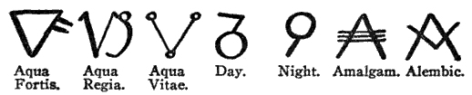

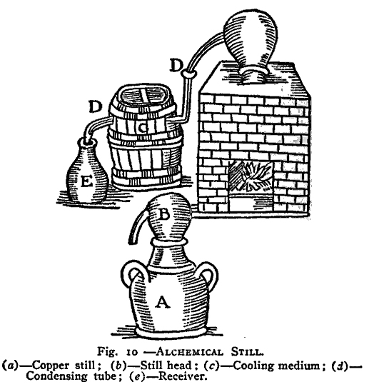

Glossary of Terms

A
ADMIXTURE: Another name for an Alchemical compound.

ADVENTURE: A short plot or scenario that lasts between one and twelve hours.

ALCHEMICAL COMPOUND: An in-game item produced with the Alchemy skill.

AMALGAM: Another name for an Alchemical compound.

ARCHIVE CHARACTER: A back up copy of a player's character sheet kept at Logistics. Can be used to replace a player's copy if it is lost or destroyed. Should be updated every time a character gains a level.

ARMOR POINTS: A measure of armor's in-game protective value. Allows the player to take extra damage in battle. Armor can be physical, like a chain shirt, or magical.

AUTOMATIC SKILLS: Automatic skills cannot be rendered useless by any means. The skills function even if the character is unconscious or stunned. Body 1 is an example of an automatic skill.

B
BODY POINTS: Body points are a measure of the amount of damage a character can take before suffering wounds or dying. Starting characters have no body points, but additional body points can be obtained with the skill Body. No character is allowed to possess more than four Body points.

BOFFER: Padded weapons used for live action combat. Only a Boffer may be used during combat. Real weapons are not allowed.

BOLT: The missile that is launched from a crossbow.

BRACERS: See VAMBRACE.

BUCKLER: A small shield that is worn on the arm and leaves the hand free. Cannot be used with a weapon in the free hand, or it becomes a passive shield.

C
CARRIAGE BOLTS: Used to attach handles to shields. The bolt is rounded at the top and has a square block directly under the bolt's head. This block sinks into the wood of the shield, preventing the bolt from spinning.

CHARACTER AMNESTY: A policy that allows new players to change their character if they are unhappy with it. A player may use Character Amnesty only once. Character Amnesty does not apply if the character dies.

CHIRURGEON: Pronounced “Ki-urge-on”. Another name for the skill First Aid.

COMPOUND: See Alchemical Compound.

D
DAY-TRIPPER: A player who, for whatever reason, cannot stay overnight at a weekend long game.

DEMO: A demonstration of live action role-playing. During a demo players are safe from death and are encouraged to demonstrate their talents to prospective new players.

DETAILED SEARCH: A described search of another player involving no physical contact.

DRUMROLLING: See Machine Gunning

DUB: A light blow used against an unaware opponent. A dub is basically a light tap or poke with a boffer weapon on any legal target area.

DUCT TAPE: Sticky, cloth-backed tape used to build boffer weapons. Duct tape comes in several colors but the most common color is gray. Duct tape is available at most hardware stores. British people call this gaffer tape.

E
ELECTRICAL TAPE: Sticky, flexible, thin tape used to mark weapon edges or seal seams when making boffer weapons. Electrical tape comes in several colors but the most common color is black. Electrical tape is available at any hardware store.

EXPERIENCE POINTS: Experience points are used to represent a character's life experience. Points are awarded for attending games, playing an NPC and similar activities. These points are used to increase a character's Level.

EXP: Slang term for experience points.

F
FLORENTINE: Fighting with two weapons, very often a sword and dagger. Fighting with two weapons requires the Two-Weapon Training skills.

FLAIL: A medieval weapon that is comprised of a spiked stick attached to a handle by a chain. Flexible weapons of this nature are not allowed in Kingdoms of Novitas.

FIGHTER PRACTICE: A chance for players to practice fighting skills. Fighter practices are out-of-game. Characters cannot be killed at a fighter practice.

G

GAME DAY: A game day is a period of twenty-four hours. The game day cycle starts when the game officially opens. For example, if the game started at 6 p.m. Friday night the start of the next game day would be 6 p.m. Saturday night. Many special abilities reset every game day.

GAME HOLD: A verbal safety command that can be used to bring the game to a stop. Most often used for safety reasons. Should be called in a clear, loud voice. During a hold players should not move, but may speak out-of-game and look around.

GAME MASTER: Game Masters is in charge of the game. They design scenarios, settle disputes amongst players, and monitor safety. The Game Master’s word is law!

GARB: Costume, clothing.

GLOW STICK: A chemical light that activates when its container is bent and shaken. Lasts about eight hours. Comes in several colors. Available at most Army/Navy or hunting stores.

GREAT WEAPON: A weapon that is longer than 42” and can only be used with two hands.

H
HAFTED WEAPON: Any weapon with a shaft such as a pole-arm or axe.

HAUBERK: A long shirt of chain armor.

I
IG: In-game. Describes objects or people participating in the game. Players sitting around the inn are in-game. Kingdoms of Novitas coin and gems are IG. Other players may steal IG objects.

IP: In-play. Describes objects that are used during the game but cannot be stolen. Normal weapons are an example of in-play items. Players cannot be in-play; they are either in-game or out-of-game.

INCANT: A short phrase that must be spoken in order to cast a magic spell.

INSTANTANEOUS: Spells or powers that occur without delay.

J
JERKIN: Medieval vest or jacket.

JUICED UP: Describes an object or character that is armed with poisons.

K
KILLING BLOW: A blow that quickly kills a character that is Wounded, helpless, or unconscious.

L
LARP: An acronym for Live Action Role-Playing. Kingdoms of Novitas is a LARP.

LEVEL: A measure of a character's overall experience. Levels are sometimes used to organize players into groups of equal strength.

LIVE STEEL: Describes real weapons of any sort. Live steel weapons are not allowed at Kingdoms of Novitas.

LOGISTICS: Where all players must check in at the start of the game. Logistics handles sign-in, weapon inspection, character creation, costume approval, and similar housekeeping duties.

LOOP-HOLING: A form of cheating where a player bends or reinterprets rules to their own advantage.

M
MACHINE GUNNING: A rapid succession of low power weapon hits. Machine gunning is against the rules. Players hit by a machine gun attack should count the attack as a single hit. Also known as Drum-rolling.

MAGIC CLOAK: Describes a player that ignores shots in combat claiming that they hit clothing. Hits to clothing, pouches, and other objects on a player’s person still count. Ex. “He’s wearing his magic cloak again.”

MELEE WEAPON: Describes a weapon with a total length of less than 42” wielded with one hand, such a sword.

META-GAMING: Use of OOG information or abilities for the benefit of a player's character.

MISSION: Another name for an Adventure.

MODULE: Another name for an Adventure.

N

NEWBIE: A slang term describing a player at their first game. There is no offense intended through the use of this term.

NON-PLAYER CHARACTER: Non-player characters, or NPCs, are the supporting characters in the game. Non-Player Characters portray parts created for them by the GM, such as monsters. Players who play the part of an NPC will be awarded experience points for use with their regular character.

NPC DRIFT: Occurs when NPCs drift out of place during a game. Often a result of Non-Player Characters becoming bored waiting for Players to arrive.

O

ORBITAL SOCKET OF THE EYE: The skull cavity protecting the eye. The ridge of the orbital socket can be felt through the skin around the eye. Boffer weapons must have tips large enough to prevent them from easily entering this socket.

OOG: Out-of-game. People or objects that are OOG are not part of the game. For example, players going to the bathroom, cars, and things colored hunter orange are OOG.

P
PHYSICAL SEARCH: A search of a player where they are actually patted down, and their belongings are rifled through.

PLAYER CHARACTER: Player characters, or PCs, are the main catalysts of the plot. Player Characters are created and portrayed by the people who create them.

PLAYING POSSUM: Players who feign mortal wounds or death to avoid encounters, then pop back up to rejoin the action at a more opportune time.

POMMEL: The butt-end of a weapon, typically a sword or dagger. Referred to as a Butt Spike on hafted weapons. It is not legal to strike an opponent with the Pommel of a weapon. It is required to pad the pommel of a weapon to protect opponents from accidental contact in battle.

PRODUCTION SKILLS: Alchemy, Poison, Brew Potion, and Scribe Scroll are collectively referred to as Production Skills, as they all require Production Points to use.

PROTECTIVES: Describes protective magic such as spell created armor or spell shields.

Q
QUEST: Another name for an adventure.

QUILLION: The cross-guard of a sword or dagger. The quillions on boffers are most often made of foam or thick rubber hose.

QUIVER: A case or sheath used to carry arrows or bolts, usually worn on the back or hip.

R
REPERTOIRE: A selection of skills or abilities. For example, a magic user would have a repertoire of spells.

RHINO-HIDING: Term used to describe a player who ignores shots in battle. Rhino hiding is considered cheating. Also see “Magic Cloak”.

S

single step mechanism: This means a single tripwire, button, lever, or other mechanism that must be bypassed to disarm a trap.

SKILL POINTS: Used to purchase skill levels. Skills cost more points based on their in-game complexity. Each character starts with thirty skill points and gains ten additional skill points every time the character gains a level.

SPACKET: Spell Packet. See TAG BAG.

T
TAG BAG: Small beanbag packed with birdseed that represents ranged magic spells, poisons, or the special abilities of some monsters.

TIME STOP: A verbal command used to pause the game. Only used by Game Masters to set the scene or position encounter elements. Players should take a knee, close their eyes, and make meaningless noise to mask the sounds of the GM.

TRAP: Devices designed to cause damage or another effect to the target once the trigger has been tripped, and represented by small electric or mechanical artificial noisemakers. If the trap is tripped it will make noise and the target will take damage or another effect.

TRICK OR TREAT: A phrase used to describe players wearing improper racial costuming or bad garb. Trick or treat is in reference to a costume that looks like a bad Halloween outfit as opposed to a proper live action role-playing make-up job.

TUNNEL CRAWL: A short adventure held indoors. A building is set up to resemble a cave or dungeon. Tunnel crawls are filled with all sorts of traps and monsters, and are very often physically demanding to navigate, involving much crawling and wriggling through tight spaces.

V

VAMBRACE: Lower arm guard that protects the forearm and at times the elbow. Shorter vambraces are often called bracers.

W

WANDERING MONSTERS: Simple encounters involving small groups of monsters that are not part of a larger plot. Usually one time encounters.

WEEKENDER: Slang term describing a weekend long game typically lasting from Friday to Sunday.

WOUNDS: Serious damage to a character. Wounds can cause permanent injury or even death. Wounds occur when a character is hit after they have no Body points or Armor points.

X
XP: Slang term for experience points.

Z
ZERO LEVEL TRAPS: A trap that can be disarmed without the skill Disarm Trap. Open pit traps and buckets of acid (water, confetti) placed over a doorway are examples of zero level traps.

